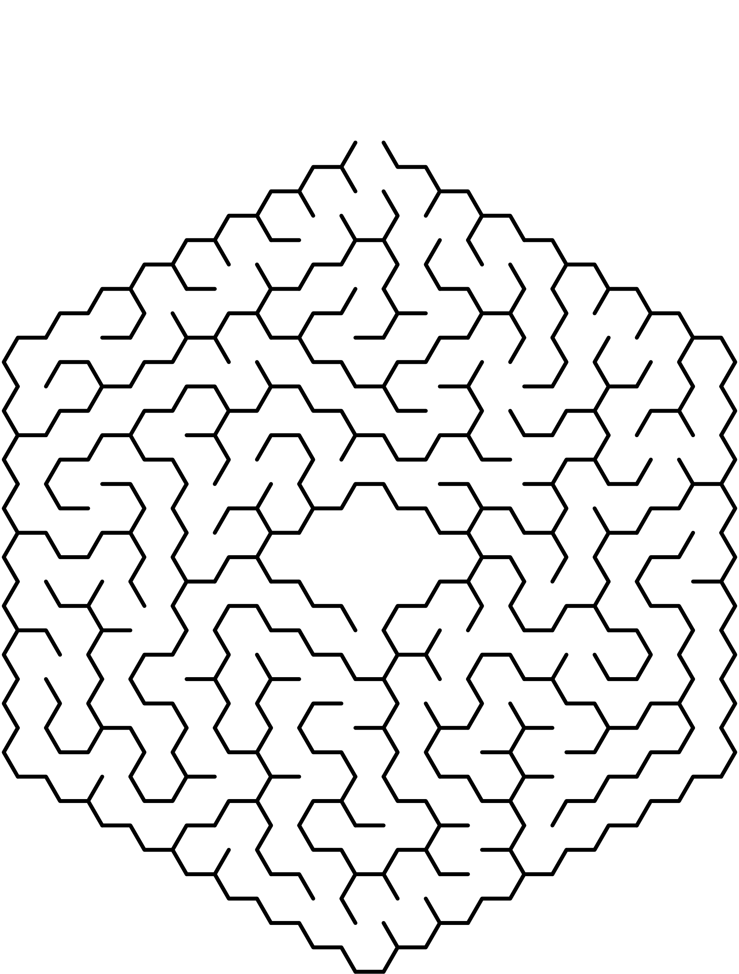
,reach the center of the maze
Finish
Start
Reach the center of the maze

,start

,finish

