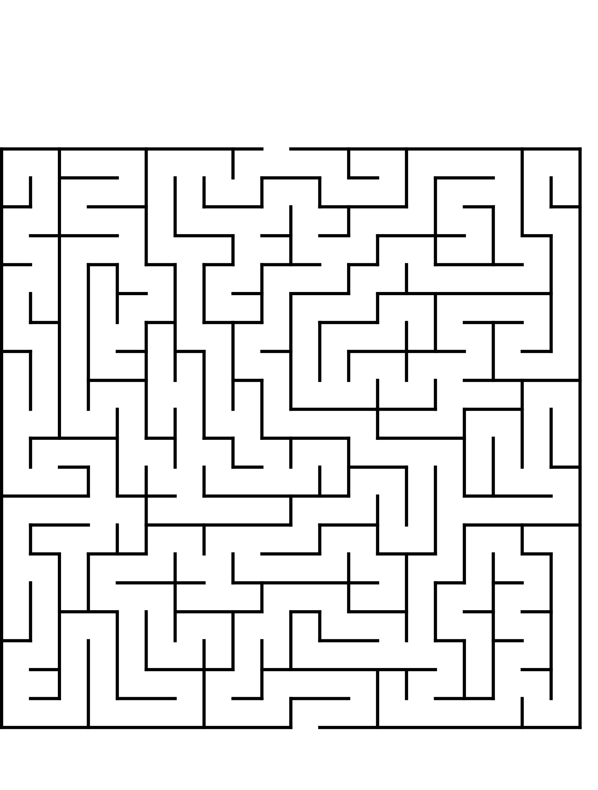
,reach the end of the maze
Finish
Start
Reach the end of the maze

,start

,finish

