,ocean ,scene3 ,find the #e
Ocean Scene: Find the 5
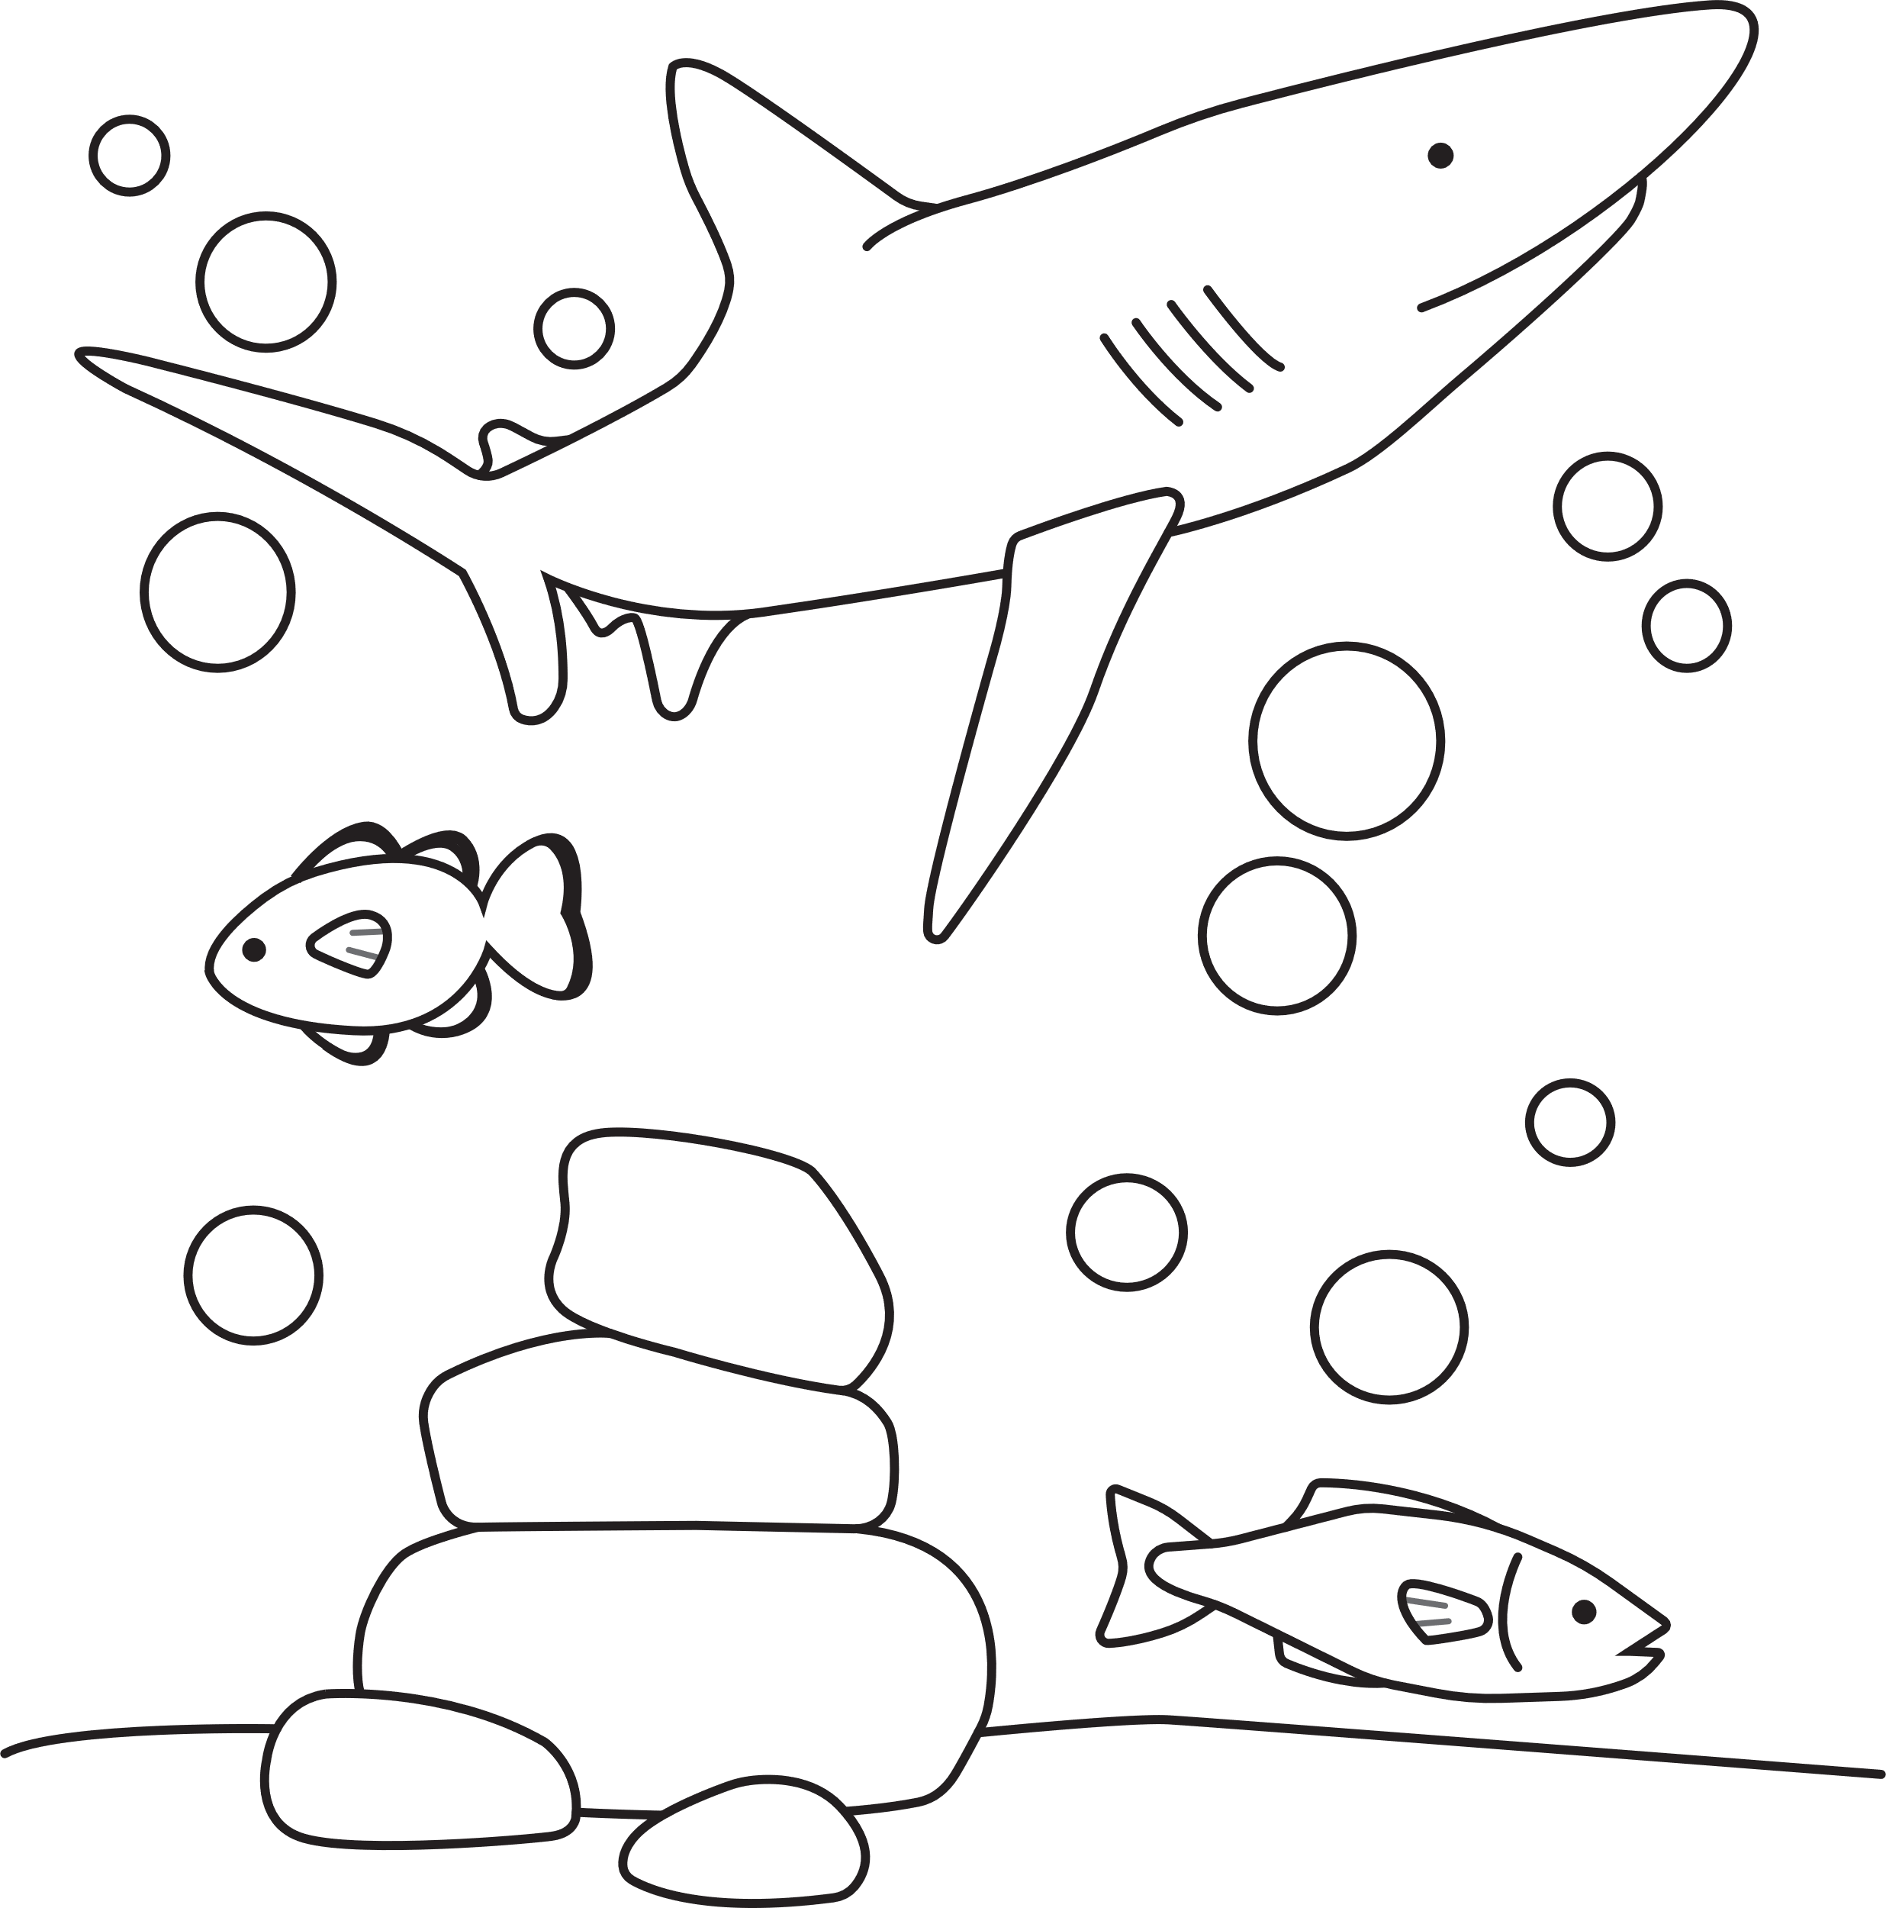
differences
differences

,ocean ,scene3 ,find the #e
Ocean Scene: Find the 5
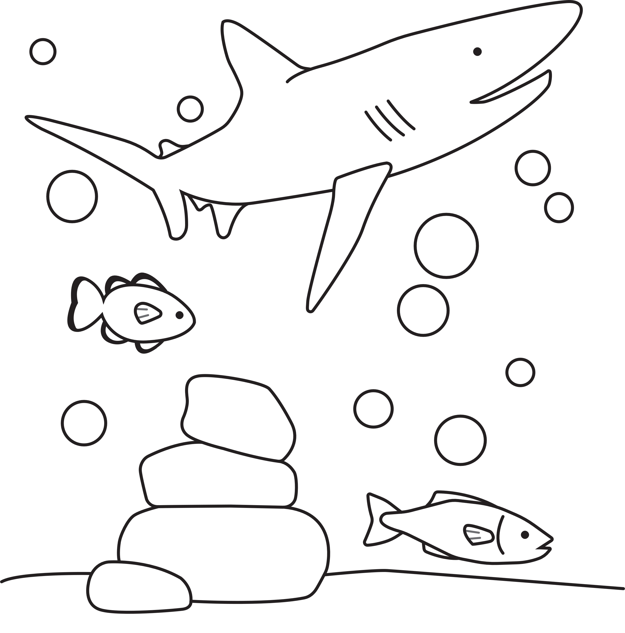
differences
differences

