,farm ,scene3 ,find the #e
Farm Scene: Find the 5
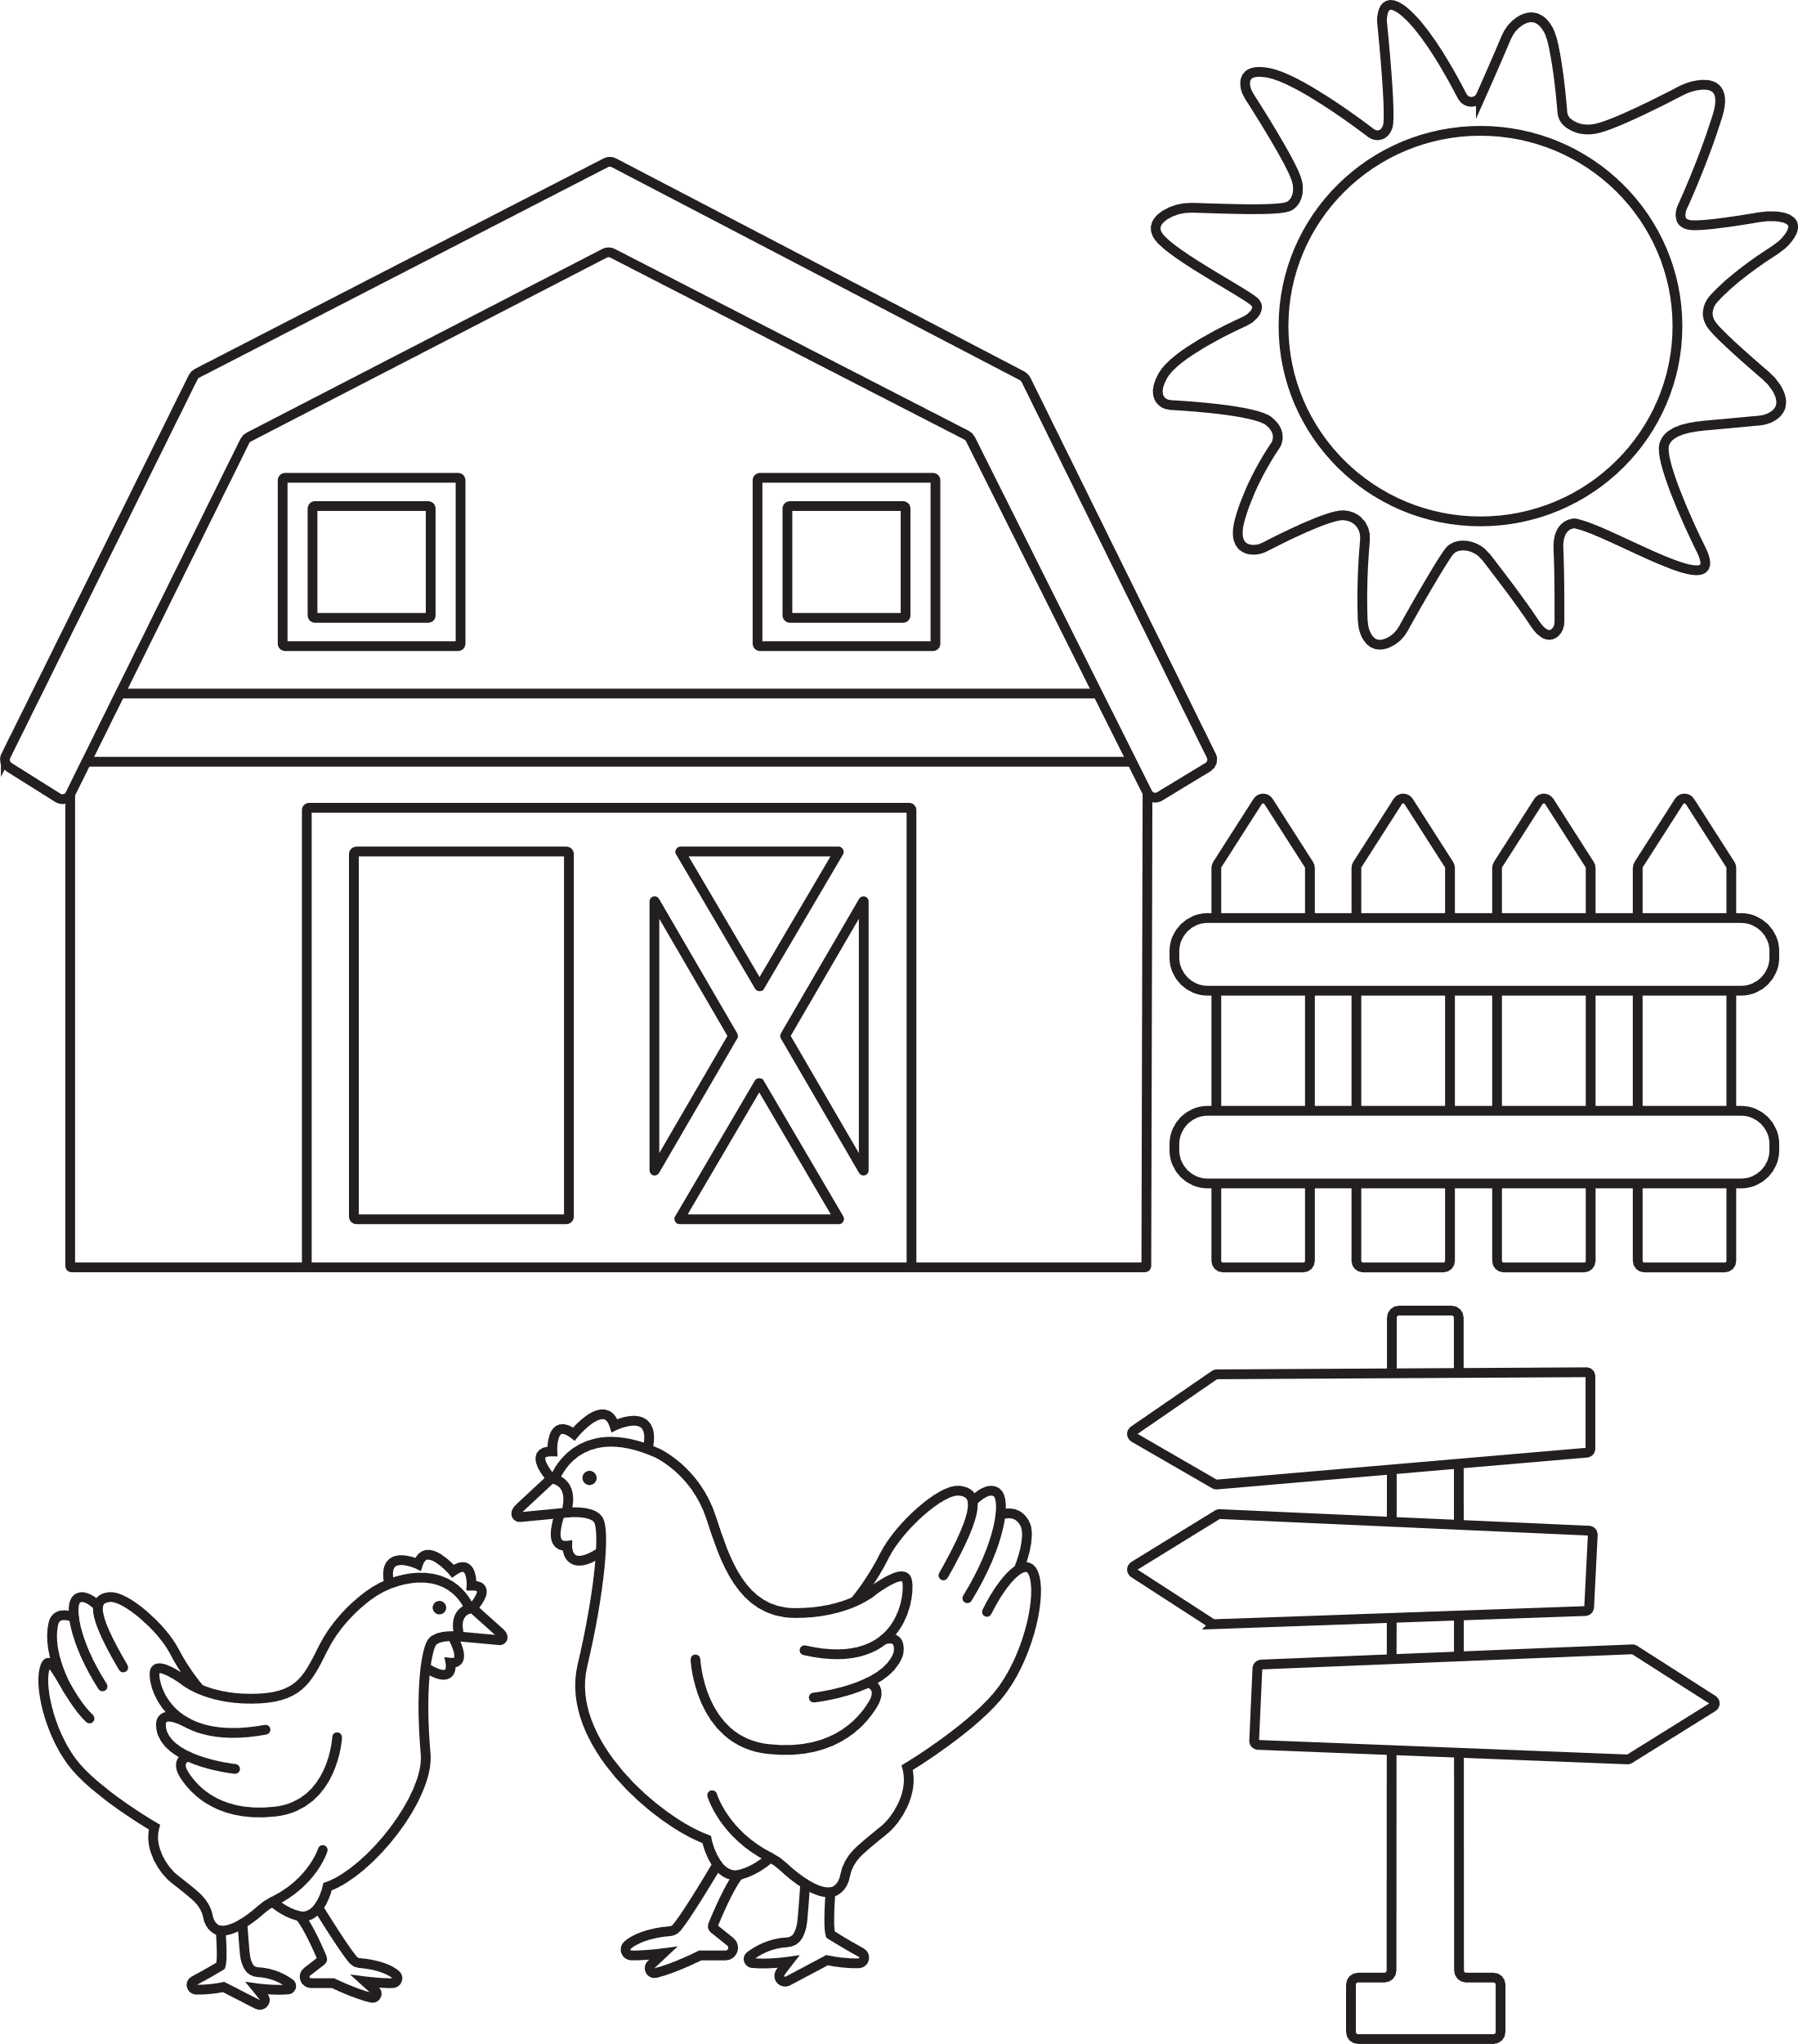
differences
differences

,farm ,scene3 ,find the #e
Farm Scene: Find the 5
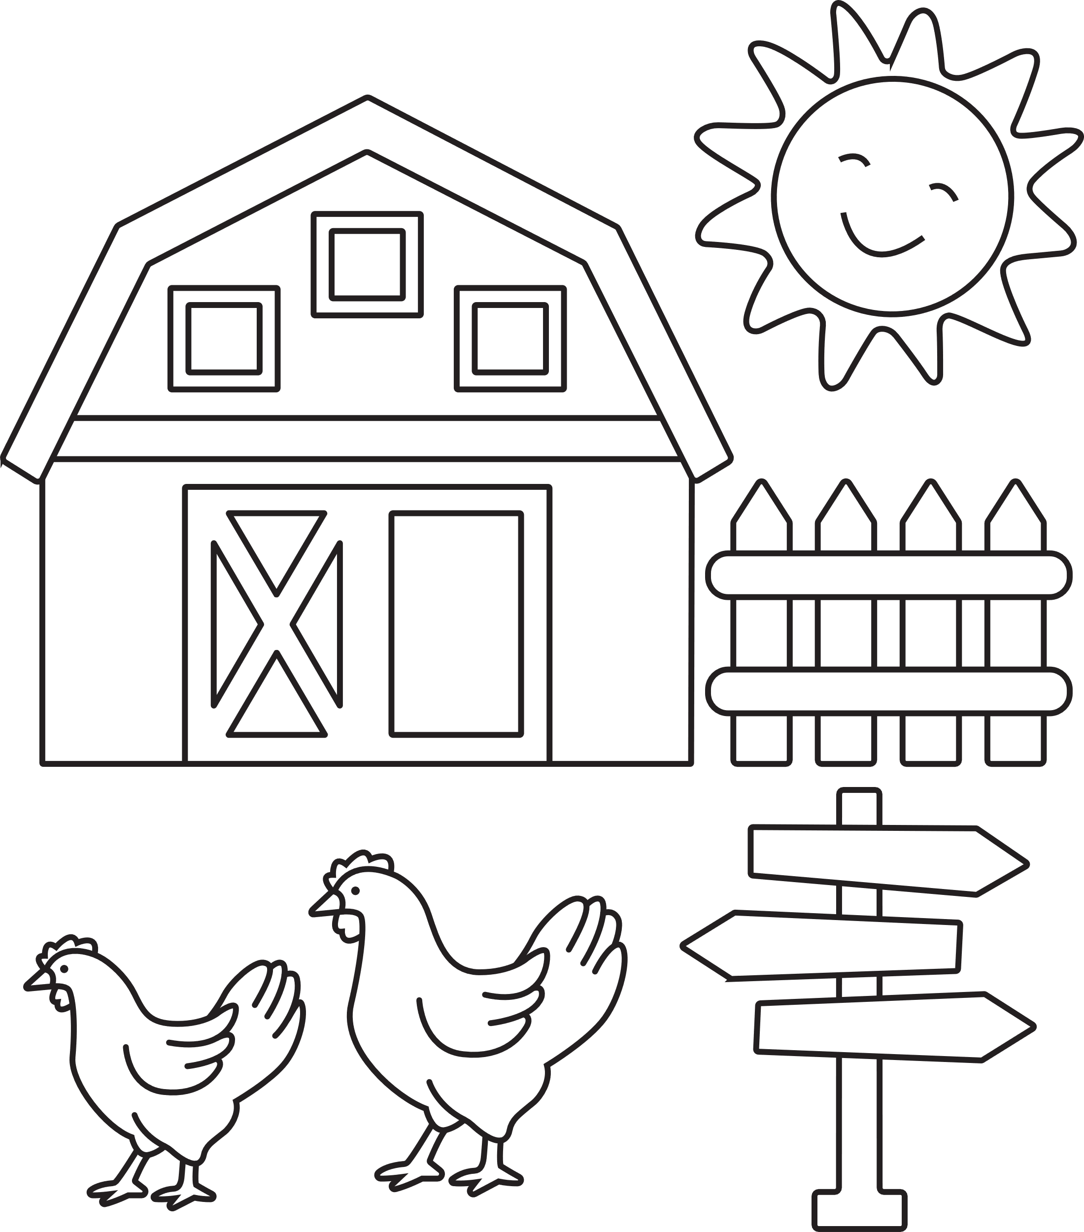
differences
differences

