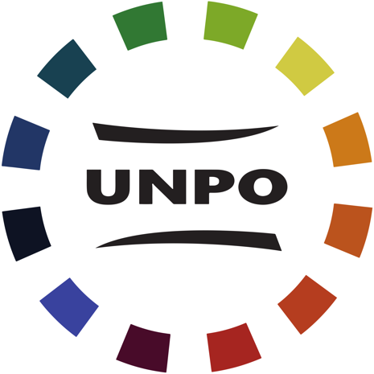

INITIAL INQUIRY FORM

Membership of the Unrepresented Nations and Peoples Organisation (UNPO) is contingent on adherence to the provisions of the UNPO Covenant. Please read carefully Title II of the Covenant on Provisions Governing Participation.
If you have any questions regarding the application procedure or membership, please email us at: membership@unpo.org
Please fill the below questionnaire with as much details possible.

- Basic Information and Contact Details

1. Name of the Nation or People.

Your text here

2. Organisation representing the Nation or People.

Your text here

3. Names and positions of the main representatives of the organisation applying.

Your text here

4. Contact details (At least 2 contact)

Main contact person: Your text here
Address: Your text here
Telephone/fax: Your text here
E-mail: Your text here

Main contact person: Your text here
Address: Your text here
Telephone/fax: Your text here
E-mail: Your text here

Main contact person: Your text here
Address: Your text here
Telephone/fax: Your text here
E-mail: Your text here

Main contact person: Your text here
Address: Your text here
Telephone/fax: Your text here
E-mail: Your text here

Main contact person: Your text here
Address: Your text here
Telephone/fax: Your text here
E-mail: Your text here

II. About your Nation or People

5. How your Nation or People constitutes a distinct Nation or People. (Article 6a)

Your text here

6. A brief history of your Nation or People. (Article 7a)

Your text here

7. Reasons for wishing to become a Member. (Article 7b)

Your text here

