Granger causality between Gold, Stock Market Returns and Volatility
Student’s Name
University Name:
Date

Granger causality between Stock Market returns, Gold, and Volatility
Contents
Introduction: 2
Literature Review: 2
Methodology: 5
Empirical Analysis: 8
Implications: 10
Conclusion: 11
References 12

Introduction:

Since decades the study of the capital market of different countries visa set of macro-economic and different financial indicators has been underway. Research articles using empirical studies have shown that as financial deregulation happens both domestic and, external stock markets become much sensitive. In regards, one prominent factor is the price of gold. When gold became a standard system, from 1900 to 1971, the gold price was regulated with USD standard system. However, since 1972, gold has been regulated without and relation to USD, and since then gold price has been controlled independently of USD. Thus, the price of gold is being determined by the market forces of supply and demand. Traditionally, gold was used as a medium of exchange in various regions of the world. With time, world governments moved towards adopting a paper-based currency to streamline economic activities. In the modern financial system, along with paper-based currency, different other forms of financial securities emerged. Although the emergence of paper-based currency revolutionises the financial landscape, stock market added a new dimension to the trading world (Choudhry, Taufiq & Hassan, Syed & Shabi, Sarosh, 2015). In this paper, we will analyse the correlation between gold and stock market returns and their volatility, particularly the Granger causality will be applied to investigate the relation.

Literature Review:
One interesting case regarding the relation of gold and stock market returns is that of India. Before the beginning of liberalisation and globalisation the relation of gold prices was positive, thus showing an increasing trend. Despite the formation of stable stock markets, the price of gold in India is increasing. The major driver of this increase is the growing demand for gold in the Indian market. One major factor for such high demand for gold is its immense value of storage. Gold has remained much stable store of value over the years.
Furthermore, gold has good liquidity even in times of recession and economic downturns. These factors have contributed to the stable demand of gold vis a vis stock market returns, where volatility has been the major bone of contention for investors. According to an empirical paper written by P K Mishra, J R Das, and S K Mishra
When the study of the capital market for any country of wide range is done on financial variable s, and economics are the main subject of matter in different types of research from the last few decades. Gold price volatility has got attention to a lot of academic, researcher and analysts. This paper represents the relationship between the stock market and domestic gold price which is in India. The study which is taken on the stock market and gold prices based on BSE-100 index which evaluates the Granger causality in VCMC( vector error correction model) which starts from the January 1991 to December 2009. When the analysis was made it shows the evidence feedback causality between variables. During the sample period, Gold prices granger caused to return stock market and other hand stock market return cause to the gold price (Mishra, & Mishra, Santosh, 2010). So these both variables have some relation which brings effect on each other.
Another experimental paper which researches the connection among gold and securities exchanges return is composed by Taufiq Choudhry, Syed Shabi Ul Hassan, and Sarosh Shabi. In this exploration paper, they have examined the nonlinear unique co-developments to stock, gold returns, securities exchange instability and market returns in which as of late money related emergencies created in the US, UK, and Japan. A rundown of the experimental paper is given underneath:

This paper demonstrates the nonlinear powerful co-developments between the securities exchange unpredictability and market returns amid the as of late delivered the worldwide emergency in the US(p&S), UK(FTSE-100) and in Japan (Nikkei-225). To start with, there are dynamic bariatric standards between the securities exchange and gold return through financial exchange and gold return are tried here; these the two connections are judge by taking three-month work rates in multivariate nonlinear conduct. This paper demonstrates that relationship fundamental which depends on a bivariate model that features the impacts of nonlinear input between factor. This was going on amid the monetary emergencies' of the nation that was under investigation. In these emergencies, the extremely constrained proof was explained. At the point when the examination was done on it, these outcomes demonstrated the changing lab our rates have comparability to the bivariate model. ( O'Brien, P. C., and Bhushan, 1990) During the budgetary emergencies, gold did not perform well in light of the fact that bivariate does not rely upon it between the stock returns and gold returns, for example, securities exchange instability. Another focal point unpredictability is utilized in stable money related condition, and the support is utilized against the securities exchange.
Arouri et al. (2012) have examined the vital value markets of Europe and condensed a noteworthy unpredictability overflow sway between stock costs and raw petroleum costs on account of Europe. Basher and Sadorsky (2006) have completed a vital investigation; they contemplated the effect of raw petroleum costs and the developing markets and abridged that the decreases in oil costs applied a noteworthy certifiable impact on stock costs of the developing markets.
As detailed by Ramos and Veiga (2010), it isn't fundamental that lowering in the cost of oil have a clear increment in stock costs. Past research suggests about for example Canada and Perez de Garcia (2005), Bec and Gaye (2016), Kilian (2009), Albulescu et al. (2016), and Hamilton (1983, 2003) have closed a positive and persuading causality relationship between unrefined petroleum costs, and numerous financial pointers for swelling, GDP and value returns of created markets.
Benhmad, François(2019) had noteworthy research think about on Modeling Nonlinear Granger Causality Between The Oil Price And U.S. Dollar. Aftereffects of the examination think about finding a noteworthy effect of unrefined petroleum costs on the value returns of these securities exchanges. Nonetheless, that sway was fluctuated area to-division and nation-to-nation. The effect of raw petroleum costs stuns on the value advertises likewise relies upon the idea of a nation's position; the effect of oil costs is desperate for oil trading and oil bringing in nations. The economy, which is the oil sending our nation, the impact of oil costs has a fitting beneficial outcome on the value advertise; be that as it May, for a situation of oil imports, the stock returns have a negative impact (Wang et al., 2013).

Methodology:
The procedure of empirical analysis has been chosen to know about the interrelationships between these variables. Before running this model, we make all these three variable stationary to run a VAR model. In the VAR model, we check for the number of lags selection that how much lags will be affecting the models. The data for these variables are monthly based data from 2016-2018 of the US.
In this report, the variables; the gold, stock market return, and volatility index factor in the market are not stationary. For this reason, we used to estimate the bivariate model of VAR in levels as best explained by Sims et al. (1990). As estimating in VAR in levels correctly approximates the dynamics of the system taking into account whatever cointegration and integration which may exist in the data (O'Brien, & Bhushan, 1990). The Granger causality explained the dynamics of the variable under the assumption called linearity. Baek and Brock imply that Granger causality test has less effect on non-stationary variables which indeed cause direct focus on the future forecast.
Equation | Par ms | RMSE | R-sq | F | P>F
Price | 7 | 32.6254 | 0.5870 | 5.447387 | 0.0012
 | 7 | 66.9767 | 0.9545 | 80.4038 | 0.0000
 | 7 | 2. 87353 | 0.4797 | 3. 534111 | 0.0126

 | Coeff. | Std. | ER. | t | p>|t| | 95% coeff.
Price L1 | 1.103901 | .2388794 | 4.62 | 0.0000 | .609741 | 1.59806
L2 | -.3680558 | .1913075 | -1.92 | 0.067 | -.7638055 | .0276939
Sreturn L1 | .0353833 | .1369924 | 0.26 | 0.798 | -.248007 | .3187736
L2 | -.031851 | .1381378 | -0.23 | 0.820 | -.3176109 | .2539089
Volatility L1 | -0309827 | 3.373215 | 0.01 | 0.993 | -6.947045 | 7.00901
L2 | -.6441713 | 2.56881 | -0.25 | 0.804 | -5.95816 | 4.669818
-Cons | 329.5825 | 189.7863 | 1.74 | 0.096 | -63.02041 | 722.1854
Sreturn:
Price L1: | -.4114976 | -4903953 | -0.84 | 0.410 | -1.425958 | .6029624
L2: | .1915448 | -3927349 | 0.49 | 0.630 | -.6208893 | 1.003979
Sreturn L1 | .5439144 | .2812315 | 1.93 | 0.066 | -.0378573 | 1.125686
L2 | .4036759 | .283583 | 1.42 | 0.168 | -.1829602 | .9903121
Volaity L1 | -9.712905 | 6.92487 | -1.40 | 0.174 | -24.03809 | 4.612281
L2 | 9.679324 | 5.273508 | 1.84 | 0.079 | -1.229759 | 20.58841
cons | 434.442 | 389.6122 | 1.12 | 0.276 | -371.5322 | 1240.416
Volatity:
Price L1: | -.0048253 | .0210396 | 0,23 | 0.821 | -.0386985 | .0483491
L2: | .000537 | .0168497 | 0.03 | 0.975 | -.0343192 | .0353932
Sreturn L1: | .0222052 | .0120658 | 1.84 | 0.079 | -.0027548 | .0471652
L2: | -.0204453 | .0121667 | -1.68 | 0.106 | -.045614 | .0047234
Volatility L1: | 1.065159 | .2971006 | 3.59 | 0.002 | .4505597 | 1.679759
L2: | -.3793223 | .2262516 | -1.68 | 0.107 | -.8473593 | .0887147
Cons | -7.13331 | 16.7157 | -0.43 | 0.674 | -41. 71236 | 27.44574

Granger causality test
Equation | Excluded | F | df | Df_r | Prob>F
Price | Sreturn | .04356 | 2 | 23 | 0.9575
Price | Volaity | .06839 | 2 | 23 | 0.9341
Price | ALL | .08498 | 4 | 23 | 0.9862
Sreturn | Price | .4093 | 2 | 23 | 0.6689
Sreturn | Volaity | 1.6851 | 2 | 23 | 0.2075
Sreturn | ALL | 1.1079 | 4 | 23 | 0.3767
Volatility | Price | .09755 | 2 | 23 | 0.9074
volaity | Sreturn | 2.0093 | 2 | 23 | 0.1569
Votality | ALL | 1.2018 | 4 | 23 | 0.3369

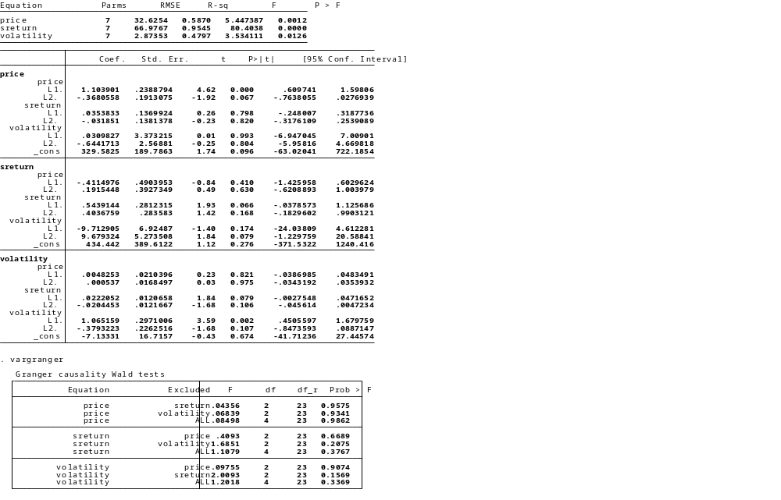

Price of Gold:
Null hypothesis: Stock Return and Volatility cannot affect the Price of gold
Alternative hypothesis: Both of this variable affect the Price of gold
Stock Return:
Null hypothesis: Price of gold and Volatility cannot affect Stock Return
Alternative hypothesis: Both of these variable affect Stock Return
Volatility:
Null hypothesis: Price of gold and Stock Return cannot affect Volatility
Alternative hypothesis: Both of these variable affect Volatility

Empirical Analysis:
According to the hypothesis testing and the results of the Granger causality test suggests that we do not have enough evidence to reject the null hypothesis. So, it’s clear means that each of the variables has a significant effect on others. While testing their lags it has been seen that increasing the number of lags for each of these variables has also affected the other two variables.
The Granger causality investigation as exhibited by the methodology in the interrelationship between variables of US Stock Market Return and Gold Prices in USD, and Volatility in the market. The Granger causality is fundamental to show and look at whether one variable can estimate another variable in an alternate information time inside the arrangement. The information gathered is assessed for both financial exchange and gold and permits count for estimation. The most critical variable is the return of volatility (Francis & Lessoire, 2019).. The factors engaged with the examination are all related gold. Even though these factors have been examined independently, this report presents to give increasingly understandable approach.
The correlation of lags term of Stock Market Return has Prob value 95% which is higher than 5% so we cannot use the reject our null hypothesis and shows that lags of stock market not affecting the return of gold. Similarly, the prob value of lags of volatility is also greater than 5 % which also suggest that volatility in the market structure has no significant influence on the return of gold (Francis & Lessoire, 2019). But the Stock market return and volatility may affect others as the volatility of market increases the stock return path start changing.

Implications:
- There has a list of suggestions comes out under the report results because of not get enough evidence to reject the null hypothesis of " that stock market return and volatility has not affected the return of gold." Based on this result on thing is clear from this result that gold is the long run investment as it cannot be affected by the market volatility or stock market return structure and also not following or depended on these factors while keeping the exogenous factor as a constant like they are not changing.
- Regarding the Stock Market Return and Volatility, the results suggest that both of these factors affect each other by increasing the number of lags terms. Market volatility may directly or indirectly affect the stock return in the broad market.

Conclusion:
In this paper that results of monthly numeric data of variables; gold return, stock market return, and volatility index factor are not linearly following the path of each other. The return of gold has not influenced by the stock market return and volatility of the market structure for that current period. Under the null hypothesis that the other two cannot affect the return of gold, the Prob value is greater than 5% which shows that we cannot reject the null rather accept it. Likewise, the other two have also followed the structure of the price of gold which indicates these variables are highly interlinked with each other.

References

Benchmade, François. Modeling Nonlinear Granger Causality Between The Oil Price And U.S. Dollar: A Wavelet-Based Approach. 2019.
Bouri, E., Jain, A., Biswal, P. C., & Roubaud, D. (2017). Cointegration and nonlinear causality amongst gold, oil, and the Indian stock market: Evidence from implied volatility indices. Resources Policy, 52, 201-206.
Balcilar, M., Bonato, M., Demirer, R., & Gupta, R. (2017). The effect of investor sentiment on gold market return dynamics: Evidence from a nonparametric causality-in-quantiles approach. Resources Policy, 51, 77-84.
Choudhry, Taufiq & Hassan, Syed & Shabi, Sarosh. (2015). The relationship between gold and stock markets during the global financial crisis: Evidence from nonlinear causality tests. International Review of Financial Analysis. 10.1016/j.irfa.2015.03.011.
Francis, Lessoire. "Cointegration And Causality Among Dollar, Oil, Gold And Sensex Across Global Financial Crisis". SAGE Journals, 2019, https://journals.sagepub.com/doi/full/10.1177/0972262918804336.
Mishra, P.K. & , J.R.Das & Mishra, Santosh. (2010). Gold Price Volatility and Stock Market Returns in India. American Journal of Scientific Research. 9. 47-55.
Mishra, P. K., Das, J. R., & Mishra, S. K. (2010). Gold price volatility and stock market returns in India. American Journal of Scientific Research, 9(9), 47-55.
O'Brien, P. C., & Bhushan, R. (1990). Analyst following and institutional ownership. Journal of Accounting Research, 28, 55-76.

"Oil And The Dollar - Wilmington Trust." Research And Insights | Wilmington Trust, 2019, https://library.wilmingtontrust.com/wilmington-wire/oil-and-the-dollar-and-the-chicken-and-the-egg.

