Unit 3 Simulation Essay
1. Jesse wants me to investigate GanttProject software to determine whether it would be suitable for SCR. She asked me to prepare a summary of pros and cons, and a sample of screen shots and information.
The GanttProject software is free, open source, Java-based program. SCR would definitely benefit from using GanttProject software. It is a seemingly useful project management tool that would be a good addition to SCR.
Pros:
- Can show the progress that’s been made in a project
- The software is able to be translated into several languages
- MS project files can be imported by users
- Creates and organizes tasks and milestones efficiently
- Organizes tasks in a work breakdown structure
- Resources within the project can be managed by users
- Can draw dependency constraints
- The software is supported on most common operating systems
Cons:
- Some of the language translations are fairly out of date
- There isn’t much information about how to use the product
- Was created by a group of sovereign individuals, not a business. No company to be held accountable is something goes wrong
- Outdated features.

➢ Could become too complex and cumbersome to navigate with time and additional tasks
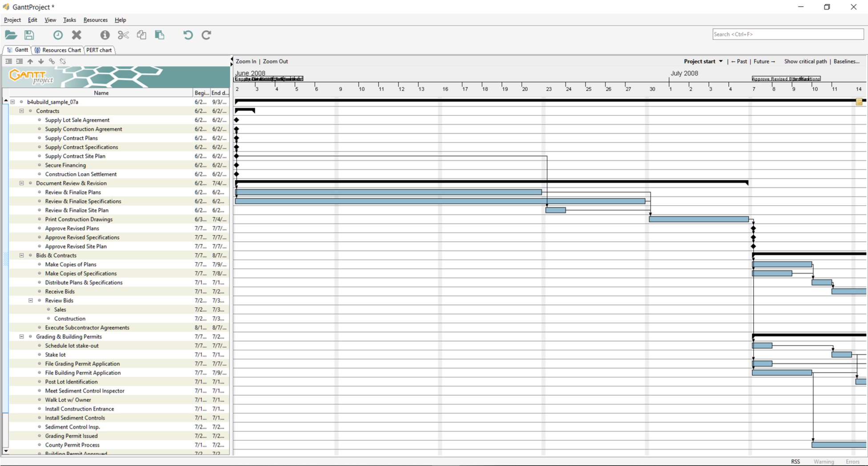
- Jesse likes the idea of using task completion estimates with best-case, probable-case, and worst-case estimates. She said that I should use typical formulas and weight values to create a Microsoft Excel spreadsheet that would make it easier to calculate expected task durations.
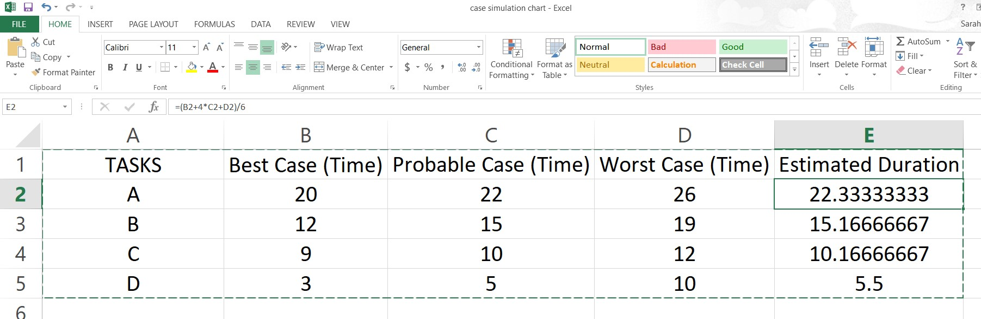

- To practice my skills, Jesse asked me to create an imaginary project with at least 12 tasks, which include dependent, multiple predecessor, and multiple successor tasks. She wants me to create a list showing the tasks and dependencies, and patterns. She also needs to know the duration, start, and finish for each task. She said to use my best guess regarding duration, and we could adjust it later.
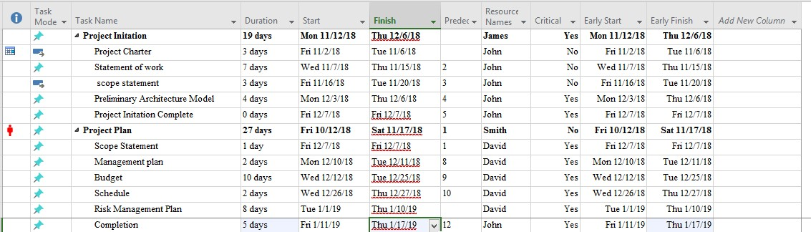
- Jesse wants me to prepare a brief handout for the other team members with some do’s and dont’s regarding project management. She wants me to include at least image. She suggested either a screenshot or a drawing that would show some aspect of project planning.

*Delegate project
tasks
*Plan projects
while identifying
needs of the
company
*Schedule the
project
*Monitor all
processes of the
project
*Share amd jear
odeas amd
concerns
*Have only one
source of
communication
*Underestimate
a Project
*Be ashamed of
feedback
D
O
'
s
D
O
N
T
'
s
