Title: Web Server Statistics Analysis
Introduction
The following data sample represent web server statisctics for computer science department. It contains eleven sections namely total successful requests, average successful requests per day, total successful requests for pages, average successful requests for pages per day, total failed requests, total redirected requests, number of distinct files requested, Number of distinct hosts served, corrupted logfile lines,total data transfered and average data transfered per day. The figures are indicated in the figure below:
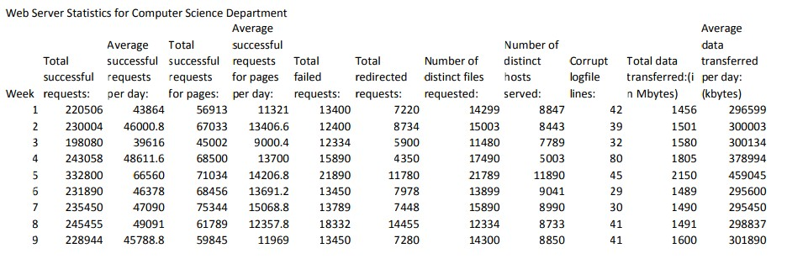

A complete overview of the data, identifying anomalies in different weeks, and the
weeks that the data are not regular.
The statistical data in the table above shows that total successful requests is normal in most weeks evidenced by range of between 10,000 and 2,000 approximately. During the fifth week the range widened by over 100,000 with corresponding average successful requests per day being 66560. The second, fourth and nineth weeks have the highest value of average successful requests per day above 40,000 mark. The total successful requests for pages is normal since the range varies between 1,000 and 2,000 without questionable anomalies(Hox, Moerbeek & van de Schoot, 2010).
The average successful requests for pages per day from the table above shows that the figures went down during the first week, third week and nineth week. The remaining weeks recorded figures between 15,068.8 and 12357.8 which leads to range of 2729. The range is considerably normal, the total failed requests recorded highest value during the fifth and eighth week which represents anomaly or breakdown in consistency of the web server.
The total redirected requests recorded highest values on eigth and fifth week with fourth week having the minimal value redirected requests but recorded second highest figure for number of distinct files requested where the 5th week recorded 21789. The 5th week serve most number of distinct hosts while the fourth week recorded most corrupted logfile lines(Ferreira, 2011). The total data transfered in terms on Megabytes is consistent for most weeks except the fifth week recorded elavated results. The average data transfered per day was highest on the fifth week followed by the ninth week.

Choose 5 different sections of data, examine these sections, and provide the specific
selection process and criteria you used to select this data set.
Corrupt log file lines,Average data transfered per day,Number of distinct files requested,Total failed requests and average successful request per day.
The corrupt log file lines will enable the analyst to determine number of attempts recorded assuming that data corruption is malicious act for attack. The average data transfered per day help in developing the web server rate and speed. Number of distinct files requested per day assist in determining number of uses that access sensitive data within the network assuming the requests are system administrators and top personnel access of the resources(Hox, Moerbeek & van de Schoot, 2010). Total failed request help in determining criteria of malfunctions that are physical or technology related. Average successful request per day provides effectivess of network operations and their technological success to meet business organization success.

Provide the measures of tendency and dispersion for each of the 5 different sections
of data you selected
· Corrupt log files lines (29,30,32,39,41,41,42,45,80)
Mean=(29+30+32+39+41+41+42+45+80)/9=42.11
Mode=41
Median=41
Range=(80-29)=51
Variance =234.61
Standard deviation=15.32
· Average data transferred per day
295450, 295600,296599,298837,300003,300134,301980,378994,459045 Mean=(295450+
295600+296599+298837+300,003+300,134+301980+378994+459045)/9=325182.44
Mode=0
Median=300,003
Range=(459045-295450)=163595
Variance= 3235610590.23
Standard deviation=53629.27
· Number of distinct files requested(11480,12334,13899,14299,14300,15003,15890,17490,21789)
Mean=(11480+12334+13899+14299+14300+15003+15890+17490+21789)/9=15164.89
Mode=0
Median=14,300
Range=(21789-11480)=10309
Variance= 9316199.11
Standard deviation=3052.24
· Total failed requests(12334,12400,13400,13450,13450,13789,15890,18332,21890)
Mean=(12334+12400+13400+13450+13450+13789+15890+18332+21890)/9= 14922.78 Mode=134450
Median=13450
Range=21890-12334=9556
Variance=9118336.84
Standard deviation= 3202.83
· Average successful requests per day
39616,43864,45788,46000.8,46378,47090,48611.6,49091,66560
Mean=(39616+43864+45788+46000.8+46378+47090+48611.6+49091+66560)/9=48111.
04
Mode=0 median= 46378
Range=66560-39616=26944
Variance=55709204.80
Standard deviation=7463.85
0  100000  200000  300000  400000  500000  wk1  wk2  wk3  wk4  wk5  wk6  wk7  wk8  wk9
  Corrupt Log files
  Average data transferred per day
  No. of distinct files requested
  Total failed requests perday
  Average succesful request per day
This graph provides a collective overview of the 5 sections of data used in this statistical analysis of web server for computer science depart ment. The average data transferred per day is the most stable set of data in the avaliable content with anomalies on 4th and 5th week.
· Explain why the graph you provided gave a good visual representation of the data.
Answer: The graph provided above has different colours to represent bar for every dataset.It clearly shows that every data set is marked by color and bar height. They support clear representation of data elements and relationships.
· Based on your explanation above, identify some specific advantages why, in general, charts and graphs are important in conveying information in a visual format.
Answer: advantages of graphs and charts clear visibility, practical data presentation, easy interpretation, doesn't require complex processes when performing analysis and based on proportionality.
· Determine the standard deviation and variation, and explain their importance in statistical analysis of a data set.
Answer: Standard deviation and variance for data set
Standard deviation of the selected data set are indicated above. Standard deviation enables us to determine the negative and positive scope of processes and operations from which data was collected (Harris, Tailor, Thielke, Payne, Gonzalez & Conde,2009).
· Based on the tasks you performed in this project, research how statistics are used in information technology (IT), and provide references for your research
Answer: Statistics is used in information technology to determine trends and analyze large volumes of data such as ip addresses or network packet to generate meaningful information(Psychogios,Xia,Wishart & Young, 2009). Information such as network perfomance, server redundacy and transmission rate can be determine through application of statistical methods to interpret data. statistical analysis is conducted on interpreted data to develop trends that can be related to real life situations.
Reference
Xia, J., Psychogios, N., Young, N., & Wishart, D. S. (2009). MetaboAnalyst: a web server for metabolomic data analysis and interpretation. Nucleic acids research, 37(suppl_2), W652-W660.
Harris, P. A., Taylor, R., Thielke, R., Payne, J., Gonzalez, N., & Conde, J. G. (2009). Research electronic data capture (REDCap)—a metadata-driven methodology and workflow process for providing translational research informatics support. Journal of biomedical informatics, 42(2), 377-381
Ferreira, D. F. (2011). Sisvar: a computer statistical analysis system. Ciência e agrotecnologia, 35(6), 1039-1042.
Hox, J. J., Moerbeek, M., & van de Schoot, R. (2010). Multilevel analysis: Techniques and applications. Routledge.

