Tableau Exercise
1.) I believe this exercise did enable an application that illustrated the 3 V’s of big data. One of the V’s of big data, Volume of data types was illustrated through the sheer number of data and values which were given and shown through the exercise. Mapping all the building permits and dragging the different dimensions to map the data you see how much information is being displayed and utilized in the application. Further proof of this is the excel sheet supplied to us. There was a substantial amount of information on the excel sheet which occupied over 2,000 rows, if that isn’t volume of data I am not sure what is. Just a substantial amount of data being utilized and illustrated through the application. Another one of the V’s, variety of data types, is also illustrated through the color feature of the application. We had to change the color of the different types of data to be able to distinguish them in the maps and charts and it looked like a rainbow with all the different colors for the various data types. Velocity of changes in data was illustrated through dragging the different dimensions to the panel to the right of the dimensions. When you dragged a different dimension over it changed the way the data was being presented and the data being presented, adding whatever you dragged into the information being displayed. Through this exercise and application, I was able to change the data and the way it was being presented instantaneously and with no issues. I do not believe any V’s are weak in this exercise, they were all illustrated well and in their own way.
2.) The dashboard illustrated the power of Spatial Analytics and Big Data by allowing you to change basically everything about it to make it look how you want and display the information you want. In the exercise we had to change the legends on the right of the dashboard to floating and move them to where we want and this allowed us to really take up any blank spaces in our charts or maps that didn’t need to be there, this also freed up more room where the legend was previously located. We also removed the titles from the map and charts to create more room but once could chose to leave them on to better display the information being shown. On top of being able to customize the dashboard however you wanted, the dashboard itself displays the 3 V’s of big data very neatly and pleasing. By combining the different sheets into one dashboard you are able to see the Volume of the data, the Variety of data being shown and the Velocity of changes in data through the different sheets. The dashboard provides complete customizability to the business decision-maker regarding locational analytics because they’re dealing with more than a single map and legend. There are various maps and charts all with different information being shown so the business decision-maker can chose to display that information however they want.
3.) I would suggest narrowing the focus of the application to one or few categories because the number of records is already substantial, if you add several categories to an already huge number of records then the volume of data will most likely be overwhelming. However, Tableau is the perfect application for a situation so like that because of it’s ability to organize massive amounts of data into neat maps and charts. You can use the color feature of the application to categorize
certain data by color to differentiate through all the records. There were a lot of features I am sure we did not get to use during this exercise, but I am sure Tableau has features to organize and categorize massive amounts of information even easier and more efficiently, so I think utilizing this application and its features is the best move for a massive database of two million records.
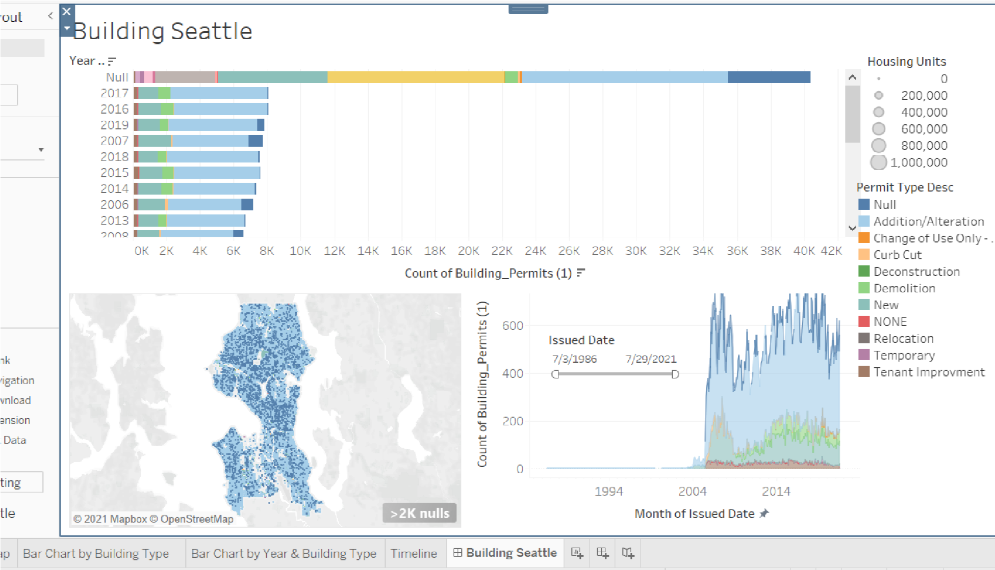
Powered by TCPDF (www.tcpdf.org)

