Tableau Assignment
Introduction
In this paper we are going to analyze data given, which is statistics regarding professional soccer players. We shall analyze this data using Tableau software in a bid to run a statistical test and plot a dashboard as we dim fit. The assignment will involve applying visually arresting visualizations in a variety of forms, next will be applying strategies for the systematic visual exploration of multidimensional and heterogeneous data sets. After that is covered, we shall then look into how to communicate complex data information’s and insight using data visualizations. We shall also propose the appropriate visualization for a given audience and defend choices through evaluation of the different ways of communicating data in Tableau. This paper will also strive to clarify and support data visualizations through effective use of annotations. Last but not least we will create dashboards, design scorecards and represent spatial data through exploratory data visualization.
Tableau is one of the most important data tools that can be used to analyze data in the modern era (Lerman, pg. 27). We see that in order for one to be able to understand data, especially vast amounts of data, it is imperative that certain groups of the data are represented and highlighted so that all the data involved can be analyzed and critically looked at. In our case the data involves professional football players. These vast amount of data looks at various aspects of their careers ranging from their height, goals scored, weight, race, clubs, ball control, accuracy, curve, composure, dribbling, long passing and many more features. All these data are individual to a vast array of players making the data to be huge and contain many records of which have to be pooled and grouped in certain data sets for them to portray conclusive information regarding professional football players.
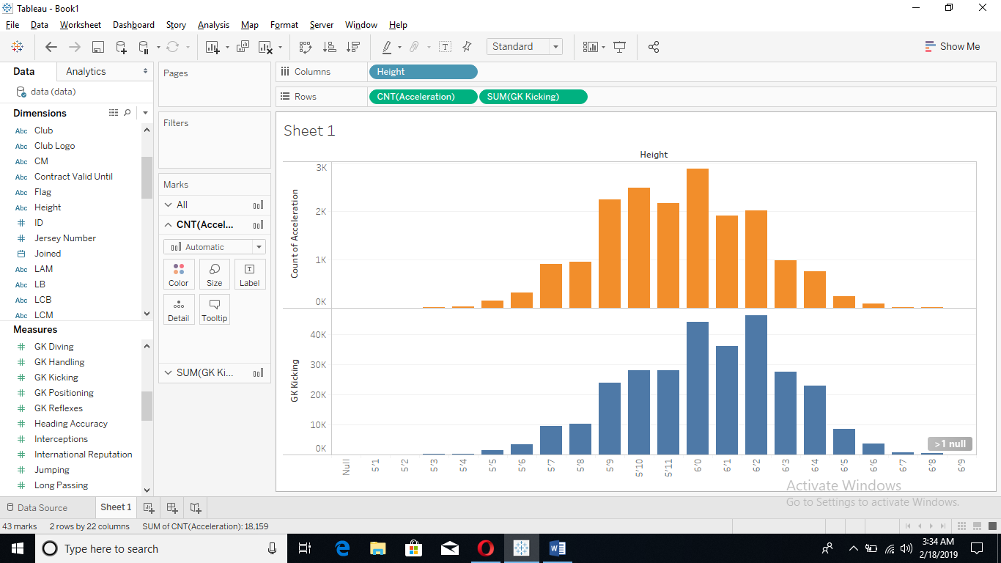
In order to be able to apply strategies for the systematic visual exploration of multidimensional and heterogeneous data sets, the data has to be imported to tableau and the different data visualizations have to be executed in order for the various data to be compared and conclusive results to be realized from the data. In our case we see that visualization systems and strategies in the football fraternity have traditionally focused on building graphical depictions of relationships between different football players in a human comprehensible format. By doing this, these information is not capable of providing integrated analytical services that can greatly aid in tackling complex knowledge discovery issues within the football world. For instance, information gained from Tableau can in an instant avail the best players for a certain position for a coach faster than having thousands of scouts look for an individual to fit a certain profile manually. Hence by being able to offer such complex information in an instant we see that from the charts we were able to find the fastest footballers combined with skill and height and group them together making it easier for whoever might search for them to be able to get them. These set of data can then be father separated in accordance to the salary earned and many other nitty gritty details that define a good professional footballer. 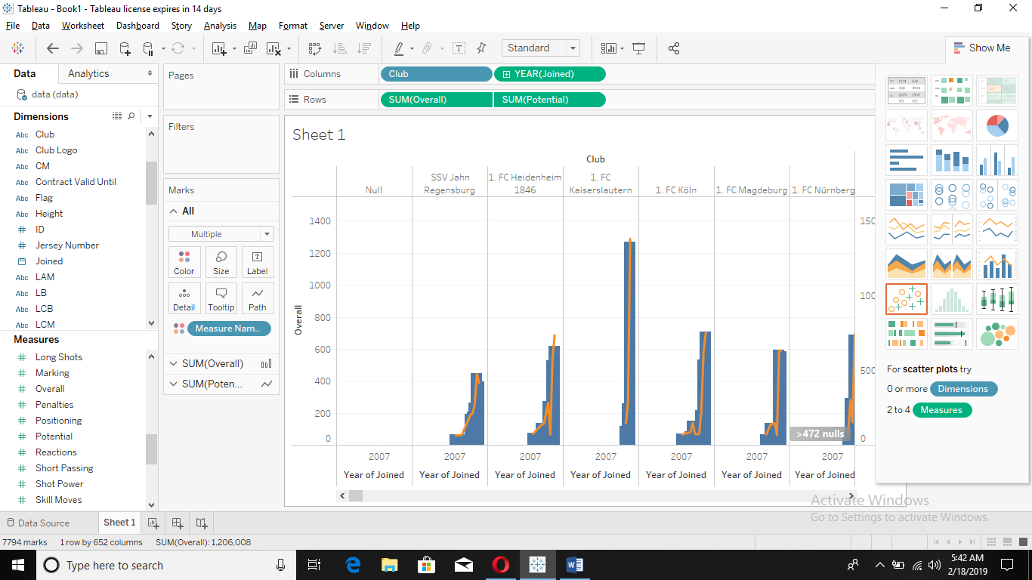
In order to be able to communicate complex data information and obtain insight using data visualizations in tableau, we see that it is imperative that all data is carefully plotted and analyzed. The Fifa dataset that is being analyzed has been put into visualization, showing easily information such as the highest paid Fifa players, the best ranking players, fastest, most accurate, tall, short and all the others attributes. Without having such a software, most of these data could not have been outlined in such an easy to understand manner as compared to the past where valuable information was hard to discover when too much data was portrayed at once. We also see that discoveries that were made, based on human being’s perception were at times biased, subjective and most of the time insensitive to some of the characteristics in the information.
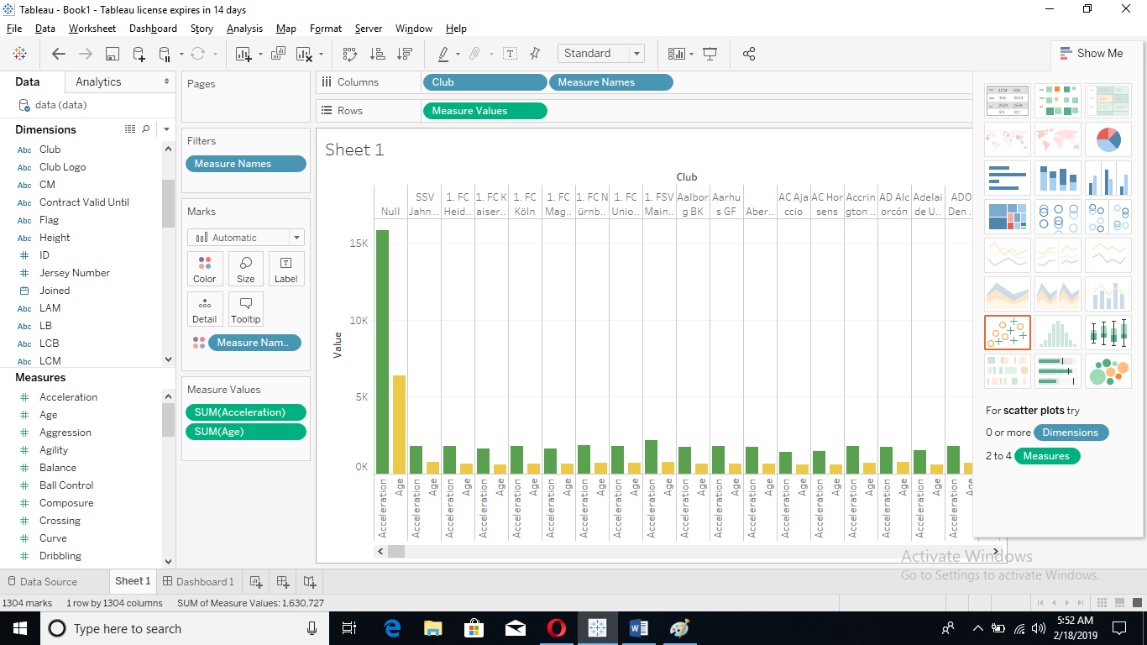
To propose the appropriate visualization for an audience for this data and defend my choice of visualization through the evaluation of the different ways of communicating data. We see that the appropriate manner to display these Fifa dataset will be to use histograms. These portray basic information in a simple and easy to understand manner that is imperative to anyone understanding a huge and complex data set such as these (Christopher, pg. 98). By use of histograms valuable information are easier to be discovered and accessed. Histogram also enable data to be accurately grouped, the data set is arranged in a manner that has integrity and visualization. Histograms are able to leverage the collaborative effort of human comprehensibility and Tableau efforts in a bid to facilitate the human visual exploration process. To do this, histograms first and foremost extract the valuable information that is hidden in huge data sets. These data sets when converted to histograms will most likely at any particular time have different sizes with each size portraying a different aspect of a group of data, unlike other data structuring systems. Histograms also consolidate hidden data sets, making sure that any individual who interacts with that particular set of data, gets to look at the data from all type of angles. Be it the data is homogenous or multidimensional in nature. Histograms are also able to solve problems such as inaccurate discoveries that might not exist at a particular time (Han, pg. 56). The data pool obtained is also used to guide user exploration in that when a used is observing a particular set of data, they can use the information they have received from the data to dig in some more and find other useful information.
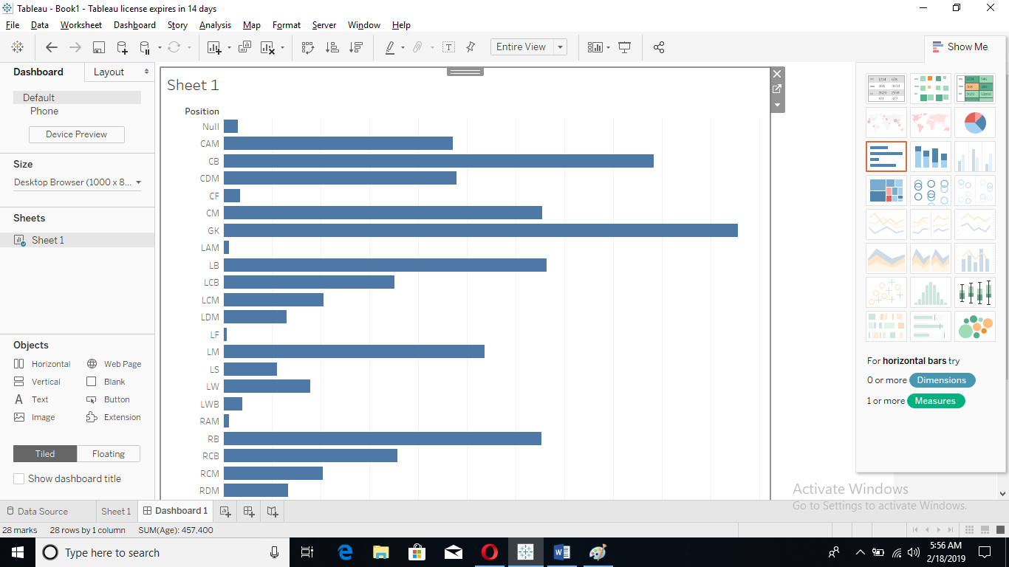
Dashboard age vs position. fig
In order to be able to appreciate data sets and the various information they hold, how they relate and complexity of what is at hand. It is important that we support data visualization in Tableau through the effective use of annotations. Data visualization actually refers to any help that is advanced in regards to helping people understand better the significance of a given set of data by placing the said data in a visual context. Various patterns, trends and other various correlations that may at times not be recognized in the immediate context of data, can be realized after the data has been visualized. In these case different data visualizations have been put in place namely, use of histograms and the use of pie charts and bar graphs. As mentioned earlier, histograms pause a number of important advantages over other data visualization techniques. However different techniques such as bar charts are also important in that, in a case such as this with the Fifa data set. Bar graphs and charts tend to display more detailed information as compared to other data visualization techniques. They also have the ability to portray constantly changing information that would otherwise be difficult to understand given the huge array of information involved. These advantages assist people to be able understand data faster and also pick trends from the data. Pie charts are also an important part of data visualization, where as it portrays fixed data, it is able to give cohesive information that can be used in an instance to decipher a set of data and understand its meaning without delving deeper into the content of the data.
As observed histograms are good for huge data sets because of its ability to contain data sets within other data sets. It can also account for change in case the data is variable all these being contained among the different data sets. On the other hand, other different data visualizations have their own various shortcomings. X-Y plots are used to determine relationships between two different entities in tableau. A change in one variable affects change in the other variable in this relationship hence it can be used to find the exact relationship between two entities at any particular time, and also define a lack of relationship.
Conclusion
All in all, we have been able to use Tableau software to analyze the Fifa data set which contained a humongous list of players that are on Fifa. This list also contained all their details as far as their footballing career and physical performance was concerned. All these data have been uploaded to tableau and carefully analyzed enabling us to come up with creative and visually striking data visualizations that have enabled us to closely understand the inner workings of Fifa, and also appreciate the various rankings of players and their individual abilities combined with other extra activities that accompany their professional lives. Tableau has enables us to effectively analyze the data and extort reasoned information from the data.
Reference
"The Data is In: New Policy & Advisory Board for Tableau Public". Tableau Software. 2011-02-21. Retrieved 2015-04-07.
Lerman, Rachel (22 August 2016). "Seattle Times". Retrieved 23 August 2016.
Christopher R. Stolte: Ph.D. Candidate @ Stanford". Graphics.stanford.edu. Retrieved 2011-11-16
.Han, Mike. "Learning Tableau". Retrieved 2018-12-03.

