Project Deliverable 3: Database and Programming Design

Database Schema and Design
In mandate to offer a suitable and sufficient database design of the proposed digital distribution e-commerce platform by Vapor incorporation with EGS as its principal competitor, consider the requirement for database design. In particular, the information on the key business functions and how data will move across all domains of the company consequently. The central role of the system database will be to make sure that a centralized repository of data exists and is made accessible via complete relationships in mandate to fulfill the needs of several business operations and functions such that the long-term goals and tactical objectives of the company can be fulfilled. For this purpose, there will be a significant component of revenue, inventory, and marketing and gaming sales data delivered into the system database and data categories existing in the proposed database scheme. Various entities will be described in the database schema in addition to data that is beneficial and can likewise be utilized as a part of effective and meaningful data relations (Morris, Peter, & Coronel, 2012). For the described business, the following database schema has been developed which comprises of a total of eleven entities and respective attributes (fields) with defined index values in the form of a primary key and foreign key identification with relationships established in the schema.
Admin – the Main user of the digital platform to manage gamer and developer accounts and other administrative tasks such as to publish or delete of the gaming content on the digital website/platform. The admin entity has a one-to-many relationship with customer and developer.
AID (PK)
Username
CID (FK)
- GID (FK)
Developer – the individual upload or download gaming content shared on the website after registering with the system.
- DID (PK)
- Name
- GID (FK)
Customer/User (Gamer) – Individual video game users and developers who want to buy or rent game item through an ecommerce digital platform provided by the supplier. The customer entity has one-to-many relationship with admin and game entity.
- CustomerID (Primary Key)
- Name
- Rating
- CCT
- Rent Hours
- ST
- YOP
- GID (Foreign Key)
- GEID (Foreign Key)
Employee – Individuals within Vapor organization deals with service providers and interacts with supplier to distribute on-demand game services to customers through digital system.
SSN (PK)
Name
Sex
- DOD
- Address
- Salary
Supplier – will have interaction with employees and will fulfill gaming purchases or service requests through a digital system. The supplier entity has a one-to-many relationship with the game entity and a one-to-one relationship with the employee entity.
- SID (PK)
- Name
- Address
- Contact Info
- Email
Game – A gaming package/gaming equipment or content that a customer (gamer) or video game developers explore to purchase on digital ecommerce platform published by developers.
- GID (PK)
- Title
- Creator
- Developer
- Genre/Type
- Publisher • Year
Rating
Platform
Award

Orders – A request for purchase or acquisition of gaming content/game package by a customer on the platform. The orders entity has one to many relationship with gamer/customer and one to one payment with payment entity.
- OrderID (PK)
- Total Price
- Date
- CustomerID (FK)
- PID (FK)
- GID (FK)
Payment – an entity that outlines the value of the cost of the gaming content purchased by a customer. It has one-to-many relationship with orders entity.
- PID( (PK)
- Method
- Total Amount
- Payment Details
- Security Code
Categories – the entity (table) in the database that documents all the data associated or related with all the categories of the gaming content available on the digital platform. The table will comprise the subsequent fields or attributes documented in the system database. It has a one-tomany relationship with sub-categories entity.
CID (PK)
Category Name
Sub-Categories – the entity (table) in the database that documents all the data associated or related with all the sub-categories of the gaming content available on the digital platform. The table will comprise the subsequent fields or attributes documented in the system database
- SC-ID (PK)
- Category Name
Gaming Equipment – the individual game component/written component that is available for purchase by customer on the platform.
- GEID
- Name

Database Tables
The online game distribution system/platform for incorporating the two digital functions into single e-commerce distribution platforms requires a business firm to scheme a new database system that would support and fulfill business requirements and reporting needs of management. The database scheme explained above for the Vapor’s new digital system has a different number of tables with various fields (attributes) entities, relationships, indexes and views (Morris, Peter, & Coronel, 2012).
Referential integrity in a database is a subgroup or subset of information completeness that is related to the consistency and accuracy of all records (relations or else) (Halpin & Morgan, 2010). Therefore, keeping the integrity of information is a critical task of functioning with business databases. Also, referential integrity here is essential to accomplish because it infers to the consistency and accuracy of information or records within a relationship (between two entities or tables existed in database schema). In the context of the database schema proposed for the above case, in a relationship, information is interconnected amid two or more database tables (database, 2016). It is accomplished by having a foreign key (present in the related table) reference value of the primary key (present in the parent – or primary – database table). Due to this reason, it is a necessity to make sure that information on two sides of the relationship always remains integral. As a result, referential integrity necessitates that when a value of the foreign key is utilized it should reference an authentic, real present primary key in the main table (parent). For example, in the case that a Developer erases a record value within a main or primary table, the Developer will need to ensure that there is no foreign key in an associated table with that value. The referential integrity will avoid company users or clients from:
- Modifying values existing in a primary table that outcome in orphaned information in an associated table.
- Adding new records or data to an associated table in case there is no related data in the primary database table.
- Removing data from a primary table in case there is equally associated data[ CITATION
Car92 \l 1033 ].
The tables demonstrated below are comprised of different entities and fields with each of their respective data types and relationships defined through referential integrity. The following database tables are transformed into the 3rd standard form of database normalization.

Table 1: Customer Table
CustomerID
(
Primary Key
)
Name
Rating
CCT
Rent
hours
YOP
ST
GID
(
Foreig
n Key)
GEID
(
Foreign Key
)
Integer
String
Integer
Integer
Date
Integer
String
Integer
Integer

Table 2: Games Table
GID
(
Primary
Key)
Title
Creato
r
Develope
r
Type/Genre
Publishe
r
Year

Rating
Platform
Award
Integer
Strin
g
Integer
Integer
Date
String
Intege
r
Integer
String
String

Table 3: Supplier Table
SID
(
Primary Key
)
Name
Address
Contact Info
Email
Integer
String
String
Integer
String
Table 4: Employee’s Table
SSN
(
Primary
Key)
Name
Sex
DOD
Address
Salary
Integer
String
String
Integer
String
Integer
Table 5: Payment Table
PID
(
Primary
Key)
Method
Total Amount
Payment Details
Security Code
Integer
String
Integer
String
Integer
Table 6: Orders Table
OrderID
(
Primary
Key)
Date
Total Price
CustomerID
(
Foreign Key
)
PID
(
Foreign Key
)
GID
(
Foreign
Key)
Integer Date Integer Integer Integer Integer
Table 7: Categories Table
CID
(
Primary
Key)
Category
Name
Integer
String
Table 8: Sub-Categories Table
SC-ID
(
Primary
Key)
SC-Name
Integer
String
Table 9: Gaming Equipment Table
GEID
(
Primary
Key)
Name
Integer
String
Table 10: Admin Table
AID
(
Primary
Key)
Username
GID
(
Foreign
Key)
CID
(
Foreign
Key)
Integer
String
Integer
Integer

Table 11: Developer Table
DID
Name
GID
(
Primary
Key)
(
Foreign
Key)
Integer
String
Integer

ER (Entity Relationship) Diagram
After normalizing the database tables into 3 NF (third normal form), an ERD is created in MS-Visio tool. This diagram is included in the appendix of the paper (see figure 1 in appendix section). The rationale behind this diagram is explained in the subsequent section.

Rationale for ERD of the Vapor Digital Game Distribution System (Online)
The database is unconditionally a critical component of the digital application (platform). To completely use ERD in database production, promotes businesses to create a high-quality and standard database design to utilize in database management, creation, and support. The ERD model likewise offers a way of communicating with the system. To fulfill the requirement of Vapor to build a database for the new digital distribution platform for supplying gaming content to customers or gamers and game developers, ERD typically offers a structured approach for utilization in database design (Bagui & Earp, 2011). It helps to graphically visualize all of the vital records in the form of entity values in the scope of the proposed digital platform/system and the equivalent inter-relations amid them. We have identified the different data tables as represented by the entities involved in the data management from the source clients like customer data or game data to analyze and manage it using the schema in the relational tables with respective relationships identified through foreign and primary keys mapped on it. These entities along with the fields with attributes are interlinked with each other. The primary and foreign keys are defined to reference the different database tables in the schema developed for the company’s digital game distribution system. All the entities are maintained with key fields and related to the corresponding entity through a relationship as defined within the diagram. The diagram comprises a total of nine entities involved in the system design.
The main aim of developing an ERD is to help in designing the database schema of the digital distribution platform system for gamers and developers. It is very complicated and severe to directly alter any entry within database management system. Therefore, creating an ERD is imperative to prevent loss of records. ERD here originated as a design tool supports to identify possible errors within database schema to take appropriate steps for making any changes in the database and correct the flaws in the database. It will help company to automate database creation and patching process lot more efficient and easy to understand the system database structure. With the help of this ERD model one can visualize a comprehensive database schema and effortlessly locate all key entities, see their values and fields and to recognize the important
relationships they all have with one another[ CITATION Ter10 \l 1033 ].

Data Flow Diagram (DFD)
The diagram made in the MS-Visio tool is a data flow diagram of level 1 for the digital game distribution platform (online game store) of the Vapor E-commerce business for its users and developers. The chart demonstrates that users and suppliers (gaming service providers) and company employees collaborate onto a single platform providing gaming facilities and business services to the customers/users through developers and employees of the company. The users and developers collaborate with the digital platform by registering their accounts on the system. The diagram is included in the appendix of the paper (see figure 2 of the appendix section). The rationale behind this diagram is explained in the subsequent section.

Rationale for DFD (Level 1) of the Vapor Digital Game Distribution System (Online)
The data flow diagram created for presenting the process of purchasing/getting gaming content on the digital platform depicts all the important entities involved in the process and respective data stores. It shows from where input and output data flows throughout the process within the system e.g. request (input) and response (output). Apart from just entities and processes involved in data flow it depicts data stores (keep database records). The information flow displayed with the help of arrow symbols that further describes the direction of data in and
out of the gaming distribution system[ CITATION Fre10 \l 1033 ].
The level 1 diagram
principally demonstrates the flow of data from customer or supplier to and from the system. After the customer registers with the digital game store, he/she will be able to purchase or see the gaming content/packages on the platform by paying a cost to the system. After matching the availability of the requested gaming content, the gamer downloads the required packages. They are then notified with the content once they are registered in the system. The diagram comprises of two entities, four data stores and other processes showing the data flow. This depicts the flow of information within processes making the system. The gamer as a customer firstly registered with the system to see the gaming content available on the platform. After registering, customer requests for checking game availability and system will check for the availability in the game database (data store). The customer after receiving game will proceed to payment for purchase or rent the game from the store. The supplier offers the information and gaming content as requested by the customer. The supplier updates the database for new content uploading and availability.
The DFD in figure 3 outlines the processes and flow of data within these processes involved in any action performed by an entity e.g. customer. A system analyst who is performing system analysis and design using DFD will efficiently help business to accomplish its data reporting requirements. The movement of information is illustrated with the help of symbols e.g. arrows, processes, entities and data stores. The DFD help company to keep a focus on movement of records within database of the new system and help to scheme database system in real-time.

Sample Queries
The following are two important SQL based queries that will help the reporting requirements of the Vapor Corporation.
Query 1:
SELECT CustomerName, City FROM Customers;
Query 2:
SELECT * FROM Customers;

Screen layouts
The following screen layouts (UX design) illustrate the two interfaces of an online digital distribution system for game packages that organizational customers will make use of for interaction with the new system.

Screen Layout One
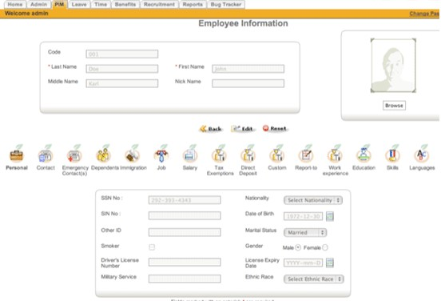

Screen Layout Two
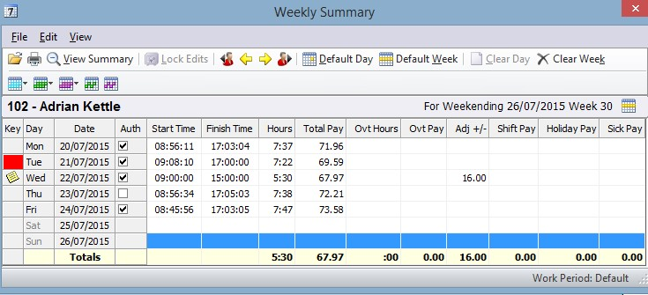

Section 2: Revised Project Plan/Gantt chart
Using the previous week 4 Vapor project plan file from project deliverable 2, we updated the schedule with some other new tasks required in the project fulfillment. This comprises the inclusion of important activities (summary and detailed tasks).
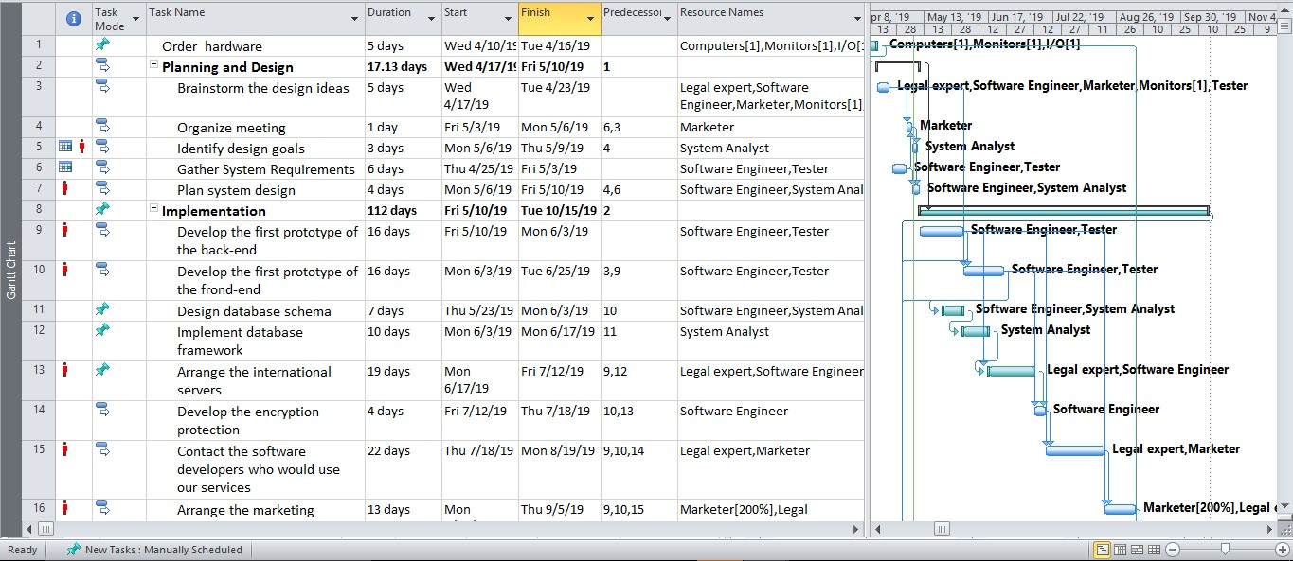
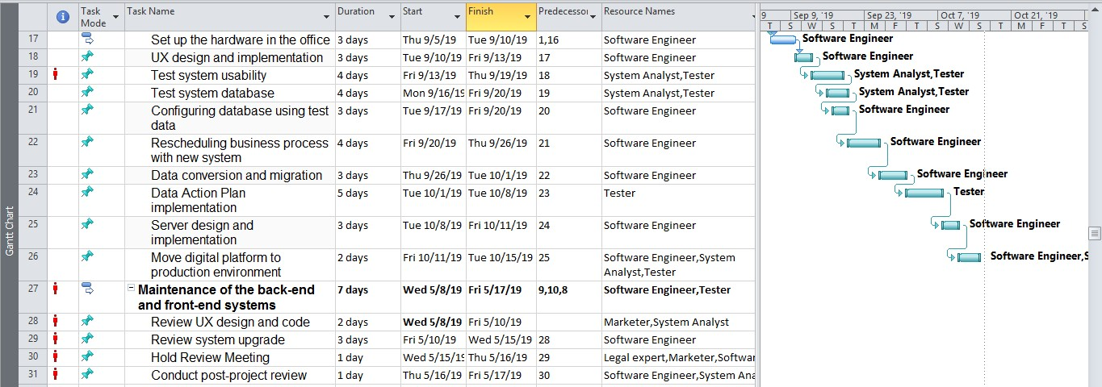
Figure 1 Revised Gantt chart/project plan of the Vapor Digital Game Distribution System
(Digital Game Store) Project
Appendix

ERD (Entity-Relationship Diagram)
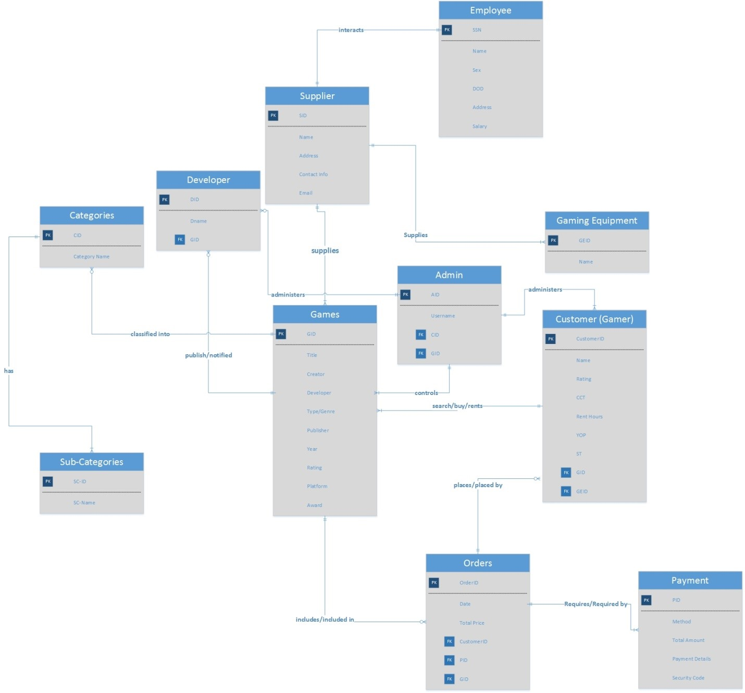
Figure 2 ERD of Digital Game Distribution System
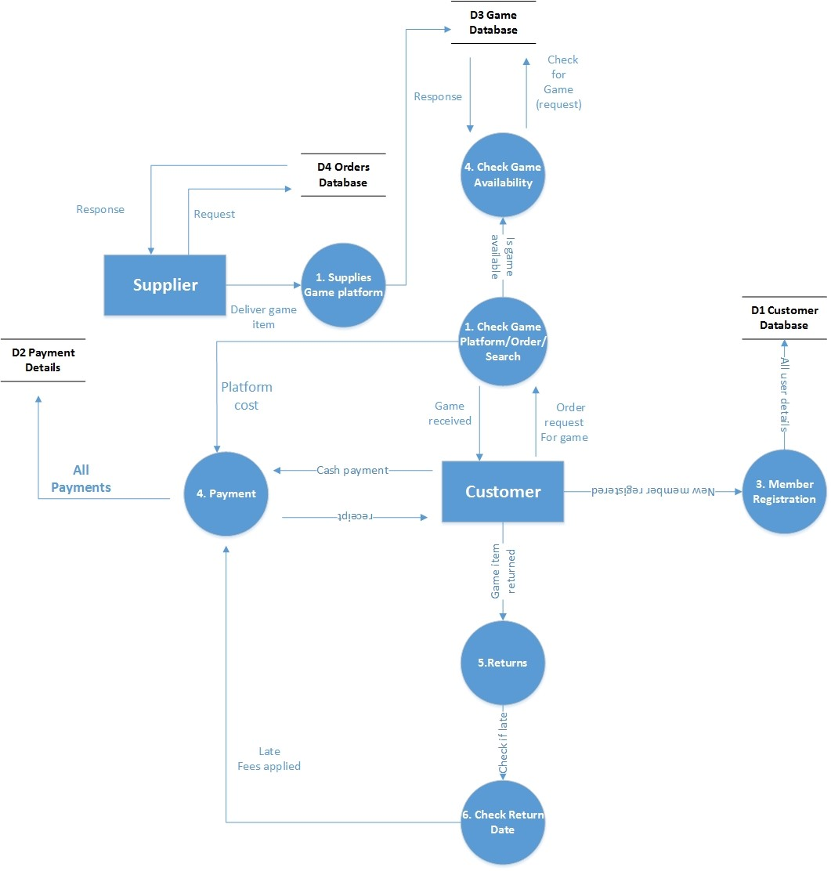
Figure 3 of DFD (Level 1) of the Digital Game Distribution System
References
Bagui, S., & Earp, R. (2011). Database Design Using Entity-Relationship Diagrams, Second
Edition. CRC Press.
Batini, C. (1992). Conceptual Database Design: An Entity-relationship Approach.
Benjamin/Cummings Publishing Company.
database. (2016, May 28). What is Referential Integrity? Retrieved from database:
https://database.guide/what-is-referential-integrity/
Halpin, T., & Morgan, T. (2010). Information Modeling and Relational Databases. Morgan
Kaufmann.
Miller, F. P., Vandome, A. F., & McBrewster, J. (2010). Data Flow Diagram: Information
System, Visualization, Computer Data Processing, Flowchart, Control Flow Diagram, Data Island, Dataflow, Functional Flow Block Diagram. Alphascript Publishing.
Morris, S., P. R., & Coronel, C. (2012). Database Systems: Design, Implementation, and
Management. Cengage Learning.
Roberts, D. (2013). Unleashing the power of IT. (2nd ed.). Hoboken, NJ: John Wiley
&amp; Sons, Inc.
Kerzner, H. (2014). Project management best practices: Achieving global excellence. (3rd
ed.).
Chichester, U.K.: John Wiley &amp; Sons, Inc.

