Project and Program Information & Communication Systems Assignment Sample

Part 1: Proposal
System Requirements for ICT for a Project Management Information System (PMIS) in Construction Industry: A case of BGC Construction

1. Introduction
ICT based project management is quintessential for the project in order to ensure the right people are engaged in the right job. In today's day and age, the Information and Communication Technology (ICT) have gained tremendous popularity. It has contributed hugely in improving the not only the productivity of all the sectors but also their revenues. Here, the ICT system requirements for PMIS for a construction firm, namely BGC Construction have been discussed. In addition, an analysis of business processes is also done and a web-based project management information system is proposed

2. Literature Review

2.1.ICT And PMIS Overview
Information and Communication Technology (ICT) is the type of information that provide information through telecommunication services, such as Internet, wireless network, mobile phones, etc. In other words, ICT is the integration of telecommunication services with the data processing and handling (Taghavi and Patel, 2011).
Project Management Information System (PMIS) is centralised tool which is usually a web-based application that is used for collecting and accessing project information which can be used by the organisation for monitoring business processes and managing funds (Gao, et.al, 2014).
Get free samples written by our Top-Notch subject experts for taking assignment help services.

2.2.Impact Of ICT On Project Management
According to Afolabi, Fagbenle, & Mosaku, (2017), ICT in modern world has become the necessity of project management.Projects are now being governed based on the large amount of data and information. This requires a great deal of management skills. ICT can make it easier for the project manager to collect, store, extract, and distribute information to people at different location timely and properly. It also protects the information from illicit uses and reduces the project cost as well.

2.3.Significance Of PMIS
According to Joseph, et.al (2014), the role of an information system can be very supportive in shaping organisational strategy. However, utilising information system is a great challenge for the construction industry.
PMIS can be a game changer for any industry as it provide an extra edge to them over their competitors. The PMIS can be implemented easily by making use of ICT. However, Schwalbe (2015) believes that holistic assessment of an information system in the real estate and construction industries is still not very mature. This may be because of the comprehensive and subjective nature of IS in construction.
Lack of understanding and poor management of project information can cost an organisation a great fortune including increased cost and less efficient human resource.

2.4.Project Management Information Flow
In every construction project, there are three levels in carrying out a project. These are strategic level, tactical level, and operational level. The role of the project manager is to manage and monitor processes, fund allocation, and assessment of work quality (Andreassen, et.al, 2015). Due to large amount of information associated with the project management, there exist difficulties too. First, and foremost is due to the large number of interrelations between information services. The information flow become very complex when it involves multiple stakeholders.
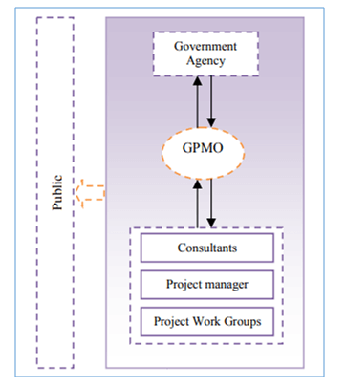

2.5.System Configuration
For the construction industry, there are four information systems available:-
- Developed In-house (proprietary)
- Enterprise Resource Planning (ERP)
- Groupware System
- Speciality Software: CPM, CAD, and other Professional System

3. Analysis Of Business Processes

3.1.Organisation's Overview
Buckeridge Group of Companies, also called BGC, is one of the leading private corporate group of constructions. The company was founded in 1960 in Perth, Australia. The company is the leading home builder in Western Australia. In addition to this, it has numerous subsidiaries, namely National Homes, Designer Homes, JCP Construction, etc.
The business processes associated with BGC Construction are:-
- Planning
- Sales
- Design,
- Estimating
- Scheduling
- Materials management
- Contracting
- Cost control
- Quality management
- Safety management
- Human resource management
- Accounting/financing
- General administration
- R&D

3.2.Current Issues With Project Management Of Construction Firm
There are usually two primary problems faced by the construction firm
- Control and cooperation of integration management in various processes of a project, such as working process management and bidding
- Issues related to collection, management, and distribution of information for the realisation of process tasks.

4. Proposed Web-Based Project Management Tool(Teamwork PMIS Tool)
Looking into the business processes associated with the firm, the proposed model of PMI Tool will have two subsystem applies to make sure the proper sequencing and relation among various processes. The name of the PMI tool is "Teamwork"
The unique characteristics of the Teamwork Tool include the following:
- Journey Mapping and helps in outlining even the tiniest tasks as per the milestone
- Can be integrated with other tools and software, such as MS Office, Google Drive, Hubspot, etc., in order to accelerate the work
- Teamwork can be combined with Hubspot and can create powerful marketing campaign for the residential projects of BGC Construction.
- Reduces complexities by increasing transparency as everyone can see the workflow and deadlines
- Prioritise work based on the amount of resources required and deadlines
Design Description
- Process Management Sub-system: It will take care of all the activities related to project management as shown in figure 2. Also, it is mainly concerned with 3 areas, namely Information Management, process control, and management standard.
- Information Service Sub-System: This system facilitates information to the client and satisfies their demand by permitting the access to all kinds of data. It promotes transparency as well.
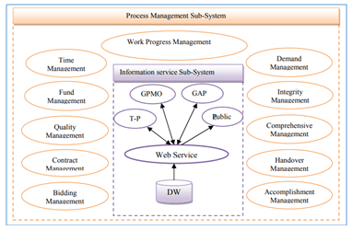
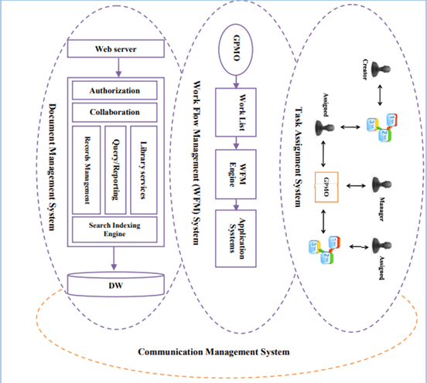
The final web-based proposed system is constructed based on four layers of client presentation or server. These layers are:-
Computer Interface: As there are stakeholders from different level with different application that are required to be taken into consideration at the designing stage. For instance, client from government would be interested in knowing tables, figures, and reports. Hence, the interface is designed as per their requirement.
Web service:It is useful in providing information services along with interoperating different applications and clients. This layer is characterised by web services, data & processes, sharing business idea, etc.
Directing Information Logic Processing:this layers arranges with specialised logic affairs which comprises data management for financial decisions, budget-making, contract procurement, etc.
Data Service:This is characterised by data reading, sorting, and writing. Here, a web server is provided to send data for security, privacy, digital, etc.
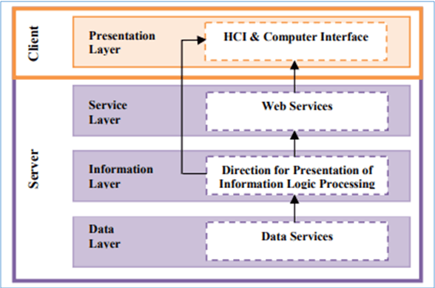

5. Justification For The Chosen Tool
There are numerous reasons for selecting the aforementioned PMIS model. First and foremost is that the proposed web-based PMIS can logically search for useful and genuine information, share and extract relevant data, retrieve pastinformation for new applications. In addition to this, it can be able to control the sequence of processes in a project. It can increase cooperation and collaboration among different stakeholders and bring transparency. Also, the proposed system is compatible withboth traditional manual systems and other ICT or web-based systems. From the below matrix it is clear that "Teamwork" tool can be used in small, medium, and large scale enterprise. Also, due to its design, it can be used in integration with other devices too. The only shortcoming in the model is that it is not suitable for agile. But, this can be resolved in future updates.

6. Recommendations For Effective Web-Based PMIS
In order to check the effectiveness of the proposed web-based PMIS (Teamwork Tool), the following KPIs are quintessential for the construction firms:-
- Productivity: BGC Construction would want that its PMIS should increase the efficiency of workers or decision-makers in order to gain competitive advantage.PMIS should be able to tell the information about how much resources are being deployed.
- Quality:It is all about conforming to standards and requirements of clients. PMIS should be able to provide right information to the workers and project managers in order to reduce % defects, rejection rate, etc.
- Cost:The lesser the cost of quality the successful and effective the PMIS. If the right information is provided to the project manager at the right time, then this would result in lesser faults. Ultimately, the amount of rework done would get reduced.
- Delivery:In construction project, timely delivery of project is beneficial for the company. A successful PMIS would reduce the time taken by the information to reach from one person to another, time taken in extracting information should also be less. These are some parameters that would make a PMIS effective.

7. References
Afolabi, A., Fagbenle, O., & Mosaku, T. (2017). IT Management of Building Materials' Planning and Control processes Using Web-Based Technologies. In World Conference on Information Systems and Technologies (pp. 12-19). Springer, Cham.
Andreassen, H. K., Kjekshus, L. E., & Tjora, A. (2015). Survival of the project: a case study of ICT innovation in health care. Social Science & Medicine, 132, 62-69.
Gao, S., Xu, H., Jia, Y., Mobasher, A., Bayesteh, A., & Cai, Z. (2014). U.S. Patent No. 8,644,422. Washington, DC: U.S. Patent and Trademark Office.
Joseph, N., Erasmus, W., & Marnewick, C. (2014). The idle state of information and communication technology project management. Journal of African Business, 15(3), 184-196.
Schwalbe, K. (2015). Information technology project management. Cengage Learning.
Taghavi, M., Patel, A., & Taghavi, H. (2011, September). Web base project management system for development of ICT project outsourced by Iranian government. In 2011 IEEE Conference on Open Systems (pp. 267-272). IEEE.


