PowerPoint Presentation
Directions for you to CREATE your
Presentation!
Directions
Using 4 slides create a PowerPoint presentation about yourself.
⇨ Slide 1: Introduction; opening slide
⇨ Slide 2: Family; parents/guardians, siblings, pets; extended family
⇨ Slide 3: Hobbies or Activities or Fun Facts about you
⇨ Slide 4: Your Choice!

Be Creative
Minumum!
Need to have pictures, and slide animations and text animations that work for the presentation!
Need ONE slide with a Picture as BACKGROUND SLIDE.
Make sure you don’t have too much information on one slide (6 by 6 Rule)
You will need to have at least 5 pictures
◦ Use your own jpeg, internet or clipart.
You need ONE Smart Art, ONE Shape, ONE Word Art and ONE Hyperlink
Must have Transitions on Every Slide (can be different) and AT LEAST FIVE ANIMATIONS
(throughout the presentation!)

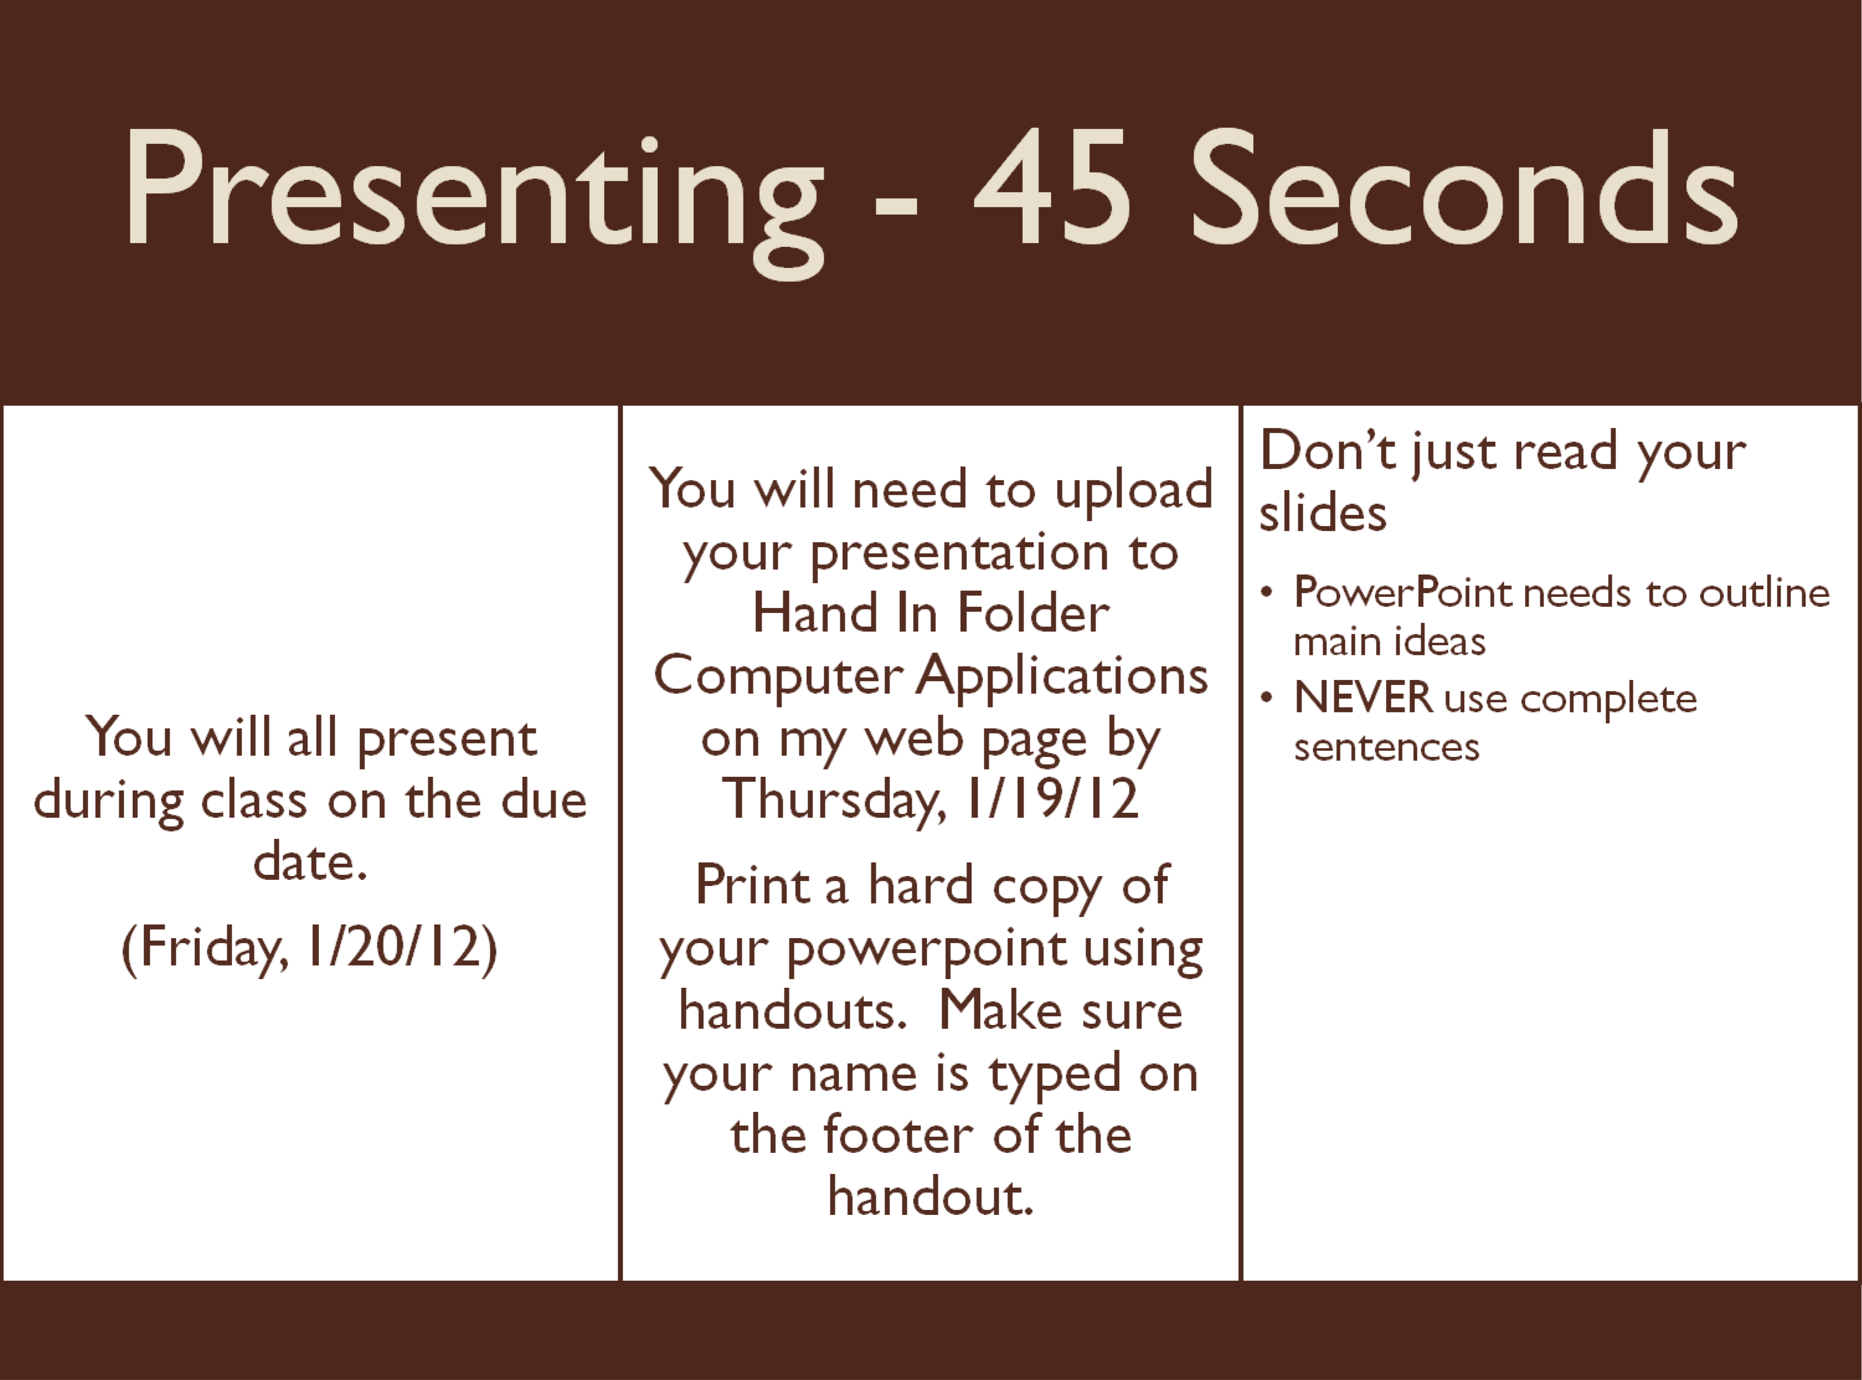
Powered by TCPDF (www.tcpdf.org)

