Module 3 Organizational Analysis
Abstract
This paper is about the entrepreneurial projects option. The business that uses for this business is automobile service center. It is start-up organization that offers a complete domestic and outside care repair service just as a full-featured retail parts store. Many internal organizational capabilities will be needed to launch the business. This organization will endeavor to be precise and legitimate with customers regarding citing cost gauges and repair culmination time gauges. All employees are prepared and considered in charge of giving prevalent service, building up an enduring trust bond with customers. In-car repair it turns out to be promptly evident that a limited geographic territory can incorporate numerous business sectors. There can be customers and businesses. This business will follow various types of policies to launch its services. Strong vendor relationships will be set up with the most legitimate sellers as far as transportation time of significant parts. This paper describes the initial assumptions about the financial needs in the start-up and growth acceleration stages of the business. The short-term loan is relied upon to be paid out inside one year, while an SBA advance will reimburse in ten years. The paper also explains the kind of personal leadership capacities that will be needed to launch and sustain the entrepreneurial vision.

Option 2: Entrepreneurial Projects
I am currently working on an automobile service center plan. It is start-up organization that offers a complete domestic and outside care repair service just as a fullfeatured retail parts store. It will develop into a business with exceptional deals by year three. It will separate themselves by offering an issue free repair service, however a wholly supplied parts store[ CITATION Lar151 \l 2057 ]. Not exclusively will this serve a full scope of customers for both service and parts, however, the parts department will bolster the service department by enabling the service department to turnaround occupations far quicker than the challenge with commonly the majority of the necessary parts in stock and on area. It will attract and maintain a dedicated customer base through their customer-arranged spotlight on business.

Internal Organizational Capabilities
Many internal organizational capabilities will be needed to launch the business. Some main internal organizational capabilities for this business discuss as follows:

Core Competencies
With ten service straights at every area and all employees concentrated on active customer service, quick turnaround is consistently the standard at this organization. This organization will endeavor to be precise and legitimate with customers regarding citing cost gauges and repair culmination time gauges. The organization's representatives will concentrate on conveying what they guarantee[ CITATION Jai1 \l 2057 ]. This emphasis on structure stable customer connections dependent on trust and honesty will be the impetus in building up a solid usual customer base. The organization will use the most elevated level of innovation in dealing with a full scope of vehicle parts stock. The objective is to never be out of a particular part while amplifying stock turnover.

Staffing Requirements and Leadership
All employees are prepared and considered in charge of giving prevalent service, building up an enduring trust bond with customers. It is significant, particularly in the auto repair industry where trust and trustworthiness are not the pictures of repair offices. The association beginning staffing will comprise of proprietor, who will go about as low maintenance office supervisor[ CITATION Mar1813 \l 2057 ]. The organization will look for two passage level mechanics to be employed inside a couple of months after the organization is working. Bookkeeping, accounting, and marketing services will be re-appropriated. The organization's middle of the road objective is to have four full time, completely prepared mechanics at the first office, in addition to a full-time office chief. In any case, the board has chosen to anticipate future advancements before deciding the best time to expedite such a workforce. A few components sway the computations of work request and supply. On the exciting side, redistributing practices are likely the most significant factor[ CITATION DSW10 \l 2057 ]. Fleets with large geographic service regions, for example, state governments, will, in general, redistribute a considerable level of their repair work — 100 percent sometimes.
On the other hand, some city and area fleet organizations perform almost all services in-house. This factor obviously should be viewed as when surveying what number of mechanics an association needs. Fleet age is another significant factor. An old fleet requires more work to keep in service than a fresh out of the plastic new one. Benchmarking fleet age is muddled because fleet organization must be considered[ CITATION ESW10 \l 2057 ].
However, the average fleet age for a run of the mill government fleet of mixed vehicle types should run from three to five years. OpenWorks fleets with a convergence of trucks and development hardware plainly would be higher in age, while law authorization fleets usually would be lower. Different components that affect work request incorporate utilization levels, working condition and fleet task rehearse (for example, mutual use or bring home vehicles).

Leadership
Achieving a leadership position in the market can stimulate business development and achievement. The primary essential to arriving at a leadership position is a reasonable meaning of the market. In-car repair it turns out to be promptly evident that a limited geographic territory can incorporate numerous business sectors. There can be customers and businesses. Moreover, further breakdowns can be found in kinds of vehicle or extraordinary intrigue, for example, execution. Auto repair businesses will enter these business sectors to adjust a particular market. The capacity to read the natural and industry pointers and foresee where the market is going will give the chance to set up a leadership position. The organization that initially presents another product or service will have a preferred position in that shoppers will, in general, remain with what they have as opposed to change. So if every other factor is specific for the customer they will not change service suppliers. To keep up a leadership position nature of products and services are fundamental. Customers will remain with what they are acquainted with as long as the quality is steady. If quality decreases, at that point, they will think about different choices.

Processes for a Testing product, and IP resources
T-Systems bolsters its customer's overall businesses in digitizing their maintenance and servicing procedures because of a high-quality service lifecycle- management portfolio. The potential for reserve funds and procedure upgrades is unusually high for plants, hardware and other capital merchandise with long service lives. Predictive maintenance speaks to only one component of the total start to finish thinking behind Next Generation Maintenance. Thorough sensors, diagnostic strategies from the spaces of enormous information and shrewd information and savvy service arranging interlace with the goal that the plants can work dependably, cost-viably and economically. It goes right to "closing the loop" with continuous improvement of products and generation through criticism into building and product design. Every one of the modules hence structures singular deals and after deals service forms. They rapidly prepare to utilize and expandable. Regardless of whether it is another CRM system, web-based interface, investigation or maintenance system, there can be no uncertainty that expert incorporation into the system scene is necessary for upgrading the service procedure for the customer. It applies to on-premise establishments and for actualizing cloud services of numerous types[ CITATION DSW10 \l 2057 ]. Vehicles should keep up, regardless of whether they are straightforwardly off the sequential construction system or have been around for a long time. Service and repair focuses are aggressive and do not have standard rates for their services, which can make it hard for customers to get a reasonable deal. By networking administration with other customer service suppliers, they can expand their digital security, measure vehicle execution and stay with track of their company’s growth.

Systems and Policies
This business will follow various types of policies to launch its services. It is foremost that in setting up its rates, a service center does not oppress any private gathering of service center clients. A service center must charge every inside client a similar rate for a similar degree of services or products acquired in similar conditions. Rates should not differentiate among inner clients[ CITATION Sta2 \l 2057 ]. A service center which plans on sponsoring its tasks must advise RAPC/CMA in its yearly spending accommodation. RAPC/CMA will work with the middle to appropriately represent the arranged endowment before the financial year closes. Service centers should deal with year-end and different billings reliably every year, to guarantee that pay recorded appropriately coordinate with expenses brought about, and that the year-end breakeven estimation is exact.

Partnerships Agreements with Key Stakeholders
Strong vendor relationships will be set up with the most legitimate sellers as far as transportation time of significant parts. Purposes of association exist all through different phases of the service delivery procedure and include partners and numerous assets or infrastructural segments set up simultaneously[ CITATION Mar1813 \l 2057 ]. Most recognized cooperation focuses are associated with the physical vehicle qualities (e.g., catches) or vehicle condition. Further recognized touch point measurements are human associations (e.g., through the service staff), the external condition (e.g., traffic signaling gadgets), or virtual interfaces using data system gadgets.

Initial Assumptions about Finance and Growth Acceleration Stages
This business expects to raise quite its very own bit capital and to obtain on an ensured multiyear SBA loan. It gives the central part of the present financing required.

Personal Plan
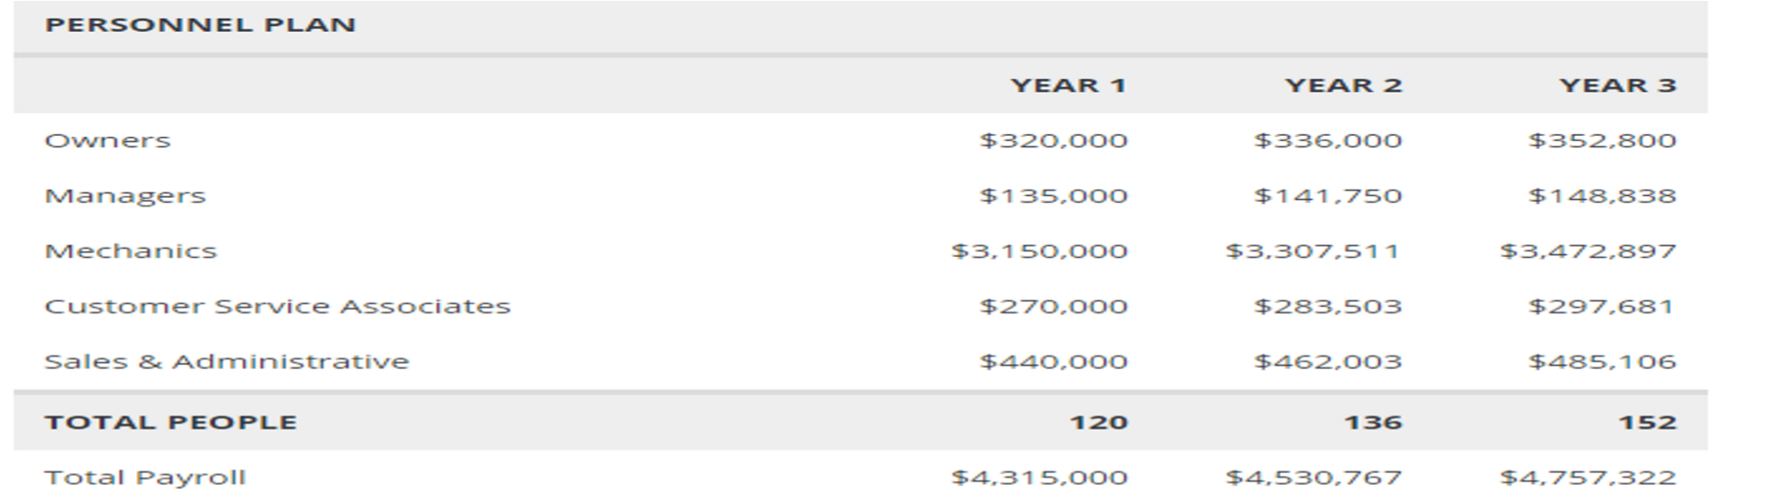
As the personnel plan appears, the business hopes to make continuous interests in staffing as a few new offices open throughout the following ten years.

Break-even Analysis
The break-even point in your business is the time when your business income rises to your fixed costs. By then you neither profit nor do you lose any. The make back the initial investment tells you what it will take in deals to endure. It gives a decent sign of the feasibility of a business venture. The equal the initial investment can likewise be utilized to assess a business development or some other business consumption[ CITATION Mar1813 \l 2057 ]. You are asking how much extra income will be required to take care of the extra expense. There are some key definitions essential to decide the equal the initial investment for the business. The business' make back the initial investment investigation depends on the midpoints of the first-year figures for absolute deals by units, and for working costs. These exhibit, according to unit income, per-unit cost, and fixed expenses. These traditionalist suppositions make for a progressively exact gauge of genuine hazard.
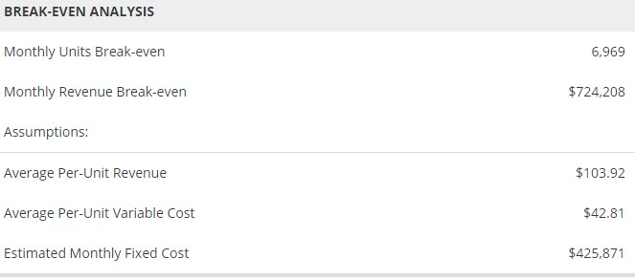
This business hopes to proceed with its constant development of benefit throughout the following three years of tasks. The cash flow projection that arrangements for progressing costs are satisfactory to address the business' issues as the business creates income adequate to help activities.
The short-term loan is relied upon to be paid out inside one year, while an SBA advance will reimburse in ten years[ CITATION Jai1 \l 2057 ]. The start-up balance sheet is essential if you realize how to make and sort a list. You have to make two records to begin. The main list is your list of Current Assets. These are resources (things your business claims) which will be spent inside the first year of working together. Regularly they incorporate money, stock, and prepaid costs, (for example, prepaid protection). Although Accounts Receivable is another case of a present resource, there are no records receivables in a business start-up.

Personal Leadership Capacities
Some personal leadership capacities will be needed to launch and sustain the entrepreneurial vision. Leadership is practically 100% about overseeing individuals. Having good thoughts and a critical vision will not get you far if your workers are not willing to tail you. Moreover, such a large number of entrepreneurs underestimate leadership aptitudes. As a successful entrepreneur, you will need to work intimately with individuals – this is the place it is essential to have the option to assemble extraordinary associations with your group, customers, providers, investors, speculators, and that is just the beginning[ CITATION Lly12 \l 2057 ]. A few people are more talented here than others, at the same time, luckily, you can learn and improve these abilities. Offer victories and disappointments with your people. Data transmitted gives them setting and a feeling of having a place with the organization. As an entrepreneur, you additionally need to concoct fresh thoughts and use sound judgment about circumstances and potential ventures[ CITATION Lly12 \l 2057 ]. Numerous individuals feel that you're either brought into the world innovative or you're most certainly not. In any case, imagination is an expertise that you can create if you contribute the time and exertion. Passion and an incredible business thought are not sufficient to prevail in business. They offer, delegate and engage their groups. Leadership should begin at the highest point of the association, yet pioneers do not originate from places of intensity[ CITATION San171 \l 2057 ]. They can find at all levels in an association.
Recognize them and help them to build up their leadership abilities. Since absence of uprightness has caused a groundswell of response via web-based networking media over various enterprises, this, as well, will be an all the more exceptionally looked for healthy for pioneers in more prominent associations going ahead.
References
DeHays, L. (2015). The Car Care World: How to Get Your Car Fixed Without Being Taken for a Ride. AuthorHouse.
DS Walia, J. H. (2010). Equipment maintenance and repair. Community Eye Health, 26–29.
Grieger, M., & Ludwig, A. (2018). On the move towards customer-centric business models in the automotive industry - a conceptual reference framework of shared automotive service systems. Electronic Markets, 1-28.
Jain, S., & R.K.Garg, D. (n.d.). Business Competitiveness: Strategies for Automobile
Industry. Retrieved from http://citeseerx.ist.psu.edu/viewdoc/download? doi=10.1.1.630.3823&rep=rep1&type=pdf
Plante, L. (2012). A Guide for Entrepreneurs Who Lead and Manage Change. Technology
Innovation Management Review, 1-5.
Sanchez-Barrios, L. J.-N. (2017). Evolving Entrepreneurial Strategies for Self-Sustainability in Vulnerable American Communities. IGI Global.
Stanford. (n.d.). Service Center Manual (Complete). Retrieved from Stanford:
https://doresearch.stanford.edu/policies/32184/print#anchor-61702
Wibbeke, E. (2010). Global Business Leadership. Routledge.

