Microsoft Word Assignment

• Styles o Modify Heading 1 and Heading 2 with a different font sizes and colors from the defaults.
- Use these styles to creating headings for each paragraph in your document.
- (NOTE: If you do not want to change these styles permanently, make sure you only save these styles to the document and not to the template!)
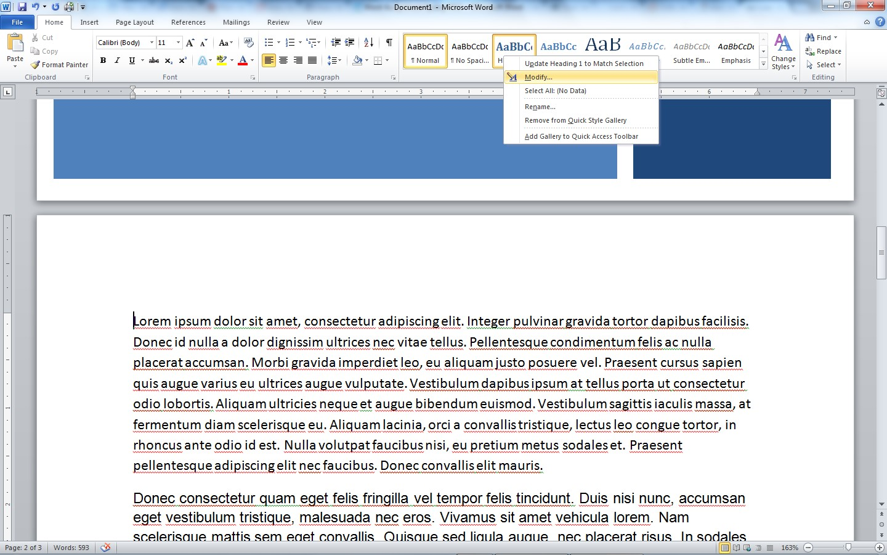
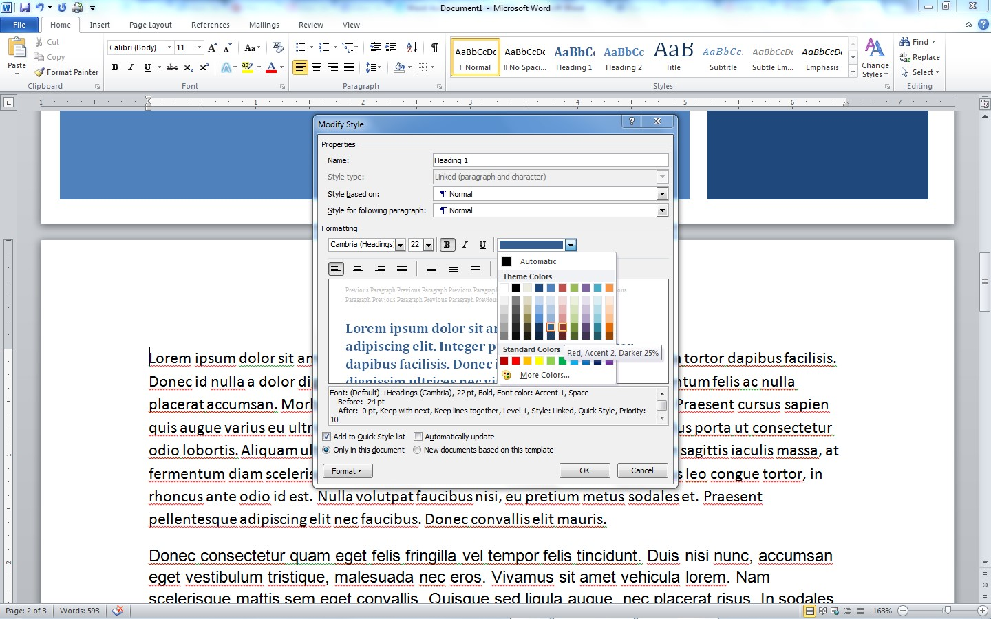
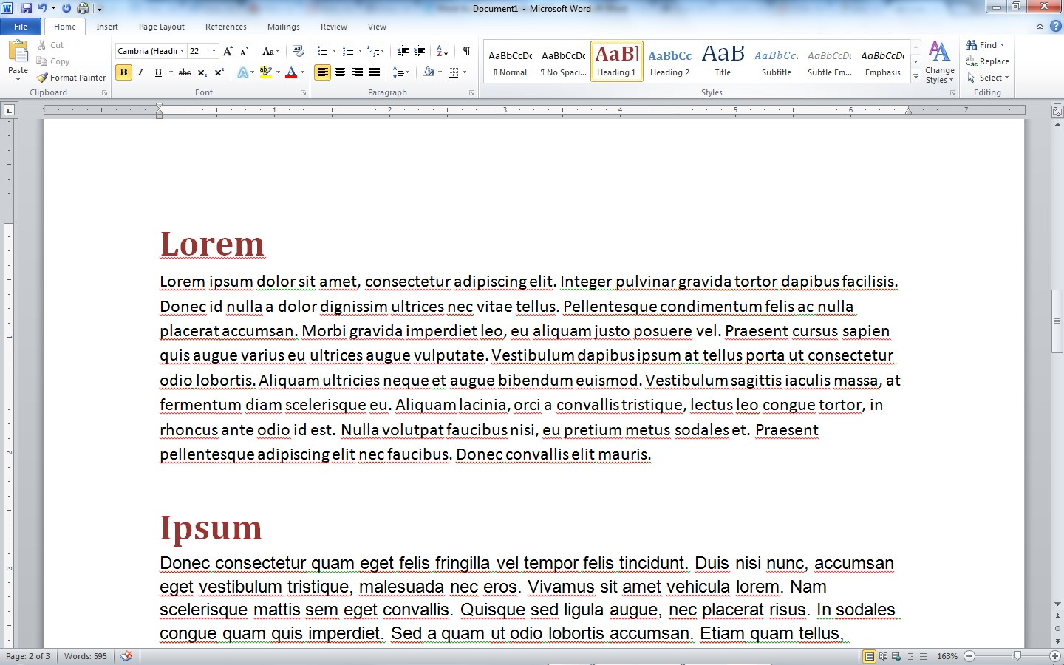
- Create your own customized Paragraph Style
▪ Name the new style “Custom Paragraph” ▪ The paragraph style should be formatted with:
  - The font of your choice (different than the Normal font default)
  - 1.5 line spacing
  - 12 pt space after each paragraph
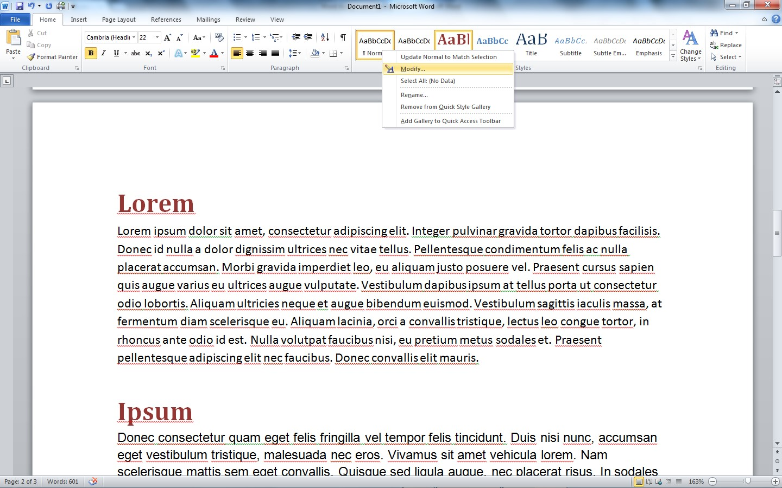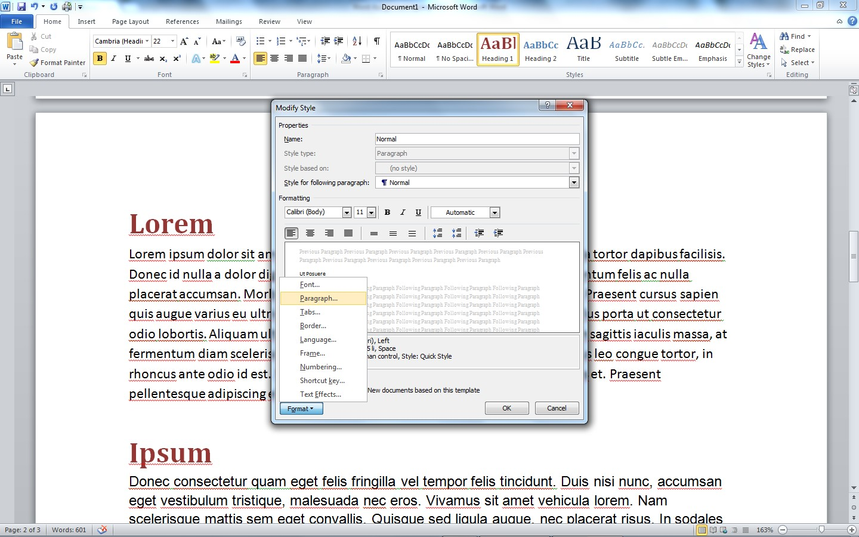

  - At least one Bulleted List o At least three 1st level bullets, and two 2nd level bullets.
- Customize the symbol for your bullets instead of using the default bullet style

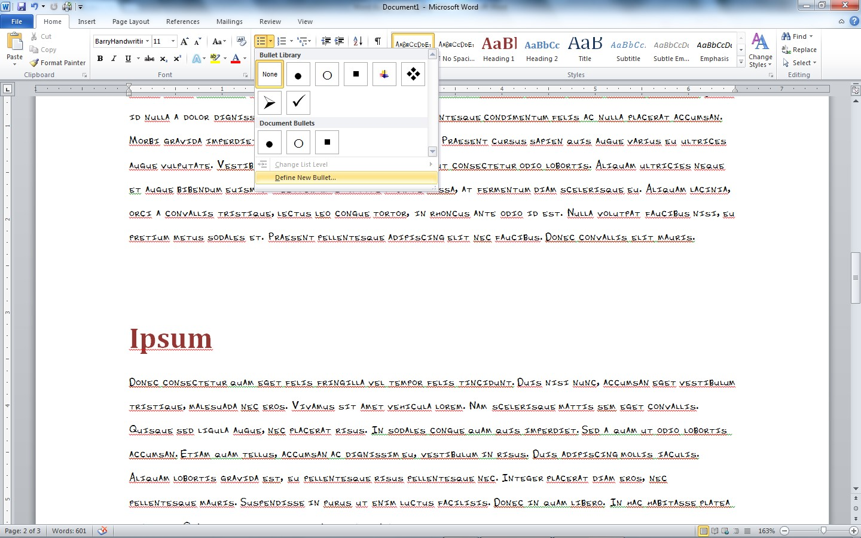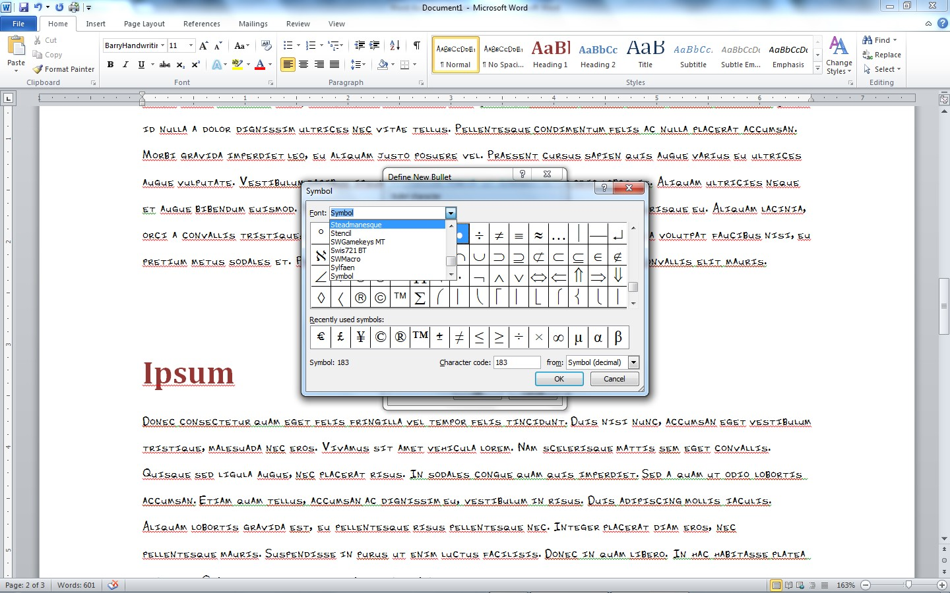
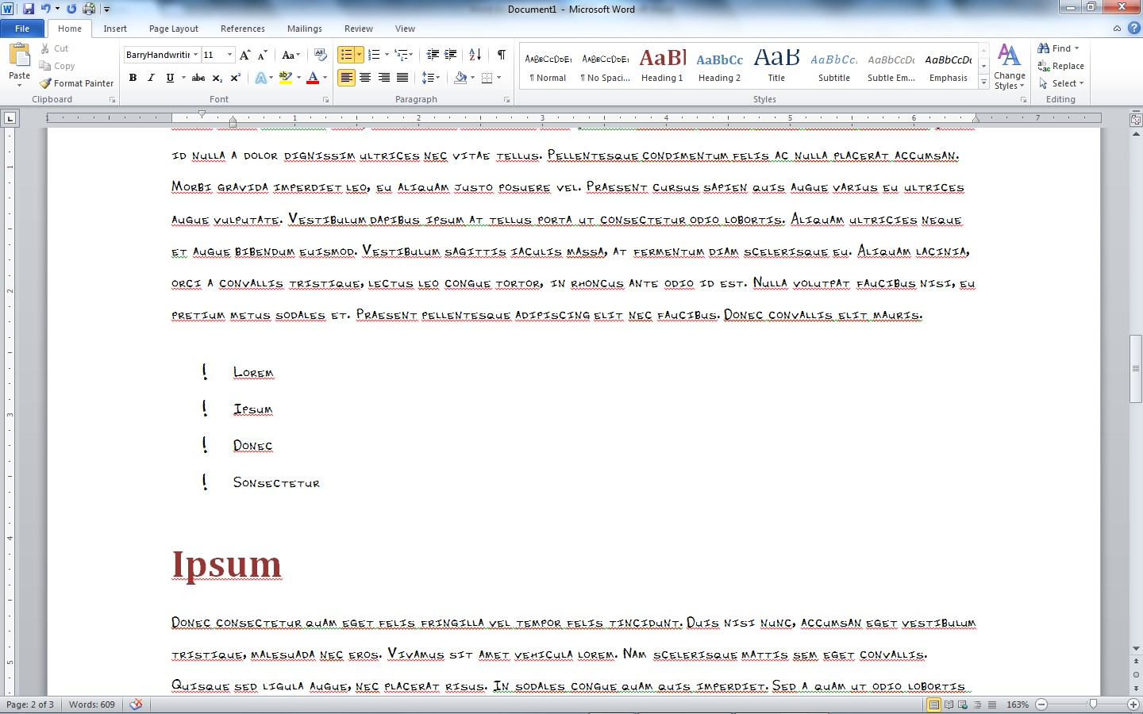

- Insert at least one Table of information with the following features:
o At least four rows and three columns. o At least two colors used for cells. o The outline line border of the table should be modified to be thicker than the inside lines. o Add a Caption (using the Caption feature) to your Table.
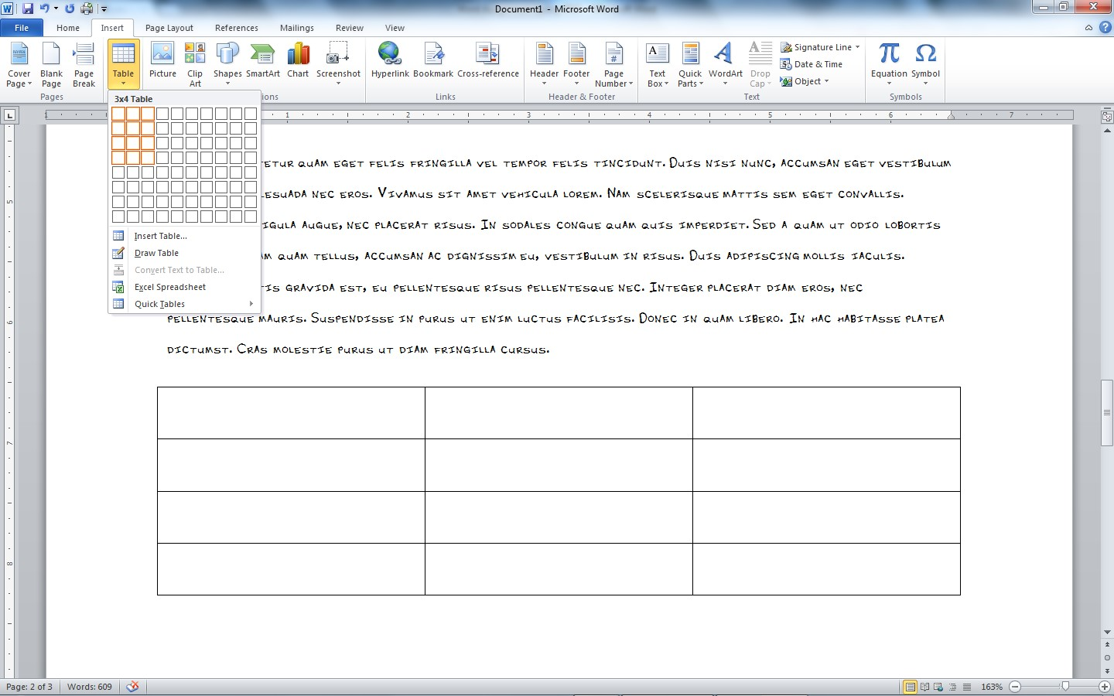
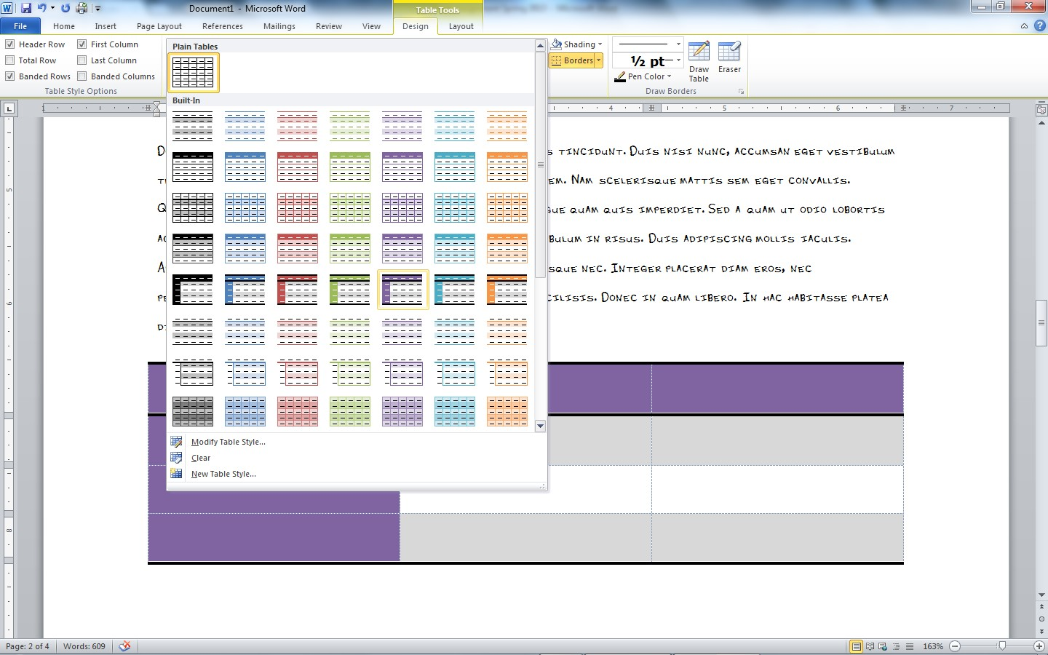

- Tables of Contents o Add an automated Table of Contents on the page after the Title Page o The Table of Contents should import text using the styles Headings 1 and 2
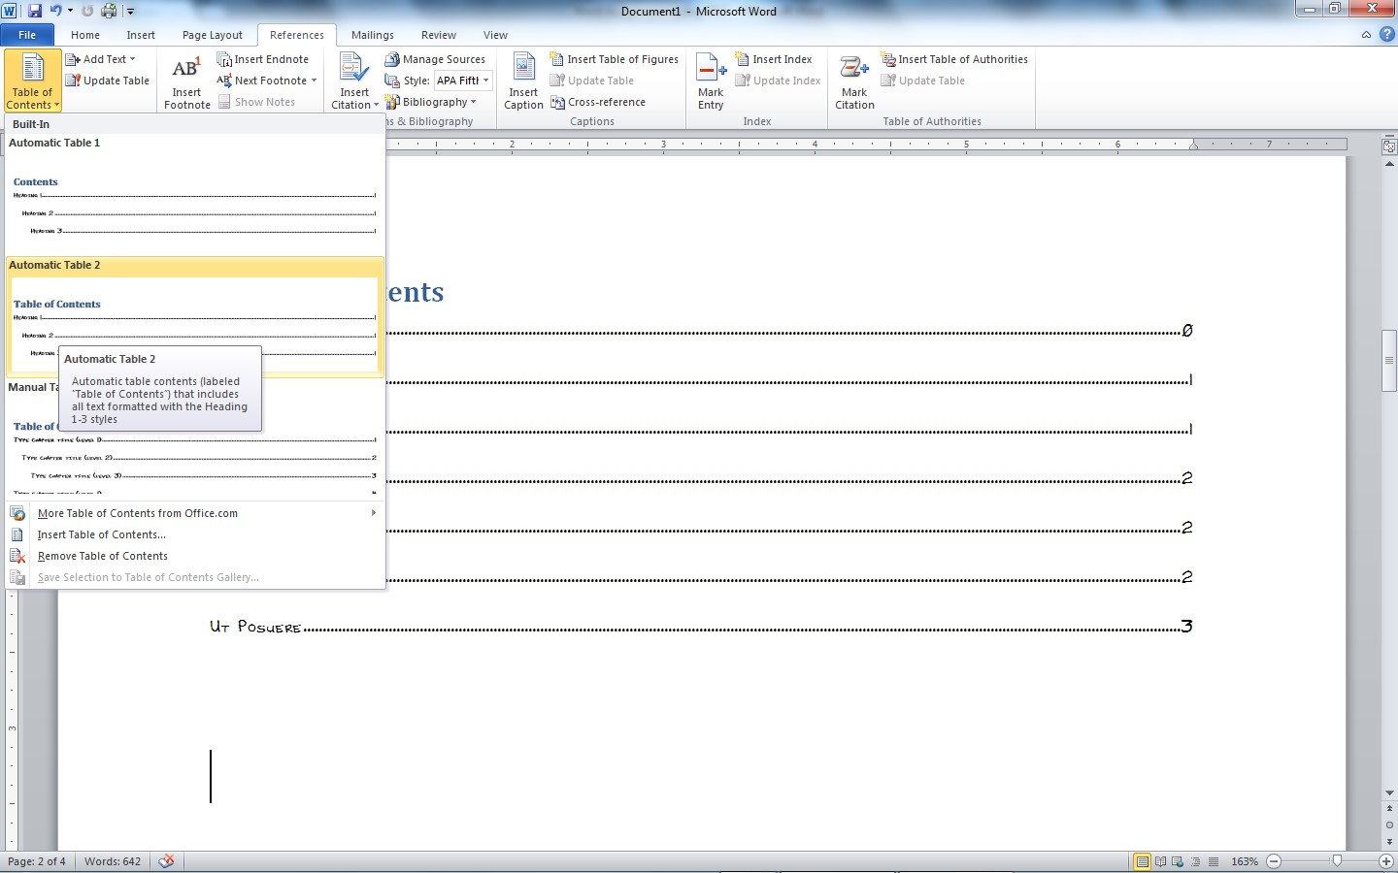
- Pictures o Add two pictures to your document o Revise the size of the pictures to be no more than 3 inches wide o Revise the text wrapping to allow text to wrap around the pictures. o Add a Caption (using the Caption feature) to both of your pictures.

- Footnotes o Add at least 3 footnotes.
o The contents of one of the footnotes should include an Equation of your choice.
- Make sure you use the Equation feature on the Insert tab to insert the equation into the footnote.
- The equation doesn’t actually need to relate to the material. (I just need to see that you know how to use the feature.)

Powered by TCPDF (www.tcpdf.org)

