Microsoft Power Point
The Microsoft PowerPoint is one of the Microsoft Office suites of programs. It primary function is to produce presentation materials.

1: To start a PowerPoint Program
- Click on the Start button, point to Programs, follow by Microsoft Office and click on Microsoft Office PowerPoint 2003.
Note: For previous version of Office - Click on the Start button, point to Programs and click on Microsoft PowerPoint.
- Immediately you will see the screen shown below. The right hand side Getting Started task pane provides help to you.
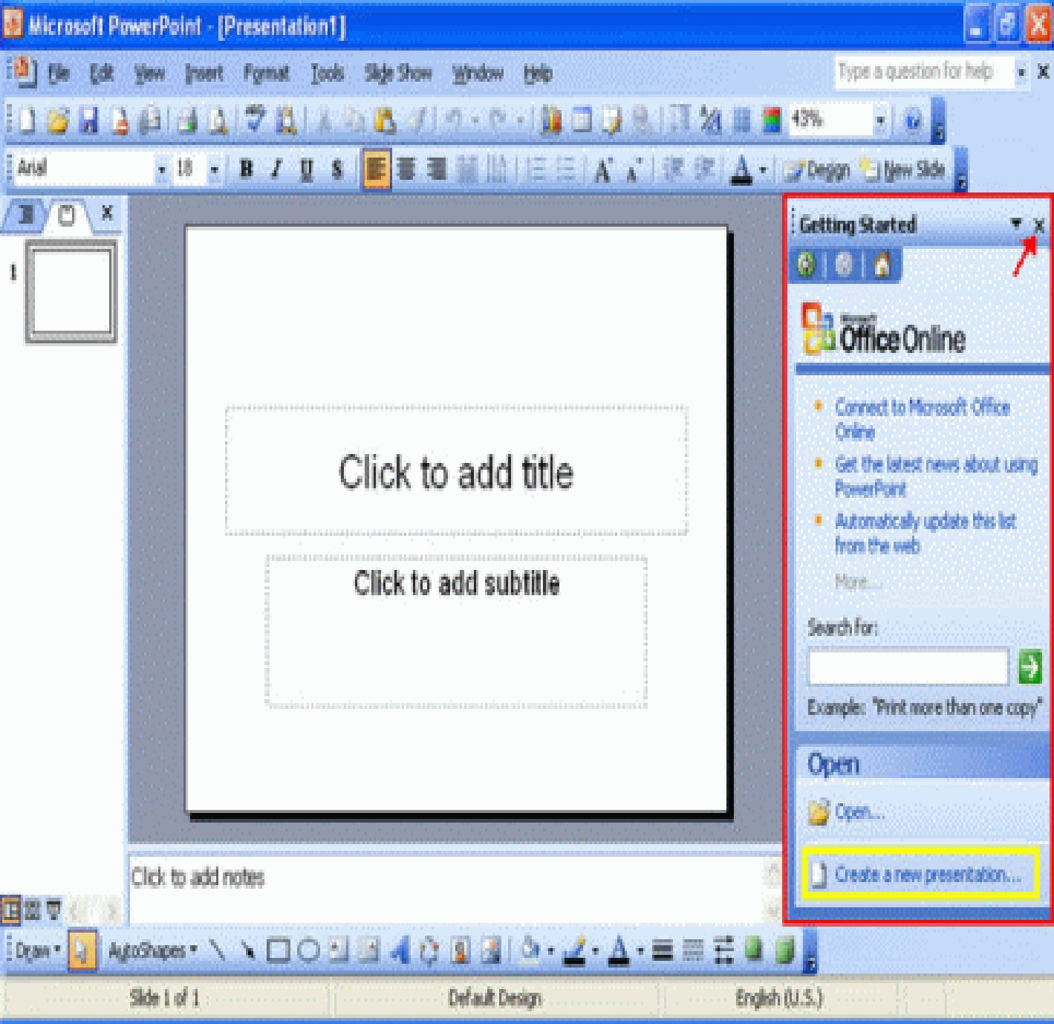
- If you are not using it, you can click on the Close icon to close it. You also can start by clicking on Create a new presentation… at the bottom of the task pane.
- The PowerPoint 2003 screen elements:
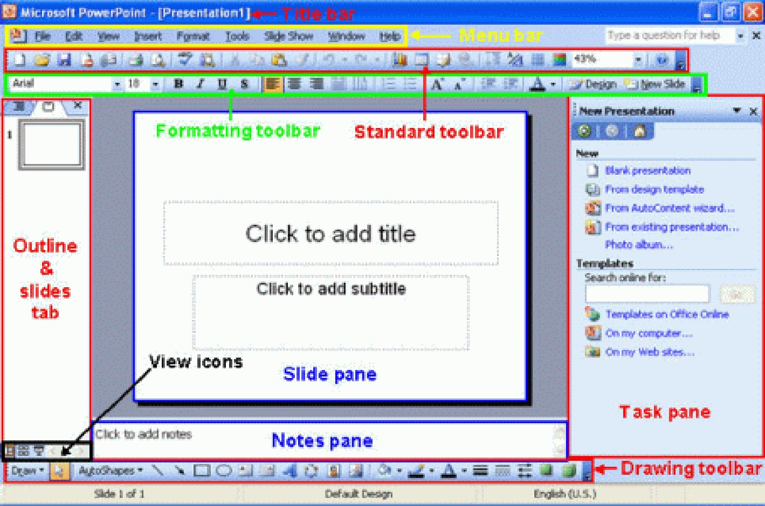
To enter text into a presentation, do the following.
- From the PowerPoint slide pane, there is ‘box’ that labeled ‘Click to add title’.
Just simply click and enter the text there.
- For example, you may enter “This is my first presentation.”
- Then click on ‘Click to add subtitle’ and you also can enter some text there.

Saving and Closing a presentation
This feature allows you to store new or existing presentations on disk. If you not save the file, you will be unable to view the presentation in the future. Once saved, you can reopen the file for viewing or editing.

To save a presentation
- From File menu, click Save.
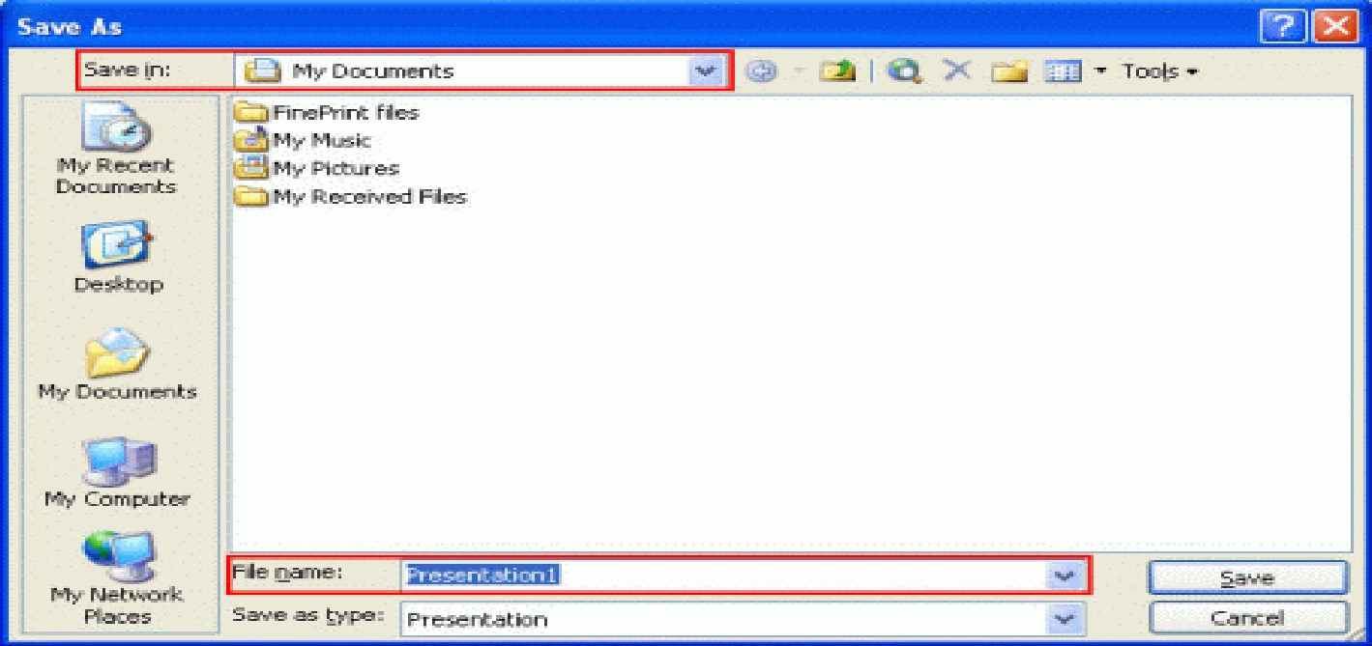
- If it is a new file, the Save As dialog box displayed, ensure that you are located inthe folder/disk drive of your choice by clicking the arrow to the right of the Save in: drop down box and navigating to your required location.
- Enter the file name in the File name: text box. The default file name is Presentation1, you can use it or type in a new file name.
- Let say we key in First presentation for the file name, click on the Savebutton to save. Note: Now the presentation is saved to My Documents folder.

To close a presentation
- From the File menu, click Close OR click Close Window icon.
- If unsaved changes have been made to your presentation the dialog box below is displayed, giving you the chance to save the presentation prior to closing.
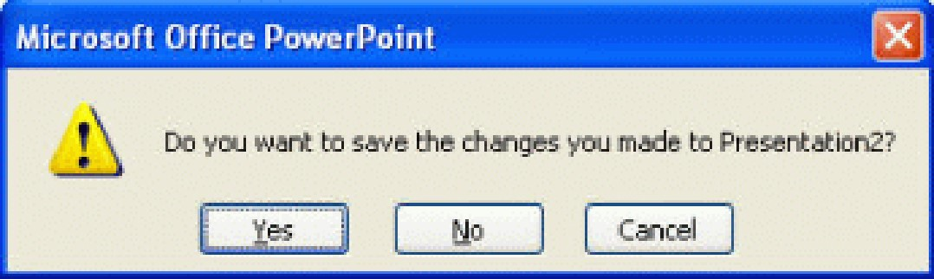
- Click Yes to save the presentation before closing
Or
- Click No to close without saving changes
OR
- Click on Cancel to cancel the operation.

To exit Microsoft PowerPoint
- Click on the Close icon displayed on the top-right corner of the screen.
- To create a new blank presentation
- Click the Blank Presentation in the New Presentation Pane.
OR
- Click the New icon on the Standard toolbar.
- This will display the Slide Layout pane that allows you to choose the layout of your slide. The layouts contains text, content and both text and content.
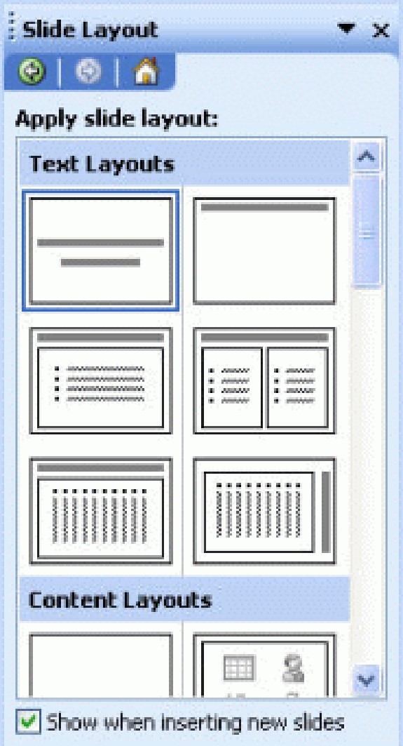
- Click on the particular layout and begin create the slide.

2: Different PowerPoint Views
To see the different PowerPoint views, from the Menu bar, click on theView and you will see 4 types of view. Click on the particular view to see the effect.
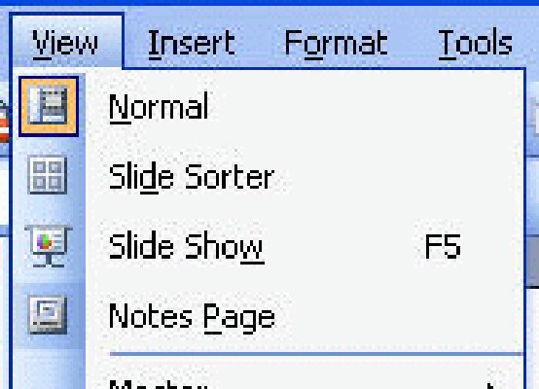
- Normal View- The Normal View is the default view in PowerPoint. All slide editing isperformed in this view. The normal view comprises the Slide Pane, Outline and Slides tabs and the Notes Pane.
- Slide Sorter View- The Slide Sorter view displays all slides in your presentation asthumbnails. This view is useful to reorder, add, or delete slides. You an also preview animation effects applied to each slide.
- The Slide Show View- The Slide Show view allows you to view your presentation as aslide show. Your presentation is displayed as a full screen and you can view applied animations.
- The Notes View- The Notes Page view displays how notes pages will print. A notespage contains a smaller version of the slide and notes entered from the Notes Pane underneath the slide.
To show a toolbar, do the following.
  - From the View menu, choose Toolbars and select the toolbar you want to display
(you will see a check mark beside a toolbar when it is visible)
To hide a toolbar, do the following.
  - From the View menu, choose Toolbars
  - Select the toolbar you want to hide (you will not see a check mark beside a toolbar when it is hidden).

The Standard Toolbar
The commonly used action is represented by an icon of the Standard toolbar. When you put your mouse pointer over an icon, it is highlighted and a descriptive wording appears. Click the icon/action you want to apply to your slide objects.
The icons on the Standard toolbar and it function:
Icon | Function
New | To start a new presentation
Open | To open a presentation
Save | To save a presentation
Permission | To sets permissions for opening or changing a presentation
E-mail | To send the presentation as an e-mail
Print | To print the presentation
Print Preview | To change the display to print preview
Spelling | To start the spell checker
Search | To display the Basic Search Pane
Cut | To cut selected text or object to the Clipboard
Copy | To copy selected text or object to the Clipboard
Paste | To paste the last item from the Clipboard
Format Painter | To copy formatting (for duplication purpose)
Undo | To undo the last action
Redo | To redo the last undo action
Insert Chart | To start the Chart Wizard
Insert Table | To insert a table
Table and Borders | To display the Table and Borders toolbar
Insert Hyperlink | To insert a hyperlink
Expand All | To expand the title and text for all slides on the Outline tab
Show Formatting | To show or hide character formatting
Show/Hide Grid | To show or hide gridlines
Color/Grayscale | To show the presentation in color, black and white, or grayscale
Zoom | To zoom the Slide, Outline tab area, or Slides tab area

The Formatting Toolbar
The formatting toolbar is located near to the top of your screen as shown here. Each toolbar icon on the toolbar has specific function that allows you to change the effects of the objects in your PowerPoint slides.
The icons on the Formatting toolbar and it function:
Icon | Function
Font | To select font styles from the drop-down list
Font Size | To select a font size from the drop-down list
Bold | To apply bold formatting to selected text
Italic | To apply italic formatting to selected text
Underline | To apply underline formatting to selected text
Shadow | To apply shadow formatting to selected text
Align Left | To align text or inline objects to the left
Center | To align text or inline objects to the center
Align Right | To align text or inline objects to the right
Distributed | To align text or inline objects distributed across the whole line
Change Text Direction | To change the text direction (horizontal to vertical)
Numbering | To add or remove numbering from a selected paragraph
Bullets | To add or remove bullets from a selected paragraph
Increase Font Size | To increase font size
Decrease Font Size | To decrease font size
Decrease Indent | To decrease the paragraph indent
Increase Indent | To increase the paragraph indent
Font Colour | To change the font colour with a drop-down list
Slide Design | To display the Slide Design Task Pane
New Slide | To insert a new slide
To insert a new slide, do the following.
- From the Insert menu, click New Slide.
OR click the New Slide icon on the Formatting toolbar
To insert a duplicate slide, do the following.
- From the Insert menu, click Duplicate Slide.

Copy and Paste Slides
You can copy and paste slides in Normal View with the Outline and Slides tabs or in Slide Sorter view.
To copy slides with the Outline tab, do the following.
- Click the slide icon of the slide you want to copy.
- Click the Copy icon on the Standard toolbar.
OR
- Right-click on the slide icon and select Copy.
To paste the slide, do the following.
- Click the slide icon after which you would like the newly copied slide to appear.
- Click the Paste icon on the Standard toolbar.
OR
- Right-click on the slide icon and select Paste.
Note: You also can copy and paste the slide with the Slides tab or in the Slide Sorter view.

Deleting Slides
You can delete slides in Normal View with the Outline and Slides tabs or in Slide Sorter view.
To delete slides with the Outline tab, do the following.
- Click the slide icon of the slide you want to delete.
- From the Edit menu, click Delete Slide.
OR right-click on the slide icon of the slide you want to delete and select Delete Slide.
To delete slides with the Slides tab, do the following.
- Click the slide thumbnail of the slide you want to delete.
- From the Edit menu, click Delete Slide.
OR right-click on the slide thumbnail of the slide you want to delete and selectDelete Slide.
To delete slides in Slide Sorter view, do the following.
- Click the slide thumbnail of the slide you want to delete.
- From the Edit menu, click Delete Slide.
OR right-click on the slide thumbnail of the slide you want to delete and selectDelete Slide.
To create a new presentation from a design template, do the following:
- Click the From design template in the New Presentation Pane.
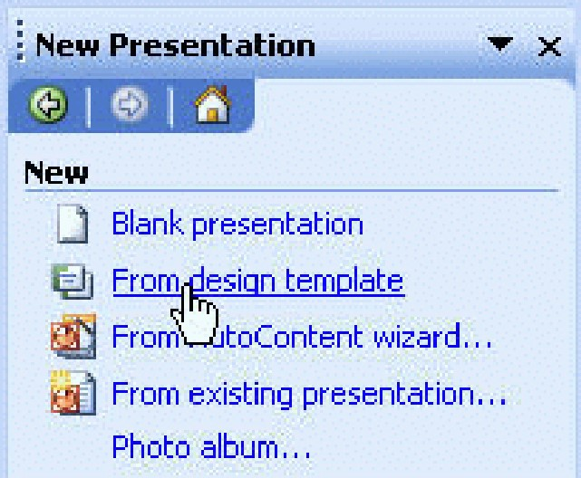
- Immediately you will see design templates available below the pane. For example, if click on Mountain Top template, you will see the slide as follows.
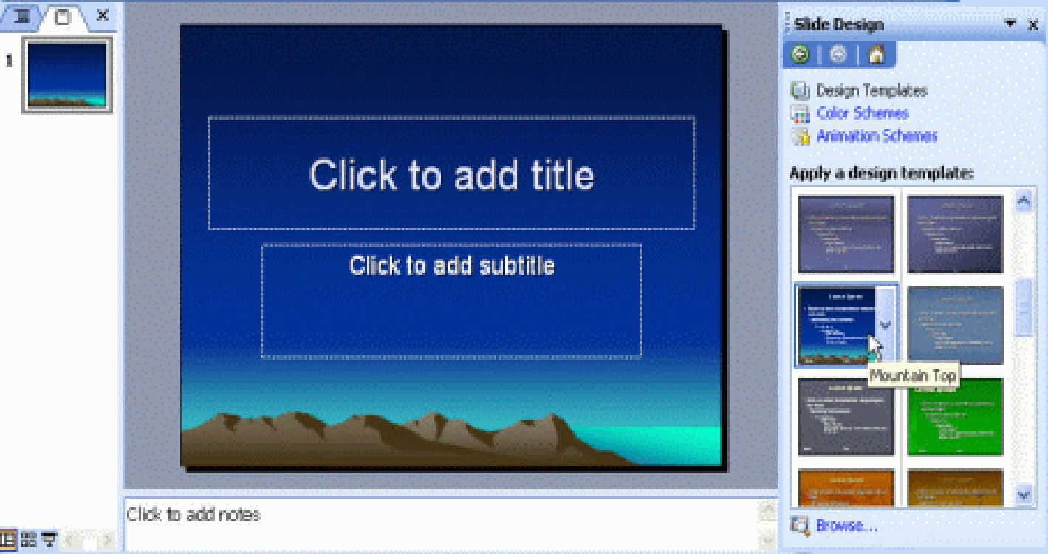
- The background of the slide is included and you just need to insert the text as you wish.

3: PowerPoint AutoContent Wizard
The AutoContent Wizard allows you to create a presentation based on suggested content and design. There provides the idea for your presentation so you just need to modify the suggested idea or you can add your own points.
To create a new presentation using the AutoContent Wizard, do the following:
- Click the From AutoContent Wizard… in the New Presentation Pane.
- From the AutoContent Wizard dialog box displayed, click Next to continue.
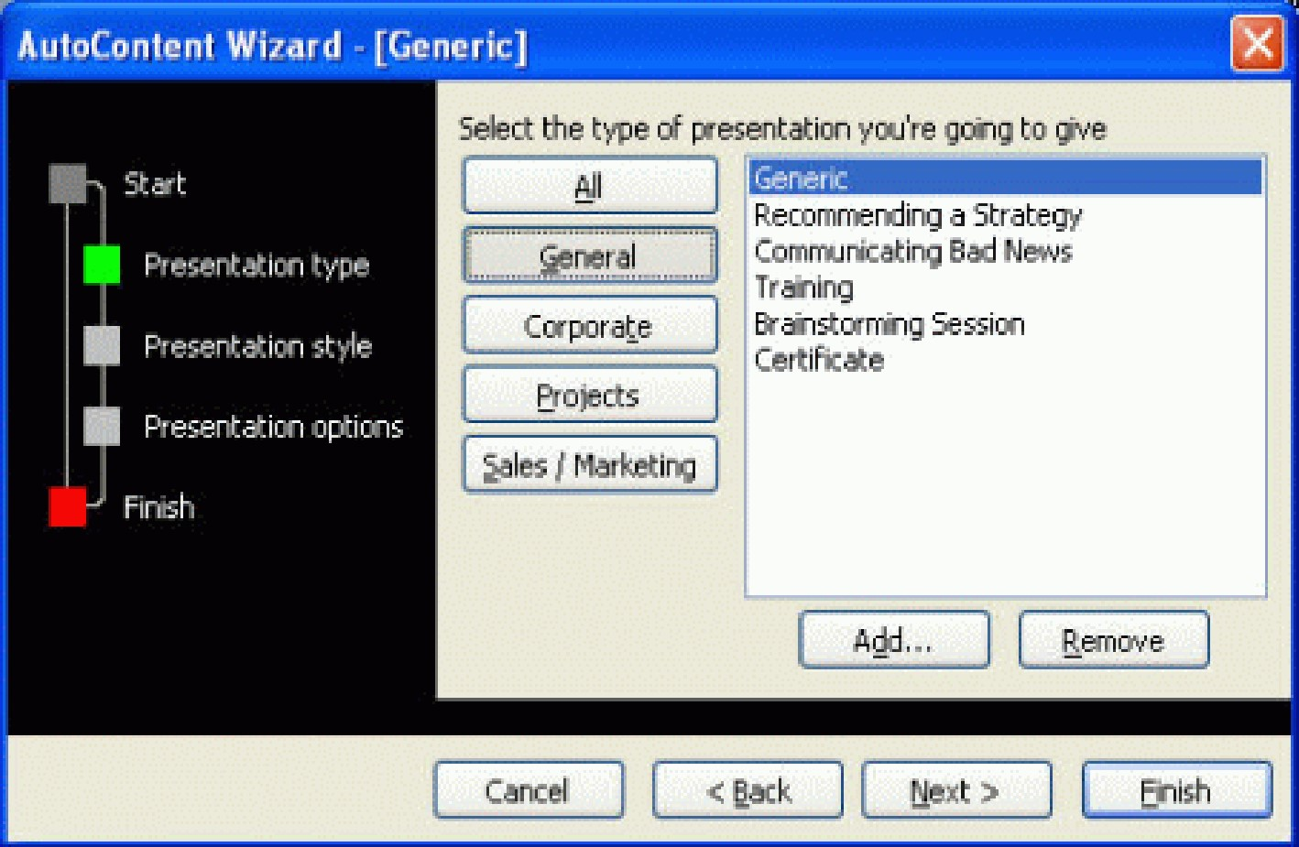
- You need to select a type of presentation that you wish to create. If you click on the All button, then you can use the scroll bar to move down the list and then select the type of presentation that you are interested in.
Note: Some options displayed may not be installed on your system and you may ask to insert the Microsoft Office installation CD to install it before use.
- Click Next button to continue.
- The next step is to decide how you will use your presentation once it has been produced. By default, On-screen presentation was selected.
- Click Next button to continue working through the Wizard.
- You can enter a presentation title and footer.
- Click on the Next button to continue.
- Click Finish to complete the AutoContent Wizard.
- From this point you need to open each slide and using the guidelines supplied, modify the content to meet your requirements and needs.
To display the Slide Layout Pane (if it has been closed), do the following:
- From the Format menu, click Slide Layout.
To apply a text layout to a slide, do the following.
- From the Slide Layout Pane, Text Layouts section click on the particular layout you want.
- Text Layouts normally contains the text only. Those layouts included Text Slide, Title Only, Title and Text, Title and 2-Column Text, Title and Vertical Text, and Vertical Title and Text.
To apply a content layout to a slide, do the following.
- From the Slide Layout Pane, Content Layouts section click on the particular layout you want.
- Content layouts can have Charts, Clip Art, Pictures, Tables, Diagrams or Organization Charts, or Media Clips.
To apply text and content layouts to a slide, do the following.
- From the Slide Layout Pane, Text and Content Layouts section click on the particular layout you want.
- Text and Content layouts have the text and also the charts, tables, etc in the slide.
To apply other layouts to a slide, do the following.
- From the Slide Layout Pane, Other Layouts section click on the particular layout out want.
- Other layouts contain those layout that is different from the text, content, and text and content layouts.

PowerPoint Slide Background
Backgrounds can be applied to the PowerPoint slides, handouts, and notes. The Background options that you can change include colours, gradients, textures, patterns, and pictures.
To select a Slide Background Colour, do the following.
- From the Format menu, click Background.
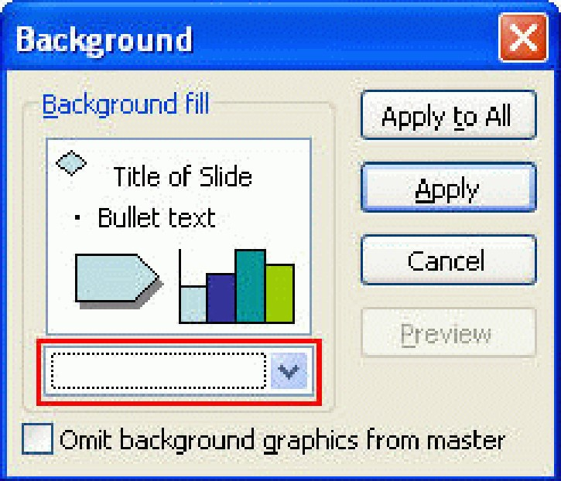
- Click the down arrow and select the colour you wish to apply to the slide background.
- Click on More Colours to choose from a wider selection of colours.
To select a Slide Background Fill Effect, do the following.
- From the Format menu, click Background.
- Click the down arrow and select Fill Effects. This will open a Fill Effects dialog box.
- Click on the Gradient, Texture, Pattern, or Picture tabs to apply the fill effect.
Choose the colours as you like.
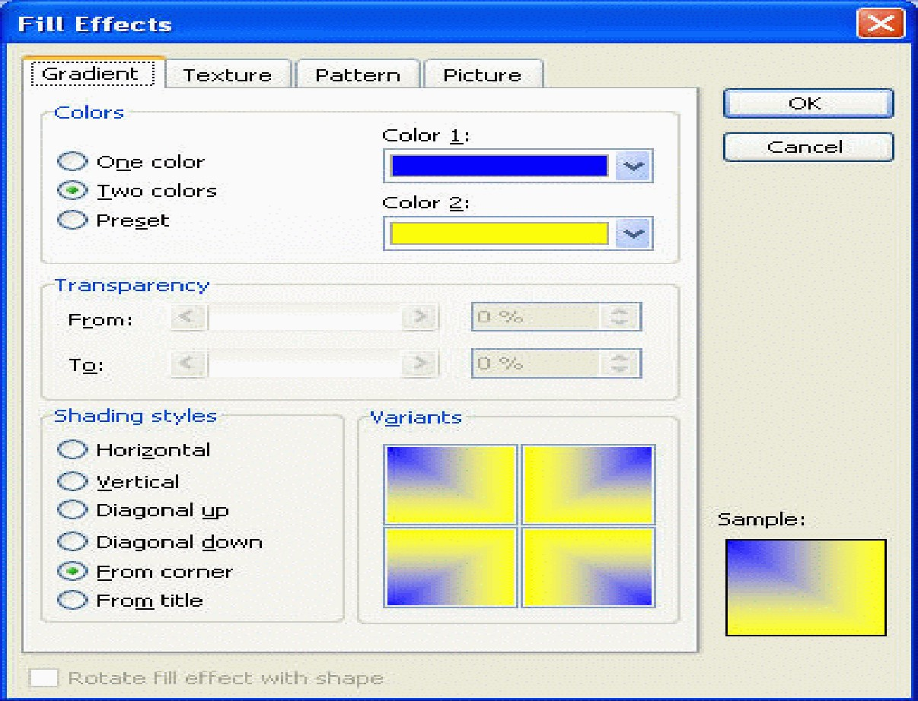
- When finish, click OK.
- It will back to the Background window, there are 4 buttons:
Apply to All | To apply the formatted background to all slides.
Apply | To apply the formatted background to the current slide only.
Cancel | To cancel the formatted background.
Preview | To preview what the slide background will look like.
- Click on the button that suit your needs.

4: PowerPoint Slide Headers and Footers
Headers and footers consist of the text, slide or page number, and date you want at the top or bottom of your slides. You can use headers and footers on single slides or all slides.
To insert slide Headers and Footers, do the following.
- From the View menu, click Header and Footer. This will display theHeader and Footer dialog box.
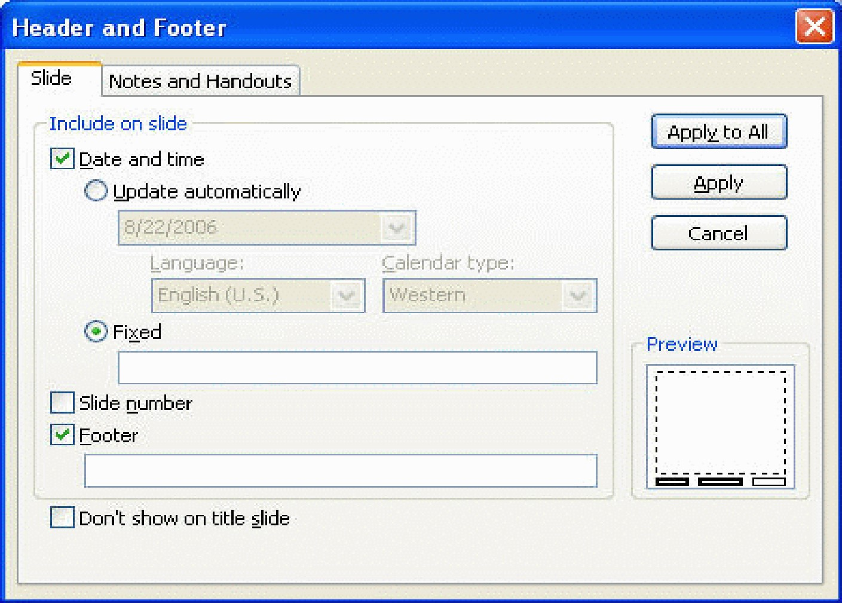
- To insert the date and time, tick the Date and time check box.
- To add a slide number, tick the Slide number check box.
- If you choose to insert the footer, make sure the Footer check box is checked and type in your desired text.
- Click Apply to apply to the current slide. Click Apply to All to apply to all slides.

5: Bullets and Numbering
Bullets and Numbering is useful tool to divide your slide into points. Bullets and numbering come in different styles, sizes, and colours that you can apply.
To add or remove bullets, do the following:
- Highlight the paragraph/s you want to add or remove bullets from.
- Click the Bullets icon on the Formatting toolbar.
To change bullet style, do the following.
- From the Format menu, click Bullets and Numbering.
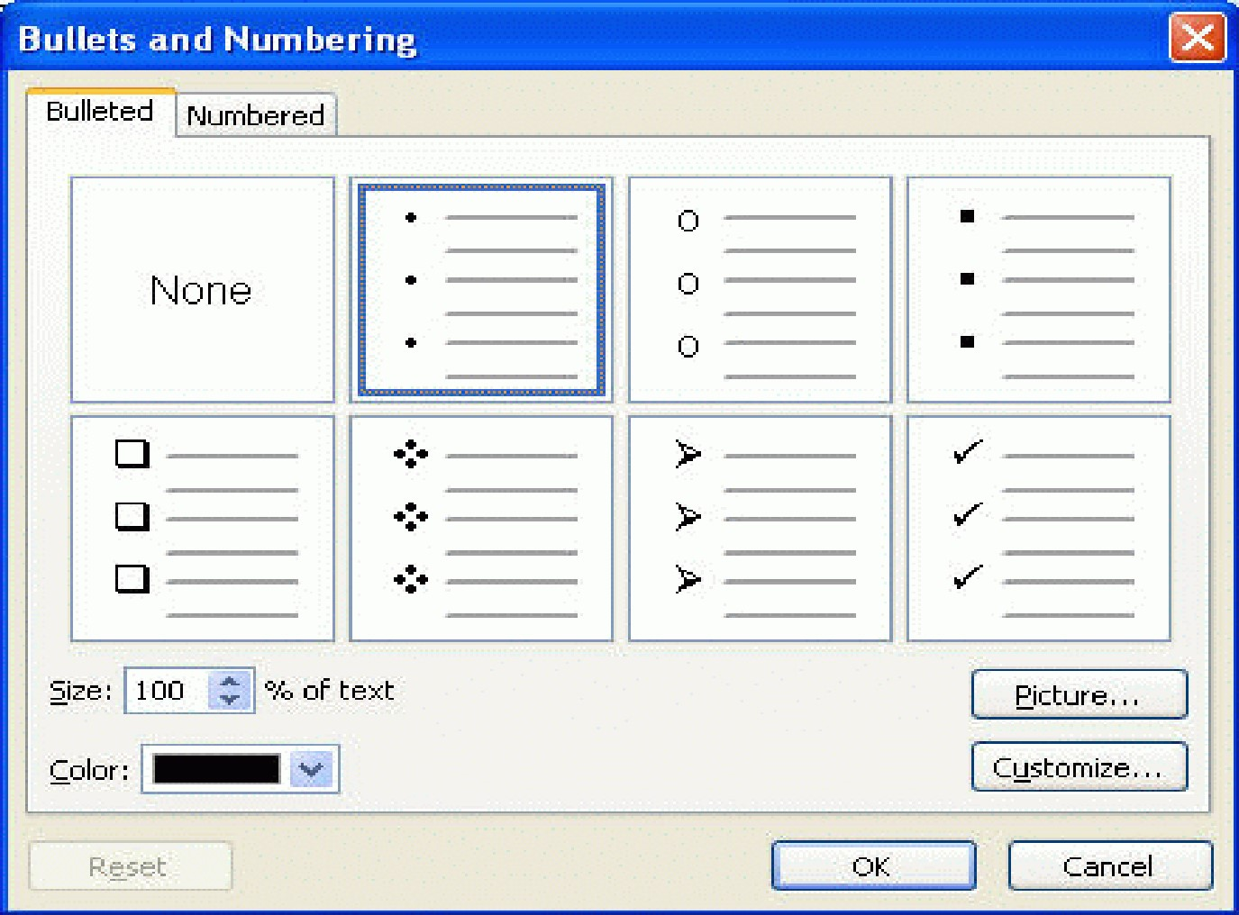
- Click on the bullet style you want.
- Click OK.
To create Custom Bullets, do the following:
- From the Format menu, click Bullets and Numbering.
- From the Bullets and Numbering dialog box, click on the Customizebutton to display the Symbol dialog box.
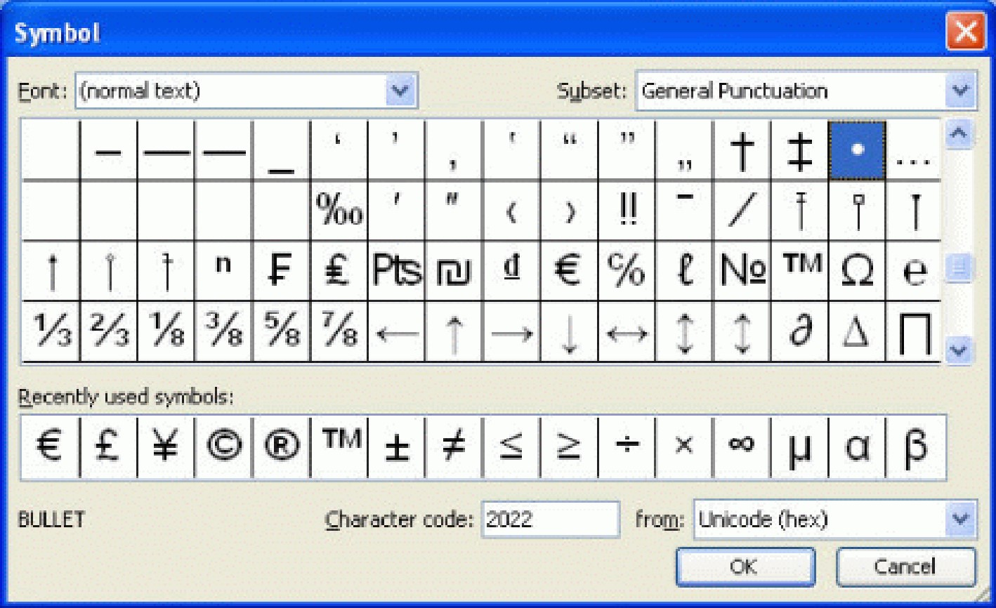
- Select a customized bullet and click OK.
To add or remove numbering, do the following.
- Highlight the paragraph/s you want to add or remove numbering from.
- Click the Numbering icon on the Formatting toolbar.
To change numbering style, do the following.
- From the Format menu, click Bullets and Numbering.
- Click on the Numbered tab. Click on the numbering style you want.
- Click OK.
To change Bullets or Numbering Colour, do the following.
- From the Format menu, click Bullets and Numbering.
- Click the down arrow next to the Colour drop-down menu box.
- Select the colour you wish to apply to your bullets or numbering.
- Click OK.
The PowerPoint drawing toolbar provides many commands for creating and editing graphics. The toolbar normally located at the bottom of the PowerPoint screen.
To display the drawing toolbar, do the following.
- From the View menu, point to Toolbars and click on Drawing.
Here are the PowerPoint Drawing toolbar icons and its function:
Draw | Enables you to apply different adjustments to the objects that you draw.
Select Objects | Enables you to select a particular drawing object. For selecting multiple objects, keep the Shift key depressed.
AutoShapes | Click on the AutoShapes icon to bring up a list of shape menus. Drag the mouse on to a selected set of shapes and select one from the list.
Line | Used to draw a line. To draw perfectly horizontal or vertical line, depress the Shift key while dragging.
Arrow | Used to draw a line with an arrowhead on it.
Rectangle | Used to draw a rectangle. To draw perfect square, depress the Shift key while dragging.
Oval | Used to draw an oval. To draw perfect circle, depress the Shift key while dragging.
Text Box | Used to draw a text box into which you can enter text.
Vertical Text Box | Used to draw a vertical text box into which you can enter the text vertically.
Insert WordArt | Used to insert different pattern of WordArt to your presentation.
Insert Diagram or Organization Chart | Used to insert diagram or organization chart.
Insert Clip Art | Used to insert clip art.
Insert Picture | Used to insert picture from the location that you specify.
Fill Colour | Used to fill a drawing object with a colour or shading.
Line Colour | Used to define the line colour of a drawing object.
Font Colour | Used to formats the selected text with the colour you pick.
Line Style | Used to define the line style used by an object.
Dash Style | Used to define the dashed line style used by an object.
Arrow Style | Used to define the arrow line style.
Shadow Style | Click the shadow style you want for the selected object.
3-D Style | Click the 3D style you want for the selected object.
To add an AutoShape, do the following.
- Click on the AutoShapes icon on the PowerPoint Drawing toolbar to display the AutoShapes menu.
- Click on the AutoShape you required to select it.
- Position the mouse pointer at the location where you want theAutoShape to begin.
- Hold down the left mouse button and drag to position the AutoShape on the slide.
- Release the mouse button when the size and proportion you require.
- To further adjust the shape, select the shape and drag the adjustment handle.
To draw a line, do the following.
- Click the Line icon from the PowerPoint Drawing toolbar. The mouse pointer changes into a cross-hair pointer when moved over the slide.
- Click at the location where you want the line to begin and drag. Release the mouse button when you want the line to end.
To draw an arrow head, do the following.
- Click the Arrow icon from the PowerPoint Drawing toolbar. The mouse pointer changes into a cross-hair pointer when moved over the slide.
- Click at the location where you want the line to begin and drag. Release the mouse button when you want the arrow to end.
To draw rectangles, do the following.
- Click the Rectangle icon from the PowerPoint Drawing toolbar. The mouse pointer changes into a cross-hair pointer when moved over the slide.
- Click at the location where you want the rectangles or ovals to begin and drag to draw the object. When you have finished, release the mouse button.
To draw ovals, do the following:
- Click the Oval icon from the PowerPoint Drawing toolbar. The mouse pointer changes into a cross-hair pointer when moved over the slide.
- Click at the location where you want the rectangles or ovals to begin and drag to draw the object. When you have finished, release the mouse button.
To create a text box, do the following.
- Click on the Text Box icon on the PowerPoint Drawing toolbar.
- Position the cross-hair pointer using the mouse and depress the left mouse button. Drag the mouse until the size you require, then release the mouse button.
- The text box will appear in the document, and you can now type in text or import a graphic into the text box.
To create a vertical text box, do the following.
- Click on the Vertical Text Box icon on the PowerPoint Drawing toolbar.
- Position the cross-hair pointer using the mouse and depress the left mouse button. Drag the mouse until the size you require, then release the mouse button.
- The text box will appear in the document, and you can now type in text or import a graphic into the text box.
To create a WordArt object, do the following.
- Click on the Insert WordArt icon on the PowerPoint Drawing toolbar.
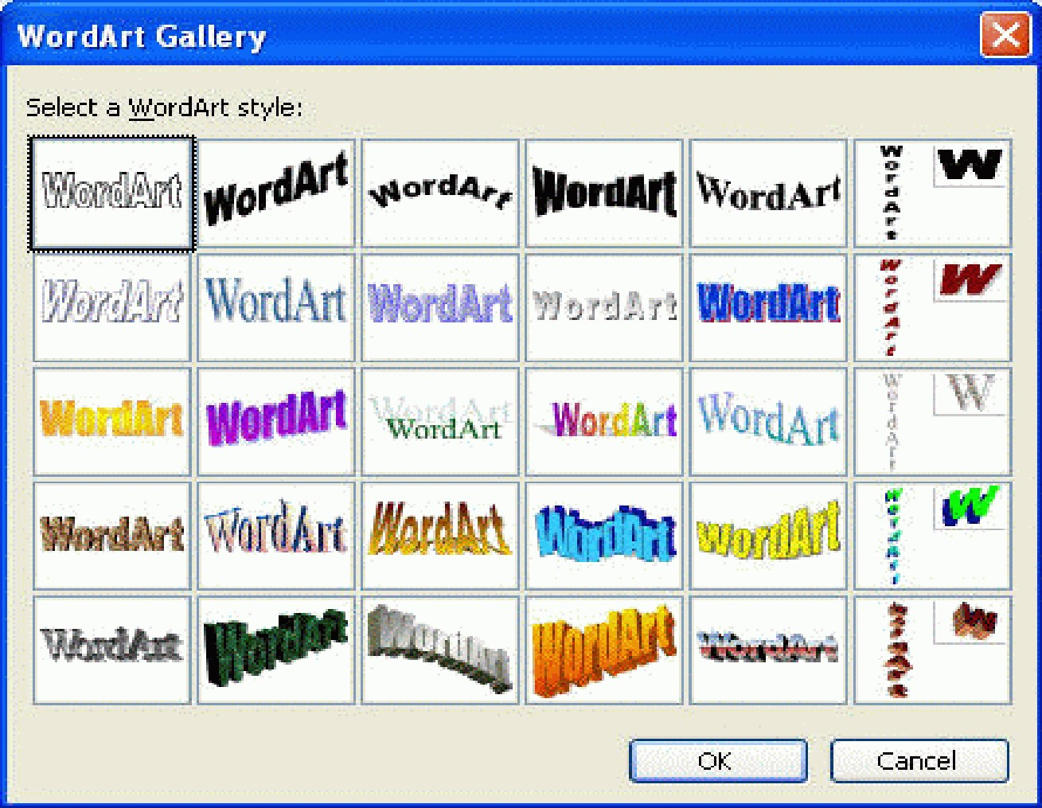
- From the WordArt Gallery select a style to use and click on the OKbutton.
- From the Edit WordArt Text dialog box displayed, enter the required text in the ‘Your Text Here’ area.
- Click on the OK button to insert the WordArt. You can move theWordArt to the intended place in the slide.
To create a Diagram or Organization Chart, do the following.
- Click on the Insert Diagram or Organization Chart icon on the PowerPoint Drawing toolbar.
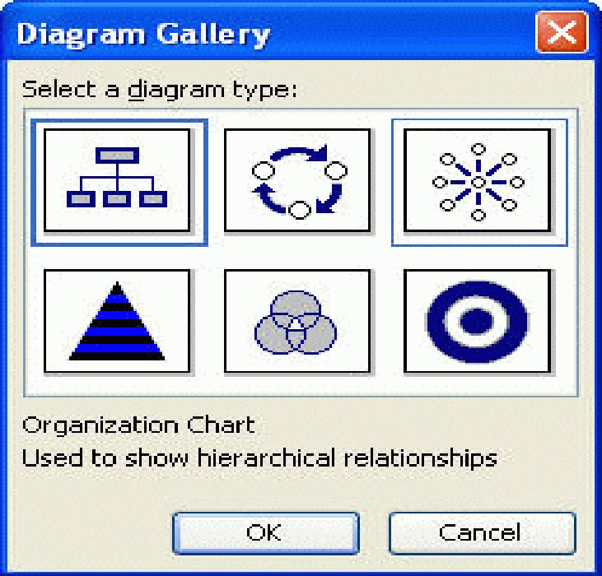
- From the Diagram Gallery select a diagram type and click on the OKbutton.
To insert a clipart, do the following.
- Click on the Insert Clip Art icon on the PowerPoint Drawing toolbar to open the Clip Art side pane.
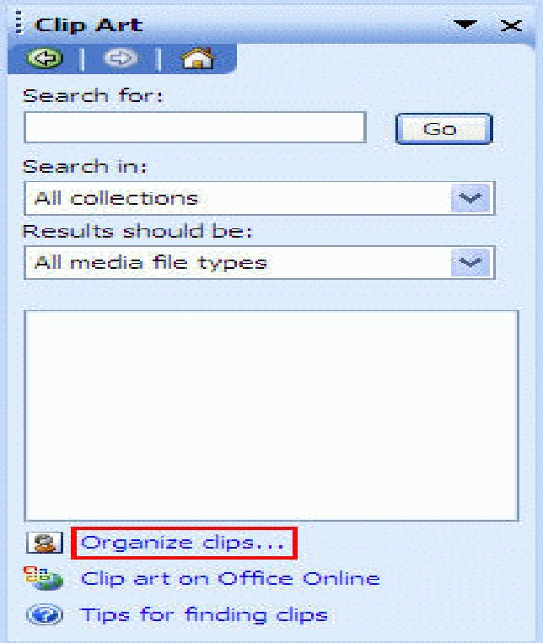
- The Search for: field allows you to enter one or more words pertaining to a specific graphic you wish to search for. Once enter, click on Go button to begin search. Note: Most of the time, this required Internet connection. If you do not have, then…
- Click on the Organize clips… (blue colour wordings)
- From the Microsoft Clip Organizer window, double-click on the Office Collections.
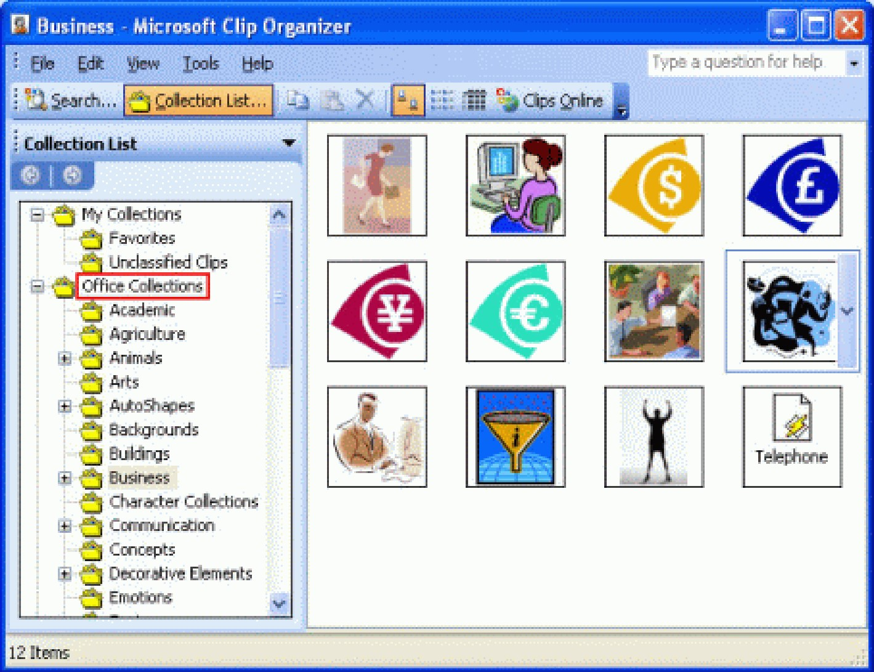

As you can see, there are sub-categories such as academic, agriculture, etc. Each category has few clip arts on it.
- Click on the down arrow at the right hand side of the picture and select Copy.
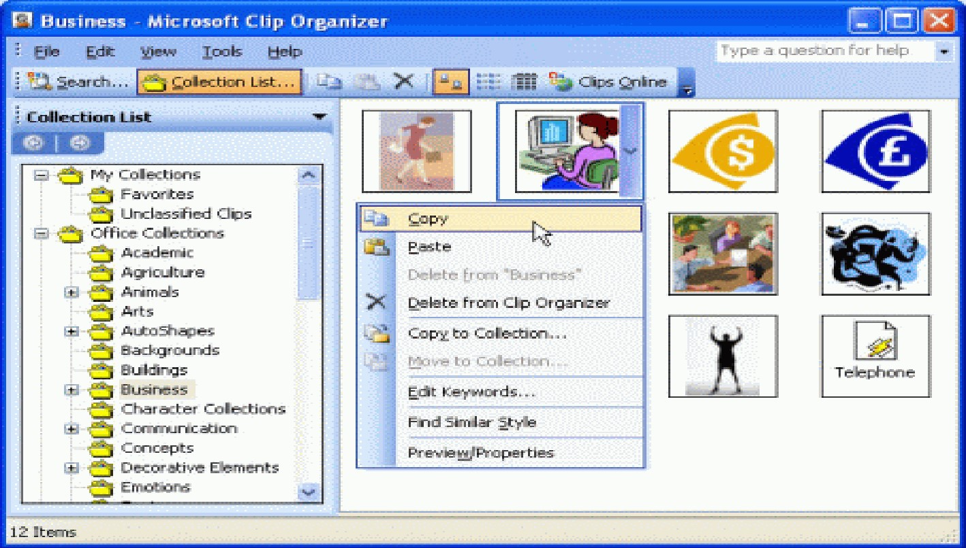
Position your mouse cursor at the location where you wish to place the clip art. Click the Paste icon on the Formatting toolbar.
To insert a picture do the following.
- Click on the Insert Clip Art icon on the PowerPoint Drawing toolbar to open the Insert Picture dialog box.
- Select the picture you wish to insert and click on Insert button.
- PowerPoint Slide Design- Design Templates
Design Templates offer a quick and easy way to provide an attractive and interesting background to your presentation. For more information about the design templates.
- PowerPoint Slide Design- Colour Schemes
Colour Schemes quickly add to or change the colours of your slides including the background, title text, body text, fills, shadows, and hyperlinks.
A default colour scheme is applied to your slides when you select a Design Template. Each Design Template includes additional Colour Schemes you can use.
To apply a Colour Scheme to One Slide, do the following.
- Open the PowerPoint slide where you want to apply the Colour Scheme.
Click the down arrow next to the Colour Scheme you want.
- Click Apply to Selected Slides.
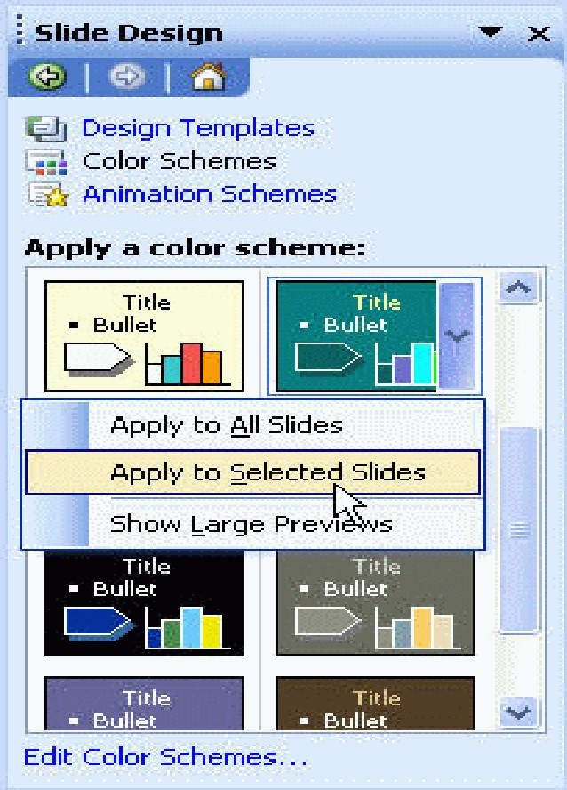
Note: If you wish to apply the colour scheme to all slides, click Apply to All Slides.
To customize Colours Schemes, do the following:
- At the bottom of the Slide Design – Colour Schemes Task Pane, click Edit Colour
Schemes…
- This will open the Edit Colour Scheme dialog box.
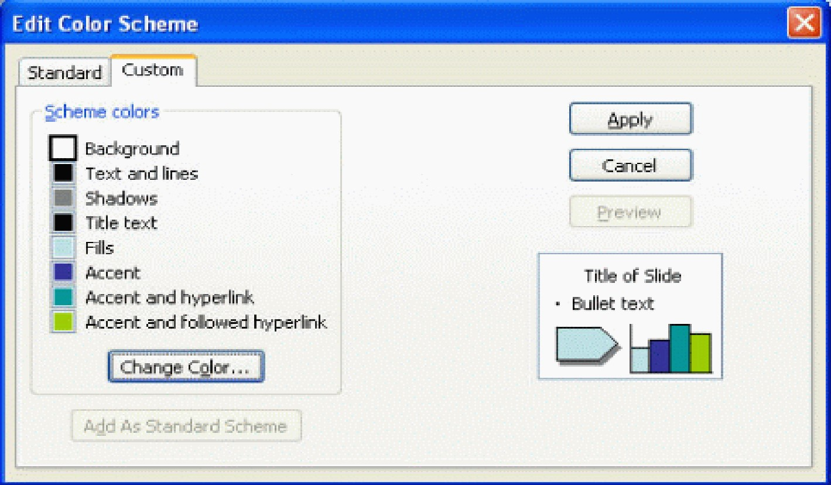
- Click on the element you want to customize (e.g. Background, Title text, etc) and click Change Colour… button.
- Select a colour and click OK.
When you have completed customizing your colours, click Apply button.

PowerPoint Slide Design- Animation Schemes
Preset Animation Schemes make it easy to animate your slide show. Animations are divided into subtle, moderate, and exciting schemes, and generally apply animations to titles, bulleted lists, and paragraphs.
To apply an Animation Scheme to One Slide, do the following:
- Open the PowerPoint slide where you want to apply the Animation scheme.
- Open the Slide Design – Animation Schemes Task Pane, and select the animation you want.
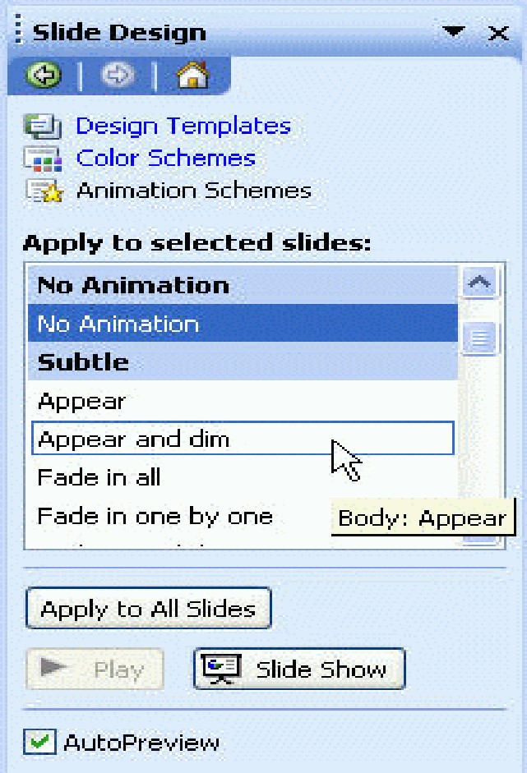
- The animation will automatically be applied to the current slide.
To apply an Animation Scheme to All Slides, do the following:
- Select the animation you want.
- Click on the Apply to All Slides button at the bottom of the Slide Design – Animation Schemes Task Pane.

PowerPoint Slide Show
Yes, PowerPoint slide show is the slide that running in 'full screen' mode. That is the actual show screen that your audiences will see, so run it with just a click or press of a button.

To view a Slide Show from the first Slide
- From the View menu, click Slide Show.
To view a Slide Show from the current Slide, do the following.
- Click the Slide Show icon at the bottom left of the PowerPoint screen.
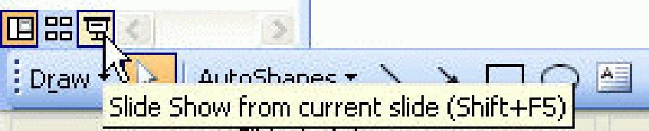
To move to the next slide in a Slide Show, do the following.
- Press the Enter key.
To move to the previous slide in a Slide Show, do the following.
- Press the Backspace key.
To move to a specific slide in the Slide Show, do the following.
- Right-click on the current slide (in the slide show) and select Go to Slide.
- Select the slide you want.
To Pause the Slide Show, do the following.
- Right-click on the current slide (in the slide show) and select Pause.
To Turn the Screen Black, do the following.
- Right-click on the current slide (in the slide show).
- Point to Screen and click on Black Screen.
To Turn the Screen White, do the following.
- Right-click on the current slide (in the slide show).
- Point to Screen and click on White Screen.

Pointer Options
The Automatic Pointer is the default pointer in a PowerPoint slide show. When set to automatic, the pointer disappears after fifteen minutes of inactivity.
To use the arrow pointer, do the following.
- The Arrow pointer is always visible during a presentation.
To select the arrow pointer, do the following.
- Right-click on the current slide (in the slide show).
- Point to Pointer Options and click on Arrow.
To change the pointer to a pen, do the following.
- By changing the pointer to a pen, you can write on your slides during the slide show.
- Right-click on the current slide (in the slide show).
- Point to Pointer Options and click on Pen.
To change pen colour, do the following.
- Right-click on the current slide (in the slide show).
- Point to Pointer Options and Ink Colour.
- Select the colour that you want.
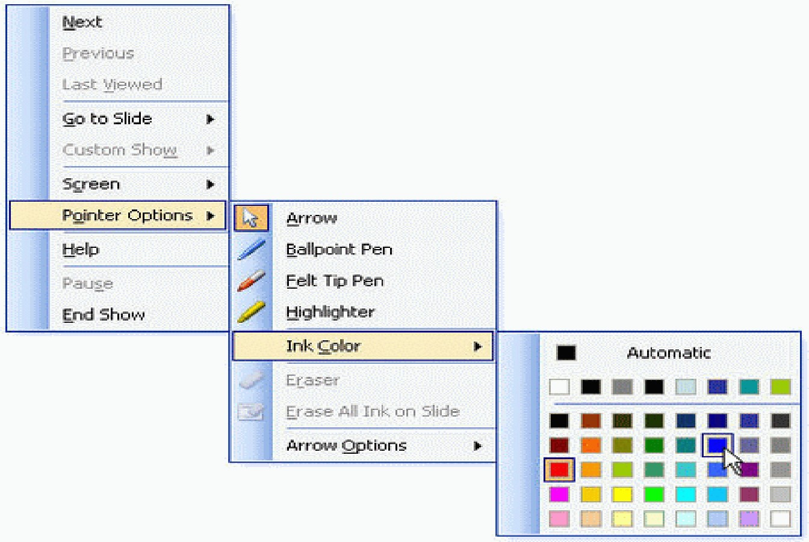

Exiting Power Point
Typically, you would save your work before exiting. This lesson does not require you to enter any text, so you might have nothing to save. To exit Power Point do the following.
- Click File.
- Click Exit, which can be found at the bottom of the drop-down menu.
- If you have entered text, you will be prompted: "Do you want to save changes to Document1?" To save your changes, click Yes. Otherwise, click No.
- Specify the correct folder in the Save In box.
- Name your file by typing lesson1.doc in the File Name field.
- Click Save.

