

Microsoft PowerPoint

Presentation

PURPOSE
♦Microsoft PowerPoint is used to create informational slide shows by using text, graphics and animations.
♦Used most often in business, training and educational presentations.
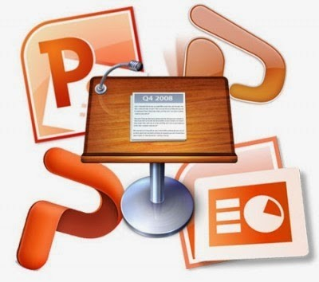

GENERAL FUNCTIONS
♦Consists of individual pages or slides which may contain text, graphics, sound, movies or other objects.
♦Allows for unrestricted arrangement of objects to suit the presenter
♦Presentations may be printed in multiple layouts for distribution and saved in different file formats
♦PowerPoint provides three types of movements:
♦Entrance, emphasis, and exit of elements on a slide itself are controlled by what PowerPoint calls ’Custom Animations’.
♦Transitions, on the other hand, are movements between slides. These can be animated in a variety of ways.
♦Custom animation can be used to create small story boards by animating pictures to enter, exit or move.

BENEFITS
Multiplatform
Easy to More visually understand appealing and modify
PowerPoint
OrganizedFlexible
Ease of content
sharing and collaboration

PRACTICAL USES

School Presentations Business Information Self-Running Presentations Animation of Information Creating video presentations
COMMON ISSUE #1
- Inconsistency in format or design
  - SOLUTION: Use the Slide Master view to help ensure consistency since it controls the look of your entire presentation including colors, fonts, backgrounds, etc.
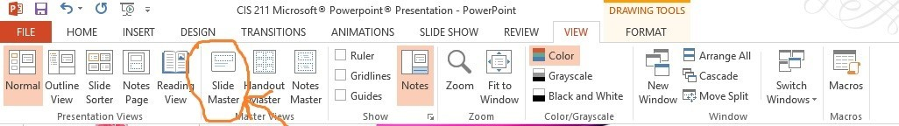
COMMON ISSUE #2
- Audience can’t read the text
  - SOLUTION: Avoid subtle color differences when choosing your font and
background colors. Think in terms of color opposites:
Black and white
Red and cyan
Green and magenta
Blue and yellow
COMMON ISSUE #3
- Can’t find ____ command
o SOLUTION: PowerPoint’s Help has a handy chart that lists the new location for all the old commands and toolbar buttons. To find this list, click the Help button (found at the top right of the PowerPoint window), search for the word “menus,” and then choose “Where are the menus and toolbars.”
Powered by TCPDF (www.tcpdf.org)

