Matlab Assignment #1
Goal: Use Mat Lab to create simple 2-d plot.
Commands: clc clear all syms diff() set() grid on hold on ezplot(,[]) set(gca,'XTick',) set(gca,'XTickLabel',{})
xlabel() ylabel() title() legend() axis([]) linspace(); sqrt() plot() axis square
Exercise 1.1 Problem:
Let y= sin(x ² )cos( x). Produce a plot of y and y ' over the interval [−π,π]. The x-axis tick marks should be at the points with coordinates −π,^{−π}₂,0,^{π}₂,π.
Code Solution:
clc clear all syms x y = cos(x)*sin(x.^2); dy=diff(y,x); h=ezplot(y,[-pi,pi]); set(h,'Color','r') grid on hold on; ezplot(dy,[-pi,pi]); set(gca,'XTick',-pi:pi/2:pi)
set(gca,'XTickLabel',{'-pi','-pi/2','0','pi/2','pi'})
xlabel('x-axis') ylabel('y-axis')
title('Plot of y = cos(x)*sin(x^2) and dy') legend('y','dy','Location','NorthEastOutSide') axis([-pi,pi,-5,5])
Graph:
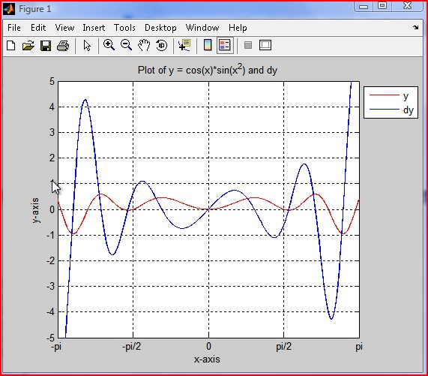
Exercise 1.3 Problem:
Plot the expressions y= 1−x ² and y=− 1−x ² on the interval [−1,1] . The two graphs should form the circle x ² +y ² =1. Look up the axis command in Help to see how to get the picture to actually look like a circle, rather than an ellipse.
Code Solution:
clear all clc syms x y x=linspace(-1,1,80); y=sqrt(1-x.^2) hold on; y2=-sqrt(1-x.^2) plot(x,y,x,y2) grid on; xlabel('x-axis') ylabel('y-axis')
title('Plot of y=sqrt(1-x^2) and y=-sqrt(1-x^2)') legend('sqrt(1-x.^2)','-sqrt(1-
x.^2)','Location','NorthEastOutSide') axis square
Graph:
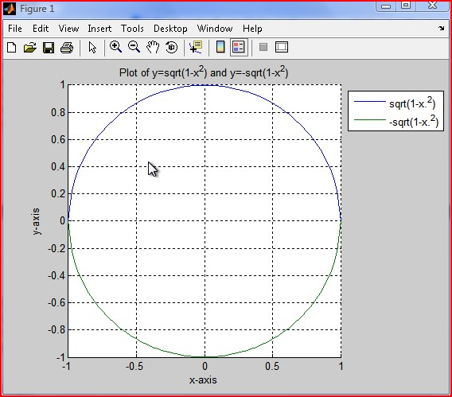
Powered by TCPDF (www.tcpdf.org)

