MS Word template
iii
TABLE OF CONTENTS
LIST OF FIGURES.............................................................................................................II
LIST OF TABLES...............................................................................................................II
DEDICATION......................................................................................................................II

ACKNOWLEDGEMENTS................................................................................................II
CHAPTER 1 INTRODUCTION.....................ERROR! BOOKMARK NOT DEFINED. 1.1 Problem Description and Motivation.......................Error! Bookmark not defined.
1.2 Research Hypothesis and Questions........................Error! Bookmark not defined. 1.3 Research Contributions............................................Error! Bookmark not defined. 1.4 Organization of the Dissertation..............................Error! Bookmark not defined. 1.5 Bibliographical Notes...............................................Error! Bookmark not defined. CHAPTER 2 COLLEGE STYLE GUIDE........................................................................2
2.1 Style Guide and Instructions for Thesis and Dissertation..........................................2
2.1.1 Reasons for Regulations..................................................................................2
2.1.2 Responsibilities................................................................................................2
2.1.3 Approval..........................................................................................................2
2.1.4 Paper................................................................................................................2
2.1.5 Copies and Binding..........................................................................................2
2.1.6 Font Styles.......................................................................................................2
2.1.7 Margins............................................................................................................2
2.1.8 Spacing.............................................................................................................2
2.1.9 Pagination........................................................................................................2
2.1.10 Front Matter.....................................................................................................2
2.1.11 Figures..............................................................................................................2
2.1.12 Tables...............................................................................................................2
2.1.13 Footnotes..........................................................................................................2
2.1.14 Appendices.......................................................................................................2
2.1.15 Bibliographies/References...............................................................................2
2.1.16 Abstracts..........................................................................................................2
2.1.17 Publication Requirement for Doctoral Dissertation.........................................2
2.2 Some Examples of tables and figures......................Error! Bookmark not defined.

CHAPTER 3 CONCLUSIONS AND FUTURE RESEARCH.......................................2
3.1 Main Results.............................................................Error! Bookmark not defined. 3.2 Future Research Directions......................................Error! Bookmark not defined.
APPENDIX A EXAMPLE OF AN APPENDIX...............................................................2
APPENDIX B ANOTHER APPENDIX EXAMPLE.......................................................2
REFERENCES......................................................................................................................2
v

LIST OF FIGURES
Figure 2.1. An Example figure. Chapter 2 figure 1 (of chapter 2)....................................2
vi

LIST OF TABLES
Table 2.1. An Example table. Chapter Number and Table Number within chapter...........2
Table 2.2. Another table.....................................................................................................2
ACKNOWLEDGEMENTS
Acknowledge those who helped or supported you in finishing this dissertation/thesis.

Introduction
This MS Word template (.dot file) was prepared by Dr. Jonathan I. Maletic in the Department of Computer Science at Kent State University. This is Version 1.0. It is a template for Thesis/Dissertations for the College of Arts and Science at KSU.
Please read the entire document and the College’s “Style Guide and Instructions for Typing Thesis and Dissertations”. You can get this document from the College or Department.

0.1 Organization
The is an introduction to this documents and how to use this template. Error: Reference source not found is the College’s style guide and instructions copied over from their pdf document and put into Thesis format. 1 is composed of a set of examples of the styles described in the College’s guide and defined by this template.

0.2 How to Use this template
You can open this document ThesisDissertation-Tempate.dot and do a “save as”. Or you can put this .dot file in your templates folder for MS Word and do a “New…” and select this template.
MS Word allows you to define styles. For example this text is “Body Text”. You should use the “Styles and Formatting” tool bar for changing and applying styles to your

text. Select the text and apply the appropriate style. The chapter heading is Heading 1 and the sub section is Heading 2 and Heading 3 for subsubsection.
This document has place holders for all the major components of a thesis or dissertation in the corresponding Style.

0.3 Cross-References
Word allows you to automatically generate the Table of Contents and List of Figures/Tables via the “Insert Reference Index and Table” function. If you use the styles properly for each heading and captions this tool will save a large amount of time.

0.4 References and Bibliography
Use EndNote or some other plugin tool to manage your references and insert your citations. These tool automatically generate your bibliography and will save you 100’s of hours. The references in this document are done with EndNote.
CHAPTER 1

College Style Guide
This chapter is the information contained in the College’s style guide – but put in the format of what it describes. I got rid of the word “type” in the title as no one uses a typewriter (or has seen one) in years. There are a few annotations noted that are helpful comments from students who’s gone through the process.

1.1 Style Guide and Instructions for Thesis and Dissertation
This is the official style guide for theses and dissertations in the College of Arts and Sciences. It was approved and adopted by the Arts and Sciences Graduate Council on April 24, 1996. Special style guides are used by various departments for footnote forms and other matters of detail. These should be consulted for matters not covered in the College of Arts and Sciences Style Guide, but anything covered in the College of Arts and Sciences Style Guide takes precedence over the guides used by the various departments.
Some departments prefer that students not prepare the final typed copy until after their final oral examinations. Copies of the theses or dissertations supplied to examination committees, however, must be neatly typed and legible. Consult with the graduate coordinator concerning departmental policies and guidelines.
3

1.1.1 Reasons for Regulations
The rules given here are not arbitrary but necessary. Theses and dissertations are deposited in the University Library as bound volumes and must be produced with the same care as printed books. Margins must be uniform to allow for binding and trimming. Paper must be of uniform color because all dissertations and some theses are microfilmed. (Theses and Dissertations which do not conform to these guidelines may be rejected by the Library.)

1.1.2 Responsibilities
Degree candidates are responsible for the accurate preparation of copies, including printing or typing, footnote form, etc. Candidates should not expect their advisors to copy-read their theses or dissertations for errors, nor should they expect their typists to correct or edit the copies. They should supply their typists with copies of this Style Guide as well as style sheets appropriate for the various disciplines in which the theses or dissertations are being written.

1.1.3 Approval
Certification that the thesis or dissertation is in the correct style and format is made by the student, the thesis or dissertation advisor, and the department chairperson.
Such certification is made by the submission of a Thesis Preparation or Dissertation
Preparation Approval Form along with the copies of the thesis or dissertation to the College of Arts and Sciences. (See Exhibits I and J, pages 22 and 23). NOTE: The Dean will NOT sign a dissertation or thesis submitted without this form. A dissertation advisor

may request that the College of Arts and Sciences also review the dissertation for mechanical style and format.

1.1.4 Paper
- Paper must be 8½ inches by 11 inches in size.
- Copies of the thesis or dissertation submitted to the College of Arts and Sciences must be on twenty pound white bond paper with a 50% or higher cotton fiber content.
NOTE: Any paper meeting the above requirements will be acceptable, but the same paper must be used throughout to avoid variations in color and texture. Do not use coated papers advertised as having “Easy-Erase” qualities. If you use the wrong paper, the thesis or dissertation will have to be completely recopied!

1.1.5 Copies and Binding
- Two copies of the thesis or dissertation must be deposited in the College of
Arts and Sciences Office.
- These copies can be printed or photocopied so long as a sharp, high contrast, black image is produced.
- All illustrations, photographs, and other materials in the original must also be included in the second copy.
- The fee for binding is $10 for a thesis and $65 for a dissertation. The dissertation fee is explained more fully on page 8.
- Students desiring bound copies for themselves may take their additional copies to the Special Order Counter at the University Bookstore for binding.
- Copies must be made before obtaining signatures.

1.1.6 Font Styles
Scalable fonts should be 10 to 12 points in size. Do not use exotic fonts (slanted, square, or script type) for the entire document, but special fonts may be used for emphasis or when otherwise appropriate. Students should make sure that the print is uniformly letter quality. Laser print, ink jet print, or high-quality photocopying is acceptable. Dot matrix or near letter quality print is not acceptable. The type style and size must be the same throughout the thesis or dissertation.
Added note: The font size (i.e., 10, 11, or 12) and style (e.g., New Times Roman) must be same throughout the thesis, TOC and abstract. Different/variable size and style is not allowed for chapter headings or any other titles. However, titles can be bold,
italics, etc.

1.1.7 Margins
On the top and left-hand side of the page, use 1½ inch margins except on pages beginning every major division (i.e., contents, list of tables, list of illustrations, preface, introduction, each new chapter, bibliography, and appendices) where the top margin must be two inches. On the bottom and right-hand side of the page, use one inch margins. Margins that are smaller than, or substantially larger than these specifications are not acceptable. Illustrations, graphs, and tables must not extend beyond these margins.
Materials that extend beyond these margins should be retyped or reduced in size. Materials reduced in size photographically (except half-tone photographs) may be copied onto regulation paper for both copies.

1.1.8 Spacing
Triple-space between major division heading (i.e., contents, list of tables, list of illustrations, preface, introduction, each new chapter, bibliography and appendices) and text. When using chapter divisions, triple space between the chapter number (example: CHAPTER I) and the title and triple space between the title and the text.
All subheadings are triple spaced from the preceding text and double spaced between the subheadings and the text following. Footnotes and long quotations that are set off are usually single-spaced, but check the style manual accepted by the department in which the thesis or dissertation is being written.
Any centered information (titles, chapter headings, page numbers centered at the bottom of the page) should be centered between the right and left margins.
Double-space the text throughout, except as noted above for footnote and long quotations.

1.1.9 Pagination
Every page in the thesis or dissertation (except blank pages in the front matter) must be assigned a page number. It is sometimes necessary to place the title for a figure or table on the back of the preceding page. The face of that page would then be blank except that the page number is to be placed in the upper right-hand corner, as on other pages. (See page 20 in Appendix.)
Use lower case Roman numerals without punctuation or dashes on all front matter of the thesis or dissertation. These page numbers must all be centered with respect to the text, no less than 5/8 inches but no more than 1 inch from the bottom. The title page is page, i (not to be typed on the page); the approval page is page ii; Table of Contents, page
iii, etc.
Added Notes: Be extra careful with margins! Double space between paragraph text and indent the first line of every paragraph (0.3") consistently. Make sure the TOC and spacing between topics and subtopics looks consistent. Be extra careful about it.
Use Arabic numerals without punctuation or dashes at the upper right-hand corner one inch from the right edge of the paper and no higher than 5/8 inches or no lower than
1¼ inches from the top, except for pages carrying chapter headings, first page of the Bibliography, and the first page of each section of an Appendix where the page number must be centered at least 5/8 inch but no more than 1 inch from the bottom of the page. Numbering must run consecutively with no missing numbers, and the use of 12a, 12b, etc. is not permitted. Arabic numerals are used beginning with the first page following the front matter and beginning with number 1. This would include the Introduction if there is one. Page numbers are assigned but not typed on cover sheets, if used, preceding the Bibliography and the Appendices.
Added Notes: Be careful with the pagination and make sure that the text of the thesis (particularly in case of pages with page numbers at the bottom ) is not too close to the page number and must not give the feeling that the page number is lost in the thesis
text.

1.1.10 Front Matter
See the list of exhibits in the Appendix. Particular attention should be paid to spacing if using a scalable font. The following is a list of the order in which the front matter should appear in the thesis or dissertation. Dates on title page, approval page, and abstract should be the month and year when the degree is received, not when the thesis or dissertation is completed.
- Blank Sheet
- Title Page
- Blank Sheet
- Approval Page
- Blank Sheet
- Table of Contents
- List of Figures (if any)
- List of Illustrations (if any)
- List of Tables (if any)
- Preface, including Acknowledgments or Acknowledgments alone if there is no Preface.
ADDED NOTE: The first sheet is the Thesis Preparation form (see appendix), second is Abstract. The Abstract pages are not part of thesis and must not be paginated and must not affect the page count of the thesis or front matter. The rest goes in the order as above.

1.1.11 Figures
All figures, (computer graphics, photographs, color maps, color illustrations, drawings, charts, graphs, etc.) must be neatly drawn and lettered, (no ball-point pen); good quality color illustrations can be used when appropriate. All such materials must fit inside the regular margins of the page. Oversize materials should be reduced in size to conform to the margins. Materials reduced photographically (except half-tone photographs) may be copied onto the appropriate paper in both copies. Maps in geology and geography, however, may be oversized and in color. They should be folded with care so that they may be placed in a rear cover pocket to be supplied by the bindery. These departments produce finished maps at reasonable prices
Photographs should be mounted with dry adhesive paper, though usually it is preferable to draw illustrative material directly on the page. Do not use press-type or the like for graphs and lettering as it is not permanent. However, a copy on the appropriate paper of a graph made with press-type may be submitted. Foldout graphs may be used sparingly. Computer printouts should be used only if necessary and should be copied onto paper used for the rest of the thesis or dissertation. Fairly good results may be obtained by having the printouts made on white computer paper.
Each illustration should be labeled as “Fig. 1,” “Fig. 2,” and so on, consecutively through the thesis or dissertation. If more than a few figures are used, a List of Figures should follow the Table of Contents. All pages carrying figures must have page numbers in the upper right-hand corner. Plates, figures or illustrations which are too large to allow a caption or title on the same page should have the caption or title on the preceding page, see Exhibit G.
Students should consult their departments for further information concerning the use of figures. All figures must appear in both copies of the thesis or dissertation submitted to the College of Arts and Sciences.

1.1.12 Tables
Tables of one-half page or less in length may appear on the same page with the text. If larger than one-half page, a table must be placed on a separate sheet. Two or more small tables may be placed together on a single page. Tables should be inserted as near as possible to the text they illustrate. All tables must be labeled as “Table 1,” and so on, consecutively through the thesis or dissertation. Tables must also be titled. The general instructions for the use of figures apply to tables, except that tables must be typed on the paper used for the thesis or dissertation as a whole.
If more than a few tables appear in the work, a List of Tables should follow the
Table of Contents. (See page 6 for the order of appearance.)

1.1.13 Footnotes
There is a wide diversity of practice in footnoting. The College of Arts and Sciences has no overall requirement beyond consistency. Students should refer to the style manuals indicated by their disciplines for a guide to proper footnoting (see pages 9 and 10).

1.1.14 Appendices
Appendices may be used to present detailed information whose inclusion in the text of the thesis or dissertation would unnecessarily obstruct clear presentation of the argument. An appendix should be labeled, and such appendix should be independent of others. Ordinarily, an appendix should not have footnotes (documentation can be inserted in the text.) Materials placed in the appendices must meet the standards of pagination, margins, etc.

1.1.15 Bibliographies/References
For the proper form and divisions of the Bibliography referenced, students should consult the style guide approved by their departments.
Added Notes: Follow the same style as the paragraph text of the thesis (i.e., same font size, style and double spaced). The first line of the reference should be hanging out by 0.5" then the following text of the reference.

1.1.16 Abstracts
Master’s thesis abstracts should be 200 to 400 words long, but dissertation abstracts are now limited to 350 words. Both should describe the problem or topic, any important or distinctive methods used in the research, and the principal conclusions reached. Typing instructions for the thesis apply equally to the abstract, which must be submitted to the College of Arts and Sciences with the thesis but not paginated as part of it. The abstract itself should begin three spaces below the last line of the title matter. The title “Dr.” should not appear before the advisor’s name. The number of pages following the title of the thesis or dissertation should conform with the number of the last page of the thesis or dissertation, including the Bibliography and Appendix.
For the doctoral dissertation, the abstract must conform to the requirements of Dissertation Abstracts without further editing or revision. Sample abstracts are in the exhibits section.
Two copies of the abstract should be included with the thesis or dissertation.
Added Note: Abstract is not part of thesis and must not be paginated and must not affect the page count of thesis or front matter.
1.1.17 Publication Requirement for Doctoral Dissertation
Doctoral dissertations must be published by the microfilm method through University Microfilms, Ann Arbor, Michigan. The fee for publication, which must be paid by the student, is $XX. This fee covers the cost of microfilming the dissertation, storage of one negative copy in the vaults of University Microfilms, Inc., printing the abstract in Dissertation Abstracts, presentation of one positive copy to the Library of Congress, and preparation and distribution of catalog cards for the dissertation by the Library of Congress. This fee does not cover the cost of copyrighting the dissertation; please read the Doctoral Dissertation Agreement Form for copyrighting information.
CHAPTER 2

Examples of Each Style
This chapter gives examples of all the styles and notes on using the. Examples of figures and tables are also given. Actual formats of figures and tables will vary. You should look at examples of IEEE and ACM journals and conferences for good formatting styles. Most importantly, you should be consistent in your formatting of figures and tables.

2.1 Heading 2
This is an example of a Heading 2.

2.1.1 Heading 3
Normally you don’t have a single heading 2 or 3. If you have a 1.1.1 you should have a 1.1.2. Likewise for 1.1. there should be a 1.2.

2.2 Font Styles
It is suggested to use Times New Roman 12 point font. It’s readable and common to both ACM and IEEE publications. You can use 10 or 11 point font but given there is no page limit and your committee members’ eye sight is getting poor I suggest 12 point.
The entire document is in one font and size. Figures can be in any font/size.

2.3 Margins
This documents has the correct margins.
15
2.4 Spacing
Spacing is set up correctly. The styles take care of this.

2.5 Pagination
Page numbers are given in this document and set up correctly for each new chapter. Use a “Section Break” instead of a “Page Break” between chapters. This will give you the page number at the bottom of the page for first page of chapters.

2.6 Figures
As stated in the College guidelines “All figures … must be neatly drawn and lettered, (no ball-point pen)”. My guess is this guideline was written up before you were born.
My suggestion is to use MS Visio for figures. This is one of the best drawing package and is free with the department’s MS developers site license. Once again figures should be consistent in format and presentation.
Large figures should appear on their own page. Figures less than a half a page can be put along with prose. Keep figures close to where they are referenced. Figure headings go under the figure as seen in Figure 3.1. Notice the chapter number (2) as a means to label figures.

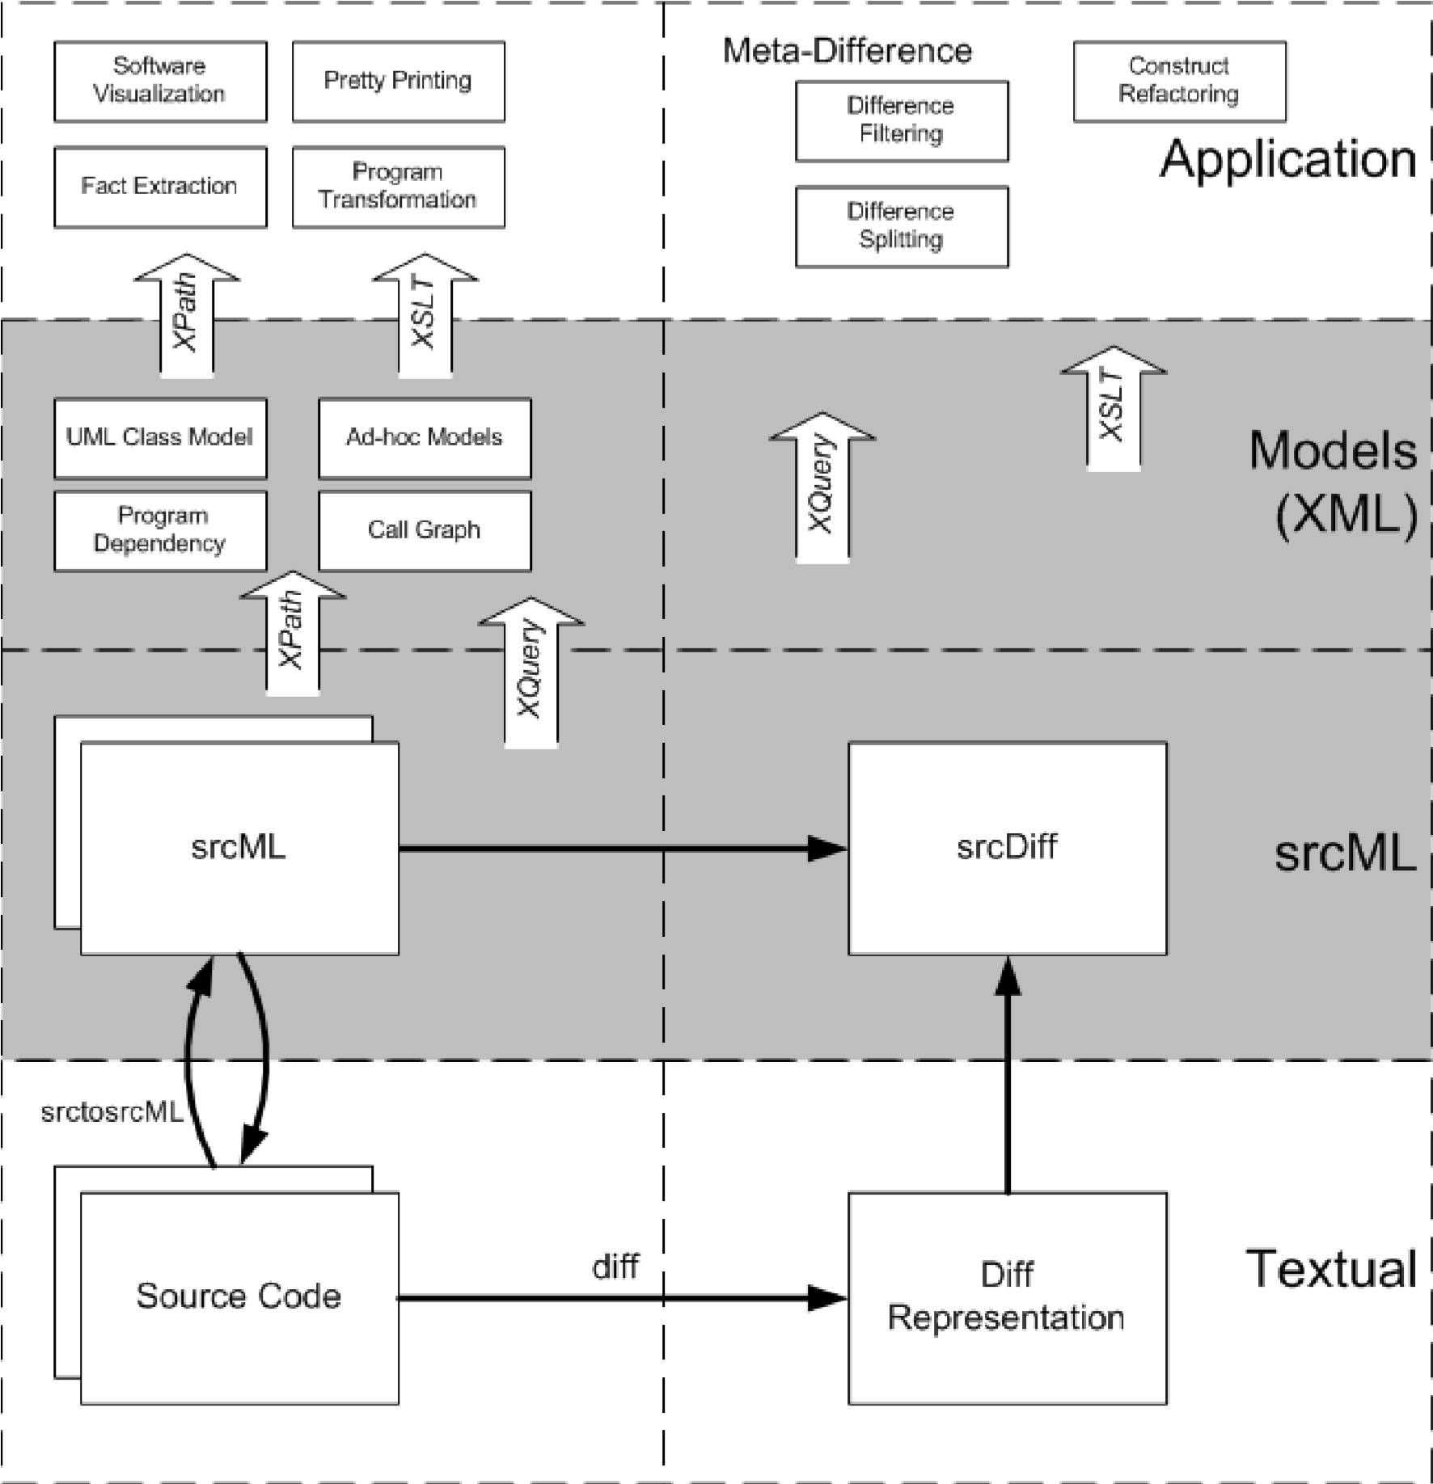
Figure 3.1. An Example figure. Chapter 2 figure 1 (of chapter 2).
Word allows you to insert a caption (figure or table). This is down with “Insert Reference Caption”. More importantly Word also has facilities to reference these figures. Use “Insert Reference Cross-Reference” to insert a reference to a figure, table, or heading. This is really helpful when you (because you will) rearrange sections or placement of figures/tables. Word will keep track of this for you if you use the cross reference tool.
Additionally, by using the insert-caption you can automatically generate a list of figures and a list of tables. If the location of table/figure moves, you just regenerate the list and it is updated.

2.7 Tables
Again, make sure tables are consistent and neat. Table heading go before the table. We have two examples of tables below Table 3.1 and Table 3.2. Notice they are numbered with the chapter, that is table 1 of chapter 2 (2.1).

Table 3.1. An Example table. Chapter Number and Table Number within chapter
 | Document Engineering |  | Software Engineering
 | Viewing/ Editing | Linking/ Querying | Software Static Analysis  Visualization
Plain-Text Source Code | Medium | None | None None
AST &  Symbol Table | Low | Low | Low Medium
srcML | High | High | High Medium
Table 3.2. Another table.
P  r  e  v  i  o  u  s  B  e  n  c  h  m  a  r  k  R  e  s  u  l  t  s | Fact Extractor | Full Answer | Partial Answer | No Answer
 | Acacia | 32% | 16% | 52%
 | Columbus | 19% | 11% | 70%
 | Cppx | 45% | 19% | 35%
 | TkSee/SN | 28% | 18% | 54%
 | srcML  Translator | 44% | 8% | 48%

2.8 Footnotes
A footnote, this is an example of a footnote and the formatting. Again, everything has to be in the same font and size. You should use footnote sparingly.

2.9 Appendices
Appendices are a good place to put things like source code, DTDs, and extra mathematical information. They are page numbered. Examples are in this document as Appendix A and B. Use Appendix Heading for the heading of the appendix.

2.10 Bibliographies/References
Once again use EndNote or some other plugin tool to manage your references and insert your citations. These tool automatically generate your bibliography and will save you 100’s of hours. The references in this document are done with EndNote.
My suggestion is to cite references within the manuscript with author-year style. This is easy on the reader as they will often recognize the particular reference just by the author and year information, without having to go to the references to look up the reference (as in the case for numbered citations). I have my students use multi-authoryear to give the most information. Again, there is no page limit on a thesis so the added text is not an issue.
Here are some examples of references the first being a journal [Aiken,
Ngwenyama, Broome 1999], the next couple are conference publications [Biggerstaff,
Mitbander, Webster 1993; Collard, Kagdi, Maletic 2003; Cordy 2003], a book [Bruegge, Dutoit 2000], a Ph.D. thesis [Collard 2004], a technical report [Faloutsos, Oard 1995], and a web page [OMG 2003].

2.11 Abstracts
This is external to the thesis and not counted in the page count. There is another template for the abstract – see ThesisAbstract-Template.dot.

2.12 Summary
It is very common to end each chapter with a chapter summary. This chapter give specifics on how to use the template for each particular style.
CHAPTER 3

Conclusions
This presents an MS word template for the KSU A&S Thesis style. APPENDIX A
Example of an Appendix
This appendix contains vital information.
Another Appendix Example
This appendix contains the DTD and source code.

REFERENCES
[Aiken, Ngwenyama, Broome 1999] Aiken, P., Ngwenyama, O., and Broome, L., (1999), "Reverse Engineering New Systems for Smooth Implementation", IEEE Software, vol. 16, no. 2, March/April, pp. 36-43.
[Biggerstaff, Mitbander, Webster 1993] Biggerstaff, T. J., Mitbander, B. G., and Webster, D., (1993), "The concept assignment problem in program understanding", in Proceedings of International Conference on Software Engineering (ICSE'93), Baltimore, Maryland, pp. 482 - 498.
[Bruegge, Dutoit 2000] Bruegge, B. and Dutoit, A.,(2000),Object-Oriented Software
Engineering Conquering Complex and Changing Systems, Prentice Hall.
[Collard 2004] Collard, M. L., (2004), Meta-Differencing: An Infrastructure for Source
Code Difference Analysis, Kent State University, Kent, Ohio USA, Ph.D.
Dissertation Thesis.
[Collard, Kagdi, Maletic 2003] Collard, M. L., Kagdi, H. H., and Maletic, J. I., (2003),
"An XML-Based Lightweight C++ Fact Extractor", in Proceedings of 11th IEEE
International Workshop on Program Comprehension (IWPC'03), Portland, OR, May 10-11, pp. 134-143.
[Cordy 2003] Cordy, J. R., (2003), "Generalized Selective XML Markup of Source Code
Using Agile Parsing", in Proceedings of 11th IEEE International Workshop on

Program Comprehension (IWPC'03), Portland, Oregon, USA, May 10 - 11, pp.
134-143.
[Faloutsos, Oard 1995] Faloutsos, C. and Oard, D. W., (1995), "A Survey of Information
Retrieval and Filtering Methods": University of Maryland, CS-TR-3514.
[OMG 2003] OMG, (2003), "Unified Modeling Language, 1.5": http://www.omg.org.

This is a footnote. A place to put additional information.

