MS Excel: Two-Sample Hypothesis of Variance
For MS Excel 2007 & 2010

Presentation Overview
- This presentation will show you an example of how MS Excel can aid you in complete a hypothesis test about the relationship between two population variances.
- This presentation follows Example 8.10, in the textbook on pages 460-462, in which you are asked to determine whether the production levels at two paper mills have different variability.
  - Slides 3-4 review this example as covered in the book.
  - Slides 5-9 review the Excel output and dialog box.
  - Slides 10-11 discuss the effects of switching variable 1 and variable 2.
  - Slides12-18 provide a quick recap of the entire process using Excel.
Paper mills example 8.10, p. 460-462

Step 1
H₀: σ₁²/ σ₂²=1 (equal variances, σ₁² = σ₂²)
H_{a}: σ₁²/ σ₂²≠1 (unequal variances, σ₁² ≠ σ₂²)
Step 2
The test statistic s₁²/ s₂², is F distributed

Step 3
α=.10 (for both tails, so only .05 in each tail) n₁= 13, n₂=18
(if paper mill 1 is represented in the numerator as population 1)

Step 4
The test statistic is F-distributed***, and the textbook provides only the uppertail critical value for the F-distribution (the lower-tail value is unknown since the distribution is NOT symmetric!!!)

Step 4 (con’t)
Using the F-distribution on p. 803-804, the critical value for ν₁=12 and ν₂=17 is F=2.38, so the decision rule is: if F > 2.38 then reject H₀
(remember v₁ is the numerator degrees of freedom, n₁-1, and v₂ is the denominator degrees of freedom, n₂-1)

α/2=.05
α/2=.05

***If you have questions about using the F-
F = ? F = 2.38 F

distribution review the other Powerpoint

notes and contact the instructor!
Paper mills, conclusion…
Step 5
F-Test statistic= s₁²/ s₂²
Using the descriptive statistics provided on p. 461 (Figure 8.20)
F = (8.36) ²/ (4.85) ² = 2.97
***remember, go back to the graph in step 4 to see whether you can reach a conclusion about your hypothesis
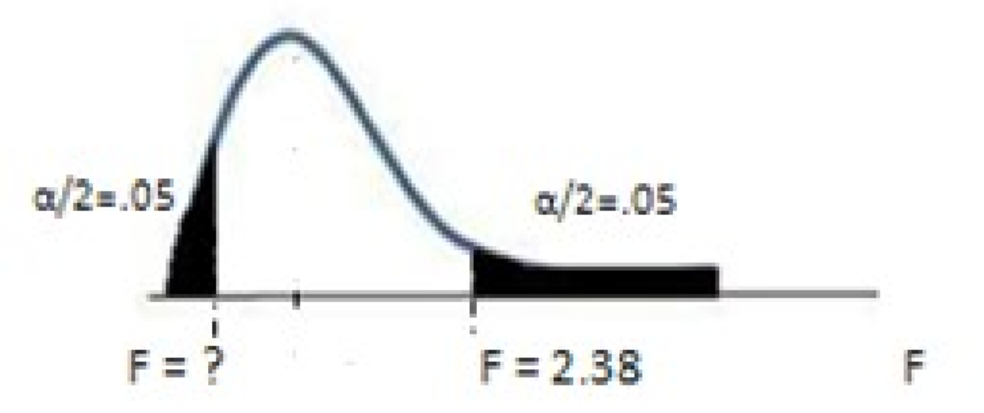
- Values LESS than 1 would be in the lower half of the distribution, but you do not know where the rejection region would begin so any test statistic on that side of the graph would not allow you to make a conclusion!
- Values GREATER than 1 are in the upper half of the distribution, and the rejection region is located above
2.38
- The F-test statistic, 2.97, is in the upper-tail rejection region
Step 6
Reject H₀, at the .10 level of significance, there is sufficient evidence to suggest the variances in daily production differ.
How could Excel have been used to complete the steps of this hypothesis test?
- Here is the MS Excel output that will be generated.
- What does it give you (in order)?
  - Sample means
  - Sample variances
  - Number of observations
  - Degrees of freedom for each sample
  - The F-test statistic (for step 5 of the hypothesis test)
  - The one-tail p-value for your test statistic (can be used in step 5 of the hypothesis test)
  - The one-tail critical value for the alpha specified in the dialog box (for step 4 of the hypothesis test)
- Return to the previous slides and see where these Excel results fit into the steps.
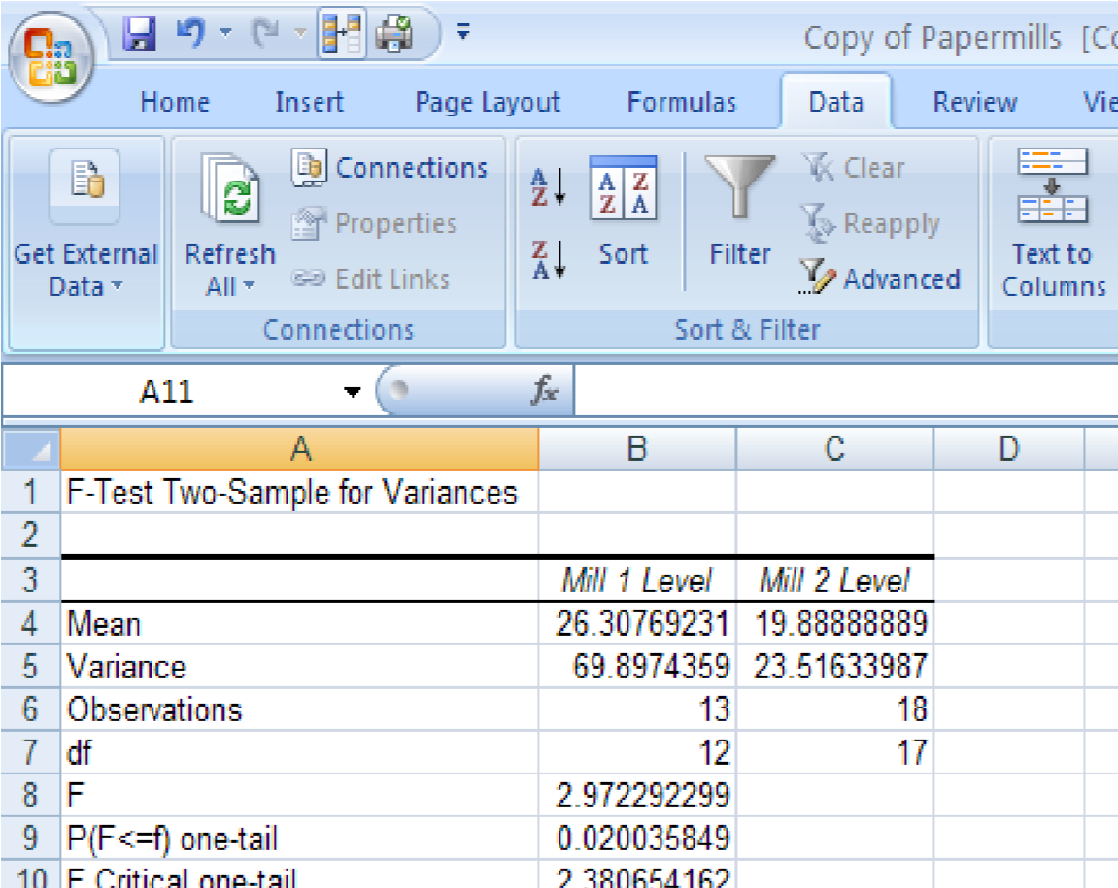
NOTE: Excel provides only the critical value for the tail closest to your test statistic! Not the critical values for both tails! (Since the test statistic, 2.97, is on the upper-tail half, Excel has provided the upper-tail critical value)

Excel and the Hypothesis Test
- Step 1: Excel does not provide the null and alternative hypotheses, you must write them. The population you identify as population 1 should correspond to “sample 1” or “variable 1” that you enter in Excel.
- Step 2: instead of referring to the sampling distribution for the test statistic, you can instead identify the appropriate MS Excel tool, in this case, the F Test: Two Sample for Variances
- Step 3: in most cases, the problem will specify the level of significance and you will report it, to determine the sample size you can rely on the “observations” reported in the results
- Step 4: MS Excel provides the critical value for writing the decision rule (as described on the previous slide)
- Step 5: MS Excel calculates the test statistic and p-value (as described on the previous slide)
- Step 6: Compare the test statistic to the critical value (or the p-value to the level of significance) to arrive at a conclusion
Excel and the Hypothesis Test, cont.
Notice, Excel will provide you with the information you need to arrive at a conclusion.
However, the results are dependent on the information entered by the user, so it is essential that the information by entered correctly. In order to know how to enter the information
correctly, you must understand what the Excel dialog box is asking for. The dialog box is covered
next…
Dialog Box for F-Test: Two Sample for Variances

The dialog box for the Excel tool used to generate the results on the previous slide requires the following information:
- The data for variable 1 in column A
(A1:A14, including the label “Mill 1 Level”)
- The data for variable 2 in column B
(B1:B19, including the label “Mill 2 Level”)
- A checkbox to indicate whether the labels are included in the steps above (they were, in cells A1 and B1), if you DID NOT include them, do not check the box
- The alpha level for ONE TAIL, so:
  - if your hypothesis test is a one-tailed test, enter the ENTIRE α
  - if you have a two-tailed test, enter HALF the level, α/2, in this case it is a two-tailed test so enter .05)
- Output location (usually a new worksheet)
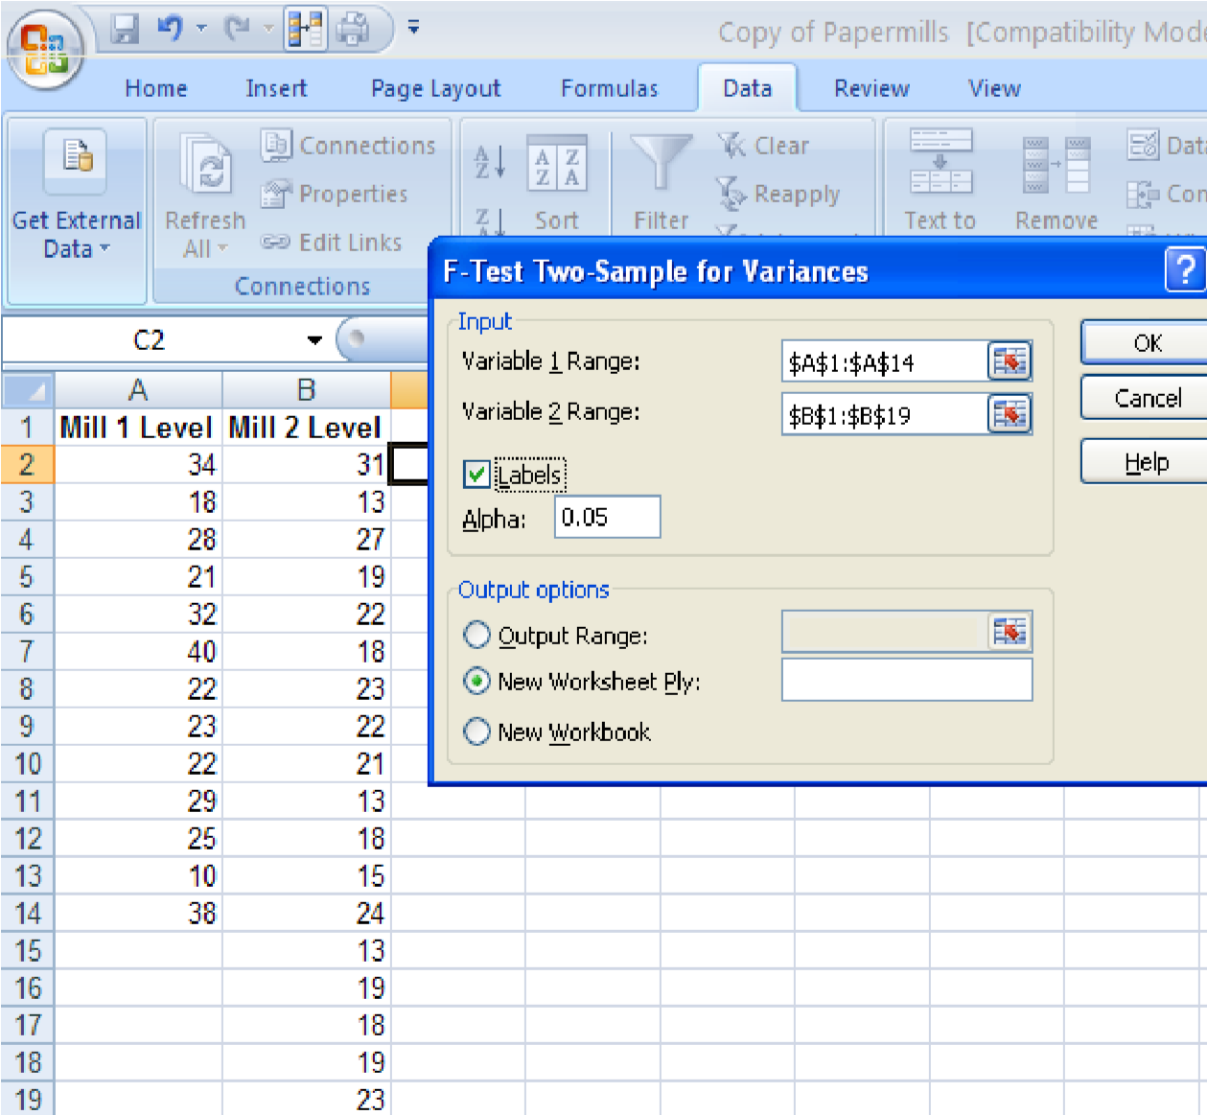
Note: this data file has been
rearranged as described in the
“Descriptive Statistics”
Powerpoint notes
Remember the note from slide 5: Excel provides only the critical value for the tail closest to the test statistic! Not the critical values for both tails. So split just like if you were using the table in the textbook.

Reviewing the Excel Results

- Go back through the example as shown in the book and compare the steps on slides 3-4 to the results we just created.
  - The F-test statistic (for step 5 of the hypothesis test)
  - The one-tail p-value for your test statistic (can be used in step 5 of the hypothesis test)
  - The one-tail UPPER-tail critical value for the alpha specified in the dialog box (for step 4 of the hypothesis test)
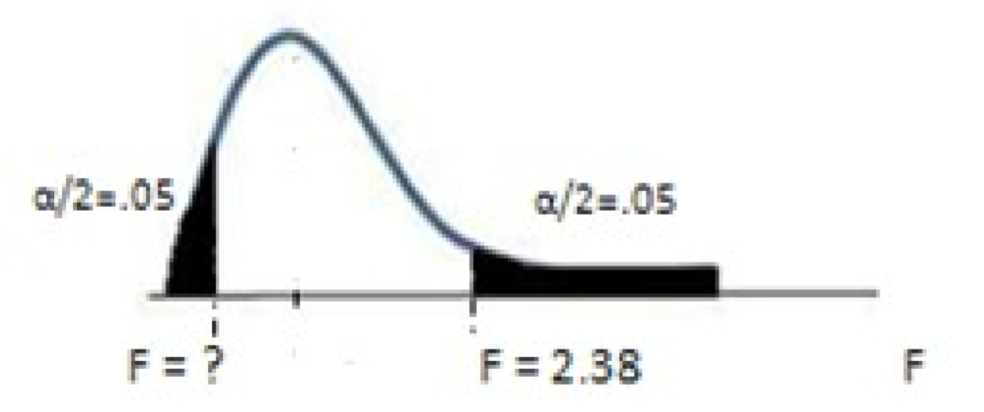

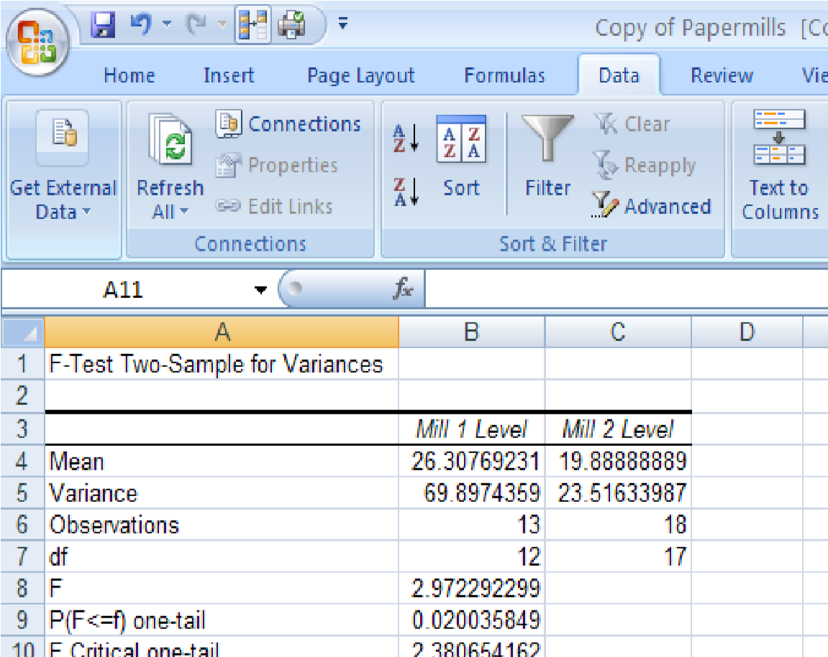
- Since the test statistic, 2.97, is on the upper-tail half (greater than 1) we know Excel has provided the upper-tail critical value. Notice, just as when the textbook was used, the lower-tail value is unknown.
- To get the TWO tailed p-value, remember to double the one-tail, pvalue=(.0200*2)=(.0400)
What would have happened if the variables were reversed (meaning column B, papermill 2, was used as variable 1)?

Updated Results
Dialog Box Reversed  Now column B is variable 1 and column A is variable 2) | • The smaller variance (23.52) is now in the numerator so the test statistic is smaller than
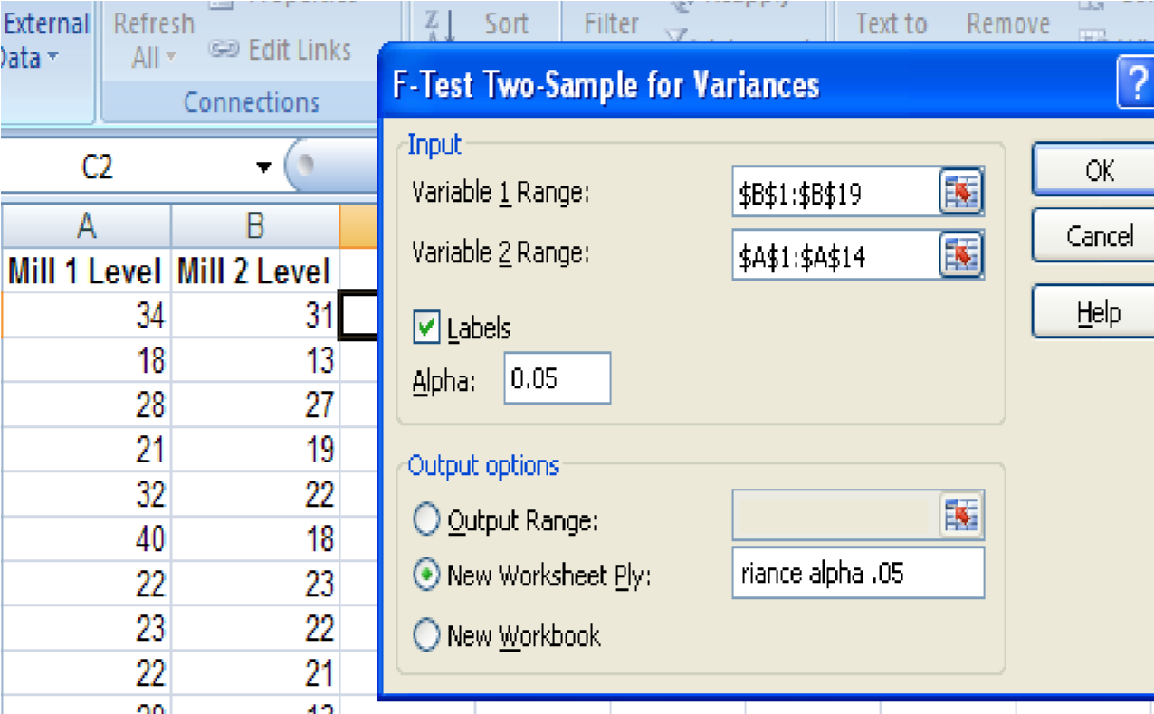
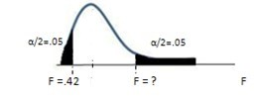
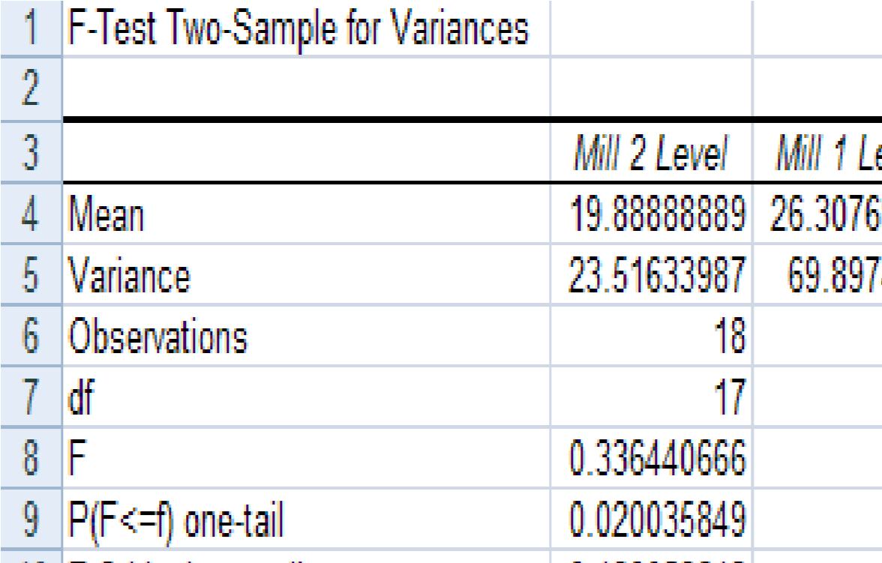
1 (see cell B8) and Excel is now providing the lower tail critical value (see cell B10) since the test statistic is now on the bottom half of the

F-distribution
•For the conclusion: now compare whether the F test statistic < F critical value, it is, .34 < .42, so you would reject H₀ (the same conclusion reached when the upper-tail critical value was used!)
Since the test statistic, .34, is on the bottom half of the graph, Excel has provided only the lower tail critical (.42) value, not the upper tail!
Which way is correct? Either! The conclusion was not affected by whether variable 1 or variable 2 was entered first.
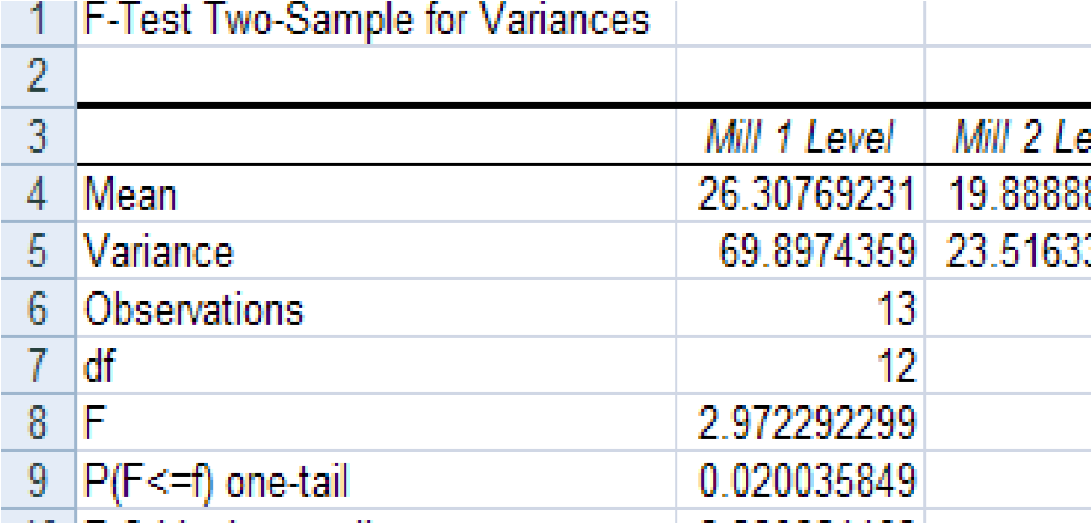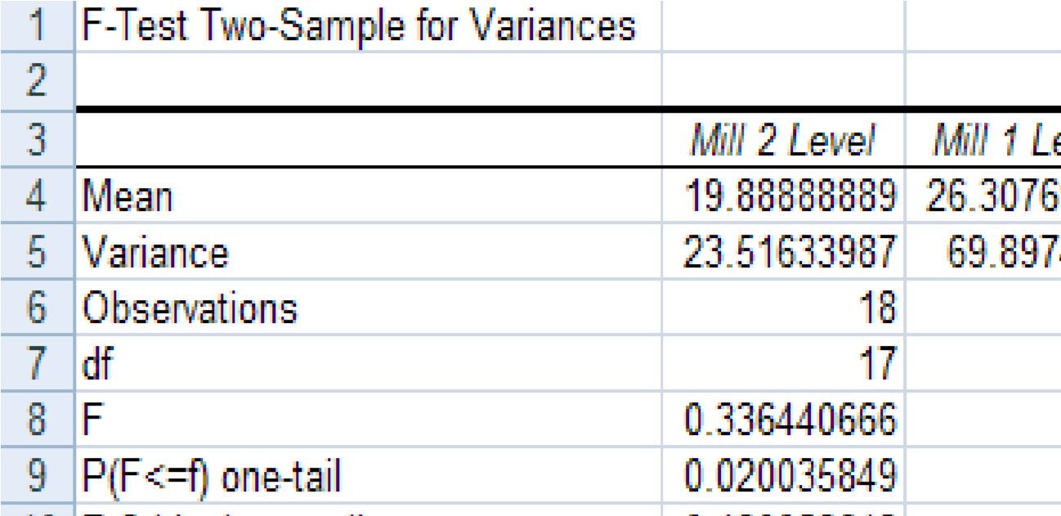
When Mill 1 is entered first, the When Mill 2 is entered first, the decision rule is: decision rule is: if F-test statistic > 2.38, reject H₀ . if F-test statistic < .42, reject H₀. It was (2.97), so the null It was (.34), so the null hypothesis was rejected. hypothesis was rejected.
BUT! You must be very careful to pay attention to whether Excel has provided you the lower-tail critical value (between 0 and 1) or the upper-tail critical value (larger than 1), so you can make the correct decision. Notice the p-value is EXACTLY the same in both examples (but it is a one-tail value so if the test is two-tailed, you must double it!)
Summary: Hypothesis test steps reviewed…

In the example on p. 460, you are asked to determine (using the PAPERMILLS data) whether there is evidence to indicate a difference in the variability in production levels at the two paper mills. (Use α=.10)
Based on this information the hypothesis test is a two-tailed hypothesis test.

Step 1
H₀: σ₁²/ σ₂²=1 (equal variances, σ₁² = σ₂²)
H_{a}: σ₁²/ σ₂²≠1 (unequal variances, σ₁² ≠ σ₂²)

Step 2
The correct data analysis tool is the F-Test: Two-Sample for Variances
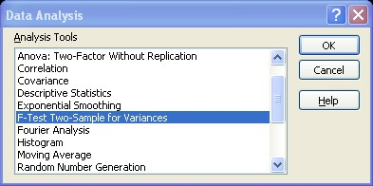
Note: since you using MS Excel, you have the option of referring to the MS Excel tool in this step instead of the sampling distribution and test statistic.

Open the data file you want to analyze and review its contents.
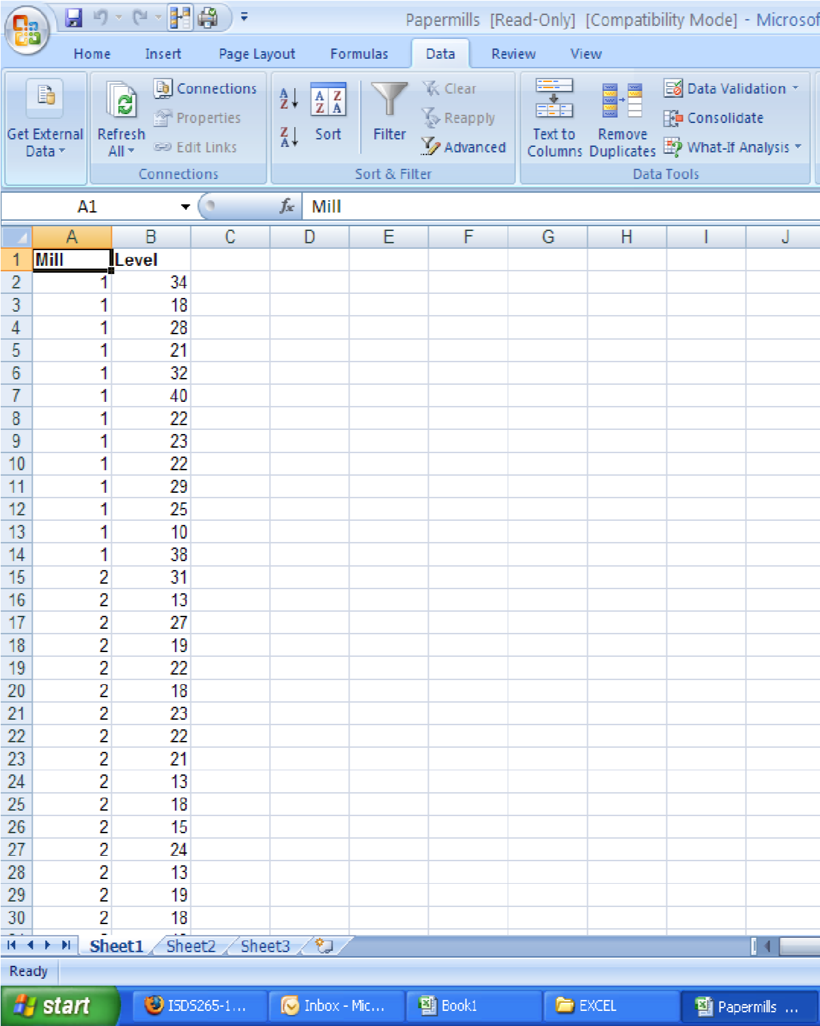
- There may be more data in the file than is needed for your analysis. You may not know this until you view the dialog box for the statistical tool you want to use.
- In this example, there are two paper mills (identified as 1 and 2 in column 1 “Mill”) for which you have production data.
- You might choose to reorganize this data so have the data you need in one column for each paper mill
- This means you will copy and paste all of the numbers for mill 1 into a column, and then copy and paste all of the numbers for mill 2 into a separate column.

Optional: Run the Descriptive Statistics
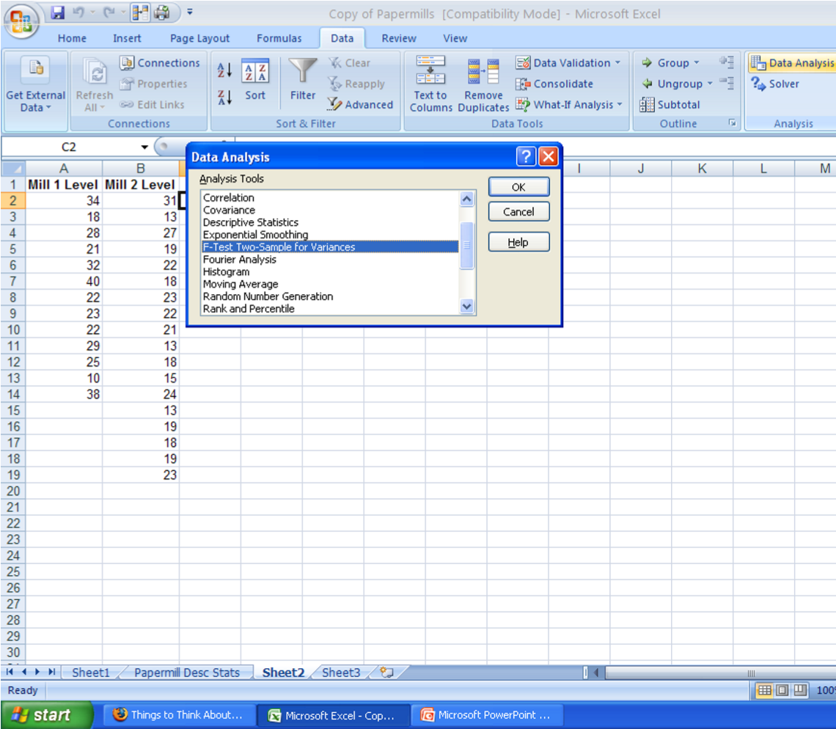
- If you want to keep with the same process as the textbook, then you should use the Descriptive Statistics tool to determine which sample variance is larger so you can enter that sample’s data in as variable 1 (see separate
Powerpoint posted on Moodle for instructions regarding this tool)
- But, remember, Excel will provide the relevant upper-tail or lowertail critical value so this step is not required when using Excel
Optional: Use the descriptive statistics to determine which should be variable 1
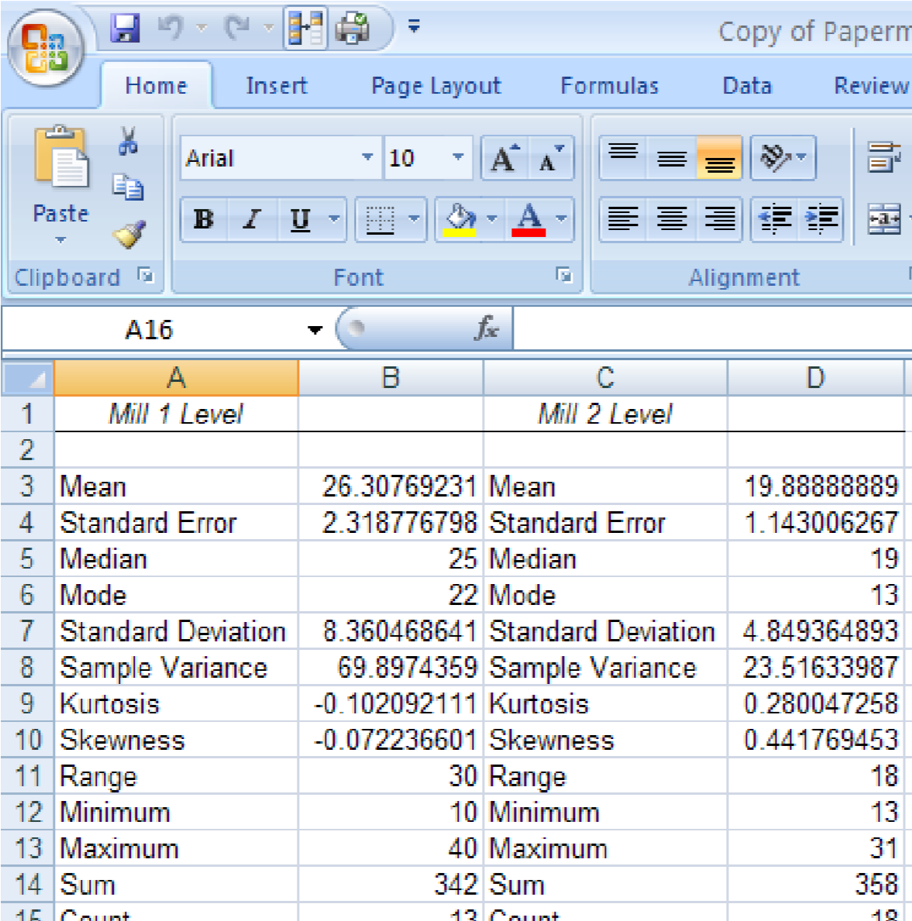
- Based on the output from the Descriptive Statistics tool you can now see that the sample for Mill 1 has a larger variance (69.9) than the sample from Mill 2 (23.52) so Mill 1 should be identified as the numerator in the Ftest of the variance
- This means Mill 1 will be “variable 1” in the data selection

Now open the F-Test for Variance Tool
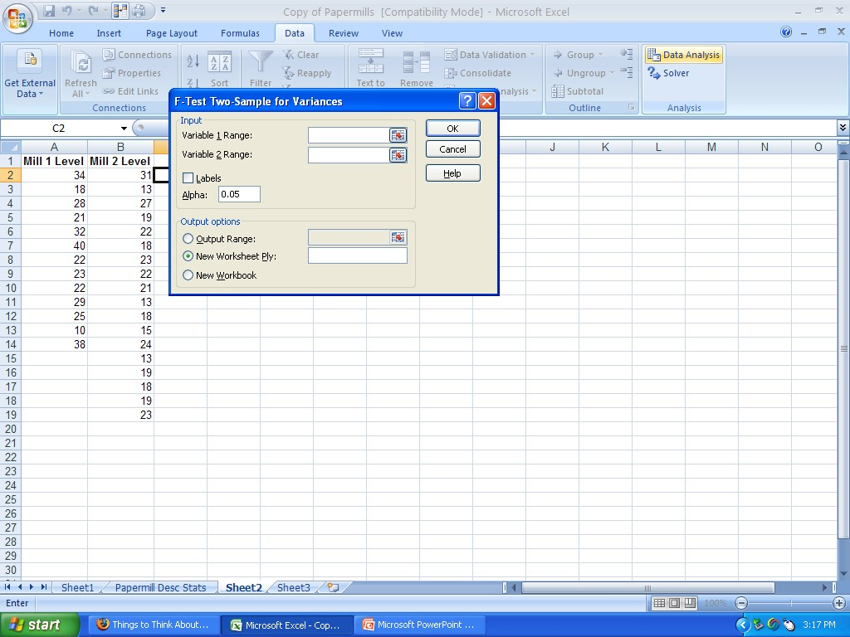
Enter the information into the dialog box (see earlier slides for an explanation about each item).
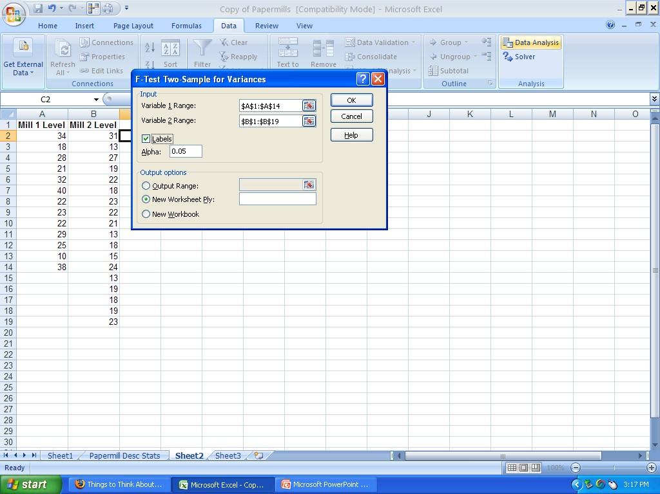
Look at your output file to complete the hypothesis test
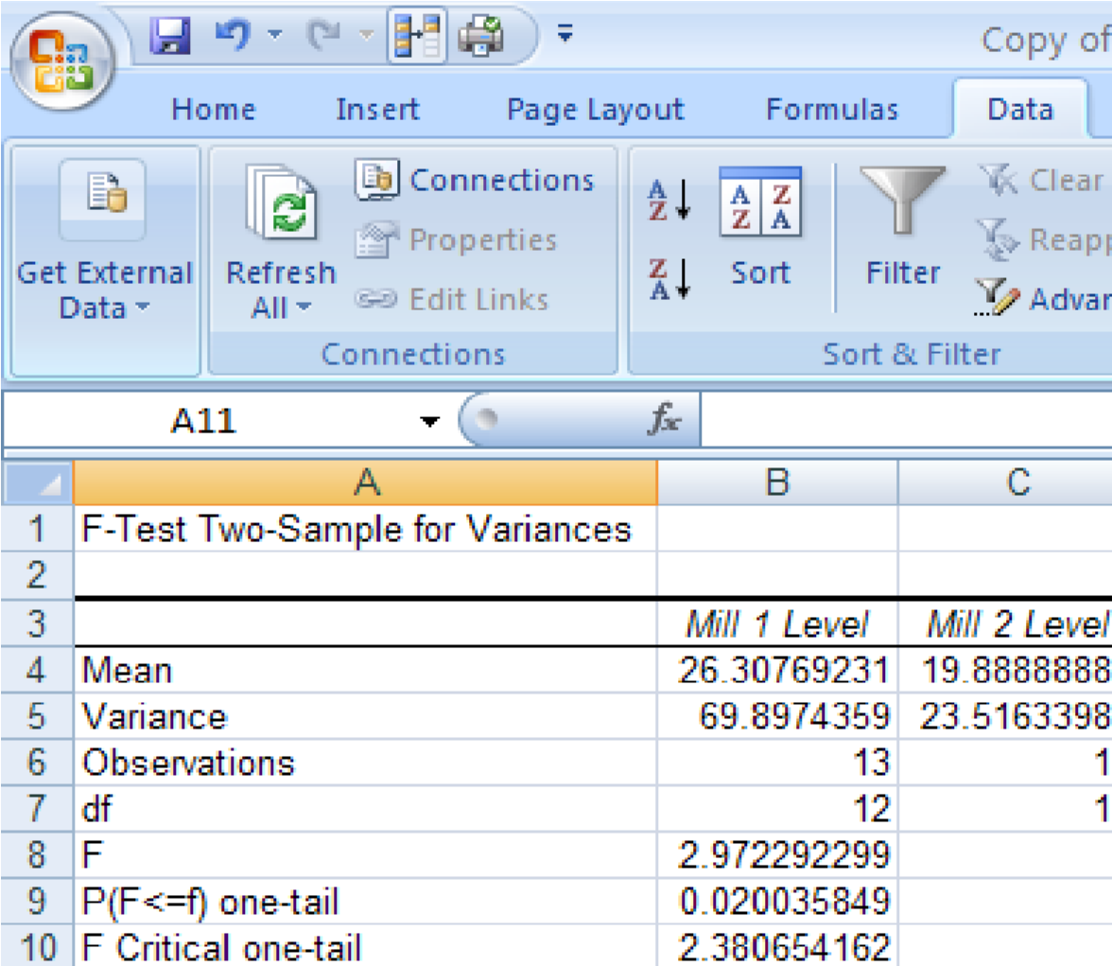
Step 3:
α=.10, n₁=13, n₂= 18
Step 4:
Rejection region is upper tail since F critical value (row 10) is 2.38, so:
If F test statistic > 2.38 reject H₀

Step 5:
Test statistic, (in row 8) F=2.97 p-value=(.0200)*2=.0400
Step 6:
Reject H₀at the .10 level of significance there is sufficient evidence to suggest the variance in production levels at the two mills is not equal

