MS ACCESS #1: TABLES, RELATIONSHIPS, AND SIMPLE QUERIES (20 POINTS)
To begin the assignment, download the Excel file, ‘Access Homework 1.xlsx’ and save to your computer.

Step 1: Create a New Blank Database
Open a new Microsoft Access session and select the option to open a ‘Blank Desktop Database’. Name your file with your first and last name (firstname_lastname) and select ‘Create’.

Step 2: Create database tables
You will be creating the database for a small boutique based on the conversion chart provided below. You will be using the prepopulated excel file to create and add data to the 13 required tables for the boutique.
Table/Class Name Primary Key(s) Other Attributes Foreign Key(s) 1 (entity) Product Category Category Code Category
Number Description,
Location Number
2(entity) Inventory Item # Item Color, Item Category Code
Size Number
3(entity) Cash Cash Account # Bank Name, Cash
Account Type,
Bank Account #
4(entity) Purchase Order PO# PO Date Supplier ID,
Employee ID
5(entity) Purchase (Receiving) Receiving Receipt Date PO #, Supplier
Report# ID, Employee
ID, Cash
Disbursement#
6(entity) Cash Disbursement Cash Check #, Check Cash Account#,
Disbursement# date, Check Total Employee ID, Supplier ID
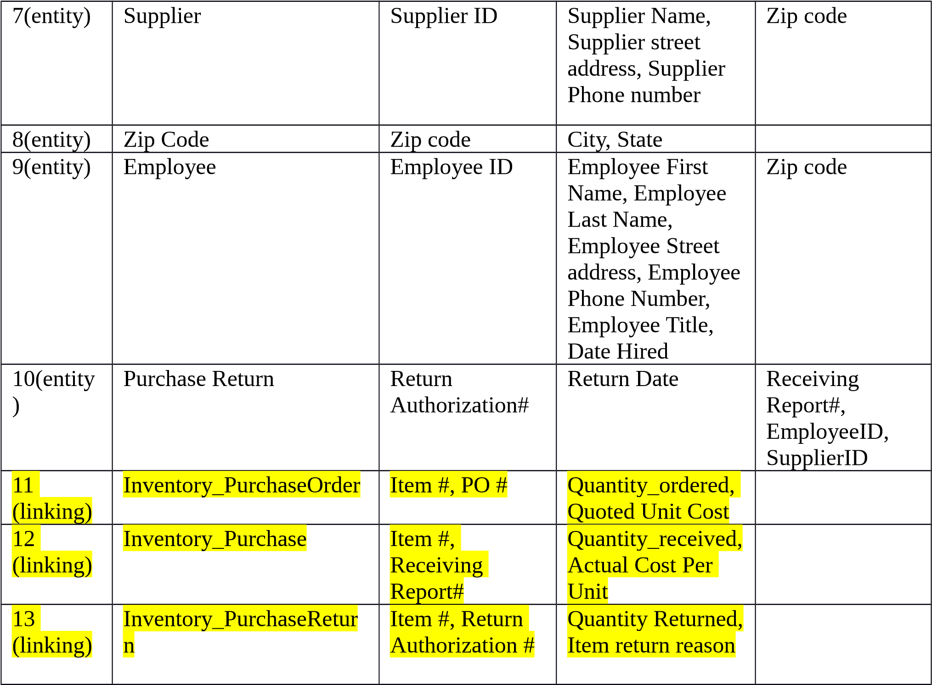
- Select the External Data tab
- On the ‘Import & Link’ ribbon, select Excel. The import spreadsheet wizard opens.
- Navigate to the appropriate location for your Excel data file and ensure ‘Import the source data into a new table in the current database’ is checked. Select OK.
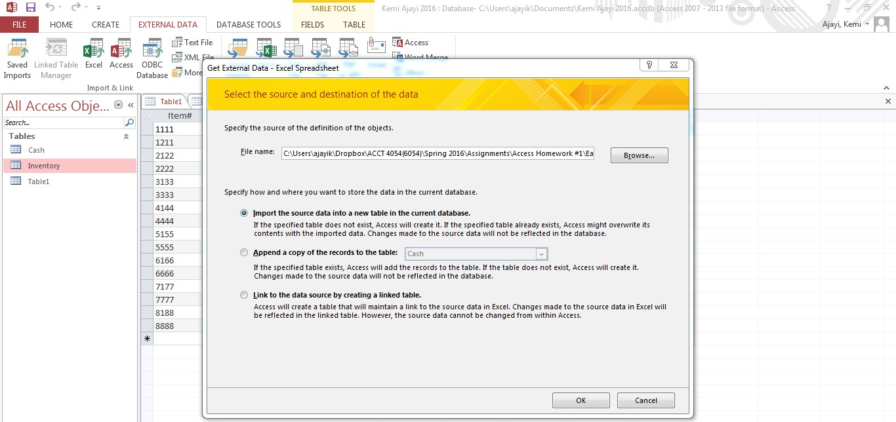
- The data in the excel file is broken down into worksheets, one worksheet for each table in the database. Repeat the following steps to import each worksheet into the database. The following show the steps for the Product Category table:
- Make sure ‘Show Worksheets’ is checked and select the Product Category worksheet. Select Next
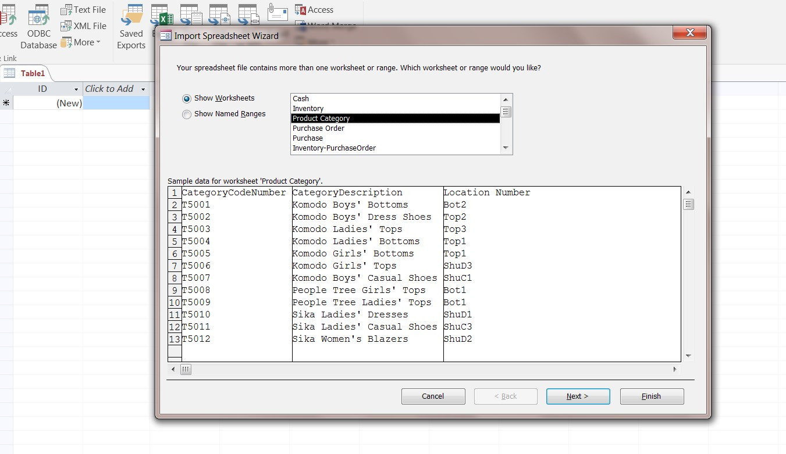
- Select ‘First Row Contains Column Headings’. Then Select Next
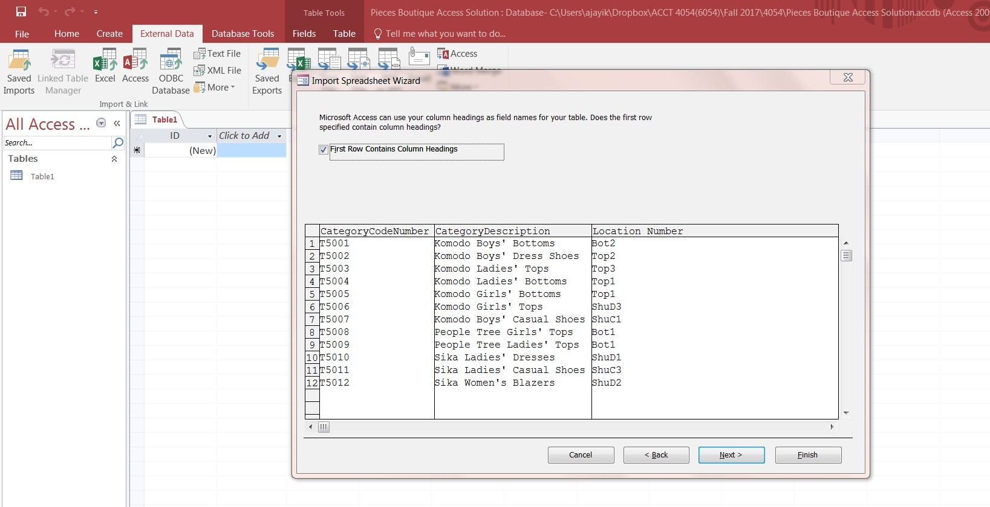
- For the first column in each worksheet, select ‘No’ in the Indexed drop-down box and select ‘Short Text’ in the Data Type drop-down box. Note: For the linking tables, do this for the first 2 columns in the worksheet. Select Next
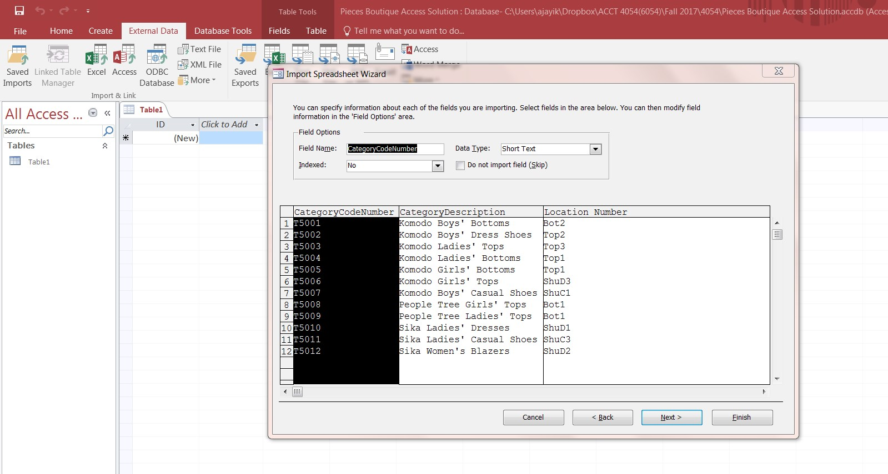
- Select ‘Choose my own primary key.’ The default column should be the first column in each worksheet. Note: For the linking tables, select ‘No primary key’. You will create the primary keys in another step instead since there are 2 primary keys. Select Next. Then select Finish to create the table and select Close on the final screen.
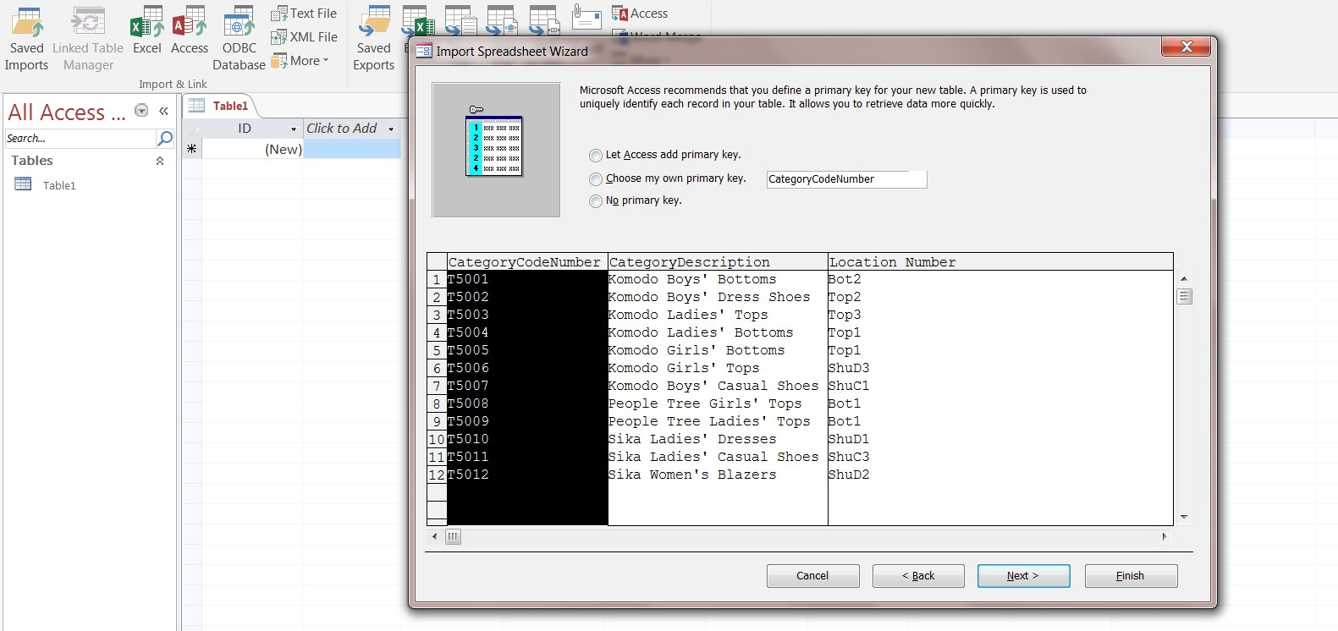
- When you are finished adding all the tables, double-click on each table name in the database to view the data. On each table view, click on the arrow on the View button on the toolbar and select Design View. The Design View is used to define the fields that make up each table. In Design View (refer to picture below), the upper portion of the window is called the Field Entry area while the lower portion of the window is called the Field properties area. The field properties area is used to format each attribute in a table. Do the attributes included in each table match the attribute list on the conversion chart? Is there a primary key attribute for each table? (The primary key(s) is shown with the picture of a key to the left of the attribute name).
- For the linking tables, create the primary keys by selecting the 2 fields that make up the primary key (click and drag your mouse over both fields to select them). Then, select the primary key button to create the primary keys. Make sure to save your changes.

Step 3: Create the relationships in the database
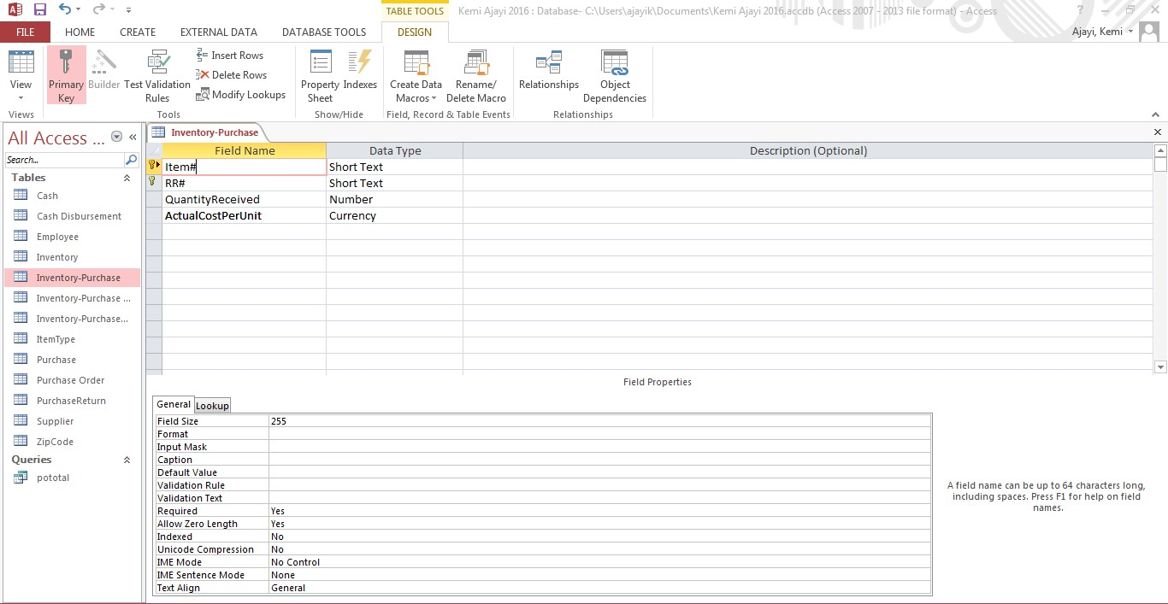
Create all of the relationships in the database based on the information provided in the conversion chart. Note: For the linking relationship tables,
you have to create two one-to-many relationships to enforce the relationship created by the two primary keys. For example, the Inventory_PurchaseOrder table will be related to both the Inventory table and the Purchase Order table.

Step 4: Create Queries
Use the database to complete the following tasks. Save each query you create as Query1, Query2, etc.
- For each inventory item received, list the item#, category description, and total quantity received. (Hint: Use the Inventory-Purchase table).
- List the PO#, POdate, and SupplierName for all purchase orders created between 01/15/17 and 2/15/17.
- List all employees whose job title is purchasing clerk and the total number of orders each has created in the database. Show the employee id, first name, last name, and the order count in the query results. List the results in ascending order by order count.
- What is the total dollar amount for all purchase transactions completed in January? (Hint: You can create an expression in the query design results section e.g. quantity * unitprice).
- List all suppliers located in zipcode 33965 and 91343. List all attributes from the supplier table.
- What is the total dollar amount for each purchase order in the database? List the PO#, PO date, and the total dollar amount in the results.

Step 5: Generating Report for Grading
Generate the following report and submit with your Access database for grading:
- Documenter Report for the database relationships, and queries. Go to the Database Tools tab and select ‘Database Documenter’.
- On the queries tab, select all 6 queries. Select the options button and make sure the print options shown in the picture below are selected. Click OK.

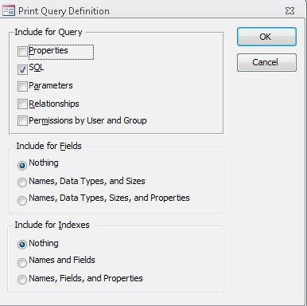
- Select the Current Database tab, select the Relationships check box. Click OK.
- Export the generated report to PDF by selecting ‘PDF or XPS’ on the Data tab. Save your report as firstname_lastname.pdf. Submit the PDF report AND the Access database that includes all your work via the assignment link on Canvas.

