MMIS642 Tableau Assignment
Data Warehousing Text
Using the Sample – Superstore data that comes with Tableau, I created 1 tabular report as well as two graphs that would help the company in decision making.
The tabular report consists of a few metrics based on sales. The metrics are based on year ordered and the type of product category. It includes quantity sold, Total Sales, average discount, total profit and 2 calculated fields which are average sale price (total sales/quantity) and average profit (total profit/quantity). This report will be helpful to see the year over year sale performance for each product category. It will be a fast and easy way to see which products are selling more and producing and profits and if they fared better that previous years.
My first graph is a sales chart by order date and year. This will help the company know how sales perform on a month to month basis, and compare them year over year.
And finally I’ve made another sales chart based on how sales perform in each state. This will help the company know where most of their sales are concentrated at and determine what kind of a marketing effort should be made in each state.
Copies of the sample bases is attached as well as the tabular report and graphs.

Sample Database
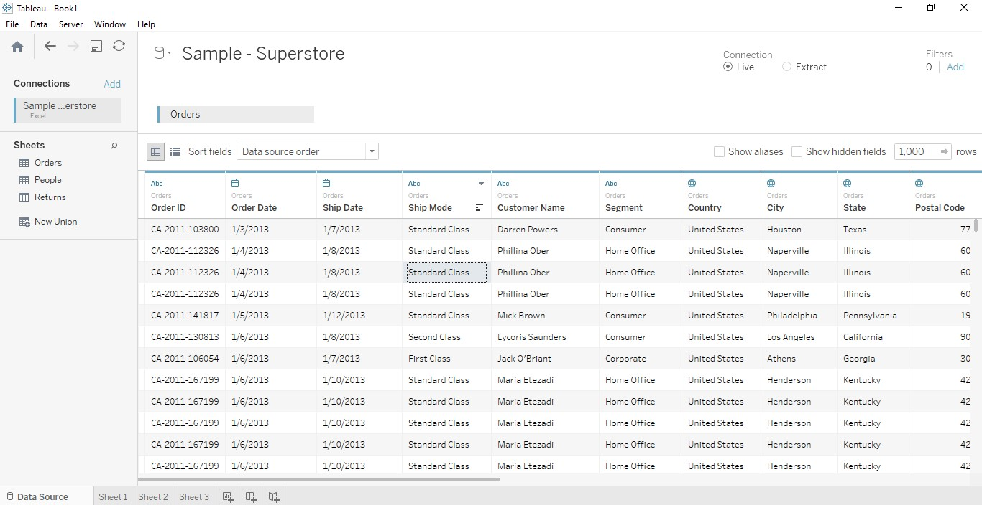
Tabular Report
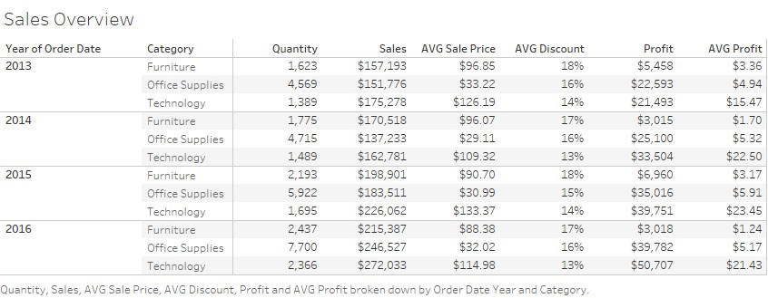

Graph 1
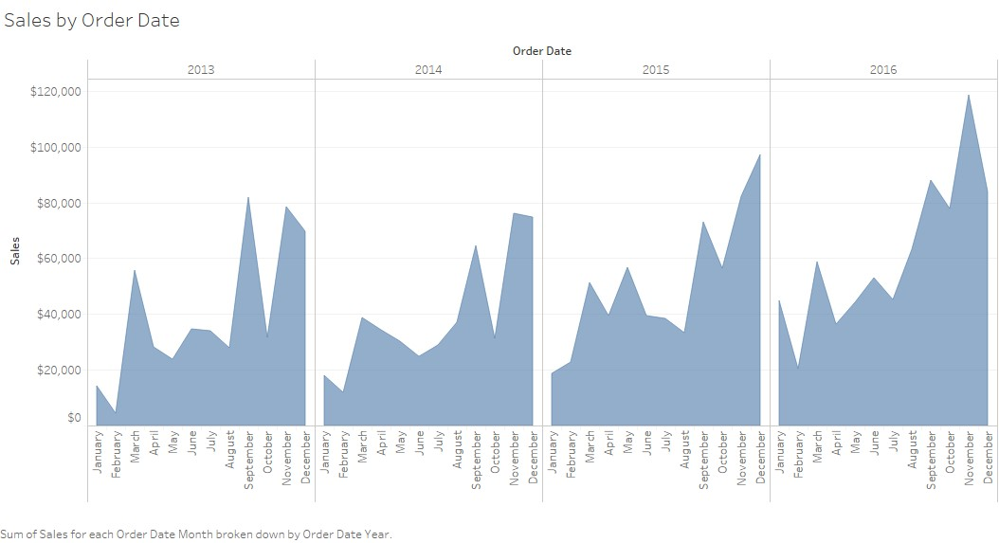

Graph 2
