MATHEMATICS Assignment
Answer each question and show all work.
Expand the terms for each expression and determine the value.
- 65
  - Expanded terms: 6∙6∙6∙6∙6
  - Value: 7776
- 117
  - Expanded terms: 11∙11∙11∙11∙11∙11∙11
  - Value: 19,487,171
Determine the value of the following expressions.
- 170
=1
- 2580
=1
- Based on your answers to questions 3 and 4, we can conclude that any number (except zero) raised to the zero power equals __1___.
Write the following using exponents.
- 130 x 130= 130²
- 10 x 10 x 10 x 10 x 10 x 10 x 10 x 10=10⁸
- Write an equation for the following problem and solve.
It’s Monday and you’ve been asked to recruit some of your friends to help an elderly couple move next Monday, first thing in the morning. You decide it will be easier for you to ask two people to help, then have each of them ask two people to help, and then have those people each ask two people to help, and so on. If a new set of friends is asked to help each day, how many people were asked to help on the fifth day?
2⁵ = 32
Find the roots.
9.
Solve.
13. 2√5+21÷7×4²+11 | 5 + 3 x 16 +11 >>> 5+48+11 >>> 2√64 = 2√16
12. /9 = 2601769
- 5 ⁽⁷⁺³ ⁾²₍6₋3₎}+1 5(100)/2 >>> 250(3) >>>750+1= 751 2
{

- Two kids decided to make some money. They pooled their money and bought four boxes of candy bars, with each box costing $16.99. There were 40 bars in each box, and they sold each bar for 80 cents. If they each invested the same amount in the candy and they sell all of the candy bars, how much profit will each child make?
4 x 16.99 = $67.96 >>> 4(40 x .80) = 4(32) = $128 >>> 128 – 67.96 = $60.04 >>> 60.04 + 128 = $188.04 >>> 188.04/2 = $94.02
16. Katie takes prom pictures for kids in town. She charges $10 per couple + $3 per hour to take their pictures. If she takes pictures one Saturday and it takes her 2 hours to photograph one group of 6 couples and 3 hours to photograph another group of 10 couples, how much money will Katie make that day?
10 x 6 = $60 >> 3 x 2 = 6 >> 60 + 6 = $66 10 x 10 = $100 >> 3x 3 = $9 >> 100 + 9= $109
$66 + $109 = $175
Determine whether the following numbers are composite or prime. If composite, write all factors for that number.
- 57 prime
- 43 prime
- Find the prime factorization of 140. 2∙2∙5∙7

- Find the GCF of 32, 80, and 112.
2∙2∙2∙2∙2
2∙2∙2∙2∙5
2∙2∙2∙2∙7

2∙2∙2∙2=16
Determine whether the following statements are true or false. Modify each false statement to make it true.
- 15 is a multiple of 30. true
- 10 is a factor of 50. true
- Find the LCM of 9 and 15.
3 9 15
3 3 5
5 1 5
1 1

3 ∙ 3 ∙ 5 = 45
- You are standing next to a display of watches in a store when two of the watches start beeping at the same time. One of them beeps every 9 seconds and the other one beeps every 12 seconds. How much time will pass until they both beep at the same time again?
- Convert 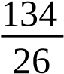 to a mixed number. Reduce if possible. 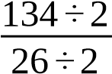 = 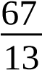
- Convert 3  to an improper fraction. 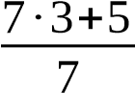 = 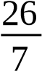
- Write an equivalent fraction for  . 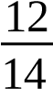
- Reduce 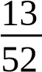 to lowest terms. 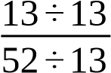 ¿
- Solve. Reduce answer to lowest terms.
1  ×  = 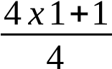 = 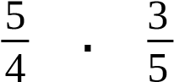 = 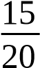 = 
Solve. Reduce answer to lowest terms.
- ³ ⁴₉ ÷ 1  =  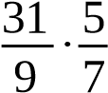 = 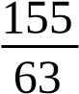
- 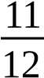 ÷ 2 =  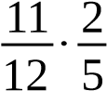 = 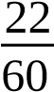 = 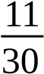
- Find  of 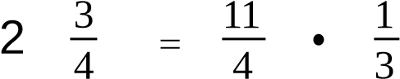 = 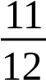
-  of what number is 6  ? 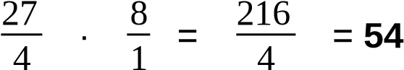
- What part of 35 is 15? Express your answer as a fraction. 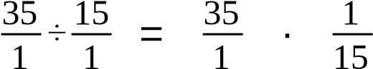 =
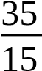 = 
Solve. Reduce to lowest terms.
-  +  = 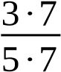 + 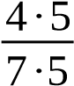 = 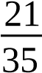+ 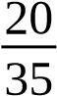 = 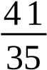

- 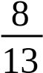 -  = 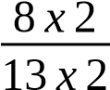 - 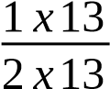 = 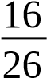− 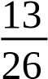₌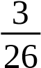
Solve. Express your answer as a mixed number reduced to lowest terms.
- 11 - 2  = 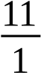− − 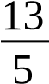=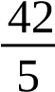
13
5
=
11
x
5
1
x
5
−
13
x
1
5
x
1
=
55
5

38.  +  = + 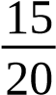=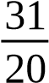
4
x
4
5
x
4
+
3
x
5
4
x
5
=
16
20
- Put in order from smallest to biggest.
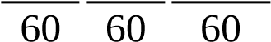
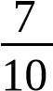 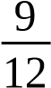 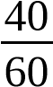 = 7 x 6 9 x5 40x 1=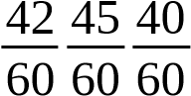=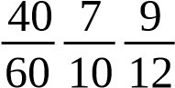
- Convert to a simple fraction. Simplify if possible.
1
7
= 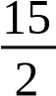 x  = 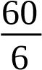=10
2
3
4
- Solve. Reduce answer if possible.
+ × =¿  x =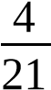+ + 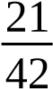=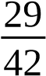
1
2
=
4
x
2
21
x
2
+
1
x
21
21
x
2
=
8
42
Convert the following decimals to fractions. Reduce if possible.

1000625÷÷125125 6
- 6.625 6 =
- 11.04 11 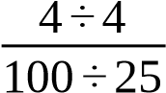 = 11 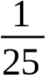
Convert the fractions to decimals. Round to thousandths place where appropriate.

44. ⁴₇ 4 ÷7 = 0.571
- 1 ⁵₉ = 1 + 1+0.625=1.625
- Solve.

1 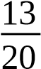 (2.18 +  ) (2 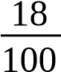+  )= 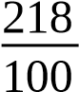+  =
=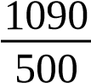+ 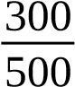 = 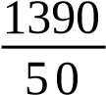= 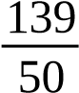 x 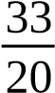=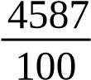
218
x
5
100
x
5
+
3
x
100
5
x
100
- Evaluate the expression.
│- (5 × 6)│= 30
- [(-4 × 5)² -14] ÷ -2 - (-4) = (-20)² = 400-14 = 386 ÷ -2 = -193 + 4= -189
- The highest point on Earth is the peak of Mt. Everest at an altitude of 29,035 feet. The lowest point on Earth is at the shoreline of the Dead Sea at an altitude of 1,354.99 feet below sea level. What is the difference in altitude (in feet) between the highest and lowest point on Earth? 29,035 - 1,354.99 = 27,680.01ft
Powered by TCPDF (www.tcpdf.org)

