Introduction to Management
Executive Summary…………………………………………………………......3
Company Summary…………………………………………………….….……4
Services………………………………………………………………………….5
Competitors……………………………………………………………………...6
Possible Factors Affecting Business…………………………………………….7
Market Strategy………………………………………………………………….8
SWOT Analysis……………………………………………………………........9
Financial Projection…………………………………………………...…….…10
References……………………………………………………………………...11
Appendix……………………………………………………………………….12
Executive Summary
Internet is one of the most appreciated development in today's society. It acts as a tool for interaction of individuals, business dealings, downloading of files, marketing and sending information. This market research is for the investment from foreigners to open a new Internet Service Provider based in my hometown, Castries in my country Saint Lucia. An internet Service Provider is an organization which provides internet access services to both personal and business customers. This report includes services our company is willing to offer, competitors, financial projections on revenue.
Company Summary
Solutions Internet Service Provider (SISP) is a company that will grant internet connections and related services to organizations and individuals. It is intended to provide a range of quality services including software packages, personal Websites, mail accounts, and a Home page, Wireless Data Services, “Always on” Internet services and more. The company will be located in the city of St. Lucia where it will be easy to attract consumers. SISP will be aimed at providing customers with fast and reliable services

Services
Every organization has an internet service provider (ISP) who offers services that facilitate the participation in the internet. The main task for any ISP is to ensure there is accessibility of the internet. There are categories of ISPs where some are commercial and others communityowned. Besides, some are established as non-profit institution while others operate privately. Whereas the ISPs may have a variance in their formulation of operation, the services offered are related. Among these services include the registration of domain names, offering accessibility of the internet, web hosting and also the colocation services. Overall, an ISP offers a user the ability to explore everything in the internet.
SISP will serve as the gateway or access point that provides consumers with access to everything on the internet. The various services we will offer include;
- Internet access: We will provide internet access to individuals, homes, offices etc., we will offer an easy way of accessing the internet usage and also dealing with any internet hitches when they arise.
- Domain registration of name: we will assist in domain name registration to establish one access in the internet extensions. We will do this by creating an exclusive address or domain for both organizations or individuals into their browsers.
- Web hosting: we will offer services of web hosting to make individuals as well as companies have access through the world wide web.
- Colocation-These are services we will assist in housing private owned servers and networks equipment in a third party center. Colocation will assist in control of their internet systems.
- Usenet Services: We will make distributions accessible on devices to allow unlimited accessing.
- Communication services: such as video conferencing and web services
- Cable TV – ISPs: We will deliver cable television to customers through coaxial cables or fiber optic
- Phone services: We will offer provision of telecommunications networks for transmission of voice, radio, sound and data.
- Access to cloud data storage: This is where we will provide a model of storing computer data in which the data is only accessible through a web-based interface. The user stores data via internet (manually or automatically) to a server which then forward the data to multiple servers.
We will also use many systems including “dial-up, DSL, cable modem, cellular, or dedicated high-speed interconnects, data can be transmitted”.

Competitors

Flow St. Lucia
Flow is an ISP located within the Caribbean. Based on market research it has clearly failed to meet consumers’ demand for reliable and fast service.
If you look at it closely, residents and businesses only have one option for internet from a provider called Flow in the whole island of St. Lucia. Therefore, this will give us the opportunity to add marketplace competition, boost economic development and control the benefits of community proprietorship with the broadband service they offer. Regardless if a customer subscribes to their service or not, marketplace competition remains vital because they still gain through approaches of lower prices and improved services among other network providers that still remains competitive. Residential survey respondents agreed that having a lot of options for an ISP is important, one because this pushes business to have healthy competition that pushes them to continuously innovate and attract new customers; and two, these ISPs is a factor that contributes big help to the economic development in St. Lucia.
Through market research, a survey was done in the city of St. Lucia where we asked respondents a series of questions based of value for their money, services and support. Respondents were both household consumers and businesses. Our survey concluded that, 100% of respondents sees the need for competition in the ISP industry. SISP realized that most consumers relied on quality service and it is what consumers lack from our competitor. Businesses also pointed out the need for another ISP as the internet has become essential to them and better service is required. The survey revealed that, Consumers chose an ISP based on price, service, reputation etc. I believe that SISP will provide just what consumers are lacking from Flow. There is great opportunity for SISP to surpass in the ISP industry against our competitor. We are aware that in order for us to be successful in the industry and remain highly competitive, we must provide reliable services to our consumers.

Possible Factors which can affect our business
- The dynamic world of technology may destabilize ISPs and they may have to engage in other activities that are not part of the core business when they were engaged by a client. An important aspect for achievement in this market is conveying dependable and predictable administrations in a quick moving business sector
- The shortage of reliable manpower and technical skills result in the shortage of expertise in this area of specialization. Therefore, the outsourcing of employees by ISPs render the process to be very expensive especially for the small and middlesized firms. As little to medium-sized organizations approach this market, they come up short on the framework and specialized aptitude to convey services in an affordable manner. Most arrangements require a lot of time and exertion, just as a huge introductory speculation and on-going help costs. These expenses incorporate —and are not restricted to—enlisting and holding qualified specialized and the board staff. These organizations face a market where there is an extreme lack of gifted IT experts, making it progressively hard to act naturally adequate in dealing with an assortment of utilizations and stages in-house.
- The capital to begin running an ISP company may be a challenge for the business. The high costs result from the cost of hardware and software which play an integral part in running the business, besides the management cost. The investment can be a financial strain.
- Inaccurate forecasts are a common problem that arise from the use of unqualified staff. This is due to the acute shortage in the market. Ultimately this costs the company. The need to envision development rates and conjectures in unpredictable business sectors can prompt erroneous appraisals and exorbitant mix-ups.
- There is a hesitation in the market for the users to use high-tech gadgets or technology that would lead to higher revenue for the ISPs. Therefore, the residential subscribers remain low which means low income for ISP companies.
Market Strategy
A marketing strategy is a plan made by a business to reach out to potential customers and turn them into actual customers for their services.
Internet Service Providers (ISPs), provide their customers with internet connectivity, software, websites among other services. The main target customers for SISP are homes, education institutions, government offices, private entities and other businesses.
Since there is already an existing ISP, as a new entrant we have a robust marketing strategy in order to be competitive in the market. We are making our services known to customers through:
- Organizing free seminars for our potential customers to discuss about upcoming technologies and how they can apply these to benefit their businesses. Examples of these technologies are how to protect their business accounts from hacking, virus protection, firewalls among others.
- Educating potential customers on an existing problem and how our company is offering a solution. This way the customers will build up trust for our company since we will show expertise in the field in which we are offering services.
- Undertaking email campaigns which are personalized to market our products in order to improve our relationship with potential customers.
- We will offer reduction in prices for internet packages for a number of months. This strategy will attract customers and there's a high likelihood that even after expiration of the offer period, they will still pay for our services.
- Designing a referral program whereby when we get existing customers, they get rewarded when they introduce new customers to purchase our services.
- Publishing articles giving detailed information about the services we are offering.
- Making alliances with the existing service provider in order to reduce costs associated with entering new markets and attracts new customer referrals.
- Lastly by expanding our network through building more data centers to improve the network performance and dependability.
SISP SWOT Analysis
Aiming to excel in the industry as a standard internet service provider (ISP) company, we will continually engage with the best advisors to aid us in becoming better in what we do and making sure we are doing it right.
With that, we are able to identify the key points that would affect our business. Summarized below is the SWOT Analysis of our company.
- Strength:
Workforce. The team will be composed of creative and highly proficient and experienced IT experts.
State of the Art Internet Server. We will have fast, secure and highly reliable internet connection that will guarantee minimal downtime. Also, the services being offered are guided by best practices in the industry.
- Weakness:
Market Share. Being new in the industry, the company will be on the 'awareness phase' with the intent to break into the market and gain acceptance in the industry.
Marketing Budget. To build the brand, the company would need budget for ads and promotion.
- Opportunities:
Growing Need. Connectivity has become essential for businesses and even for personal use. As the demand for faster and reliable internet connection rises, it is an opportunity for our business to deliver what the market needs.
- Threat:
Economic Downturn. This affects purchasing / spending power and consumer decision point.
Competition. The birth of new companies with the same services and targeting same market saturates more the already saturated market. Consumer choices widen and to be the top of the mind choice becomes a harder battle.
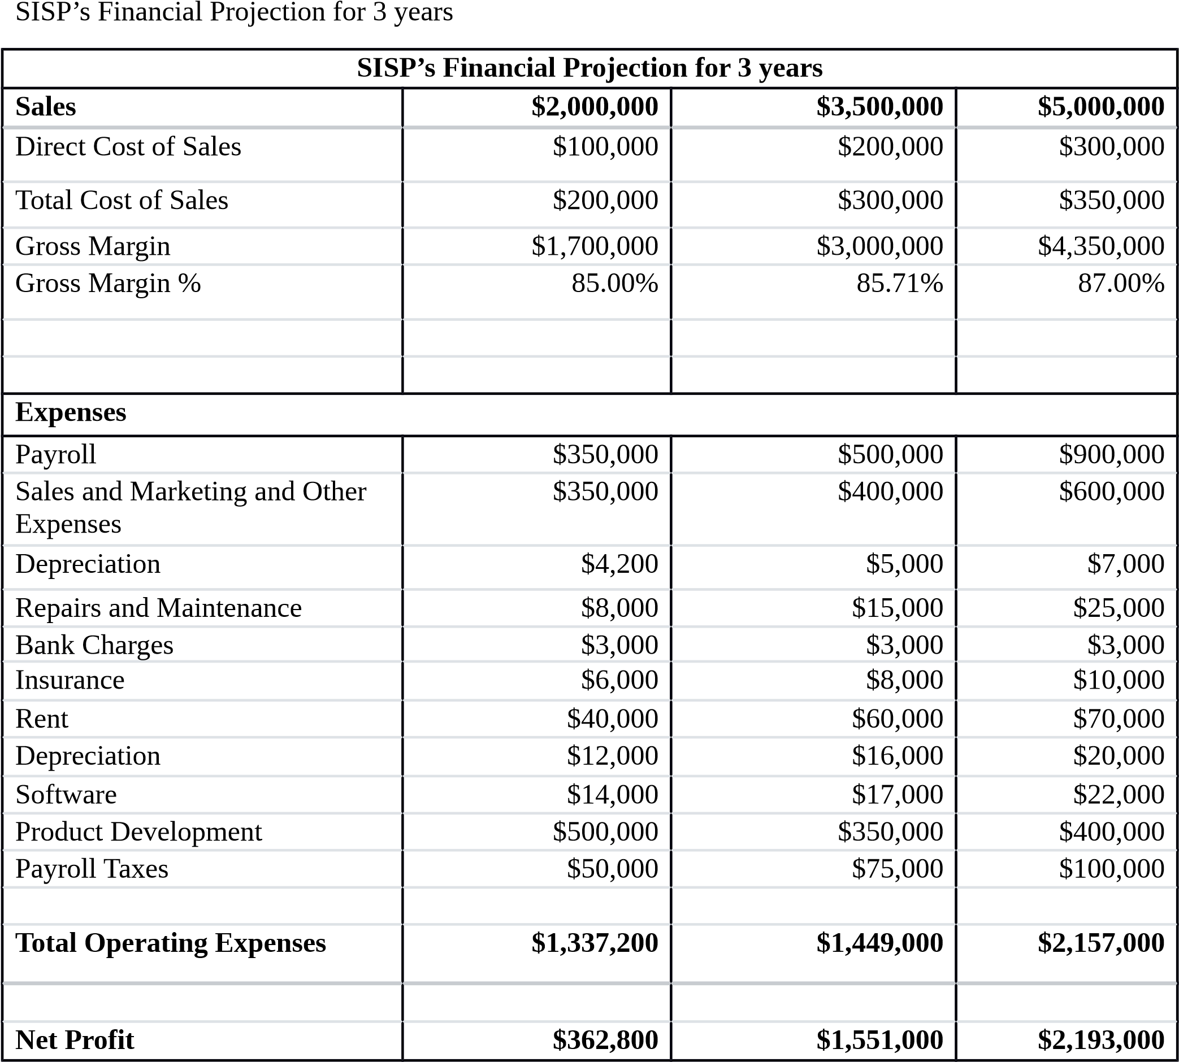
References
Barone, A. (2020). Marketing Strategy. Investopedia, Retrieved from https://www.investopedia.com/terms/m/marketing-strategy.asp
nibusinessinfo.co.uk. (n.d.). Choose an internet service provider for your business. Retrieved from https://www.nibusinessinfo.co.uk/content/different-types-internet-service-providers

