IT-697 Final Project
The experiential learning activity that I participated in was for Python Programming. Python is a program that can be utilize to read, store, and analyze data sets. It also can be used to create programs in which the end users can utilize to manipulate and store data as well. I chose this experiential learning experience because I know that Python can be a useful tool for data analysts. Most importantly I am a new programmer. I was told that Python was an easy language to learn for new programmers. I had hoped to get a decent understanding of Python so that I can build on my skills with Python. I believe that Python is an important tool for data analyst but can also be a gateway for other languages. If I increase my proficiency in Python enough so that I become an expert then in theory it should be easier to learn other languages.
The Python language is one that will lead into other languages.
What I have learned are ways the language reads and how the structure and strings and lists are developed. There are packages that can be loaded or imported such as the math module and random module. There are also variables and types that can be created for better data control. I believe we just scraped the surface on graphs and other visualizations involving Python. However, understanding that there is a methodology for creating a structure program for the end users’ needs and all that is involved in that structure is perhaps the most important concept that I have gained. One of the tricks, if you will, that I have learned is the loop function.
This allows the programmer to save time, and data space, by using the loop function for recursive programming. Instead of repeating or reentering the same code over and over again the loop allows for the program to be looped or reintegrated into the code.
Another concept I learned was variables and class concept. Objects are a condensed version of variables and functions that are involved in a single entity. These objects get their variables and functions from classes, in which classes are basically the template on how to create the objects. You can create multiple different objects that are of the same class (have the same variables and functions defined). However, each object contains independent copies of the variables defined in the class.
The Python Language is a language that is important in the data analytics industry. When I look for jobs within this career field, Python is the most required or preferred language that employers ask for, for their data analysts and data scientists. According to Information Weekly, Python is one of the top two languages to learn, next to R, and the easier of the two languages to learn. (Information Weekly, 2016) Again, if you are looking at job listings for data scientists and analysts, one of the top skills requirements is either Python or R knowledge, or often both. The same publisher considered Python as a general purpose language.
While at work, I am responsible for trying to develop and track loss deployment activities. There are various types of data and information that need to be created from that data. If I was able to understand Python enough I could create programs that would allow the data users to look at a variety of key performance indicators related to cost, over production, over processing, defect trends, time waste, and motion waste. Inventory could also be made into a program that the warehouse and inventory control associates can use to help view and control the losses related to these issues as well.
The following picture is an example of the code that I created for Assignment 6 that called for me to Write a Python program to perform the following tasks:
- Receive a filename from the user, open the text file for reading, and read the file.
- Count the sentences in the text file.
- Count the number of words in the text file.
- Print these two values with appropriate labels as a result of running the program.
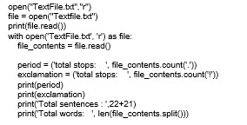
The program
that was
created to
solve the tasks that the assignment called for is not as complexed as it might seem. The initial script is calling for opening of the text file with the command “r” at the end of the first line. The “r” means to read the file only. The second line assigns “file” to mean the opening of the text file that is to be read. The next line is printing the said “file” so that the content of the text file can be seen by the user. The next lines of code puts the requested task into action. While the file is opened and being read by the program the program is counting the number of periods and exclamation marks. The period and exclamation text in lines 6 and 7 are simply assigning the word ‘period’ and ‘exclamation’ to a task of counting the number of them being found throughout the text file. The periods and exclamation points mark the end of each sentence so that the number of sentences can be accounted for by the punctuation marks depicted in the commands. The combined total of the two marks make the number of sentences. The final command in the program is to count each word that is in the text file and provide a total. This the end result:
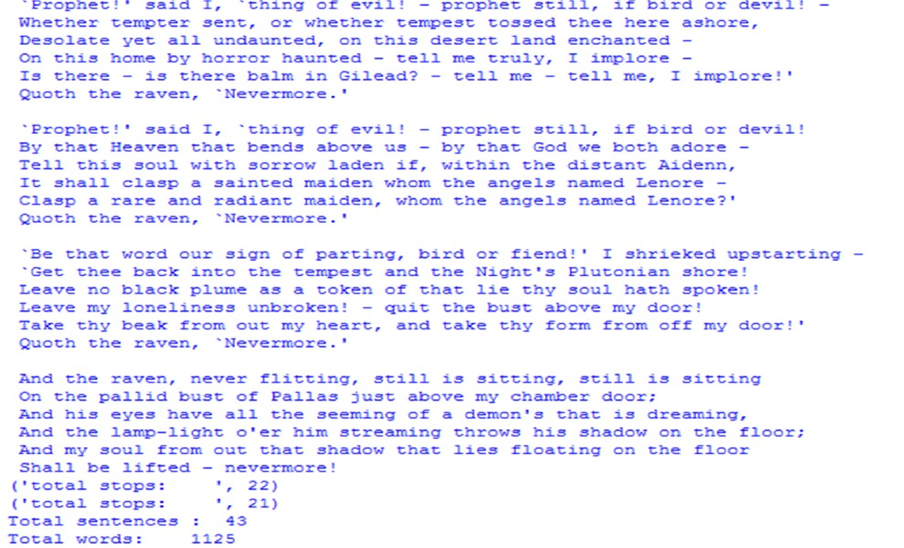
There is one thing to consider. The printing of the entire text file is not required to achieve the tasks that the assignment called for. If I were to omit the lines requiring the ‘file’ to be printed, only the results would be printed. The significance of the omitted command is to save data space and clean up the information presented to the end user. It is not really needed to show the outcome of the tasks.
Experiential learning is a learning style that utilizes hands on experience as a method of absorbing knowledge. The normal learning method of a traditional academic setting believes in a cognitive or behavioral learning style. The cognitive learning style emphasizes the role of mental processes of the subject matter while behavioral learning style ignores the possible role of subjective experience in the learning process. Behavioral learning style is a style that involves using one’s environment to instill knowledge. I have experienced all three of these learning styles. When I joined the military my basic training was a behavioral based learning style. The military changed our environment to influence knowledge of what they wanted to instill in us. While I learned from this style it was not sustainable and there are not a whole lot of subjects that can be learned through this methodology. Cognitive learning style is the traditional academic learning style that we are all accustomed to. The experiential learning style is a style that involves actively putting what you are learning to use. Mechanics learn like this as well as barbers or hair stylist. I believe that for subjects like programming, experiential learning is the absolute best way to learn. How else could you troubleshoot the code if you are not practicing what you are learning? Those are some of the differences involving experiential learning and the previous learning concepts.
The significance in these differences is the subject. I believe that all these are great learning styles. The knowledge that needs to be gained based on the subject should be learned differently. Programming language is a subject that requires practical use to learn. In the perfect world, understanding the theory of operation of Python, for example, would be a great start. However, when there are issues that may lead to having to troubleshoot the program involved then the real knowledge can only be gained in practical, experienced-based learning.
If I had to do this all over again, I would choose the same learning experience. I believe that all of the software and computer science related classes that I took from SQL to Python to R should be experiential learning. The knowledge that I have gained in this class was better than the knowledge that I have gained from the other classes of similar subjects. Reflection also allowed us to take a step back and look at what we were learning. The professor provided feedback of those reflective journals to give us a better understanding of being reflective and the knowledge that was gained during that week. The act of reflection is a great way to increase confidence and become a more proactive and qualified professional.
The only class that was similar to experiential learning was a class I took as an undergraduate involving Microsoft Project. How I learned in that class was similar. There were time sheets involved as well as a reflection period after each week. That period was to ensure that we were all gaining similar knowledge. I believe that if I were to provide feedback, the feedback would be that we review our reflection in this class to see if each student received similar knowledge giving the same learning experiences. I also believe that we should partner up with one other student to create a shared learning experience that would create some peer review type of feedback.
This learning experience like many others there are always things you can take out of it and being reflective I wish that I could have had more time gathering large data sets and creating reports from those data sets. In week 6 we took a text file and counted the sentences that lied within the text file. I think it would have been better to take a file of weather data and determine the top five warmest and coolest areas with in a 50 country, annual data set. However, given all that I have learned I plan on signing up for more experiential learning classes that I am able to apply. I think that I could have gotten more out of this one if I just took the time to be more reflective to provide the dialogue between the professor and I. I should have asked more questions and used my professor as a source rather than try to figure out everything on my own. I would encourage others to do the same and create a thread of questions and tips for the class to read and learn from.
References
Brightside. (2017). What is Reflective Practice? Retrieved from Brightside Websight:
https://www.brightknowledge.org/knowledge-bank/medicine-and-healthcare/spotlighton-medicine/what-is-reflective-practice
Cherry, K. (2016, June 15). How experience, emotions, thoughts, and the environment influence learning. Retrieved from Very Well Website: https://www.verywell.com/experientiallearning-2795154
Information Weekly. (2016, June 29). Information Weekly. Retrieved from InformationWeek Website: https://www.informationweek.com/devops/programming-languages/10programming-languages-and-tools-data-scientists-use-now/d/d-id/1326034? image_number=3
Miller, B. N. (2017). ). Introduction to Scripting: National CyberWatch Center Edition, 1st Edition. Retrieved from Vital Source:
https://bookshelf.vitalsource.com/#/books/9781284108071/

