Exploring Tableau
BA342 Individual Homework
Read these bullet points carefully before you begin this assignment.
- The objective of this assignment is to provide you with the opportunity to gain experience using the Tableau data visualization application.
- You will be required to install the Tableau application and use the software to create visualizations and a dashboard by following the steps in this document.
- Tableau Software Versions: This assignment is written based on the assumption that you will download and install the free version of Tableau called Tableau Public. However, Tableau provides students a trial license for Tableau Desktop. Choose either version – they will both work for this assignment. Read the following to learn the primary differences between the two versions so that you may make your choice:
  - Tableau Public is a free version of Tableau but if you wish to save your work you must save it at the Tableau Public site where it is available for anyone to see. If you have no plans to use this software after this assignment is complete, Tableau Public may be the better choice for you.
  - Tableau Desktop trial for students is a temporary license that you are allowed to use while you are a student. Request a one-year key through the Tableau for Students program
(http://www.tableau.com/academic/students). With this version you may save your work on your laptop and never have to publish it to the Web if you do not choose to. If you know you want to continue to use this software after this assignment is complete, Tableau Desktop trial for students may be the better choice for you. You may request a new one-year key for each year you are enrolled as a full-time student.
- Install the Tableau software on your laptop no later than Monday, , when Tableau and this assignment will be discussed briefly in class to help you get started.
  - NOTE - Everyone is welcome to start before then, as the instructions included in this document should provide adequate explanation for you to complete the assignment on your own. Additionally, there are help and training resources available for you at the Tableau Web site https://public.tableau.com/s/resources or videos at Lynda.com.
- The assignment deliverable will be a Word document that contains a screenshot of the Tableau dashboard created by following the instructions in this document. Submit the Word document (do NOT submit a Tableau file) to Canvas by Monday, (before class).
- This assignment will be scored based on the completeness of your work and based its compliance with the requirements of this assignment.
- You may discuss this assignment with others, and you are encouraged to use online resources such as https://public.tableau.com/s/resources or the Lynda.com videos, but the work itself must be completed on your own.
  - Do not share your work with others, do not ask others to share their work with you. Sharing of work includes sharing, exchanging, or providing access in any way to another individual any of your file(s), portions of your file(s), you text, portion(s) of your text, etc.
  - The UT Honor Statement prohibits plagiarism (copying and pasting from sources or duplicating the words or ideas from a source without giving proper credit). It is also plagiarism to use work from a previous semester or from another course, even if the work was your own. Cheating due to plagiarism and or the sharing of work will be dealt with as explained in the syllabus. If you have questions or need more information, speak with your instructor, a course GTA, and/or see this link: http://libguides.utk.edu/c.php?g=188584&p=1246308
Instructions:
Download files and install software:
  - Download and save to your computer the Excel workbook that is the data file we will use - USDA_activity_dataset.xls: http://www.peteraldhous.com/Data/USDA_activity_dataset.xls
  - Tableau is compatible with the Windows OS of Vista or newer, and the browser Internet Explorer 8 or newer. Tableau is compatible with iMac/MacBook computers 2009 or newer, OS X 10.9 or newer. If your Mac is older, you will need to install and run Tableau in your Windows partition.
  - Choose one version of Tableau - see the “Tableau Versions” paragraph at the beginning of this document.
    - Tableau Public http://www.tableausoftware.com/public/download-steps and install on your laptop.
    - Alternately, you may choose to download the student trial of Tableau Desktop http://www.tableau.com/academic/students and install that version on your laptop.
Examine and Connect to the data:
  - In Excel, examine the USDA_activity_dataset.xls workbook contents. The data details physical activity, obesity, and other health data in nearly 100 columns, for more than 3000 rows, one for each county in the US.
  - Close Excel and the data set workbook.
  - Open Tableau, under Connect click on Excel, then browse to where you saved the workbook USDA_activity_dataset.xls file and choose to open that file. If a dialog box appears, click OK to connect.
  - Once you are connected to the USDA data, your screen should look something like the picture below. Tableau shows you a preview of your data in the lower part of the screen. Notice that the software has automatically recognized categorical fields, like “State,” and numerical measures like “# Households ….”
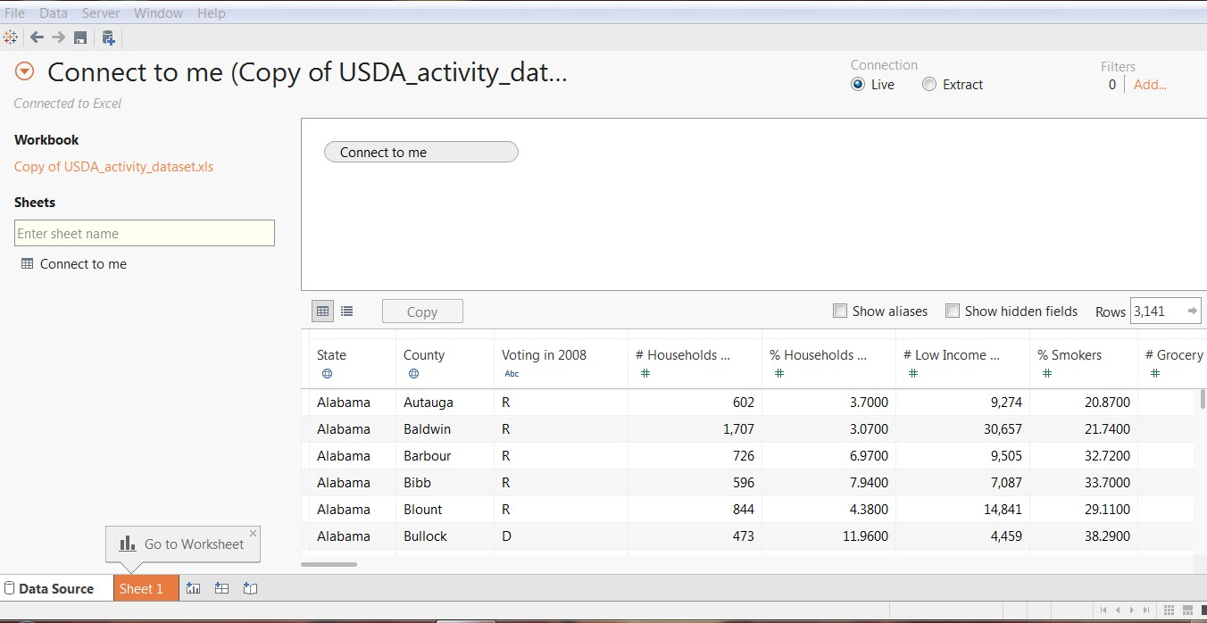

Create the first view (a map for each state showing obesity rates at the county level):
  - Click on the Sheet 1 tab at the bottom of the page.
  - Double click on the dimension “State” and then double click on the dimension “County.” Tableau Public recognizes they are geographical fields and geocodes them accordingly. (If you get a warning message, check to request not to see it again.) If the Show Me tool is in the way on the right side of the screen, click on header in blue where it says Show Me and it will collapse.
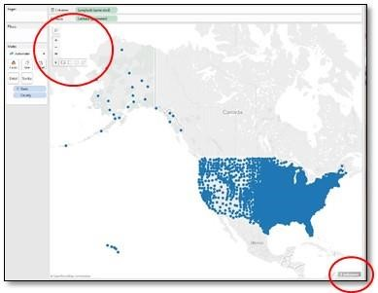
  - Single click on the grey box that says “3 unknown” in the lower right hand corner of the map work area. A Special Values popup menu will appear. Select “Show Data at Default Position.” A blue dot that represents three data points will now appear near Africa. These are null values in the data and we want to exclude them.

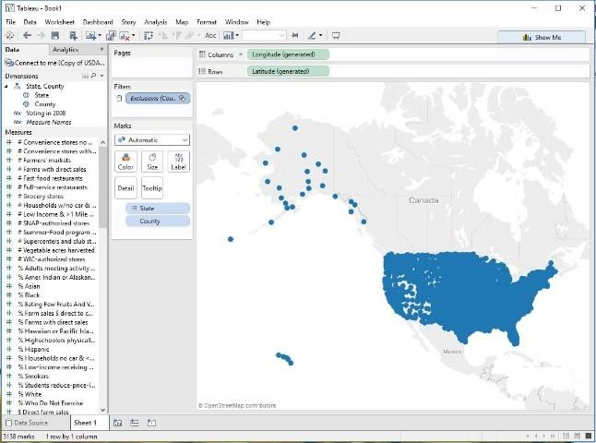
  - When you hover your mouse over the work area, in the upper left corner of the map a set of controls will appear. As you hover over the last control on the list (a right-arrow head), tools will appear. Click on the selection tool that looks like a dotted-line box. Click to one side of the blue dot that is near Africa and keep the mouse button depressed as you draw a rectangle around the dot. Release the mouse and the popup menu that appears will indicate that 3 items are selected; click on “Exclude.” (Note, if you move too quickly, you might miss the menu and you may have to repeat this step.) Once you successfully exclude the points at the blue dot, it should no longer be visible and you should see “Exclusions” in the Filters shelf.
  - Right click on Exclusions in the Filters shelf and select “Apply to worksheets,” and “All using this data source.” This will prevent these null values from appearing on any other worksheets that you create in this Tableau workbook. You now have a map showing a dot for every county where there is a record in the dataset.
  - Drag “Adult obesity rate” from the “Measures” panel into the “Color” square under the “Marks” card. Find “Adult obesity rate” in the “Measures” panel again and drag it into the “Size” square this time.
  - Click on the “Color” square: choose “Edit Colors…” to change the Color to Orange–White-Blue Diverging, and choose OK.
  - Now to add a filter to enable the selection of individual states, click and drag the dimension “State” into the Filters shelf, click OK at the dialog box.
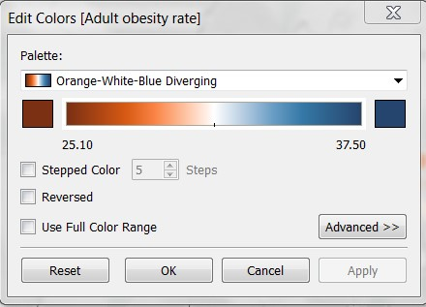
  - Right click on “State” in the Filters shelf and select to show the filter.
  - A Filter window titled State should appear on the right side of the Tableau work area. Click on All to deselect all states, then scroll down and select Tennessee.
  - Click on the Filter drop-down menu (arrowhead on the far right of the title State) and choose Apply to
Worksheets>All Using This Data Source. This will make the filter choice apply to the entire workbook.
  - Click on the Filter drop-down menu again and select Multiple Values (Dropdown). This will collapse the filter list so that it will take up less room.
  - Click once more on the Filter drop-down menu, select Customize and uncheck Show “All” Value. This will remove the All option from the menu and prevent users from seeing the entire data for all the US at the same time.
  - Rename the worksheet “Map View” by double-clicking the Sheet 1 tab at the bottom (or by single right clicking and choosing to rename from the menu).
  - Your finished Map View visualization should look like this:
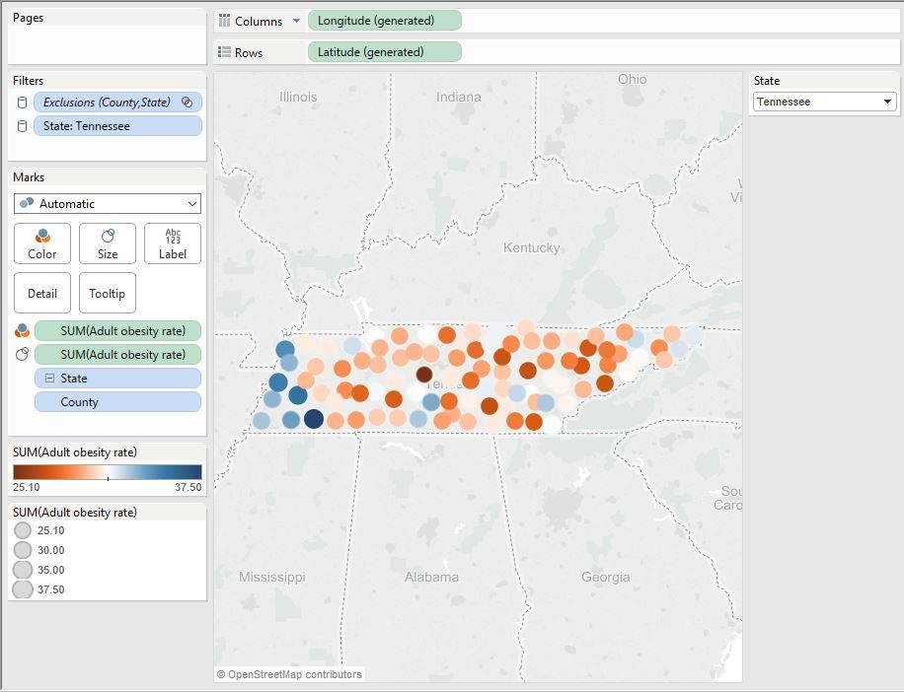
Add a second view (scatter plots showing the relationship between obesity and health-related behaviors at the county level):
  - Add a new worksheet by clicking on the new worksheet tab to the right of the Map View tab at the bottom of the page (or by clicking on Worksheet, New Worksheet from the menu across the top).
  - In the new worksheet, drag “Adult obesity rate” onto Rows and “% smokers,” “% eating few fruits and vegetables” and “% who do not exercise” into Columns. NOTE - Tableau’s default behavior is to sum the values across all the counties and states, so you now have a single data point for each graph which is not very useful.
  - We want scatter plots so drag “State” into the Detail square under the Marks card, then also drag “County” to the Detail.
  - From the Analysis drop down menu at the top of the page, choose Trend Lines, and then Show All Trend Lines.
  - Open the Drop down menu next to “Automatic” in the Marks area, and select Circle.
  - Click on the Color square, then on More Colors. Choose an orange color, then OK. Move the Transparency slider to the left to change the transparency of the circles to between 30-40%. Click anywhere on the visualization to close the Color square.
  - Rename the worksheet “Scatterplot View” and the finished second view should look like this:
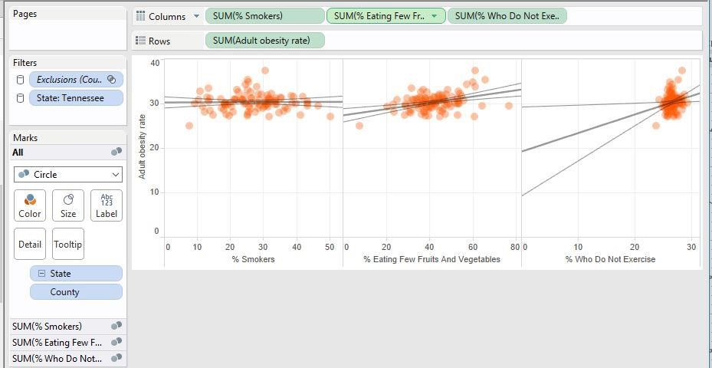

Create a Dashboard with both views:
  - Add a dashboard by clicking on the new dashboard tab at the bottom of the page (or by clicking on Dashboard, New Dashboard from the menu across the top).
  - In the lower left of the left hand Dashboard menu change the Dashboard size to Laptop and click the Show Title box.
  - Rename the dashboard tab as “Obesity by State and County.”
  - Drag the Map View from the left hand Dashboard menu and drop it in the dashboard work area.
  - Drag the Scatterplot view and drop it so that it is below the Map View.
  - Right click on the titles of each of the two views and select Hide Title. Resize the objects in your Dashboard if needed to improve the look.
  - In the Dashboard side menu, click on Floating and then drag and drop a Text object onto the Dashboard work area.
  - In the Edit Text window that pops up, enter “By First Last” where First is your first name and Last is your last name. Increase the text size to at least 12 points, and change the type style and color if you wish. Choose OK.
  - Move the new text box with your name to the lower right side of the Dashboard.

REQUIRED – Create a Screen Capture, paste it into Word, and submit to Canvas:
  - Open Word and create a new document named LastFirst_H0425.docx where Last is your last name, and First is your first name.
  - Return to Tableau and take a screen shot of your dashboard. Paste the screen shot into the Word document created in the previous step. Your screen shot should look much like this:
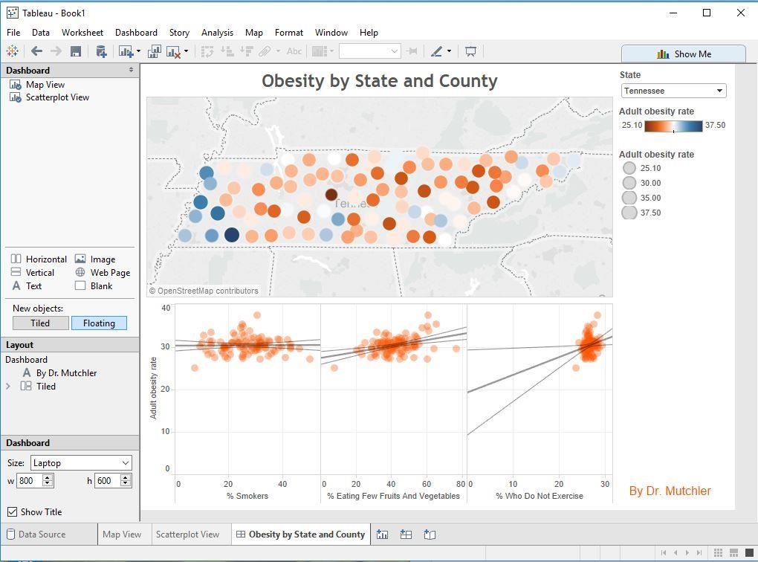
NOTE - If you do not know how to take a screen shot, then complete one of the next two steps, choosing the step based on the operating system you are running Tableau under – Windows or Mac.
  - For Windows, complete this step to create your deliverable document and skip the next step.
      - Select the dashboard screen and press the Alt and the Print Screen keys at the same time. (The Print Screen or PrtSc key is typically in the upper and right area of the keyboard.) Your screen capture is now in your computer’s memory.
      - Go to your Word document and press and hold the key Ctrl and then press v to paste your screen capture from your computer’s memory into your Word document.
      - Close your Word document, saving your work.
42. For Mac OS, complete this step to create your deliverable document and you should have skipped the previous step.
      - Press and hold the keys Command, Shift, and then press 4. When the pointer changes to a crosshair pointer, move the crosshair pointer to where you want to start the screenshot, drag to select the dashboard area. Release your mouse or trackpad button and a file of your screenshot will appear on your desktop (.png file type).
      - Go to your Word document and select the Insert tab, select Pictures, and browse to your desktop to find your screenshot .png file and select Insert.
      - Close your Word document, saving your work.
      - Upload your Word document with the screen capture of your Tableau dashboard to the H0425 assignment in Canvas. Do not upload the Tableau file.
      - This completes the requirements of the homework assignment H0425.
      - If you wish to save your Tableau work:
        - If you are using Tableau Public, complete the Optional step below to publish your work to the Web first, and then be provided with the option to save a copy to your computer.
        - If you are using the student trial of Tableau Desktop, you can save your Tableau workbook to your computer now. If you want to publish your work to the Web you should also complete the optional step below.
OPTIONAL STEP – Publishing your work to Tableau Public:
- To publish your Tableau visualization to the Web, first create a Tableau Public account at:
https://public.tableausoftware.com/auth/signup
- Return to Tableau, then:
        - In Tableau Public, click on File on the top menu and select “Save to Tableau Public.” You will be asked for your account login.
        - In Tableau Desktop, click on Server, Tableau Public, Save to Tableau Public, and you will be asked for your account login.
        - Once your visualization is published to the Tableau Public Web site, click menu at the Web site for options to save as PDF, image, or download to your computer.
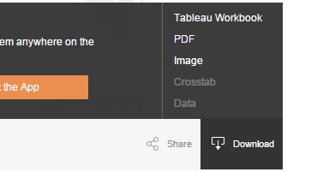

To learn more about Tableau Public and access how-to videos, sample data sets, and training, visit these links: https://public.tableau.com/s/resources https://public.tableau.com/s/

Powered by TCPDF (www.tcpdf.org)

