Design and MATLAB Simulation of Pitch Motion System Controller for Underwater Vehicle

ABSTRACT

Underwater vehicle is an important machine nowadays. It can perform multiple underwater complex tasks. For example, pipelines detection or mapping, underwater terrain exploration and underwater inspections. Due to rotation of the thruster at back of most underwater vehicle, it causes disturbances of fluid around the vehicle and affect the stability of the vehicle. Thus, a control system for the motion of the vehicle should be designed to compensate the instability. However, in this project the focus is directed to design a PID controller for one degree of vehicle’s motion which is pitch motion. The study is based on NPS AUV II which is an underwater vehicle. Recently, there are many researches related to underwater vehicle’s motion controller. Ranging from conventional and old controller of PID to a most advance adaptive system controller. However, due to limitation encountered, this project is focusing in designing a PID controller. Even though, PID controller is old, the performance of this controller is adequate and acceptable.
Mathematical modelling of the underwater vehicle is developed by derivation of vehicle’s kinematic and dynamic equation of motion. Equation of motion of pitch and depth are solved using state space approach to obtain system transfer functions. Control blocks of the system equipped with PID controller is designed in MATLAB Simulink software and simulation of the system is conducted. The respond obtained is considerably adequate achieving system stability with rise time of 1 seconds, settling time of 13 seconds and percentage overshoot of 10 percent.

ACKNOWLEDGEMENT

With the highest praises be to Allah SWT, the Most Gracious and the Most Merciful. I would like to give my utmost gratitude to my supervisor Dr. Setyamartana Parman for the endless support and guidance to me to complete this Final Year Project. My deepest gratitude to Dr. Turnad and Dr. Tamiru coordinator for FYP 1 and FYP 2 respectively for their assistance and support throughout the whole 8 months. My sincerest appreciation also goes for Dr. Mark Ovinis for his advice and support for this project.
I also would like to express my appreciation to my family especially my parents, Che Ku Amran and Wan Esah for the endless support throughout my study. Finally, I would like to thank my friends and colleagues for their support and shared knowledge.

TABLE OF CONTENT

ABSTRACT .................................................................................................................... iv ACKNOWLEDGEMENT .............................................................................................. v TABLE OF CONTENT ................................................................................................. vi LIST OF TABLES ....................................................................................................... viii LIST OF FIGURES ....................................................................................................... ix LIST OF SYMBOLS ....................................................................................................... x 1.0 INTRODUCTION ..................................................................................................... 1
1.1 Background Study ................................................................................................... 1
1.2 Problem Statement ................................................................................................... 2
1.3 Objectives ................................................................................................................ 3
1.4 Scope of Study ......................................................................................................... 3

2.0 LITERATURE REVIEW ......................................................................................... 4
2.1 Types of Underwater Vehicles ................................................................................ 4
2.2 Some of pertinent AUV projects ............................................................................. 4
2.2.1 ARPA/Navy Unmanned Undersea Vehicle (UUV) .......................................... 4
2.2.2 REMUS (Remote Environmental Measuring Units) ........................................ 5
2.2.3 Theseus AUV .................................................................................................... 6
2.3 Introduction of underwater vehicle mathematical modelling .................................. 7
2.4 Review on the state space method ........................................................................... 8
2.5 Method of Designing System Controller ................................................................. 8

3.0 METHODOLOGY .................................................................................................. 11
3.1 Project Flowchart ................................................................................................... 11
3.2 Mathematical Modeling of Underwater Vehicle ................................................... 12
3.2.1 Coordinate System, vehicle position and kinematics ..................................... 12
3.2.2 Defining system reference frames .................................................................. 13
3.2.3 Defining system Euler angles ......................................................................... 15
3.2.4 Describing kinematics of the underwater vehicle ........................................... 17
3.2.5 Describing dynamic equation of motion of the underwater vehicle ............... 22
3.2.5.1 Translational equation of motion ............................................................. 22
3.2.5.2 Rotational equation of motion .................................................................. 23
3.2.5.3 General equation of motion for underwater vehicle (6 DOF) .................. 25
3.2.5.4 Hydrostatic (restoring) forces and moments ............................................ 26
3.2.5.5 Hydrodynamic Forces and Moment ......................................................... 27
3.2.5.6 Equation used in this project to design pitch and depth control............... 28
3.3 State-Space method approach ................................................................................ 29
3.4 Computation of the system transfer function ........................................................ 30
3.5 Designing the control system ................................................................................ 30
3.6 NPS AUV II Physical properties used in this project ............................................ 31

4.0 RESULT AND ANALYSIS .................................................................................... 33
4.1 Calculation of the State Space Matrix ................................................................... 33
4.2 Open loop respond of the system ........................................................................ 35
4.3 Designing PID controller for pitch motion ............................................................ 36
4.4 Comparing the performance of designed PID controller ....................................... 41
4.5 Designing combine pitch and depth controller ...................................................... 42

5.0 PROJECT MILESTONES AND GANTT CHART ............................................ 45
5.1 Project Milestone FYP1 ......................................................................................... 45
5.2 Project Milestone FYP 2 ........................................................................................ 46
5.3 Gantt Chart FYP 1 ................................................................................................. 47
5.4 Gantt Chart FYP 2 ................................................................................................. 48

6.0 CONCLUSION AND RECOMMENDATION .................................................... 49 7.0 REFERENCES ........................................................................................................ 50

LIST OF TABLES

Table 1 : AUV 6 degree of freedom notation 12
Table 2 : NPS AUV II physical properties [4] 31
Table 3 : NPS AUV II Heave non-dimensional hydrodynamic coefficient [4] 32
Table 4 : NPS AUV II Pitch non-dimensional hydrodynamic coefficient [4] 32
Table 5 : Characteristic of PID controller 36
Table 6 : PID Tuning values 37
Table 7 : Tuning test performance 38
Table 8 : PID controller value 39
Table 9 : Performance of PID controller 40
Table 10 : Comparison of PID performance data 41
Table 11 : Combine pitch and depth controller value 43
Table 12 : Performance of combine pitch and depth control 44
Table 13 : FYP 1 Project Milestone 45
Table 14 : FYP 2 Project Milestone 46
Table 15 : FYP 1 Gantt Chart 47
Table 16 : FYP 2 Gantt Chart 48

LIST OF FIGURES

Figure 1 : Degree of freedom of underwater vehicle ........................................................ 2
Figure 2 : NPS AUV II schematic drawing ...................................................................... 3
Figure 3 : ARPA AUV ...................................................................................................... 5
Figure 4 : REMUS 600...................................................................................................... 5
Figure 5 : Theseus AUV.................................................................................................... 6
Figure 6 : Feedback Control System ................................................................................. 8
Figure 7 : Delphin 2 AUV ................................................................................................. 9
Figure 8 : Project methodology flowchart....................................................................... 11
Figure 9 : Body and earth fixed frame coordinate system [4] ......................................... 14
Figure 10 : Body fixed frame coordinates convention .................................................... 15
Figure 11 : Open loop pitch control block ...................................................................... 35
Figure 12 : open loop respond of pitch motion ............................................................... 35
Figure 13 : Pitch motion PID control block .................................................................... 36
Figure 14 : Tuning 1 ........................................................................................................ 37
Figure 15 : Tuning 2 ........................................................................................................ 37
Figure 16 : Tuning 3 ........................................................................................................ 38
Figure 17 : Tuning Comparison ...................................................................................... 38
Figure 18 : Pitch motion PID respond ............................................................................. 39
Figure 19 : Tuned PID and open loop comparison ......................................................... 40
Figure 20: Combine pitch and depth control block ......................................................... 42
Figure 21 : Depth respond of AUV ................................................................................. 43
Figure 22 : Pitch respond of AUV .................................................................................. 43
LIST OF SYMBOLS

x, y, z | Axes of body fixed reference frame
X, Y, Z | Axes of earth fixed reference frame
𝑥̇ | Linear velocity along the North-South axis (earth)
𝑦̇ | Linear velocity along the East- West axis (earth)
𝑧̇ | Linear velocity along the vertical axis (earth)
Ø | Euler angle in North-South axis. Positive sense is clockwise as seen from back of the vehicle (earth)
θ | Euler angle in pitch plane. Positive sense is clockwise as seen from port of the vehicle (earth)
Ψ | Euler angle in yaw plane. Positive sense is clockwise as seen from above (earth)
Ø̇ | Roll Euler rate about North-South axis (earth)
𝜃̇ | Pitch Euler rate about East-West axis (earth)
𝛹̇ | Roll Euler rate about North-South axis (earth)
u | Linear velocity along longitudinal axis (body)
v | Linear velocity along horizontal plane (body)
w | Linear velocity along depth (body)
p | Angular velocity component about body longitudinal axis
q | Angular velocity component about body lateral axis
r | Angular velocity component about body vertical axis
𝑢̇ | Time rate of change of velocity along the body
longitudinal axis
𝑣̇ | Time rate of change of velocity along the body lateral axis
𝑤̇ | Time rate of change of velocity along the body vertical axis
𝑝̇ | Time rate of change of body roll angular velocity about the body longitudinal axis
𝑞̇ | Time rate of change of body pitch angular velocity about the body lateral axis
𝑟̇ | Time rate of change of body yaw angular velocity about the body vertical axis
𝛿_{𝑒} | Stern planes (elevator) deflection angle. (It is noted as  Stern plane, since the vehicle used in this thesis has bot bow and stern planes. But just stern planes are used throughout the simulation.
W | Weight of the vehicle
B | Buoyancy of the vehicle
L | Length of the vehicle. Also known as characteristic length. Dynamic equations of motion are written to explicitly utilize L as normalization coefficient. [11]
g | Acceleration due to gravity
𝜌 | Density of fluid
𝐷₂ | 0.5 𝜌𝐿²
𝐷₃ | 0.5 𝜌𝐿³

 | 𝐷₄ | 0.5 𝜌𝐿⁴
 | 𝐷₄ | 0.5 𝜌𝐿⁵
 | m | mass
 | 𝐼_{𝑥𝑥} | Mass Moment of Inertia about x-axis
 | 𝐼𝑦𝑦 | Mass Moment of Inertia about y-axis
 | 𝐼_{𝑧𝑧} | Mass Moment of Inertia about z-axis
 | 𝐼𝑥𝑦 | Cross Product of Inertia about xy-axes
 | 𝐼_{𝑦𝑧} | Cross Product of Inertia about yz-axes
 | 𝐼_{𝑥𝑧} | Cross Product of Inertia about xz-axes
 | CG | Center of gravity
 | 𝑥_{𝐺} | x Coordinate of CG From Body Fixed Origin
 | 𝑦_{𝐺} | y Coordinate of CG From Body Fixed Origin
 | 𝑧_{𝐺} | z Coordinate of CG From Body Fixed Origin
 | CB | Center of buoyancy
 | 𝑥_{𝐵} | x Coordinate of CB From Body Fixed Origin
 | 𝑦_{𝐵} | y Coordinate of CB From Body Fixed Origin
 | 𝑧_{𝐵} | z Coordinate of CB From Body Fixed Origin
 | 𝑍𝑞̇ | Heave force due to time rate of change of q
 | 𝑍_{𝑝𝑝} | Heave force due square of p
 | 𝑍_{𝑝𝑟} | Heave force due to r and p
 | 𝑍_{𝑟𝑟} | Heave force due to square of r
 | 𝑍𝑤̇ | Heave force due to time rate of change of w
𝑍_{𝑞} |  | Heave force due to q
𝑍_{𝑣𝑝} |  | Heave force due to p and v
𝑍_{𝑣𝑟} |  | Heave force due to r and v
𝑍_{𝑤} |  | Heave force due to w
𝑍_{𝑣𝑣} |  | Heave force due to square of v
𝑍𝛿𝑒 |  | Heave force due to elevator deflection
𝑀𝑞̇ |  | Pitch moment due to time rate of change of q
𝑀_{𝑝𝑝} |  | Pitch moment due to square of p
𝑀_{𝑝𝑟} |  | Pitch moment due to r and p
𝑀_{𝑟𝑟} |  | Pitch moment due to square of r
𝑀𝑤̇ |  | Pitch moment due to time rate of change of w
𝑀_{𝑢𝑞} |  | Pitch moment due to q and u
𝑀_{𝑣𝑝} |  | Pitch moment due to p and v
𝑀_{𝑣𝑟} |  | Pitch moment due to r and v
𝑀_{𝑤} |  | Pitch moment due to w
𝑀_{𝑣𝑣} |  | Pitch moment due to square of v
𝑀𝛿𝑒 |  | Pitch moment due elevator deflection

1.0 INTRODUCTION

1.1 Background Study

The underwater vehicle (UV) is a kind of useful tool to finish difficult work in the water instead of human being. It can perform tasks like underwater exploring, pipe line detection or mapping, UV needs to possess certain abilities like terrain following and depth keeping. It is found that attitude changes especially pitch motion effects depth instability for UV the most.

In addition, UV often equipped with manipulators to participate in rescuing or taking samples. Pitch can increase manipulators operation error and affect UV efficiency. Meanwhile, pitch motion is one of the main reasons for surveillance video fuzziness. So, pitch motion control plays an important role on improving UV working performance. Traditionally, pitch motion control of an Underwater Vehicle can be controlled by regulating output torques of its thrusters [1-3].

Typical underwater vehicles has six degree of freedom motion. However, this project will focus mainly on designing of the pitch motion system. The datum for this project is Naval Postgraduate School (NPS) AUV II. The pitch reduction system (PRS) will be design based on the datum specifications and physical properties.

Today, there are many approaches used to design the control system of the pitch motion of an underwater vehicle. The most conventional method of control is Proportional-Integral-Derivative (PID) controller. However, in recent years an extensive research of other method of control such as Linear Quadratic Regulator (LQR), Back stepping Method Control (BMC), Sliding Method Control (SMC) and Adaptive control have been studied for better controller design. Due to the limitations of resources, this project will focus on designing the PID controller for the pitch system and evaluate the performance of such controller.

1.2 Problem Statement

Rotational motion of the thrusters may increase the disturbance of the fluid around the vehicle and aggravate its motion instability. The pitch motion system is designed for a UV that has surface control mechanism (actuated surface fins). Conventionally, an UV will have 6 DOF which are surge, sway, heave, roll, pitch and yaw. Therefore, a mechanism is needed to adjust its pitch angle. However this project the control design will be focusing on the pitch motion of the UV. The auxiliary attitude stabilizers commonly used for the UV are rudder, fins and water tank. Often, pitch motion is one of the main cause for surveillance video fuzziness. Hence, pitch motion control is important for the underwater vehicle (UV) performance.

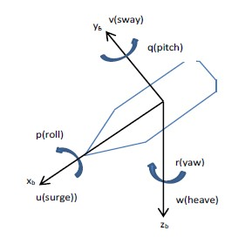

Figure 1 : Degree of freedom of underwater vehicle

1.3 Objectives

- To design pitch reduction system (PRS) for the NPS AUV II [4].
- To propose and design the proportional-integral-derivatives (PID) controller for the AUV – PRS.
- To simulate and evaluate the dynamics of AUV with propose PRS and PID controller in MATLAB,

1.4 Scope of Study

- The project will be conducted based on an underwater vehicle model Naval Postgraduate School (NPS) AUV II [4].
- The study will focused on the designing the pitch reduction system for the AUV rather than design control for all the degree of freedoms.
- The mechanism of the pitch motion system is actuated surface fins.
- Decouple system is assume for designing the pitch reduction system.
- The simulation of the pitch reduction system will be done in MATLAB Simulink.

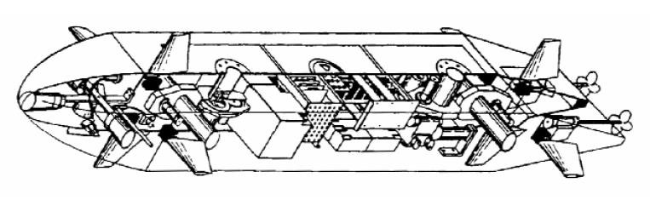
Figure 2 : NPS AUV II schematic drawing

2.0 LITERATURE REVIEW

2.1 Types of Underwater Vehicles

Remotely operated vehicles (ROVs) and Autonomous Underwater Vehicles (AUVs) are common classification of unmanned underwater vehicles. Traditionally, ROVs are often tethered to a ship or a surface structure with the tether to provide power and communication between the operator and vehicle. The advantages of tether ROVs is that the operator can maneuver the vehicles accurately and smartly in order to complete a certain task or job. For example, repairing underwater pipeline, underwater surveying. Due to the tether, ROVs are bound to a disadvantage which is the range of travel of such vehicles is short and limited.

Most AUVs are cylindrical-torpedo shape [5], with four control surface (fins and rudders) and a thruster (propellers) at the back of the AUV. These AUVs are commonly used for long range type of operation where the AUVs acts like a bus for onboard sensors to log information and data [6], for example mine detection mission, geographical survey mission and other types of underwater survey operations. AUVs are bound to a disadvantages of incapable of hovering and thus unable to conduct detailed inspection type mission. This is because AUVs has a minimum speed below which the vehicle will loses control authority due to the set actuator on-board the vehicles [7].

2.2 Some of pertinent AUV projects

2.2.1 ARPA/Navy Unmanned Undersea Vehicle (UUV)

The ARPA UUV are the largest and the most capable AUVs built to date. This AUVs is estimated at around 9 million USD. The weight of this AUVs is around 680 kg in air and capable of maneuvering between 5 to 10 knots (2.57 m/s to 5.14 m/s). The ARPA UUVs uses high density silver zinc batteries for its 24 hours operation endurance. The vehicle is also permit a depth test of 305 m due to its hulls is made from titanium [8].
The ARPA UUV was built for tactical naval mission and focusing on open ocean minefield search. The figure 4 shows the picture of the ARPA UUV.

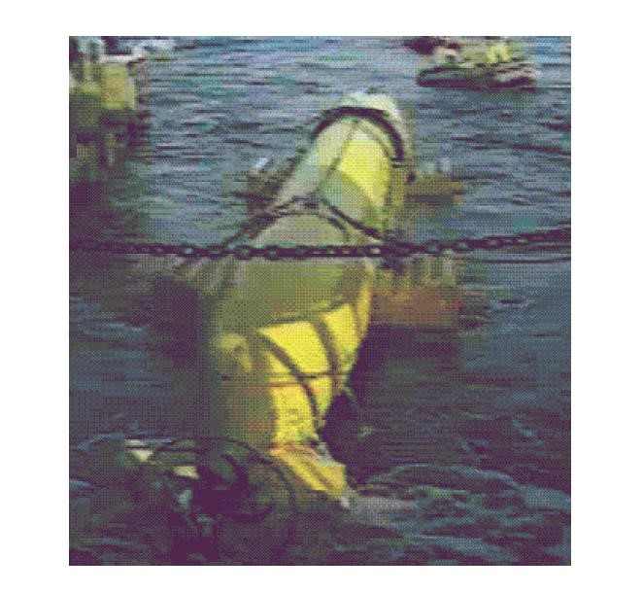

Figure 3 : ARPA AUV

2.2.2 REMUS (Remote Environmental Measuring Units)

The REMUS (Remote Environmental Measuring Units) are designed by Woods Hole Oceanographic Institute (WHOI). Later, these AUVs are moved into HYDROID Corporation. There are more than 70 REMUS AUV system designed for coastal environment operations from 100 to 6000 meters [9]. The figure below shows the REMUS 600.

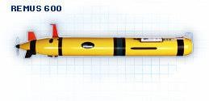

Figure 4 : REMUS 600

2.2.3 Theseus AUV

The Theseus AUV was built by the U.S and Canadian Defense Establishments. This AUV serve a purpose to lay long length of fiber optic cable under the Artic ice pack. In the year 1995 and 1996 the vehicle was completed a successful deployments to the Artic. In the year of 1996 the AUV has laid 190 km of cable at 500 meter of depth under a two and a half meter of thick ice. The total length of cable that has been laid by this AUV was 365 km making this is the longest AUV mission to date. The Theseus AUV has a length of 10.7 meters, a diameter of 1.27 meters, a weight of 8600 kg with 220 km of cable on board and a nominal speed of 4 knots [10]. The figure below shows the Theseus AUV.

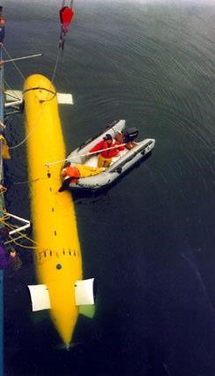

Figure 5 : Theseus AUV

2.3 Introduction of underwater vehicle mathematical modelling

Underwater vehicle mathematical modeling is a vastly research are and open source information is widely available in the internet and other source of publications. The equation that will be used in this report in order to generate the mathematical model of the underwater vehicle are given in detail in reference [11]. In order to design a control system for the pitch reduction system of underwater vehicle, the equation of motion for an underwater vehicle will be developed. From reference [11] 6 degree of freedom equation of motion can be obtain. From these 6 degrees of freedom equation of motion, the equation of motion for pitch and depth (heave) can be obtain. Pitch and depth are related to each other. Therefore, in order to design pitch reduction control system, the heave motion of the underwater vehicle has also be taken into account.
Before, the equation of motion can be applied to make the mathematical model, several assumption must be made for the physical system. The assumption that has been taken account are, the vehicle will be treated as a rigid body, the rotation of the earth is negligible, and the hydrodynamic coefficient or parameters are constant. The hydrodynamic coefficient of the NPS AUV II can be obtain in the [4]. The primary force that acts on the underwater vehicle are hydrostatic, inertial, gravitational and hydrodynamic forces. Hydrodynamic behavior of the vehicle can be obtained by combining these force.
For the study of vehicle dynamics, it will be divided into two parts. The first part will be kinematic which deals with the vehicle’s geometrical aspects of the motion and the second part is the kinetics, which will deal with the analysis of the forces that cause the motion of the underwater vehicle. The coordinate system and positional definitions of the vehicle in free space is necessary to relate with the equation motion. Thus, the design of the mathematical modeling will start with the coordinate system and position definition.

2.4 Review on the state space method

State space method of solving mathematical model of a physical system for a design of control system has been widely used in research and experiment. Pertaining to the design of control for an AUV, multiple researches have used this method in solving its physical system’s mathematical model. In [12], a paper titled ‘Simulation and Control of an Unmanned Surface Vehicle’ used the state space approach to design its PID controller for the AUV. The method is almost the same with the method used in this project. The simplicity of outlining a physical system with high order in matrix form has proved that state space method is a comprehensive method. In another paper [13], utilization of state space method for the research has been studied. The state space method is convenient because complex matrix equation can be solve using MATLAB software.

2.5 Method of Designing System Controller

After the development of the AUV, a controller is needed to ensure the AUVs design is working and operate steadily and properly. Most commonly used method in designing the controller is Feedback control [14]. Feedback control monitors its effect to the system it is controlling and modifies its output accordingly. The idea of such controller is to use the difference between actual output (error) and the desired output. The figure below shows the block diagram of a feedback control.

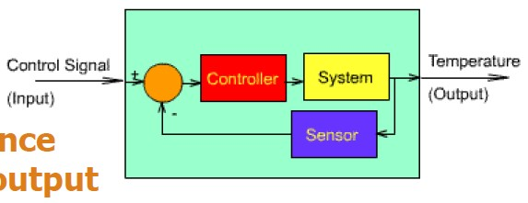

Figure 6 : Feedback Control System

Combination of feed forward and feedback control yields a better result compare to feedback control alone. Among the feedback control, Proportional-Integral-Derivatives (PID) controller is the most popular due to its simple architecture design and simple tuning parameters. In 2011, Delphin2 AUV has utilized the used of the gain-schedule Proportional-Integral-Derivatives (PID) controllers for its movement [15,16]. The design of the controller are decoupled from each other therefore each controller is independent of one another. This is possible because the Delphin2 AUV has a vertical tunnel thruster and horizontal tunnel thruster. The figure 7 shows the Delphin2 AUV.

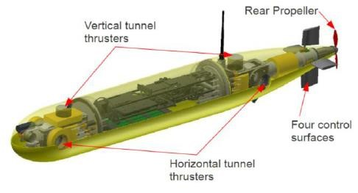

Figure 7 : Delphin 2 AUV

Differently from NPS AUV II, the control for its degree of freedom of pitch and depth depend of the thruster and the control surface which are the fins and rudder. Even though PID controller is an old controller, such controller is still utilized for numerous AUV. From paper [12], the control design for its Sea Fox AUV is the PID control. This is due to its simple to build architecture. Today, there are a lot of complicated and advance control system approach. One of the most advance control system encountered is the adaptive backstepping sliding model controller (ABSMC) [17]. From [12] even though it is using PID control for its AUV, the outcome result of the experiment is acceptable. The PID control used can achieve a steady state error of 0%, a maximum percentage of overshoot of 1.1% and a settling time of 0.03s.
In other research by Maziyah (2011), comparison of PID control and linear quadratic regulator (LQR) control has been studied. The outcomes of the experiment shows that LQR has much better performance of pitching angel where the maximum percentage of overshoot is 4.13%, settling time of 12.2s and a steady state error of zero. The PID control on the other hand yield a maximum percentage of overshoot of 22.5%, a settling time of 88.1s and a steady state error of zero. As from the result, PID control can achieve the same steady state error of zero which is acceptable. As for the maximum percentage of overshoot and settling time PID control did under performed. Yet, the PID control need an accurately modeled system for it to perform efficiently and further tuning of PID control will yield an acceptable performance. As we can see in [12], faster settling time and lower percentage of overshoot can be achieved.
The usage of PID control has also been widely used in designing other physical system. For example, in unmanned aerial vehicle (UAV). In 2011 paper by B. Kada and Y. Ghazzawi, a robust PID controller has been design as the flight control system. The performance of the controller set the experiment are zero steady state error, controllable settling time, minimum rise time 0-90% and percent overshoot and percent undershoot less than 2%. The result yield from the experiment has conform the stated performance [18]. This shows that, a PID control can perform in an acceptable way without compromising on its performance. For intuitive design practice, a set of performance figure must be determined for further PID tuning.

3.0 METHODOLOGY
3.1 Project Flowchart
START

Research and Information
Gathering

Mathematical
Modelling

Familiarization with MATLAB
SIMULINK

SIMULINK Modelling

Controller Design Addition

Simulation

Validation and Comparison

Result Analysis and Conclusion

END

Acceptable

Not Acceptable

Figure 8 : Project methodology flowchart
3.2 Mathematical Modeling of Underwater Vehicle

3.2.1 Coordinate System, vehicle position and kinematics

The necessity to study the vehicle 6 degree of freedom is important in order to know the vehicle orientation and position in three dimensional space and time.
The first 3 degree of freedom for the underwater vehicle can be translated in coordinate system as (x,y,z) which is used to determine position and describe translational motion along X,Y,Z. The second 3 independent coordinates (Ø,θ,Ψ) which is used for describing the vehicle orientation and rotation. Traditionally the component mention above are the available 6 motions of an underwater vehicle which are surge (x), sway (y), heave (z), roll (Ø), pitch (θ) and yaw (Ψ) respectively.
Positional, translational, orientation and rotation motion of a rigid body can be describe relatively from a reference position. For this reason, an arbitrary point on the rigid body are assumed to be rigidly connected to a set of chosen orthogonal axes. Therefore, a reference frame of the system can be obtained. Forces and moment acts on the underwater vehicle will also be referenced to the frame. In this project the standard notation for 6 degree of freedom quantities are taken from [11]. The standard notations can be found in the table below.
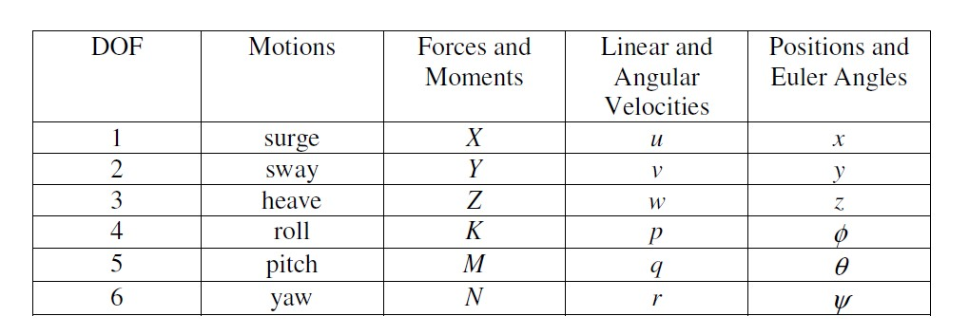

Table 1 : AUV 6 degree of freedom notation

3.2.2 Defining system reference frames

In order to describe and understand the underwater vehicle kinematic equation of motions, the independent positions and angles from table above and a clear reference frames are required. In this project two orthogonal reference frames are used. The first reference frame is called the earth fixed coordinate system. This coordinate system is a fixed coordinate system which is stacked at an arbitrary point at the surface of the sea. Three orthogonal axes are defined in the earth fixed frame which are X, Y and Z. North, East and Downward directions are aligned with the earth fixed frame axes X,Y and Z respectively as shown in figure below. A right-hand reference frame is produced from the earth fixed frame with unit vectors of 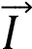, 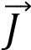, and 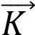. The earth fixed frame component vector of the vehicle is:
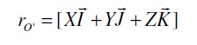 (1)

The second reference frame is the body fixed frame 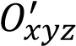, which have the unit vectors of 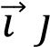, and 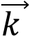. The origin  is located at the centerline of the vehicle where the movement and rotation is defined. In this project the forces and moment of the vehicle will be computed at the center of gravity, CG while the center of buoyancy, CB point is assume at the same point as the vehicle origin . Thus, the hydrodynamic forces will be computed with respect to this point. Relative to the origin of the body fixed frame, the position vector for center of gravity, CG and center of buoyancy, CB are 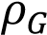 and 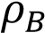 respectively. The vectors can be represented as follows:

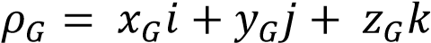

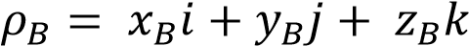

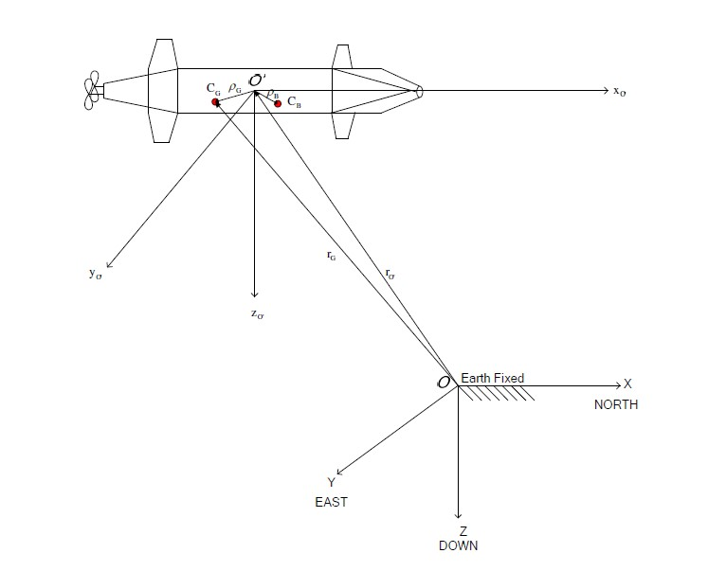

Figure 9 : Body and earth fixed frame coordinate system [4]

3.2.3 Defining system Euler angles

Based on the Euler’s theory of rotation, only three parameter can describe an arbitrary rotation which mean in order for an object to be in a specific orientation, it may subjected to three sequence of rotation which can be described using Euler angle. Therefore, a rotation matrix can be described as a product of three different rotations. In this project, the usage of Euler angle method is utilized although there are many different method to describe an underwater vehicle attitude. The rotation convention used in this project is shown in the figure below.
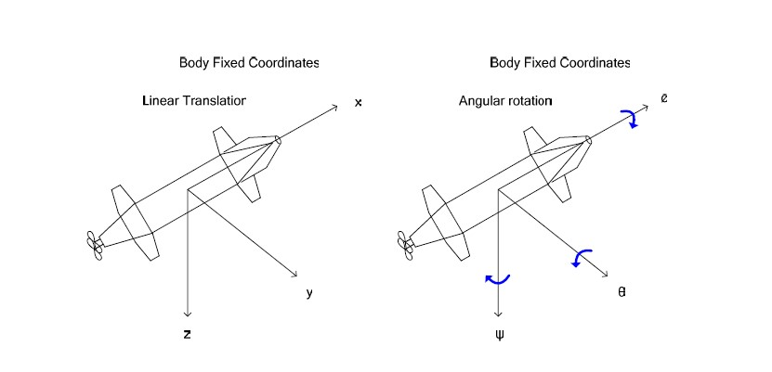

Figure 10 : Body fixed frame coordinates convention

For example, in the earth fixed frame of, a position vector, 𝑟_{𝑂} = [𝑋_{𝑂} + 𝑌_{𝑂} + 𝑍_{𝑂}] will have different coordinates when it is rotated with an angle Ø about X-axis of the earth fixed frame.
The new position is to be assumed as vector, 𝑟₁ = [𝑋₁ + 𝑌₁ + 𝑍₁], then the new vector position in the earth fixed frame can be written with the old vector position as:
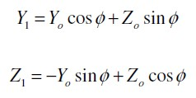
(2)

(3)

By using rotation matrix operation, the relation can be expressed as:
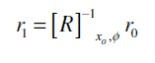
(4)

In rotation matrix operation inverse of [R] is equal its transpose and matrix [R] is an orthogonal matrix of rotation.
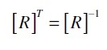
(5)

By multiplying the rotation matrix of [R] with any given vector, the new rotated frame can be obtain. Further subsequent rotation can be done by multiplying the vector with other rotation matrix about y-axes and z-axes.
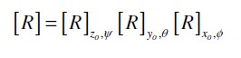
(6)

The above equation (6) of matrix rotation can be expand as follow:

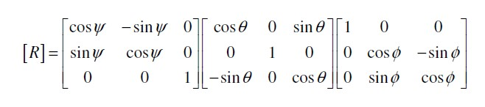
(7)

With multiplication of the above rotation matrices, the final form of rotation matrix that can be used in this project to describe the vehicle orientation is as follow:
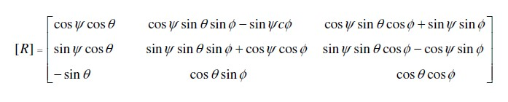
(
8
)

3.2.4 Describing kinematics of the underwater vehicle

Kinematics is defined as a motion of certain object without considering the external forces acting on the object and the mass. In this project linear velocity and angular velocity will be consider as kinematics. In previous section, linear velocity and angular velocity are describe in body fixed frame where as in this section the conversion from body fixed frame to earth fixed frame prior to the expressing the acceleration of the vehicle is discussed. Earth fixed velocity vector can be written as follow:
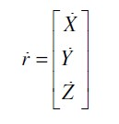
(9)

To obtain the three translation rate above, selecting linear components of the body fixed velocity and multiply it by rotation matrix in equation (8). This will give the linear velocity in the earth fixed frame. The transformation equation can be expressed as follow:

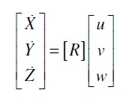
(10)

To covert from earth fixed frame linear rate to body fixed frame linear rate, the earth fixed frame linear rate is multiply by the inverse of the rotation matrix. The relation is shown as follow:

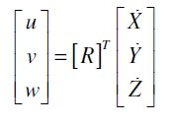
(11)

For the Euler angle rotation rates transformation from body fixed frame to earth fixed frame, the conversion can be achieved by using the given non-orthogonal linear transformation [8].

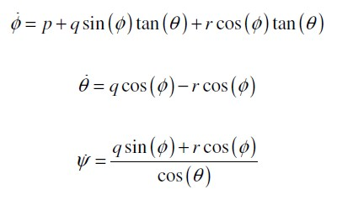
(12)

(13)

(14)

The relation in matrix form for the Euler angle body to earth fixed frame transformation can be written as:

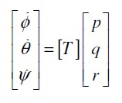
(15)

The [T] matrix is

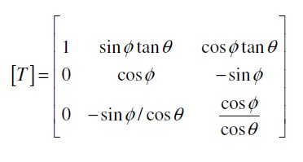

(16)

If the angle of rotation in body fixed frame is considerably small, then the relation of transformation to earth fixed frame is

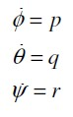
(17)

However for the [T] matrix, its inverse is not equal to its transpose which is different for [R] matrix. This is because [T] matrix is non-orthogonal. To convert the earth fixed frame Euler angle rate to body fixed frame Euler angle rate, the following relation can be used.

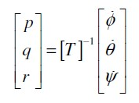
(18)

Where T inverse is
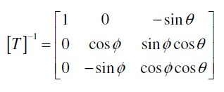
(19)

In body fixed frame the whole velocity matrix can be expressed as:
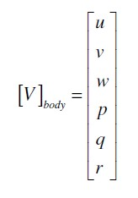

(20)

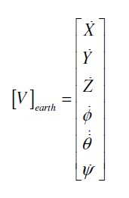
Whereas in earth fixed form

(21)

Therefore the transformation of body to earth can be expressed as
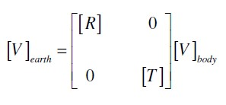

(22)

Whereas the transformation of earth to body can be expressed as

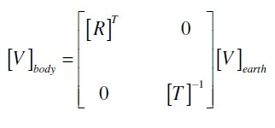
(23)

By substituting equation (8), (16) and (20) into equation (22), the expanded form of the matrix equation describe the kinematic relationship between the rate of change of position and Euler angle of the body fixed frame to the earth fixed frame transformation.
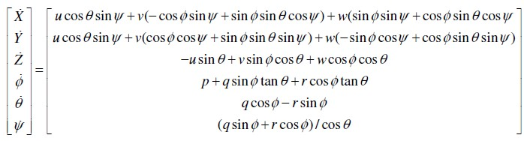
(24)

3.2.5 Describing dynamic equation of motion of the underwater vehicle

In this section, dynamic equation of motion of the underwater will be discussed. After the equations and parameters are obtain in a matrix form representation, then the simulation inside MATLAB can be done.

3.2.5.1 Translational equation of motion

For a position vector denoted by r, rotating with an angular velocity, ω in a frame, the total rate of change or derivative is
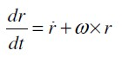
(25)

Therefore the time rate of change of r, is given as follows:

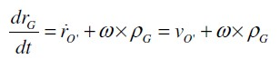
(26)

The 𝑣_{𝑂} expression can be written in either body fixed or earth fixed frame coordinates as follow:
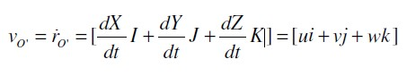
(27)

Note that above expression can be equalized for earth and body fixed frame. This is because 𝑣_{𝑂} expression is a linear change of rate of position.
Then, from equation (26), the earth fixed frame acceleration at the center of gravity, CG can be found by differentiating the mentioned equation. This differential will give:

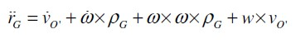
(28)

After the acceleration equation is obtained, the translation forces acting on the vehicle can be expressed by multiplying the acceleration equation with the mass of the vehicle.

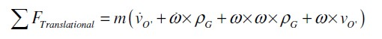 (29)

3.2.5.2 Rotational equation of motion

After developing translation equation of motion, it is required to develop rotational equation of motion of the vehicle because any rotating body produces moments. Therefore, in this project the sum of moment will be computed at the center of gravity, CG of the vehicle. The inertia that need to be computed is represented in the matrix:

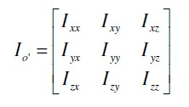
(30)

The expression of each matrix’s component:
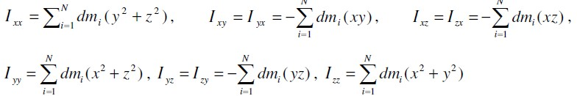

From above expression, 𝐼_{𝑥𝑥}, 𝐼_{𝑦𝑦} and 𝐼_{𝑧𝑧} are the moments of inertia of the body at 𝑋_{𝑂}, 𝑌_{𝑂} and 𝑍_{𝑂} respectively.
The angular momentum of the body is given by:
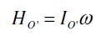
(31)

And the sum of moment at the center of origin of the vehicle’s body is

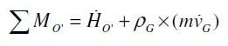 (32)

By differentiating equation (31), the rate of change of angular momentum can be obtained as:
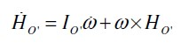
(33)

Recalling the earth fixed position’s acceleration

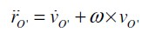
(34)

By substituting equation (33) and equation (34) in to the equation (32), the rotational equation of motion can be expressed as

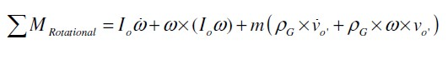
(35)

3.2.5.3 General equation of motion for underwater vehicle (6 DOF)

From the equation (29) three translational equations are obtained whereas from equation (35) three rotational equation are obtained with six unknown velocity (v and ω).
The equations yield are as follow [20]:
Translational:
(36)

(37)

(38)

Rotational:
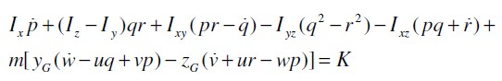
(39)

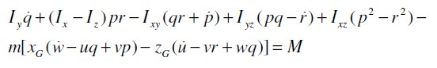
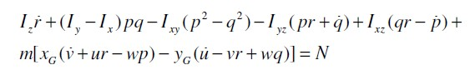
(40)

(41)

3.2.5.4 Hydrostatic (restoring) forces and moments

In hydrodynamic terminology gravitational and buoyant forces are called restoring forces. The gravitational forces is acting downward the Z directional and the buoyant force is acting upward in the Z direction. The equation of the hydrostatic force can be expressed as [8]:

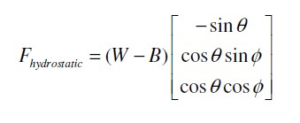
(42)

The moment of the restoring force is computed at the center of gravity for the weight part and the center of buoyancy for the buoyancy part. The equation of the moment can be expressed as follow:

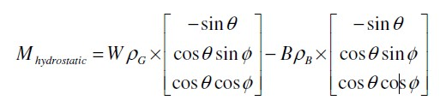
(43)

Therefore the total hydrodynamic forces can be expressed in matrix form as:

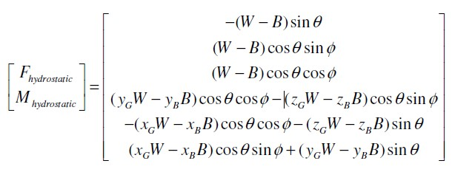

(44)

Hydrostatic forces will be added to the right hand side of the general equation of motion along with hydrodynamic forces and moment.

3.2.5.5 Hydrodynamic Forces and Moment

In this section, the hydrodynamic forces and moment will be discussed. Then, these equation will be equated at the right hand side of the equation (38) and (40) to obtain the full dynamics equation of the underwater vehicle. For this project, designing pitch controller will only require the heave and pitch motion of the vehicle. This is because pitch and depth are combined system and related to each other. The Hydrodynamic equation of pitch and heave are as follow:
Heave:
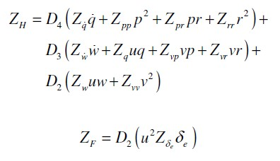

(45)

Pitch:
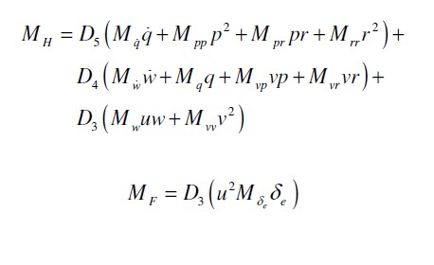

(46)

3.2.5.6 Equation used in this project to design pitch and depth control

- Force in z-direction
(47)

- Moment due to rotation about y-axis

(48)

- Hydrodynamic force in z-direction

(49)

- Hydrodynamic moment due to rotation about y-axis

(50)

Equation these equation to each other will yield full equation of motion of the underwater vehicle. Then, full equation of motion are arranged in matrix form to be solved in MATLAB using a state space approach.
3.3 State-Space method approach

After the mathematical model of the underwater vehicle has been determined. The related equations of motion of the vehicle are arranged in matrix form. The final matrix form of equations can be expressed as follow [8]:

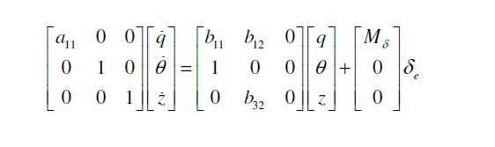
(51)

Where,
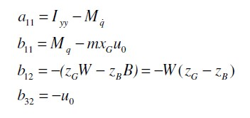

After the matrix form is obtained, state space method is applied by using the following relation:

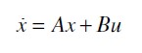
(52)

From the above matrix in order to get the matrix in state space equation, the following step is applied:
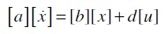
(53)

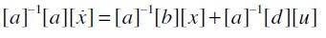
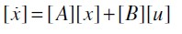
(54)

For the response of the system, the output equation is represented as follow:
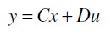
(55)

Where D is a feed forward matrix and usually a null matrix in most system. In this project D matrix will be ignored as the system designed does not have feed forward architecture. The C matrix is the output matrix of the system. The representation of matrix C and D are;

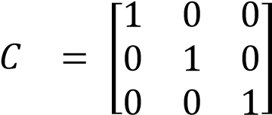 (56)

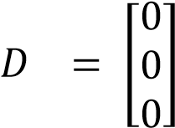 (57)

3.4 Computation of the system transfer function

After the matrix has been converted into a state space matrix form. The computation of the transfer function will be done inside MATLAB. The command entered in MATLAB is
sys = ss(A,B,C,D) tf(sys)

3.5 Designing the control system

After the transfer function of system (pitch and depth) has been obtained from the previous section, the design of the control system can be done inside MATLAB Simulink.
3.6 NPS AUV II Physical properties used in this project
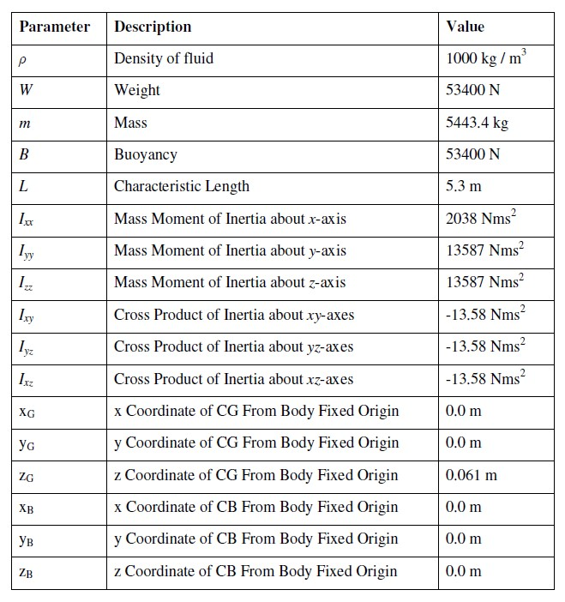

Table 2 : NPS AUV II physical properties [4]

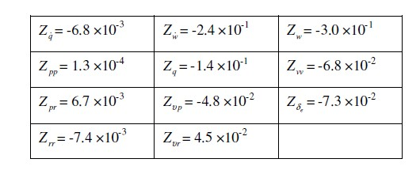

Table 3 : NPS AUV II Heave non-dimensional hydrodynamic coefficient [4]

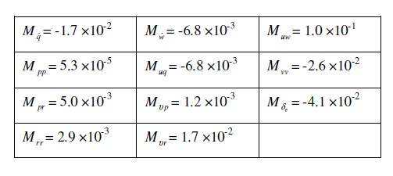

Table 4 : NPS AUV II Pitch non-dimensional hydrodynamic coefficient [4]

4.0 RESULT AND ANALYSIS

4.1 Calculation of the State Space Matrix

From (51), the state space equation can be further transform into the final state space equation form given below [11]:

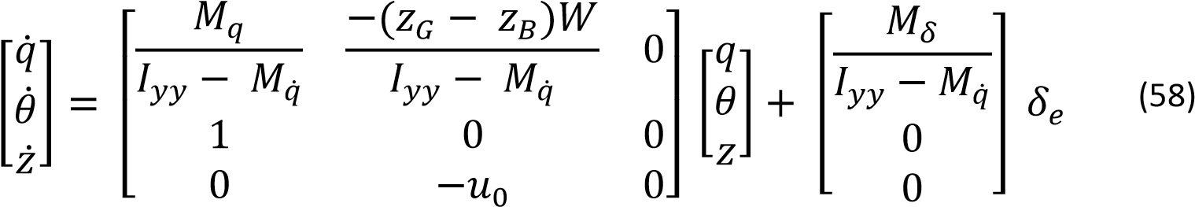

By using equation (58) the component of the state space matrix can be calculated. The value of 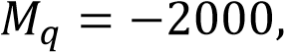  and the linear velocity component of the underwater vehicle is assume to be constant at 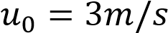. Substituting equation 58 with values will yield the following:
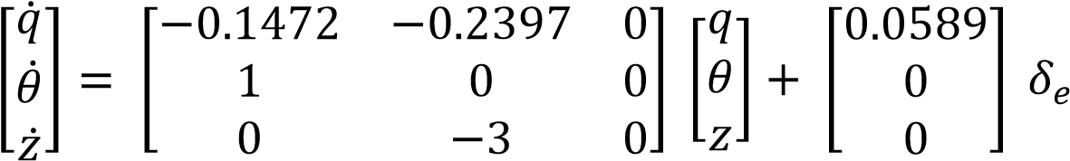 (59)

The transfer function for the pitch angle of the UAV can be found by solving the state space matrix (59) using MATLAB. The following codes were entered:

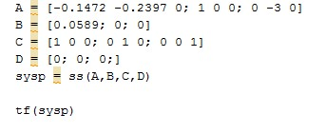

The following result are obtain:

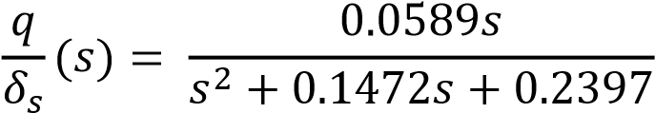 (60)

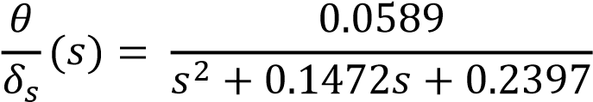 (61)

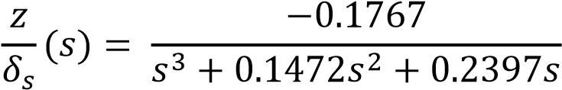 (62)

After solving the state space matrix in Matlab, the transfer function of q, pitch angle, θ and depth, z are obtain respectively.

4.2 Open loop respond of the system

For designing the pitch motion controller, transfer function equation 61 is considered. Open loop respond of the system is obtain by constructing the following block is Matlab Simulink software:
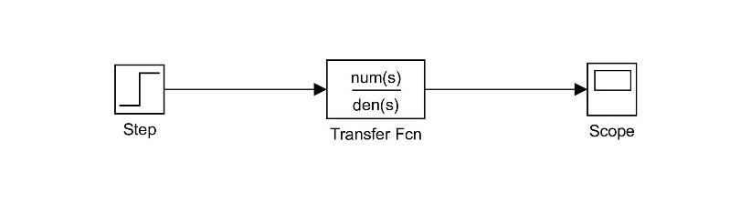
Figure
11

:
Open loop pitch control block

The step input for the simulation is set to 1 radian. After simulation complete, the respond of the open loop system is obtained as shown in figure 12:
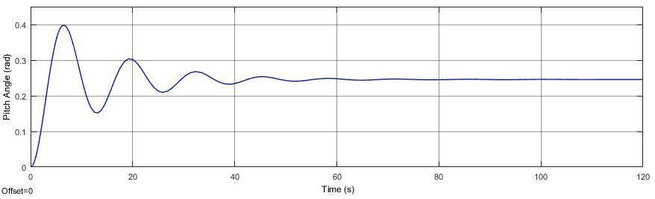

Figure 12 : open loop respond of pitch motion
From the respond the steady state error of zero percent is not achieved and the system performance is poor due to high settling time of 80 seconds and the system oscillate. Therefore, a PID controller is needed to compensate the poor system respond.

4.3 Designing PID controller for pitch motion

When designing a PID controller, the effect of each controller is taken into consideration. For example a proportional controller (Kp) will reduce the rise time but cannot eliminate steady state error. Whereas integral controller (Ki), will help in eliminating steady state error but will result in slower respond time. Increasing derivatives controller (Kd) will increase the stability and reduce overshoot. The characteristic of each controller can be shown in table 5 below:

Controller | Rise time | Overshoot | Settling time | Steady state error
Kp | Decrease | Increase | Small change | Decrease
Ki | Decrease | Increase | Increase | Eliminated
Kd | Small change | Decrease | Decrease | No change

Table 5 : Characteristic of PID controller

PID controller is designed in Matlab Simulink by constructing parallel PID control block. The control block for the pitch motion is shown in the figure 13:
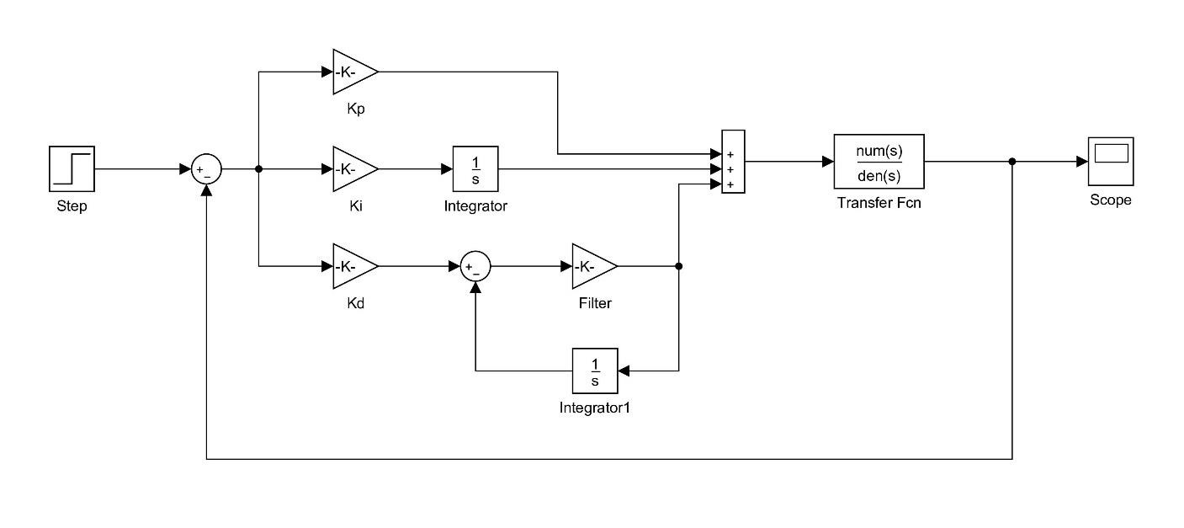
Figure 13 : Pitch motion PID control block

After the pitch control block is constructed, the value of PID controller is determined using try and error method for first attempt and PID Matlab tuner for second and third. The value of PID values for attempts are tabulated in the table 6 below.
Controller | Tuning 1 | Tuning 2 | Tuning 3
Kp | 7 | 8.77 | 17.958
Ki | 3 | 1.92 | 3.7848
Kd | 8 | 9.98 | 21.242
Filter | 100 | 100 | 172.18

Table 6 : PID Tuning values

The respond for each tuning is plotted in the below figures.
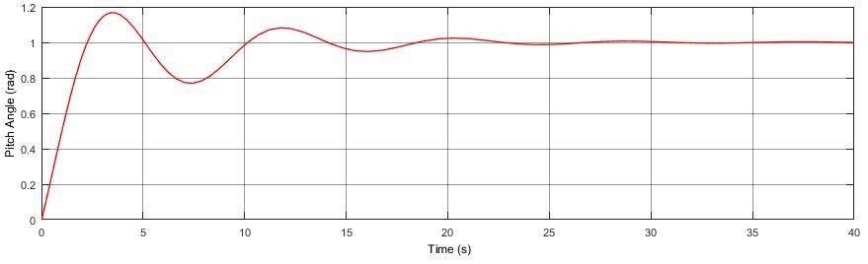

Figure 14 : Tuning 1
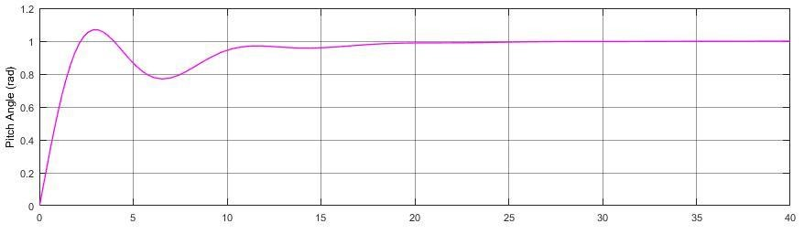

Figure 15 : Tuning 2

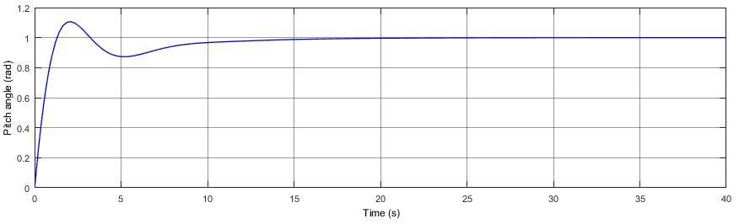

Figure 16 : Tuning 3
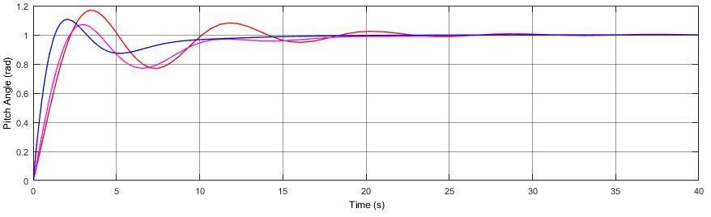

Figure 17 : Tuning Comparison

The performance of the controller for each tuning are tabulated in the table 7.

Performance | Tuning 1 | Tuning 2 | Tuning 3
Rise time (s) | 1.73 | 1.63 | 0.961
Settling time (s) | 21.3 | 17.6 | 12.8
Overshoot (%) | 16.8 | 7.04 | 10.6
Closed loop stability | Stable | Stable | Stable

Table 7 : Tuning test performance

For the tuning attempt, the optimum value of Kp, Ki and Kd are determined and tuned by using built in Matlab PID tuner. The value of Kp, Ki and Kd are tabulated in the table 8:
Controller | Value
Kp | 17.958
Ki | 3.7848
Kd | 21.242

Table 8 : PID controller value

The filter gain in the Kd block is determined to be 172.18. The filter gain is to reduce the system oscillation due to increase in Kd value. The step input of the system simulation is set to 1 radian of pitch angle and total simulation time of 40 senconds. The respond of the pitch motion system after applying PID control is shown in the figure below:

Figure 18 : Pitch motion PID respond

The result for the performance of the system are tabulated in the table below:

Rise time (s) | 0.961
Settling time (s) | 12.8
Overshoot (%) | 10.6
Closed loop stability | Stable

Table 9 : Performance of PID controller
The figure 19 shows the open loop respond and respond with PID controlled applied.

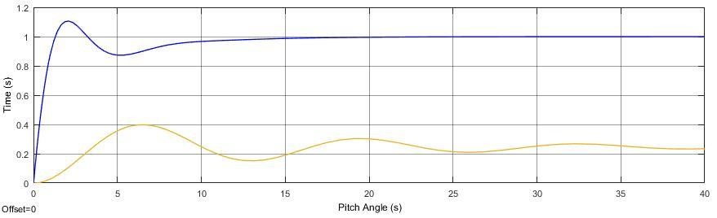
Pitch angle (rad)

Time (s)

Figure 19 : Tuned PID and open loop comparison

4.4 Comparing the performance of designed PID controller

The performance of the designed PID controller in this project are compared with other AUV project and research for validation purposes. The project taken for comparison is USM underwater glider project [19]. The result performance of each projects are tabulated in the table 10 below:

Controller performance | NPS AUV II  (this project) | USM underwater glider  [19]
Rise time (s) | 0.961 | 7.23
Settling time (s) | 12.8 | 88.1
Overshoot (%) | 10.6 | 22.5
Steady state error | 0 | 0

Table 10 : Comparison of PID performance data

In [19], the research is about comparing the performance of PID control with Linear Quadratic Regulator (LQR). In the research the performance of LQR is much better compare with the PID controller. LQR has a rise time, settling time and percentage overshoot of 5 seconds, 12.2 seconds and 4.13 percent respectively.
From the table 10, comparing the PID controller in [19], the PID controller designed for this project performed much better and its performance is close to a much advance controller which is the LQR.

4.5 Designing combine pitch and depth controller

Conventionally, pitch controller is designed together with depth controller. The design should be combined and formed the inner loop control for most AUV motion control system. In this project, the combine pitch and depth control are designed by constructing the control block using the previously designed pitch control block as the inner loop of the depth control design block. The depth control block is shown in the figure 20 below:

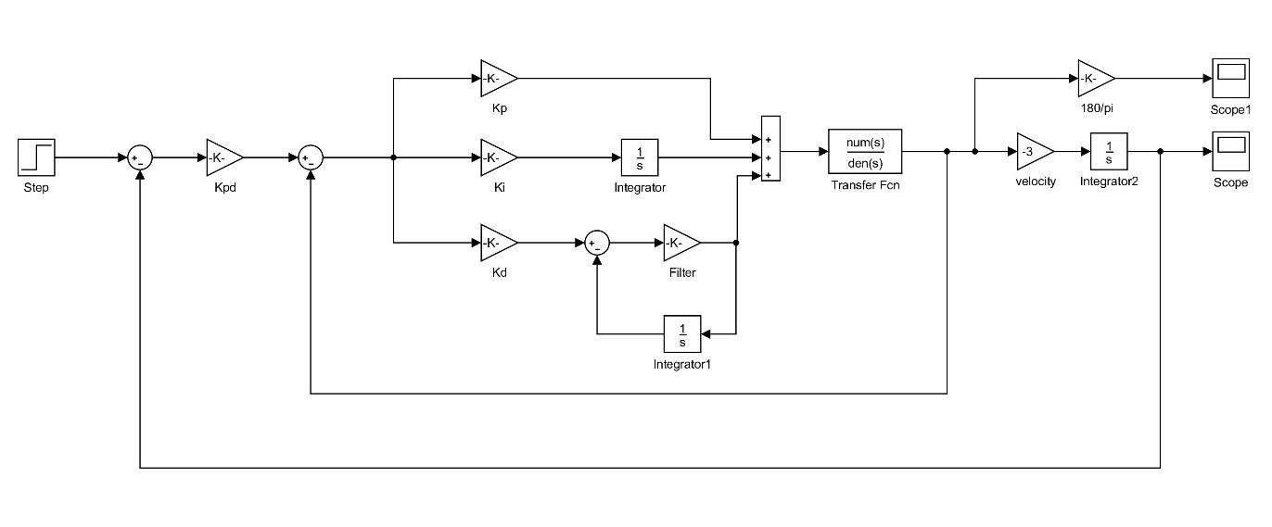

Figure 20: Combine pitch and depth control block

For the depth control design, proportional gain control is considered. This is because adding a new block of PID control outside the pitch block control will cause the system to be unstable. Tunning of the proportional gain of the depth control is done by using Matlab Simulink tuner. The depth proportional gain, Kpd is determined to be -0.267.

Adding new loop and proportional gain outside the pitch motion control block will result a changed in the system behaviour. Thus, the inner loop of the block need to be retuned. The value of Kp, Ki, Kd and Kpd are obtained and tabulated in the table 11:
Controller | Value
Kp | 17.958
Ki | 3.784
Kd | 21.241
Kpd | -0.267
Filter gain | 172.177

Table 11 : Combine pitch and depth controller value

The step input for the depth controller is set to 1 meter with simulation time of 40 seconds. The respond of depth controller and the pitch angle deflection are shown is the figure 21 and 22 below:
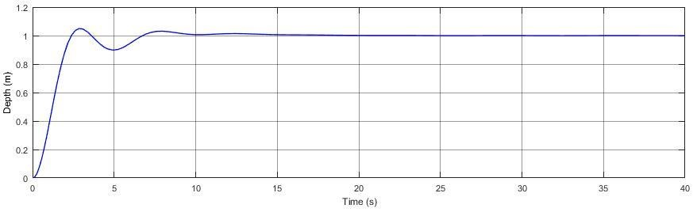

Figure 21 : Depth respond of AUV
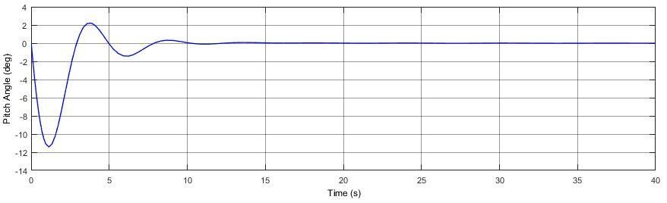
Figure 22 : Pitch respond of AUV
From the figure, when the depth command of 1 meter is input, the pitch angle of the vehicle is deflected downward given by the negative value of the angle. This pitch angle motion is caused by the actuated surface control of the vehicle.
From the plot, both have almost the same settling time around 8 seconds. This indicates that when the vehicle has achieved certain depth, the vehicle pitch angle will come back to zero degree. This proved that the pitch controller designed in this project is working as intended. Depending on the vehicle depth motion the pitch angle will deflect positively or negatively.

The performances of combine pitch and depth controller are tabulated in table 12.

Performance | Depth controller | Pitch controller
Rise time (s) | 1.55 | 0.681
Settling time (s) | 8.83 | 8.13
Overshoot (%) | 4.92 | 37.0
Closed loop stability | Stable | Stable

Table 12 : Performance of combine pitch and depth control

5.0 PROJECT MILESTONES AND GANTT CHART
5.1 Project Milestone FYP1

Week | 1 | 2 | 3 | 4 | 5 | 6 | 7 | 8 | 9 | 10 | 11 | 12 | 13 | 14
Completion of
Research and
Information
Gathering
Completion of
Extended Proposal
Completion of
Proposal Defend
Presentation
Completion of
Mathematical
Modelling
Completion of
Familiarization with MATLAB Simulink
Completion of
Interim Report

Table 13 : FYP 1 Project Milestone
.2 Project Milestone FYP 2
Week | 1 | 2 | 3 | 4 | 5 | 6 | 7 | 8 | 9 | 10 | 11 | 12 | 13 | 14
Completion of
Simulink
Modelling
Completion of
Controller
Design
Completion of Simulink simulation
Completion of Validation and comparison
Completion of Result analysis and conclusion

Table 14 : FYP 2 Project Milestone
.3 Gantt Chart FYP 1
Week | 1 | 2 | 3 | 4 | 5 | 6 | 7 | 8 | 9 | 10 | 11 | 12 | 13 | 14
Project topic conformation
Research and information gathering
Extended proposal submission
Proposal Defend
Presentation
Mathematical modelling
Familiarization with MATLAB
Simulink
Progress Report
Submission

Table 15 : FYP 1 Gantt Chart
.4 Gantt Chart FYP 2
Week | 1 | 2 | 3 | 4 | 5 | 6 | 7 | 8 | 9 | 10 | 11 | 12 | 13 | 14
Simulink
Modelling
Controller
Design
Simulink
Simulation
Validation and comparison
Result and
Discussion

Table 16 : FYP 2 Gantt Chart

6.0 CONCLUSION AND RECOMMENDATION

In this project, a simulation of pitch motion controller of an underwater vehicle is designed. The equation of motion of the vehicle are developed by obtaining the kinematics and dynamics equations of motion for a rigid body. Addition to the pitch motion controller, combine pitch and depth controller is also designed. Conventionally, this controller contributed to the inner loop control of the vehicle where the outer loop control is heading and sway control.
Solving the equations of motion for pitch and depth using state space approach, the controller are designed in Matlab Simulink. Starting, with open loop block diagram to obtain open loop respond. Then, PID controller is designed for the pitch motion. Applying built in PID controller tuner, the value of each PID control are determined. Combine pitch and depth control is designed by introducing an outer loop of the pitch controller. Using proportional gain control, the depth controller is designed and same method of tuning is applied to obtain the value of combine PID pitch controller and Proportional depth control.
The results obtained from this project is then compare to other PID based controller project for underwater vehicle to compare the performance of the designed controller. Due to limitation of actual model or prototype to work with, this method is consider to be viable. The performance of the controller designed in this project is said to be acceptable.
Recommendation for future improvement of this project or future work, a real prototype of an underwater vehicle should be built, and then applying the control system is adequate. The purpose of working with real prototype is much more convincing and experiments of control can be further validated.

7.0 REFERENCES

- S. C. Martin and L. L. Whitcomb, “Preliminary experiments in fully actuated model based control with six degree-of-freedom coupled dynamical plant models for underwater vehicles,” IEEE International Conference on Robotics and Automation, Karlsruhe, Germany, pp. 4621- 4628, 2013.

- M. Doniec, I. Vasilescu, C. Detweiler, and Daniela Rus, “Complete SE3
Underwater Robot Control with Arbitrary Thruster Configurations,” IEEE International Conference on Robotics and Automation, Anchorage, Alaska, USA, pp 5295-5301, May 2010.

- S. Y. Bian, Z. H. Gao and C. Yun, “Dynamic analysis and motion control of 6-
DOF underwater robot,” Chinese Journal of Mechanical Engineering, vol.43, no.7, pp.87-92, 2007.

- Geridonmez F. “Simulation of Motion on an Underwater Vehicle.” The Graduate School of Natural and Applied Sciences of Middle East technical University, Ankara, Turkey; 2007.

- P. Stevenson, M. Furlong, and D. Dormer. “Auv shapes - combining the practical and hydrodynamic considerations.” In OCEANS 2007 - Europe, pages 1-6, 2007.

- S. McPhail. Autosub6000: “a deep diving long range AUV.” Journal of Bionic Engineering, 6:55-62, 2009.

- B. Burcher and L. Rydill. “Concepts in Submarine Design.” Cambridge Oceans Technology Series, 1994.

- Donald. P. Brutzman, “A Virtual World for an Autonomous Underwater Vehicle,” Naval Post Graduate School, Monterey, California, December 1994.
- REMUS, Autonomous Underwater Vehicle Systems, http://www.hydroidinc.com/remus600.html, Last accessed date: October 2016.

- Theseus Autonomous Underwater Vehicle,, Last accessed date: October 2016.

- Thor I. Fossen, “Guidance and Control of Ocean Vehicles,” John Wiley, Norway, 1994.

- McLauchlan. L. “Simulation and Control of an Unmanned Surface Vehicle.” 121st ASEE Annual Conference & Exposition. June 2014.

- Steeson. V, Turnock. S. R, Philips. A. B et al. “Model Predictive Control of a
Hybrid Autonomous Underwater Vehicle with Experimental Verification.” University of Southhampton, Southhampton, UK; 2014.

- Leonard NE, Graver JG. Model-based feedback control of autonomous underwater gliders. Oceanic Engineering, IEEE Journal of. 2001; 26(4):633-45.

- L. V. Steenson, A. B. Phillips, E. Rogers, M. E. Furlong, and S. R. Turnock. Preliminary results of a hover capable AUV attempting transitional flight. In Unmanned Untethered Submersible Technology (UUST), 2011.

- L. V. Steenson, A. B. Phillips, E. Rogers, M. E. Furlong, and S. R. Turnock. Control of an AUV from thruster actuated hover to control surface actuated flight. In Specialists Meeting AVT-189/RSM-028 Assessment of Stability and Control Prediction Methods of NATO Air & Sea Vehicles, 2011.

- Qingmei Li, Shaorong Xie, Jun Luo, Peng Wu and Jiqing Chen, Pitch Reduction System Design and Control for An Underwater Vehicle, Proceedings of 2014 IEEE International Conference on Mechatronics and Automation, Tianjin, China; 2014.
- Kada. B, Ghazzawi. Y. “Robust PID Controller Design for an UAV Flight Control
System.” Proceedings of the World Congress on Engineering and Computer Science 2011 Vol II. San Francisco, USA; 2011.

- Maziyah Mat Noh, Mohd Rizal Arshad & Rosmiwati Mohd Mokhtar, Depth and pitch control of USM underwater glider: performance comparison PID vs. LQR, Indian Journal of Geo-Marine Sciences Vol. 40(2), April 2011, pp. 200-206.

- Lingli Ni, “Fault-Tolerant Control of Unmanned Underwater Vehicles,” Blacksburg, Virginia, June 29 2001

