Data Warehousing Tableau Assignment

The Superstore just like many other businesses rely on data and proper analytics to make strategic decisions for the short and long term. Superstore sells three different categories of products: Furniture, Office Supplies and Technology. The business has been operational since 2014 selling to all different regions of the US.
With the help of the Tableau software the company can visualize and analyze sales, profits and much more for each product across all regions within the US. This kind of information is important for an organization to posses in such a fast and evolving market. The report and graphs described below will assist decision makers in properly targeting the low performance areas and products, develop segment marketing campaigns for weak regions, and continue to expand on profitable ventures.
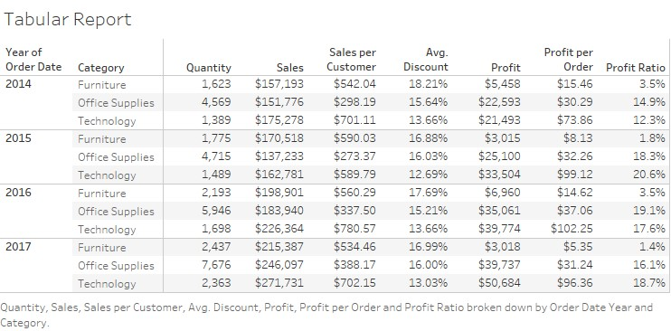
In this first report we examine multiple fields across 4 years the company has been active. Without the help of much visual aid we see that the company has increased quantiy and sales through the course of the years, yet profit hasn’t always maintained on the rise especially in the
Furniture categotry. These types of reports are the premises for more visual guides that can later be developed with Tableau. With the use of charts and graphs we can quickly analyze patterns and get a more accurate reading of the company’s state of business.
Bump Chart: A Bump Chart is a chart that shows the change in rank over time. It easily conveys changes across a period and depicts a beginning and end for the data. This Bump chart looks at profits across the market for super store. We can see that the West coast ranked #1 through the first part of the and having a fall come April time, while the East coast started at the bottom of the rankings and made a climb to rank 2nd by years end. Based upon this data management can measure why a region declined or inclined throughout the year.
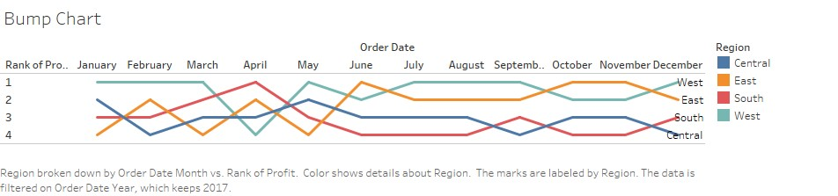
Step n Jump Graph: Straight lines portray a constant rate of change between two data points, but it’s not immediately obvious how long the value at a specific point lasts or how big the change is between the points. Step n Jump line graph are a great way to showcase durations of values and magnitudes of change. In this Graph we see the change over a 52-week period of Sales of Office Supplies from
Superstore.
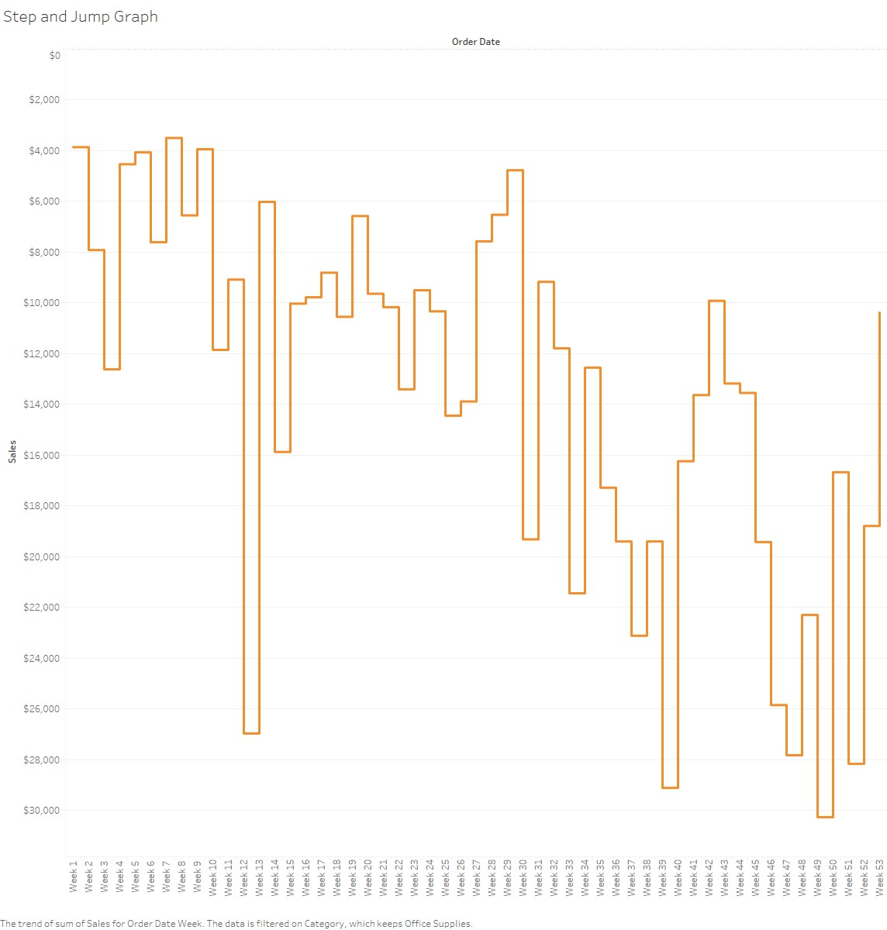
Waterfall Chart: A waterfall chart is a form of data visualization that helps in understanding the cumulative effect of sequentially introduced positive or negative values. These intermediate values can either be time based or category based. In here we see the running sum of profit from Superstore for the of 2017 accounting for profit.
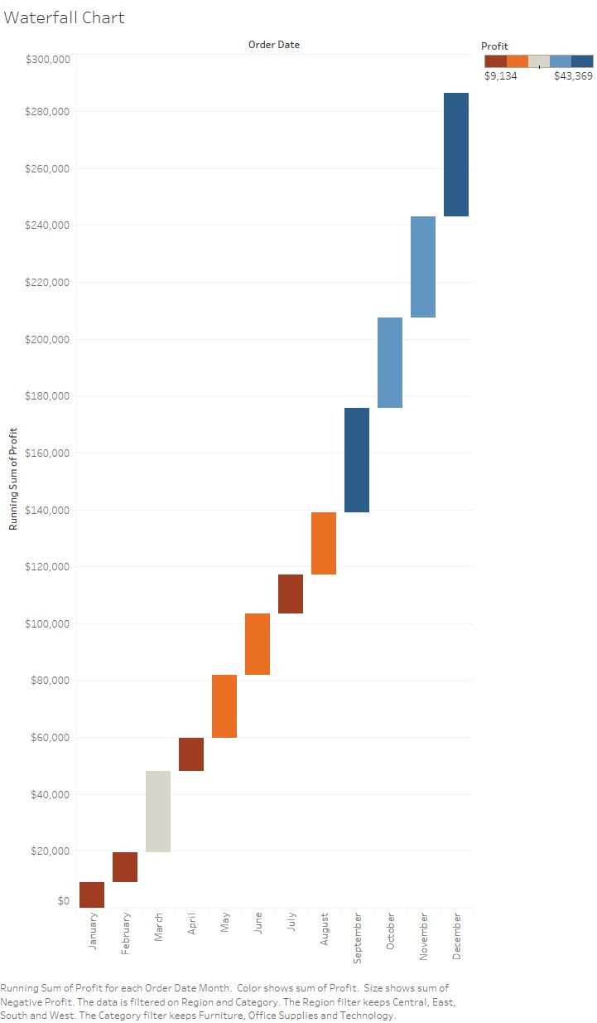
Profits by States Graph: This graph identifies each states profits for the 2017 year. States on the orange side of the scale are down in profits while states on the blue side of the scale are up in profit. When you click on each state you’re able to break it down further showing each county and its profits. This helps management identify regions where there is weakness and opportunity.
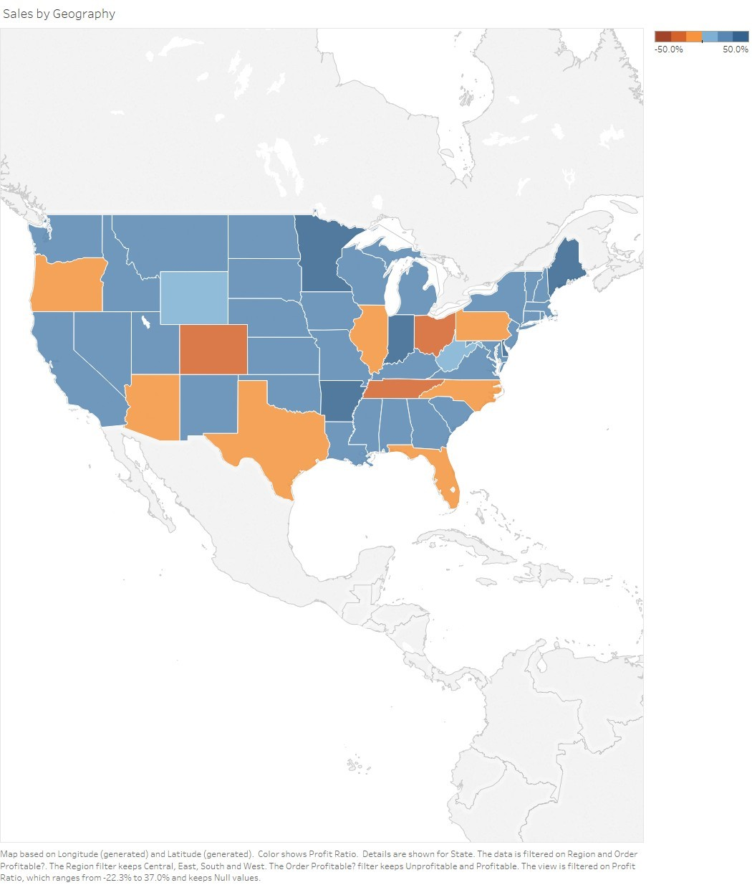
Powered by TCPDF (www.tcpdf.org)

