Data Center Transformation and Backup Project Charter

HIGH-LEVEL PROJECT SCOPE
This project addresses the needs of Data Savers Company (DSC) for upgrading their existing three legacy data centers and migrating their applications and eligible applications to a cloud storage service. The company under consideration to offer the cloud computing storage services is Azure due to the pricing convenience and the cloud storage plan. The Data Savers Company is a company that processes a vast amount of data that requires security and safety to ensure no data is lost in case of an accident where data integrity may be compromised. Data Savers Company has three data centers where two of the data centers are for production, whereas one is essential for disaster recovery.
To ensure efficient data to customers, Data Savers Company has applied 2 MPLS and one point-2point protocol for data transmission available at the three data centers to ensure efficient data transfer for users and traffic. The total amount of data required to be transferred t a cloud server for backup includes 145 enterprise applications and 1350 servers; there are 450 windows servers, 550 Unix Servers, 350 ESX,
VMWare, and legacy AIX servers. The success of this upgrade is essential to the future of the Data Savers Company and the services they offer to their clients.
Azure cloud services are preferred as a cloud provider due to their advantages compared to other providers available in the market, such as AWS and Google cloud. Due to the availability of their numerous servers available to satisfy all the storage requirements. Since Azure offers lower per GB prices to their customers, this is a tremendous economic factor to consider when deciding on the cloud computing service. Azure is considered due to the quick learning of their platform, which takes less time than learning about AWS services. This will enable the team assigned to securing the data in a cloud server to quickly understand the platform without consuming precious time that could be saved.
1.
High-level project requirements
Transferring available data in the two legacy servers to the recently acquired cloud service provider.
Ensuring that applications transferred to the cloud server are stable and will run efficiently after the data center upgrade.
Ensuring the safety of the method used in data transfer after the cloud platform on the cloud servers is correctly configured to allow the data stored there.
Ensure the technology chosen to upgrade the data centers is stable and will be available for use in a long time before another upgrade is required.
Legacy data centers available at Data Savers Company include data that has been stored for decades. That is essential for the company's performance since it contains vital data used in the daily running of the company.
These available data centers handle a vast amount of data which makes storing data to a cloud server for efficient upgrade a crucial task that requires to be completed with minimal chances of failure.

2. Business needs
The available three legacy data centers available at Data Savers Company (DSC) requires an upgrade due to the following reasons;
- The current systems make data security worse, considering the current technological advancements in data centers.
- Management of the current data centers is not cost-effective due to the many hours of handling breakdowns. iii) Compatibility issues of the applications in use with the current technology are a threat to business interactions.
iv) The systems are unhealthy for employee training because it’s an outdated technology. v) Losses to the business due to breakdowns.

3. Early estimation and forecasted cost
Acquiring of cloud computing service: $350,000
Upgrading of the existing legacy servers: $900,000
Software’s upgrade: $200,000
Contingencies amount: $150,000
Contingency reserve: $150,000

4. Stakeholder analysis (roles and responsibilities)
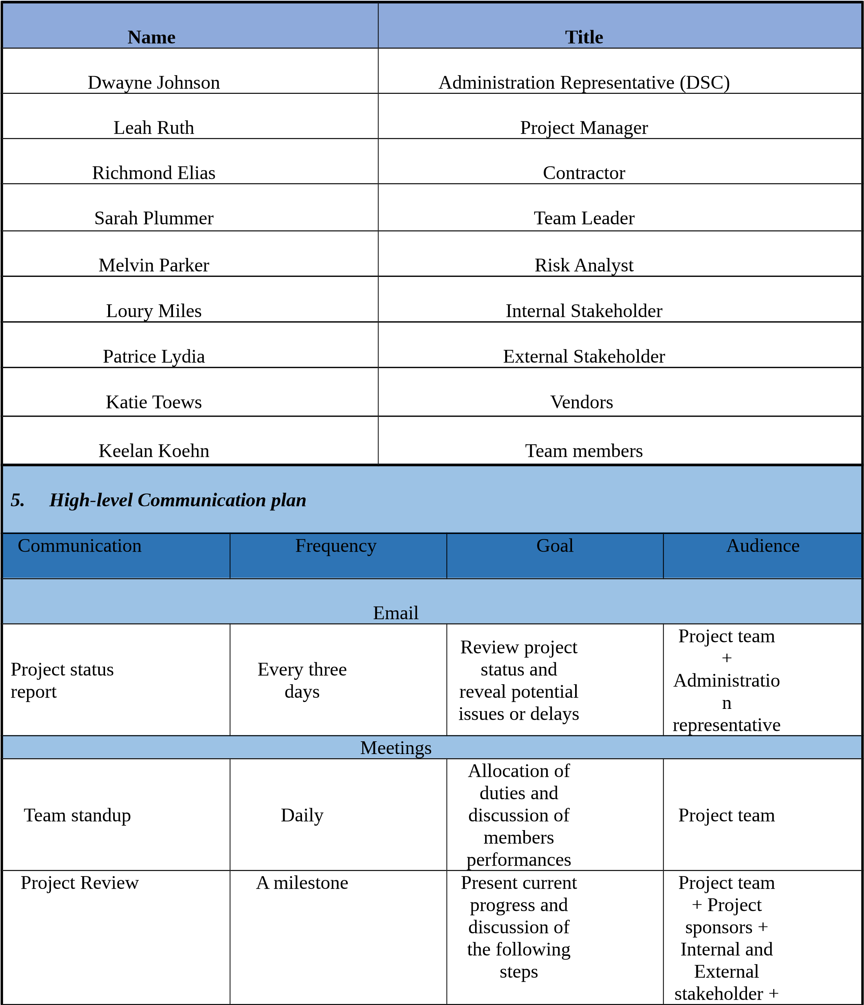
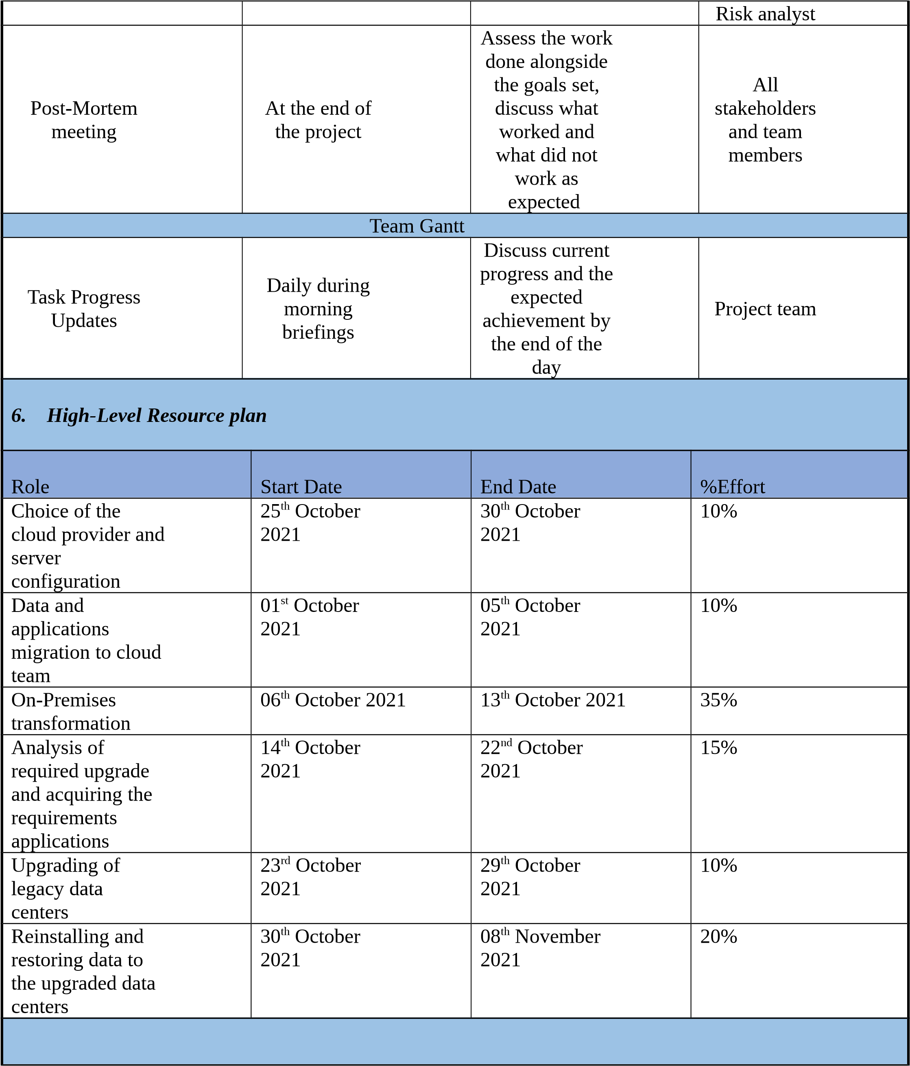
6
. Early risk indications
Early risk indicators in this project may include;
i)
No documented milestone deliverable in due dates
ii)
Significant risks to the project identified after project kick-off
iii)
Project team members lack the required skills in different levels of project development.
iv)
Absenteeism by involved personnel in the progress of the project.
v)
Unbudgeted expenses experienced during project progress.
vi)
Project members have low morale.
vii)
Functional, reliability, and performance not documented.
viii)
Unnecessary pressure from the administrators
8.
PROJECT AUTHORIZATION
Approved by:
Date
Approved by:
Date
Powered by TCPDF (www.tcpdf.org)

