CW2 Final Simulation Dissertation
Executive summary:
This report provides the operations and performance of The Lion King, both in terms of corporate and departmental performance from year 1 to year 6.
The first section is the introduction to the Lion King, where the past, current and future scenarios with respect to the mobile technology and Lion King are listed, followed by the performance overview in years 1 to year 3.
Following this is the Critical Appraisal Report (CAR) 1, with specifications to the production and operations department of year 4. It provides a literature review on the theories used, the market outlook, goals and strategies, performance analysis and recommendations for the next year.
The CAR 2 then follows, with specifications to the marketing department, with a structure similar to the CAR 1 and then followed by CAR 3, where the specifications are described with the finance department.
This is then followed by the team performance review where the teamwork theories are discussed and then the overall performance of the Lion King as a team is evaluated.
The finale of the report is the individual reflection, where the two most influential theories to the author are discussed followed by the author’s personal reflection through years 1-6 and a conclusion.
Table of Contents
1.0 Introduction: 4
2.0 Production and operation department (Year 4): 7
2.1 Introduction 7
2.2 Literature Review 8
Forecast production and operations management 8
Inventory management 8
Demand management 9
Learning curve 9
2.3Business Analysis 9
Market condition / Situation analysis 9
2.4Corporate Goals and Strategy: 10
Corporate Goals 10
Competitive strategy 11
Production Goals 11
Production Strategy 11
2.5 Analysis of the Company Performance 11
2.6 Recommendations for next year 14
2.7 Conclusion 15
3.0 Department of Marketing (year 5) 17
3.1 Introduction 17
3.2 Literature Review 17
Product design: 17
Product positioning: 18
Marketing mix: 19
Pricing Strategy: 20
3.3 BUSINESS ANALYSIS 20
Market outlooks / Situation analysis 20
3.4 Corporate goals and strategy 21
Corporate Goals: 21
Competitive strategy: 21
Goals and strategy of department 22
Department goals 22
Department Strategy 22
3.5 Analysis of Company Performance 24
3.6 Recommendation for next round 26
3.7 Conclusion: 27
4.0 Department of Finance 29
4.1 Introduction 29
4.2 Literature Review 29
CAPITAL STRUCTURE: 29
COST OF CAPITAL: 30
EQUITY FINANCING: 30
RETURN OF CAPITAL EMPLOYED: 30
TOTAL SHAREHOLDER RETURN: 31
DIVIDEND POLICY: 31
NET PRESENT VALUE: 32
4.3 Situation analysis / Market outlooks 32
4.4 Corporative goals and Core Strategy: 33
Corporative goals 33
Competitive strategy 33
Department Goals 33
Department Strategy 34
4.5 Analysis of company performance 34
4.6 Recommendations for the next round 37
4.7 Conclusion 37
5.0Team Performance Review 39
5.1 Introduction 39
5.2 Literature review 40
Leadership: 40
Motivation: 40
Teamwork: 41
Team roles allocation: 43
Organizational culture: 43
Commitment: 43
5.3 Evaluation of team performance 44
1.Decision making and Team work: 44
2.Leadership: 44
3.Cohesiveness 44
4.Commitment 45
5.4 Recommendation and conclusion 46
6.0 Individual reflection 48
6.1 Introduction 48
6.2 Personal reflection 48
6.3 Conclusion..............................................................................................................49
7.0 References 51

1.0 Introduction:
In the late 1980’s, during the economic recession, The Lion King was set up as the result of the new era of second generation (2G) technology in mobile communications which led to heavy investments in the R&D in the mobile handsets industry.
The Lion King is a mobile handset company that offers its customers with the best technology of mobile telecommunications present. In the early 2000’s, The Lion King also started producing the third generation (3G) technology in handsets, to its customers. The pace of mobile technology has been on a rapid growth that the fourth generation (4G) technology has been tested and proved viable.
The Lion King’s previous management team could not keep up with the quick advancements in the mobile technology industry, so the Lion King had to replace the top management team with new people. This new management team includes Nikhil Shivakumar (me), as one of the top management team. This team will be managing the production and operations department, marketing department and the finance department for the next 6 years. The Lion King started its operations in the USA and then extended operations in Asia and Europe due to the fast growth of the mobile communications industry. In Europe, the laws are complicated, so the Lion King does not have permission to setup manufacturing plants in Europe but can sell goods there, by importing it either from USA or Asia. As a result of the rapid advancements in this industry, The Lion King can outsource licenses and technology and productions also.
Lion King

Critical Appraisal Report – 1
Production and Operations Department
(Year 4)

2.0 Production and operation department (Year 4):

2.1 Introduction
The Lion King’s production and operations department has the responsibilities of production planning, both the in-house and contract manufacturing, in-house development, buying technology and design licences, planning of investments in new plant and tech products, managing inventory and managing logistics of all the three operational regions USA, Asia and Europe. For year 4, the company provides tech 1 and tech 2 same as year 3 in USA, tech 1 and tech 3 in Asia at the same time tech 2 sales has been stopped, tech 2 and tech 4 in Europe at the same time tech 1 sales has been stopped.
In year 4, the challenge faced by the Lion King’s production department is maximising the production capacity to meet its products demands. Lion King has their manufacturing plants in the USA and Asia. The market share was 10.93% in the 3rd year, to meet the required demand and to increase the market share, the capacity utilization was used up to 100%, that is, 8040k units in the USA and 4190k units in Asia. Lion King holds 17 manufacturing plants in total, 12 production plants in the USA and 5 production plants in Asia. The production cost remained constant while the outsourcing costs have fallen by 4% – 6% as the outsourcing capacity continues to rise at the rate of 13% in the USA and 19% in china.
In terms of R & D, Lion king has invested in the development of new features in tech
1, tech 2 and tech 3 with 46663k USD, 39593k USD and 46663k USD respectively. Lion king also purchased 2 additional features, one for tech 3 and one for tech 4 in this year. This will lead the Lion King to offer 2 additional features.
For logistics, the products which are produced in the USA are first prioritised to the USA, then to Asia and Europe. Similarly, the products which are produced in Asia are first prioritised to Asia then Europe and later the USA. In the USA, only tech 1 tech 2 and tech 3 products are manufactured and in Asia, only tech 2 and tech 4 products are manufactured. The transfer pricing is set to 2.00 for both the USA to Europe and for Asia to Europe, as the Euro rebounded it led to the taxable profit of 288408k USD only from Europe, with demands to meet its expectations.

2.2 Literature Review

Forecast production and operations management
The forecasting method of production and operations management are used by organizations to execute the production strategies. This method of forecasting involves several methods of estimating to resolute the possible outcomes for the business in the future. The job of the operation management is to plan these possible outcomes in their organizations. Creating, developing, producing and distributing products are the important aspects of the operation management for the organization. The future based forecast of all these decisions are both long term and short term strategy plans (Brain Bass, 2017).

Inventory management
The flow of goods from manufacture to warehouses and from these facilities to point of sale are administrated by the inventory management. Inventory management keeps a detail record of every new and return product as it enters or exits a point of sale, which makes it the key function of the management.
Inventory management is a complex process, mainly for larger organizations. The fundamentals of every organisation are the same nonetheless of the organisations size and type, goods are delivered to the warehouse in the form of raw materials where they are put into stock areas. Inventory management keeps track of goods through serial numbers, cost of goods, quality of goods, lot numbers and the dates when they move through the process.
Larger organizations have more physical space than smaller ones, the goods in smaller companies may go directly to the stock area, if they have a whole sale distributor the goods might be finished products rather than raw materials. These goods are removed from the stock areas and moved to the production facilities, where they are converted into finished products. Later, these goods might return to the stock areas or they can be shipped directly to the customers (Rouse, 2017).

Demand management
The basic feature of new Keynesianism suggest that the policies of demand management should be used to maintain the total of money expenditure on the domestic output of goods and service. At a similar path with a modest rate of growth. Keynesian substitutive strategy is the purpose of not keeping the total money expenditure on domestic products on predetermined growth path, but instead keeping total money expenditure on real economic activity at a fixed full employment level (Taylor & Francis, 2013).

Learning curve
It is a graphical representation of changing rate for a given activity. It is a line representing the relationship between unit production time and the cumulative number of units produced. When there is increase in the information the curve is sharpest after the first attempt, and then it eventually it evens out. Which means the less and less new information is gained after each repetition. The concept of learning curve is applicable to all learning processes. It is easy to apply the learning curve in areas such as manufacturing where your outputs are physical products. It takes less effort and time for doing one repetition (Shmula 2007).
The learning curve theory is based on 3 assumptions:
- The amount of time required to complete a given task will reduce each time the task is undertaken.
- The curve will decrease at a decreasing rate.
- There is a predictable pattern when the curve reduces in time.
These assumptions were first applied to hold the true in the airplane industry in which the learning curve was used (viana, 2013).

2.3Business Analysis

Market condition / Situation analysis
The oil exports have returned to normal levels as the war in Oilistan is over. However, there are other facts which are effecting on the demand of handsets. As the war was over they allowed passengers to use their cell phones in the airplane. Presently there has been a suspicious case with respect to a plane crash in southern China. The plane has crashed immediately after taking off. The survivors have said that other passenger’s pone was exploding when they were on video conferencing call. Luckily the amount of causalities from the crash was rather limited. The plane crash incident was widely published all over the world which resulted in breakage of market for new handsets. Market condition in all USA are expected to decrease about 3% and Asian market has expected to decrease in large amount more than any other markets, that is 7%. But the demand in European market remain unchanged (Cesim, 2017).
Production costs are expected to be very stable as it does not vary. The outsourcing capacity in the USA continues to raise by 13% growth and China outsourcing capacity is raise by 19%. This resulted in the downfall of the outsourcing cost up to 4 - 6%. Approximately 6% of the transportation costs diminish as the oil takes remedial descending action (Cesim, 2017).
The central bank of china sold a large amount of Rmb into the FX market as a result of the competitiveness in the Chinese economy. The Asian corporate Tax rate is raised now up to 22%. The interest rate up to a quarter in the USA and are up half a percentage point in China. European interest are down a quarter. The Rmb falls against USD nearly up to 10 %. The Euro rebounds (Cesim, 2017).
Swot Analysis
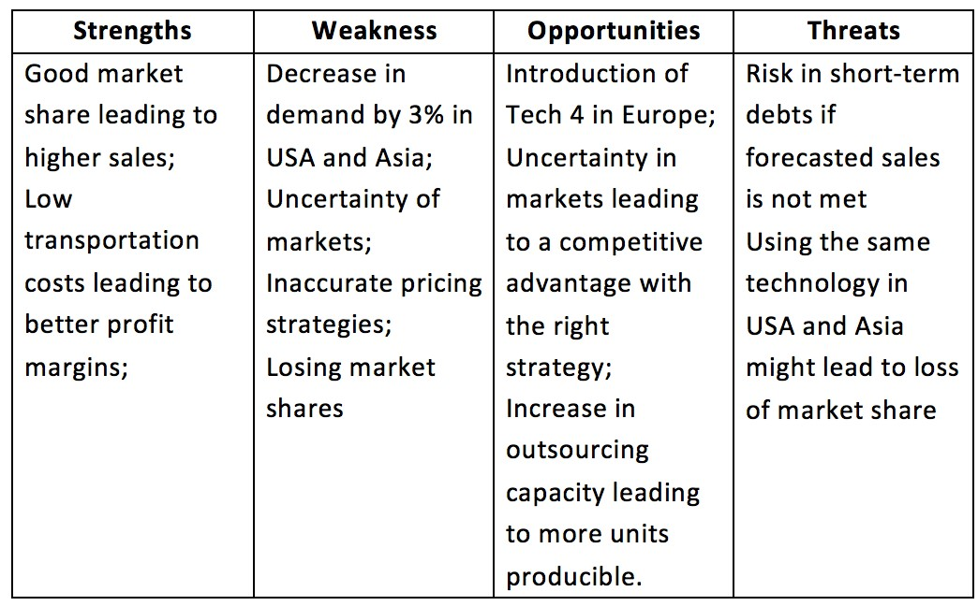

2.4Corporate Goals and Strategy:

Corporate Goals
- To increase the market share globally up to 15% by the end of year 4.
- To increase the sales revenue globally up to 7% by the end of year 4.
- To increase the cumulative shareholder return to 15% by the end of year 4. • To cut down the operational costs by 40%.

Competitive strategy
The Lion King has followed price skimming strategy and market penetration strategy based on the swot analysis of the company in all the sectors which are in the USA, Asia and Europe. Market penetration strategy can help the company to acquire the targeted market share globally by giving the competitive advantage from our competitors. Price skimming strategy allows us to gain the high sales revenue with low operational costs. The Lion King will offer 8 new features for tech 1 and 7 new features for tech 2 in the USA, 8 new features in tech 2 and 4 new features in tech 4 in European market and 7 new features in tech 2 and 4 new features in tech 3 in Asian market in year 4 (Lion King, 2017).

Production Goals
- Invest in R & D for tech 1, tech 2 and tech 3 products in the year 4.
- To introduce more features in the tech products in the European and Asian markets.
- Reduce the inventory by 50% by the end of year 4.

Production Strategy
The Lion King has invested a total sum of 132919k USD in the R & D department to improve the tech products with more number of features. The more number of inventory remaining is in tech 1 and tech 3 which is 2.09k and 1.84k respectively. Tech 2 and tech 4 remaining inventory is 416.59 and 302.76 respectively. To reduce the inventory by 50%, the Lion King will be producing all the tech products with 5% below the demand. Tech 1, tech 2 and tech 3 products will be upgraded with more features to use in this year sales (Lion King, 2017).

2.5 Analysis of the Company Performance
The Lion King company performance at the end of year 4 has been good when compared to year 3. The market share has increased from 10.93% to 14.9% which placed the Lion King in 3rd place in the global market making the company as one of the top competitors. The sales revenue has increased from 2080674k USD to 2690763k USD and total cumulative shareholder return p/a of -7.79%. except the cumulative shareholder return which went really bad this year, market share and sales revenue has showed a great improvement. Cumulative shareholder return which is in negative, effects the company. The strategies made for year 4 is not good (Cesim, 2017).
Figure 1: Market share at the end of year 3
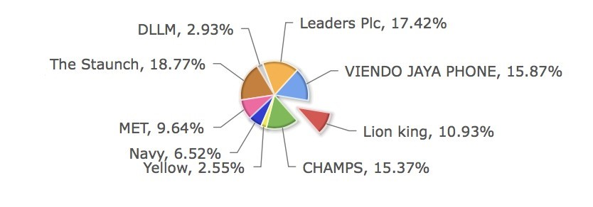
Figure 2: Market share at the end of year 4
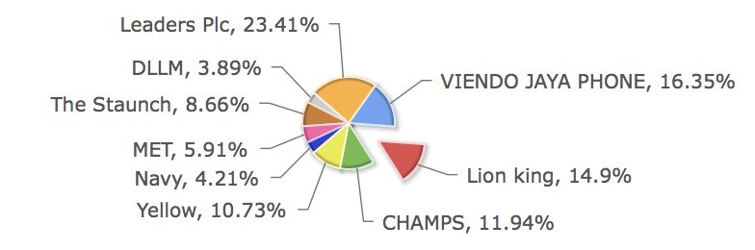
Even after reaching the expected number of sales in year 4 the Lion King still holds the inventory of tech 1 and tech 3 which is 2.09k and 1.84k respectively. Tech 2 and tech 4 remaining inventory is 416.59 and 302.76 respectively. More number of inventory is left in tech 1 and tech 3 due to the mass production by using full capacity up to 100% (Cesim, 2017).
Figure 3: Capacity utilization for year 4 (100% in both the USA and Asia)
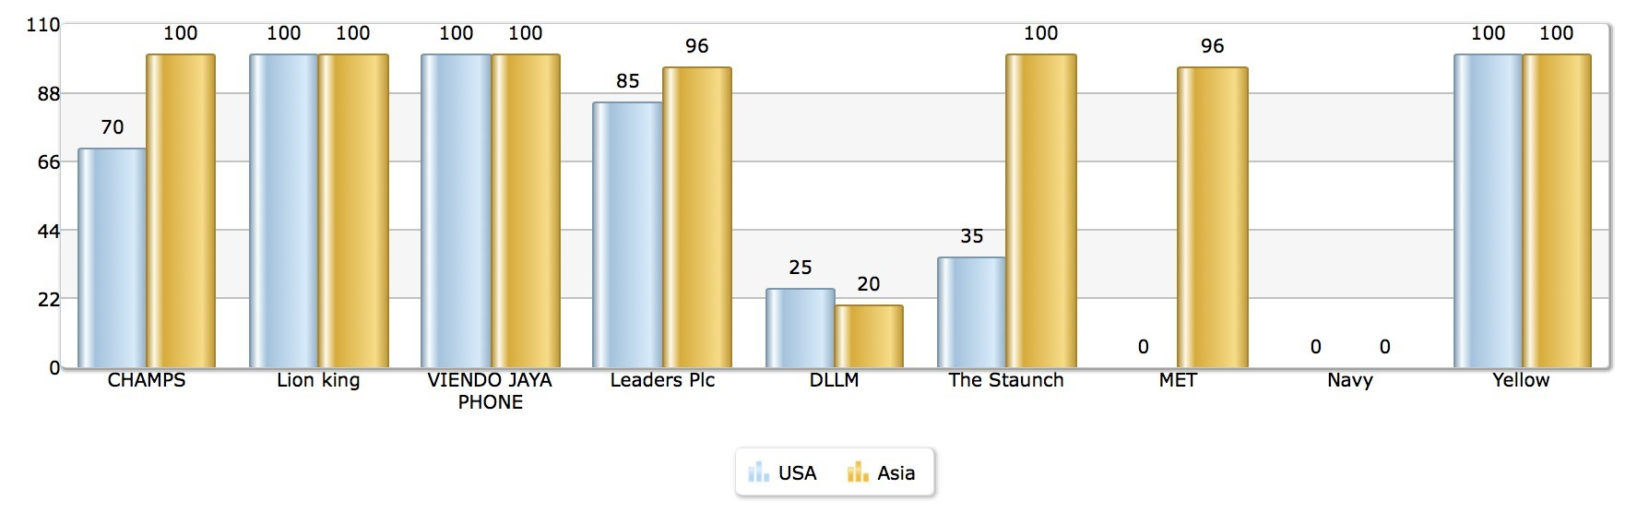
The market share in Asia has raised immensely from past year at a starting point of 6.6%. At the end of year 4 the market share in Asia is 14.88%. the European market share increased by roughly around 2% making it up to 15.72% at the end of year 4, Which helped the Lion King analyse that each market works differently. The USA market share has dropped roughly around 3 - 4% which made it up to 13.99% at the end of year 4 (Cesim, 2017). Overall strategy taken in year 4 has led to the downfall of market share in the USA. Price skimming strategy helped a lot to increase market share in Asia and market penetration strategy helped to increase market share in European market.

Figure 4: Market share in the USA at the end of year 4
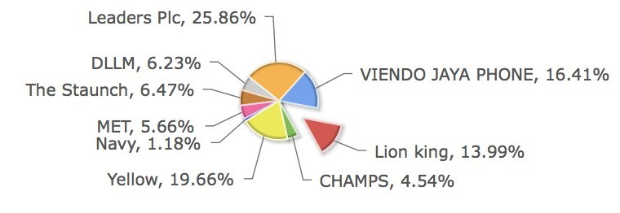
Figure 5: Market share in Asia at the end of year 4
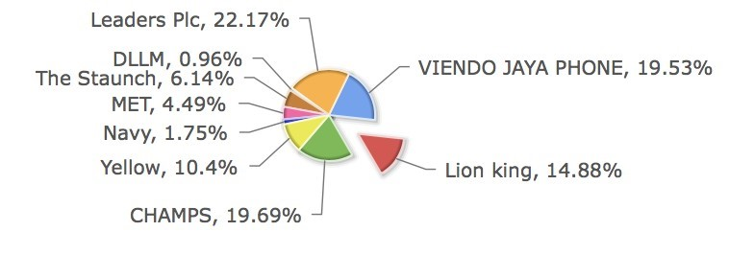
Figure 6: market share in Europe at the end of year 4
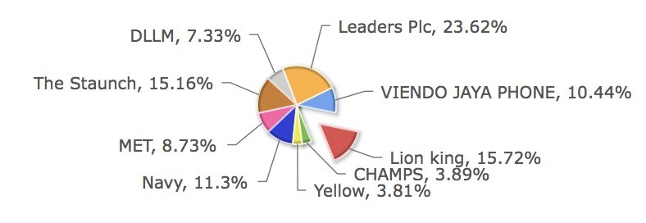

2.6 Recommendations for next year
For year 5, the Lion King’s production should be kept in accordance with the demand of that year, by using the maximum capacity of the company’s plants they need to improve the sales in order to gain more Market share, as the demand is estimated to grow a very large number of sales in Asia and an average growth in the USA and Europe.
The company has to mainly focus on the profit in the upcoming year, as the company’s current cumulative shareholder return (p.a.) is in minus, the company needs to have profit. As the production costs are falling in the USA, the company has to get more number of contract manufacturing, so they can have the production cost at a low level. They are currently using the market penetration strategy, but they need to change their strategy to price skimming method, mainly in the USA to gain more sales.
The company needs to invest more in the R & D department to gain more benefits in the future by doubling the year 4 investment amount in year 5. If we introduce more features in all the tech products with the targeted selling price, the company can gain profit which will help in its cumulative shareholder return (Nikhil, 2017).

2.7 Conclusion
Previous year has been good in the number of sales and market share of the company, except the cumulative shareholder return. The company needs to change its goals and objectives for the year 5 as few strategies used in year 4 turned out to be negative. Overall this year the company performance was not to the expected level but still it has its benefits. The market share is around 15% in the USA, Asia and the Europe. The sales didn’t go as expected but the market share has increased when compared with previous year. The strategy needs to be altered mainly and the company should invest more R & D to get good tech products with features (Nikhil, 2017).
Lion King
Critical Appraisal Report – 2
Department of Marketing
(Year 5)

3.0 Department of Marketing (year 5)

3.1 Introduction
It was a very good experience in year 4 as the company performs well in managing sales and market share with exceeding the expected target. This year the company is mainly concentrating on the profit. So, the goals and objectives of the company are changed according to the competitors of the targeted market. They main global competitors of the Lion King are, Viendo Jaya Phone and Leaders. Leaders hold the maximum number of market share, that is 23.41% in the year 4. They used price skimming strategy to gain more number of sales and to acquire market share. Whereas Viendo Jaya Phone holds the second large number of market share in year 4 with 16.35%. they use Price penetration strategy. Champs also use a good amount of market share in Asia with 19.6% with penetration pricing strategy which place them in second in Asian market share next to Leaders who hold the highest number of shares in that market, that is 22.17%. these two are the main competitors in Asian market.
The Lion King will provide the same tech 1 and tech 2 products in USA with demand of 15% and 10% respectively. cost plus pricing strategy will be adopted in this market sector. Tech 1 and tech 3 products are provided for sale with demand up to 8% for both the tech products in Asia. Cost plus pricing strategy is adopted in the market sector as well. Tech 2 and tech 4 products are provided for sale with the demand of 12% and 15% respectively in Europe. Competitive pricing strategy is adopted in this market sector.

3.2 Literature Review

Product design:
Product design is important to an organization as it differentiates one brand from others. the design can be benefit in itself as it influences consumer behaviour heavily like Gucci, Luis Vuitton, Armani, Ferragamo. Product design benefits the customer when we arrange its features and present it to them. Packaging place a major role as it is the last process done to please the customers which can increase the company sales, good packaging can make a huge difference in product design. (Bhasin, 2017) Product design can be divided into 3 categories.
- Analysis / Observation: it is important for an organization to understand the customers’ needs and note it down to give them a better product. Some organizations do not follow this as they believe it is impossible for the customers to think what they want.
- Concept / Ideation: this is a stage where various samples are made based on the given concept, these concepts are just ideas which are compared with other ideas, the better ones get through the test as creativity plays an important role.
- Synthesis / Implementation: once the organization has finalised the sample product it can be launched in a market and if it is approved it can go for mass production.

Product positioning:
According to Richards, the Product positioning is how the marketers used to determine the best way to communicate their products as their target the customer’s needs. Product positioning is the important element in marketing plan. It is an important element as it understands the key information of every customer needs. Product positioning starts with identifying the specific, for example not just working professionals but also single working professionals who enjoys adventure activities. Marketers need to understand the customer needs after segmenting the target market by demographic and psychographic attribute.

While marketers are considering positioning elements of their marketing strategy they also should keep an eye on the competition as the competitors in the market are not always stable. In other words, the companies should not copy what their competitors are doing rather they need to stand out by giving out a different product which will add more value to their brand (wang, 2014).

Marketing mix:
According to Kotler and Armstrong “The marketing mix is … the set of controllable tactical marketing tools product, price, place and promotion – that the firm blends to produce the response it wants in the target market”.
The marketing mix is the one of the most famous marketing terms as it is it a part of the marketing plan. The marketing mix is also called the 4ps and the 7ps, which are
Price: price is something a consumer must exchange to consume a product (Solomon et al, 2009).
A company’s goal is to reduce costs by I proving manufacturing an efficiency and most importantly the marketers try to benefit by increasing the price of the products.
Place: place is an area where a company targets it’s consumers to buy a product (Kotler and Armstrong, 2010).
Place is a mechanism through which goods and services are moved from the manufacturer to the consumer. Place is also known as channel.
Product: product is the target market of goods and services combination in which a company offers (Kotler and Armstrong, 2010).
Product is something which is tangible or physical that we buy or sell. For a product to reach a target it needs to be communicated, adaptable and it needs to have a popular name.
Promotion: Promotion is something which all organizations undertake to bring up the product in the market to help the consumers to by their products. (Solomon et al, 2009)
Promotion includes all tools of marketing mix which helps in the product sale, it can be done through advertising, newspapers, social media, personal selling etc.

Pricing Strategy:
Pricing strategy is when it helps an organization to determine a price point at which they can maximise profit of goods and services. When the price is being set, a company needs to consider a wide range of ups and downs as the prices can fall or rise anytime. There are many ways to price a product in different situations like premium pricing, penetration pricing, economy pricing, price skimming etc. (Biswal, 2011).

3.3 BUSINESS ANALYSIS

Market outlooks / Situation analysis
The exploding of handsets around turmoil has settled. There was no explosion on the plane as per the investigation. Both the co-pilot and the captain lost their awareness as somebody put an opened durian fruit in the cockpit. As there was no involvement of handsets the demand is expected to be highly increase with 15% in Europe, 20% in the USA and over 40% is Asia (Cesim, 2017).
The embarrassing situation between Chinese and US was increasing rapidly. China strikes back by matching the US tariff when the US sees and tried to weaken the Chinese economy with increase in tax up to 15$ for each handset. In Asia, the production costs are expected to remain constant and 5% drop of production cost is expected in the US. 15% of outsourcing capacity has fallen resulting in the drop down of outsourcing cost by 10%. This downfall of outsourcing capacity is due to some of our sourcing companies which went out of business in last time due to the industrial heavy price competitions which are already operating on thin margins (Cesim, 2017).
Euro is getting strengthen, but the RMB is still falling against USD. USA and Europe’s interest rates are unaltered (Cesim, 2017).
Swot Analysis
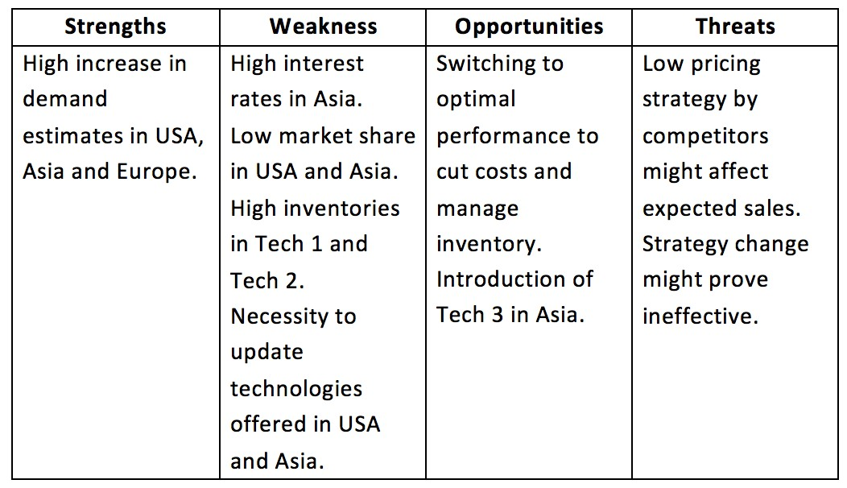

3.4 Corporate goals and strategy

Corporate Goals:
- To increase the market, share globally up to 5% by the end of year 5.
- To increase the sales revenue up to 7% by the end of year 5.
- TO Reduce the inventory of the tech products up to 60% by the end of year
5.
- To increase the cumulative shareholder return value up by 10% by the end of year 5.

Competitive strategy:
To gain more profit in order to increase the cumulative shareholder return the strategy used was cost plus pricing strategy in the USA with expecting profit margin up to 35% form both tech 1 and tech 2 products. Same strategy is used in Asian market as well with expecting profit margin up to 15% from both tech 1 and tech 3 products. Competitive pricing strategy is used in European market for the tech 2 and tech 4 products with expecting profit margin up to 22%. All the tech 1, tech 2, tech 3 and tech 4 products are added with new features to attract more customers (Cesim, 2017).

Goals and strategy of department

Department goals
- To add atleast 1 additional features to all the tech products in the USA,
Europe and Asian markets for year 5.
- To acquire new customers in the USA by 5% by the end of year 5.
- To increase customer base in USA by 10% by the end of year 5.

Department Strategy
For department strategy marketing mix is used in all the market sectors to strategize the ideal market for the business. The 4P’s is altered for each market sector based on external factors and the conditions that affects the said market (Lion King, 2017).

• USA
- Product: The tech 1 and tech 2 products are sold in the USA. Tech one product is added with 1 more additional feature compared to previous year features, making it a total of 9 features and the tech 2 products is added with 2 more additional feature making it a total of 8 features.
- Promotion: The total sum of 20000k USD is used for the promotion for tech 1 product and 30000k USD is used for the promotion for tech 2.
- Price: Tech 1 product’s selling price is kept at 165 USD and tech 2 product’s selling price is kept at 220 USD. Both the tech product prices are increased from the previous year and year 5 pricing is based on the cost plus pricing strategy(Cesim, 2017).

• Asia
- Product: The tech 1 and tech 3 products are sold in Asian market. Tech one product is added with 2 more additional features compared to previous year features, making it a total of 9 features and the tech 3 products is added with 1 more additional feature making it a total of 4 features.
- Promotion: The total sum of 10000k USD is used for the promotion for tech 1 product and 30000k USD is used for the promotion for tech 3.
- Price: Tech 1 product’s selling price is kept at 1299 Rmb and tech 3 product’s selling price is kept at 2400 Rmb. Both the tech product prices are increased from the previous year and year 5 pricing is based on the cost plus pricing strategy (Cesim, 2017).

• Europe
- Product: The tech 2 and tech 4 products are sold in Europe market. Tech 2 products is added with 1 more additional feature compared to previous year features, making it a total of 8 features and the tech 4 products is added with 1 more additional feature making it a total of 4 features.
- Promotion: The total sum of 20000k USD is used for the promotion for tech 2 products and 20000k USD is used for the promotion for tech 4.
- Price: Tech 2 product’s selling price is kept at 220 USD and tech 4 product’s selling price is kept at 399 USD. Both the tech product prices are increased from the previous year and year 5 pricing is based on the competitive pricing strategy (Cesim, 2017).

3.5 Analysis of Company Performance
The sales revenue has gone down to 2.69M k USD to 2.49M k USD, helped the company to understand the performance of the sales and strategy. The strategy needs to be altered as the sales revenue went down a little. This sales revenue puts the Lion ling in the 3rd place behind Leaders and Viendo Jaya Phone (Cesim, 207).

Figure 7: Sales revenue of the Lion King at the end of year 5
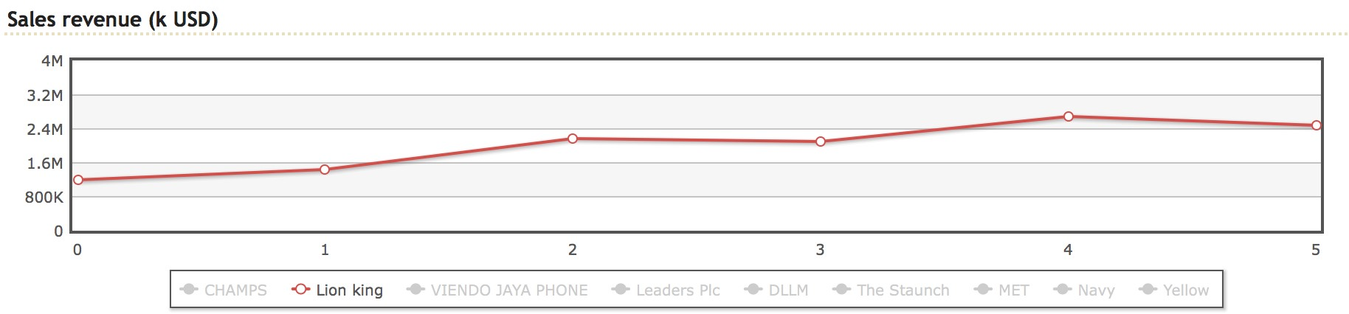

Figure 8: Cumulative shareholder return of Lion King and its competitors in year 5
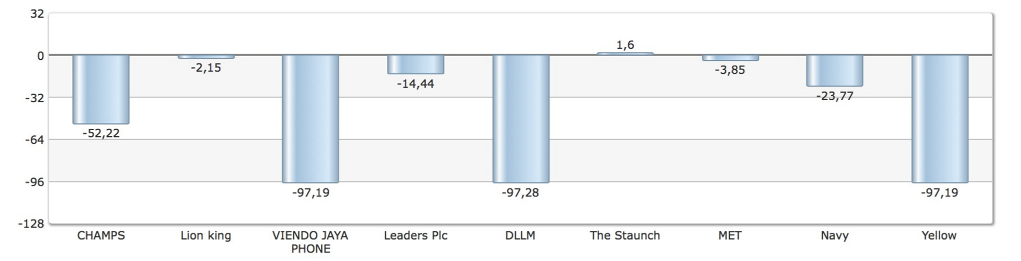
The Lion King’s was in -7.79 in year 4 and has recovered to -2.15 in year 5. This was able to achieve to the utilization of full capacity in the production sector to satisfy the targeted demands. The strategies have worked well to meet its demands (Cesim, 2017).

Figure 9: Global market share at the end of year 5
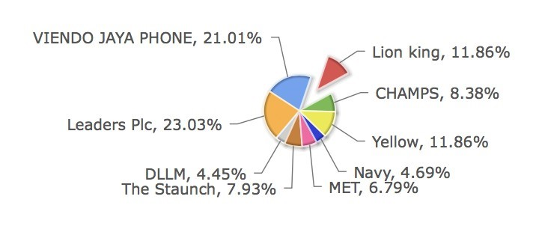

Figure 10: Market share in the USA at the end of year 5
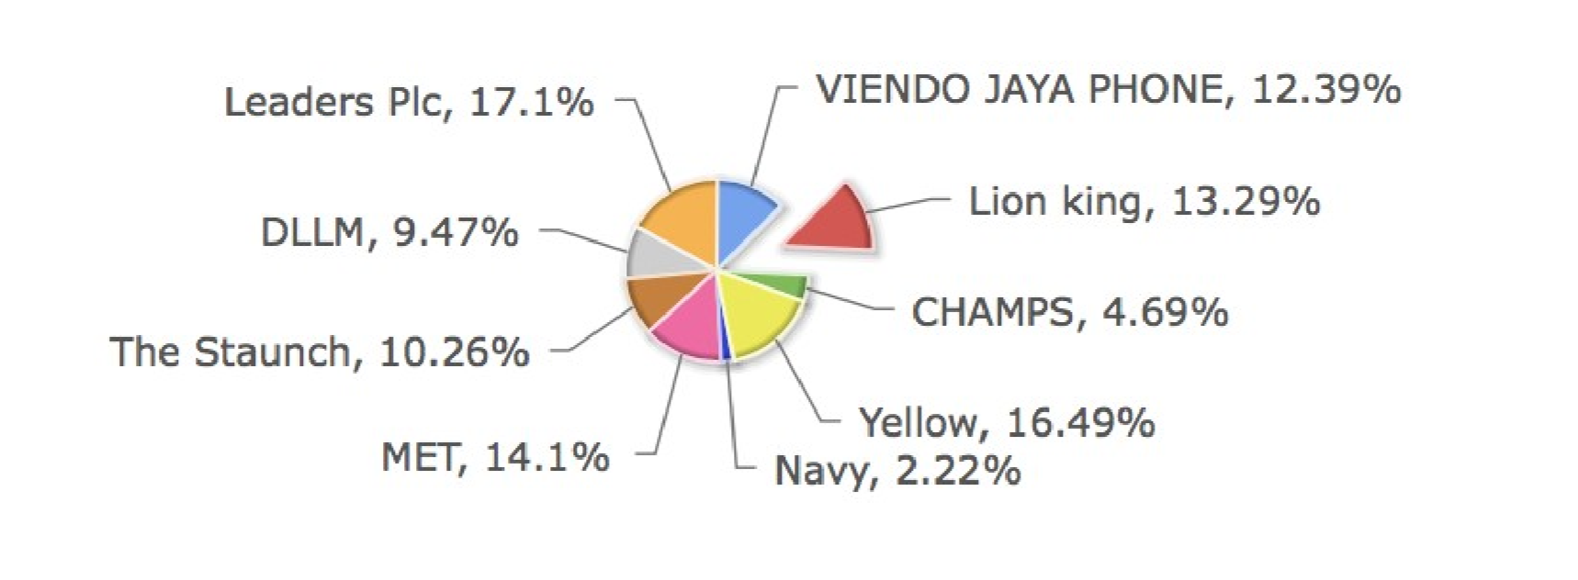

Figure 11: Market share in Asia at the end of year 5
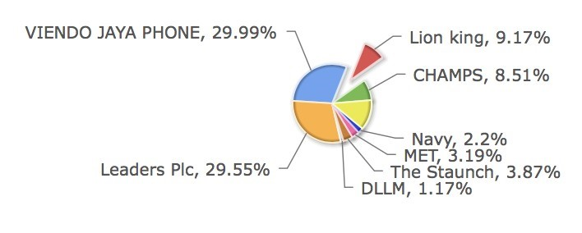

Figure 12: Market share in Europe at the end of year 5
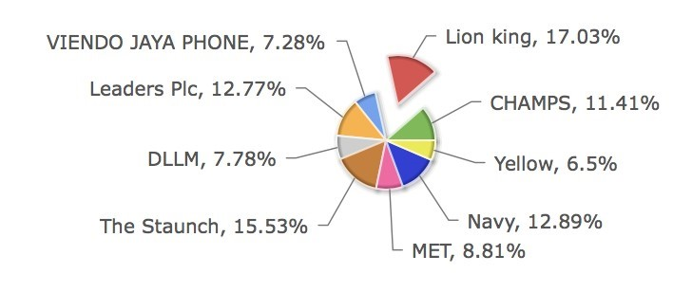
The market share of Lion King globally is 11.86% in year 5 which is 3% less approximate when compared to the previous year. In the USA, it saw a slight downfall of 3.99% in year 5 which led to 13.29%. In Asian market the market share has went down to 9.17% in year 5 from 14.88% of year 4. The cost plus pricing strategy which is used in both the Asian and the US market has led to the downfall of the market share in these two market sector. whereas in European market has an increase in market share, that is 17.03% in year 5 from 15.72% of year 4 which helps to determine that the competitive pricing strategy is has worked out very positive (Cesim, 2017).

3.6 Recommendation for next round
New strategies for the USA and Asian market should be considered for the upcoming year as there was a downfall in the market share of these two markets. Price skimming strategy is suggested for the USA and the Asian market till it regains the market share. Tech products which are selling in the USA and Asian market should be sold with new attractive features to attract more number of customers and to create a market attractiveness. 3 more new plants which are added the Asian market are helping out to reach the targeted demands. More number of production plants should be added to all the market sectors in the upcoming years to gain more number of production capacity and also to reduce the transportation cost. As the market is maturing new type of tech products should be introduced in the European market as the current tech products are falling behind even though they have good number of sales. Year 6 goal is to gain more number of market share and gaining more cumulative share holder return (Nikhil, 2017).

3.7 Conclusion:
Overall the year 5 has dropped down in sales in the USA and the Asian market has led to the downfall of the market share in these two markets. Even though the market share has fallen the cumulative shareholder return has recovered a lot with respect to the previous year. The main downfall of market share was in Asia as the cost plus pricing strategy did not work out as expected. Inventory this is very low compared to the previous year even after using the maximum production capacity. 3 more new plants in Asia is added in this round which helped the in production of more number of tech products. This year the Lion King performance was not up to the expectation but has the slight benefits with the introducing of 3 new plants in Asia.
Lion King
Critical Appraisal Report – 3
Department of Finance (Year 6)

4.0 Department of Finance

4.1 Introduction
Lion King’s previous year was one of the few bad years the company has faced in the past years. This year is only about gaining more number of market sales then the previous year with new strategies. New objectives and goals are set to execute for this year to achieve its target (Lion King, 2017).
For all the company’s profit and loss, cash flows, tax all these are responsible of the finance department. Lion King is planning to obtain a global market share of 15% by the end of this year by introducing tech 4 and tech 2 products in the USA and Asia respectively. This year they mainly aim to increase the cumulative shareholder value. The market research shows that the Euro’s value is growing against USD. So, the major priority market sectors will be the USA, Europe and then Asia. RMB is also started to grow against the USA but not as much as the Euro. it is only gaining up to 10% compared to last year. The company is planning to cut down the costs as it will be even more helpful as the outsourcing costs are cut down this year in Asia. But in other places the cost of outsourcing are increased up to 2% (Cesim, 2017).
The Lion King is buying back its 1000 shares with the price money of 169521 k USD with each share price value is 169.5 USD. The dividend price is paid with the total sum of 116743 k USD and the long term debt is paid with the sum of 50000 k USD. The change in inventories costed to the sum of 711546 k USD. The finance department mainly take care of all these cash flows in the company (Cesim, 2017).

4.2 Literature Review

CAPITAL STRUCTURE:
capital structure is defined as the specific mix of debt and equity a firm uses
to operate its finance, it can also be explained in terms of the tax benefits associated with the use of debt, as the tax policy has an important effect in the decision making of the firm in capital structure. The capital structure can be broadly divided into two forms of capital: equity capital and debt capital, each type of capital comes with its own benefits and drawbacks. The percentage of capital present at a work in a business type is known as capital structure (Joshua Kennon, 2017).

COST OF CAPITAL:
In good businesses, they earn more money than they spend. Cost of money is what a company has pay its investors for financing its business activities. The cost of capital is easily explained in the popular television show shark tank where small businesses gives out their ideas to the talented investors, if the investors like their ideas then the business can bid on how much they want to invest. During this process, the investors are looking for high return possible and the business owners want the lowest cost of financing. Therefore, the negotiation may be viewed as a crude market for regulating the cost of capital of the business (Sotiroff, 2016).

EQUITY FINANCING:
Selling the shares in the business to raise the capital is a common way in equity financing, it is different from debt financing, where the loans are secure from the financial institution. Equity financing is mainly used for business start-ups for businesses which are established and are waiting to be expanded.
Obtaining equity financing is difficult for start-ups. According to a wells Fargo small business survey, the small businesses that comes up in the industry through start-up funding comes from the personal saving,77% of small business comes from personal savings of the owners. To get a business established a solid business plan is needed, which can help in attracting investors (Susan Ward, 2017).

RETURN OF CAPITAL EMPLOYED:
Profitability and the efficiency of a company is measured by a financial ratio called return on capital employed (ROCE). ROCE is calculated as:
ROCE = Earnings Before Interest and Tax (EBIT) / Capital Employed.
For comparing profitability across companies, ROCE is a useful metric, they are based on the amount of capital they use. Return on capital employed can be calculated in two metrics: earnings before interest and tax and capital employed and Earnings before interest and tax. These metrics are also known as operating income which shows how much a company earns from its operation alone without interest and taxes.
The total amount that a company utilises in order to generate profit is the capital employed. It is the sum of shareholders equity and debt liabilities, it can also be calculated by total asset minus current liabilities.
ROCE is mainly useful when it comes to comparing the performance of companies in capital intensive sectors like utilities and telecoms, as ROCE considers debt and other liabilities, it gives a better sign of financial performance for companies having significant debt (Jim Riley, 2016).

TOTAL SHAREHOLDER RETURN:
Total Shareholder Return, otherwise known as TSR can be calculated as the total amount returned to the investors of an investment. This includes the total return of a stock back to the investor which may or may not include the capital plus dividends. Ultimately TSR can be described as the sum total returned to an investor from an investment (Brian T. Holman, 2015).

DIVIDEND POLICY:
Profit arrangement is the arrangement of rules an organization uses to choose the amount of its income it will pay out to investors. Some confirmation proposes that financial specialists are not worried about an organization's profit arrangement since they can offer a segment of their arrangement of values in the event that they need money. This confirmation is known as the "dividend irrelevance theory," and it basically demonstrates that an issuance of profits ought to have next to zero effect on stock cost. That being stated, many organizations do pay profits (Henry Servaes, 2013).

NET PRESENT VALUE:
A positive net present esteem demonstrates that the anticipated income created by an undertaking or speculation (in show dollars) surpasses the expected expenses (likewise in display dollars). For the most part, a venture with a positive NPV will be a productive one and one with a negative NPV will bring about a net misfortune. This idea is the reason for the Net Present Value Rule, which manages that the main speculations that ought to be made are those with positive NPV esteems (Woods and Randall, 1989).

4.3 Situation analysis / Market outlooks
The handset market has begun to mature and the market growth is expected to gradually decrease in the upcoming years. The expecting growth rate is to be less when compared to last year where only 15% of growth rate is expected in Europe, less than 20% growth rate in the USA, 30% above growth rate in Asia. The technologies that to in the highest level are appreciated only in European countries as per the resent market research and also based on Techno Analytics the awareness that comes along that the tech 3 products have been a “lemon” in the USA (Cesim, 2017).
Worldwide there is an increase of 2% outsourcing costs. There is a downfall of production costs and outsourcing costs in Asia. Meantime the gorilla’s population is reducing to nearly becoming extinct was announced by Nepal government. To extract the tantalum, a metal which is mainly used in the production of mobile phones are found in the jungle where the gorillas stay are being destroyed. The Nepal government along with the world wildlife foundation, for causing the destruction of the jungle the mobile phones producers has been justified certain number of fees which will result in the raise of fixed costs for each production plant (Cesim, 2017).
Against the USD the Rmb is gaining strength up to 10% when compared to the previous year. The Euro acknowledges against the USD once more. By expanding the rates of enthusiasm up to half of a percentage point the US Federal responds to signs of activity. Europe and Asia take after and raise their rates likewise (Cesim, 2017.)
Swot Analysis
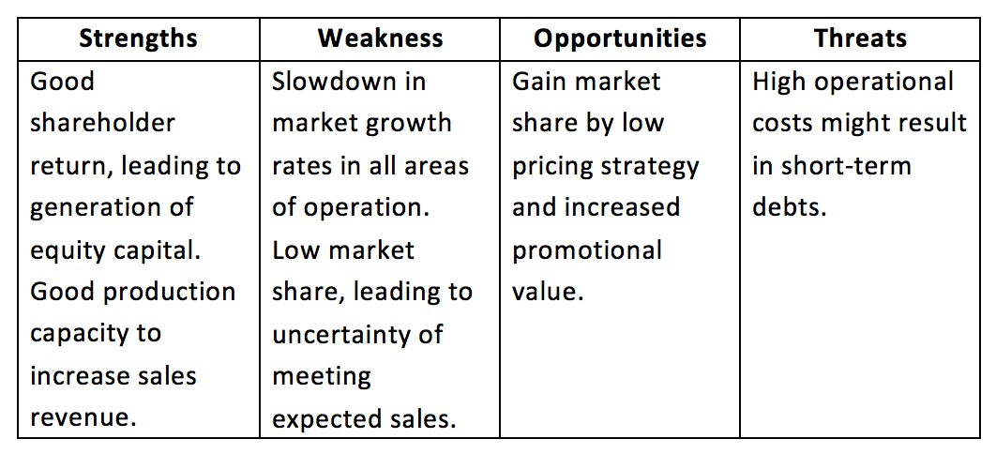

4.4 Corporative goals and Core Strategy:

Corporative goals
- To obtain a global market share 15% by the end of year 6.
- To introduce new tech 4 products in USA.
- To take the cumulative shareholder return from negative to positive atleast by a margin of 4 %.
- To introduce a new tech 2 products in Asia (Lion King, 2017).

Competitive strategy
This year Lion King is using price skimming strategy. As the cost plus pricing strategy effected sales of previous year. This year price skimming strategy is used in all the 3 market sectors in the USA, Asia and the European market. And when we look at our competitors The Staunch, Viendo Jaya Phone and Leaders they are all aiming to gain more market share by achieving more number of sales. Even with the little price skimming if the number of sales is more the profit will be there which will be helpful to achieve the target of cumulative shareholder return (Lion King, 2017).

Department Goals
- To increase the equity ratio by 20% by the end of year 6.
- To increase the Return on capital employed (ROCE) by 20 % by the end of year 6.
- To buy back up to 1000 shares by the end of year 6.
- To double up the profit by 200% by the end of year 6.
- To increase the share price by 3%.
- To increase the sales revenue by 50% by the end of year 6.

Department Strategy
One of the main department objective is to increase the equity ratio. To achieve this goal the company has to use its equity capital as main source of capital and also they have to reduce their debts. Return on capital employed (ROCE) can be increased by paying the debts. If the debts are paid, it reduces the liabilities and from which it can improve its ratio. The company also plans to increase the sales revenue by 50% by reducing the price. The Lion King has invested a sum of 10000k USD in promotion of each tech products in the USA, Asia, and Europe. By cutting down the operational costs and not investing in R & D in this year will help the company to achieve a profit margin up by 200%. Once they bought back the 1000 shares using equity capital they can increase the price of their shares by 3% which will also help the company to increase their profit (Lion King, 2017).

4.5 Analysis of company performance
In this year, the company has achieved its sales objective wonderfully with an increase of more than 50% by reaching 3094820k USD from 2491340k USD of previous year. All the expenses including operational costs transportation, promotion and tech features reaching a sum of 2325235k USD as the tech 1 and tech 2 products ended up in the inventory with 877.88 and 752.35 respectively (Cesim, 2017).

Figure 13: Lion king’s sales revenue by the end of year 6
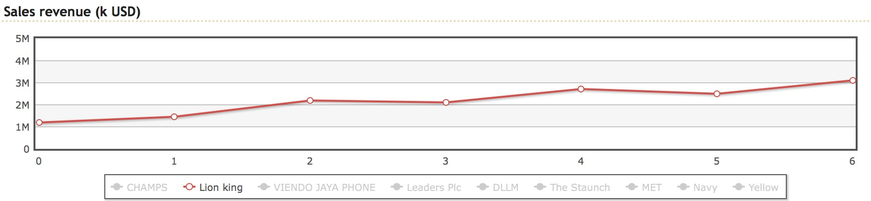
The Lion King achieved a profit of 438017k USD compared to previous year which was 152774k USD. The total number of assets has improved slightly worth of 2809206 USD from previous years 2705596k USD. Where the equity and liabilities worth of 1817919k USD and 991288k USD respectively making it a total sum of 2809206k USD (Cesim, 2017).

Figure 14: Lion King’s profit by the end of year 6
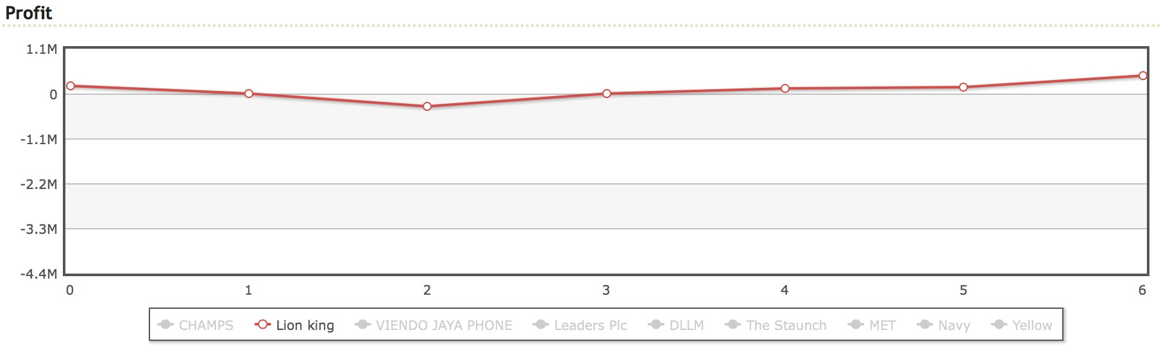

Figure 15: Global market share of Lion King by the end of year 6
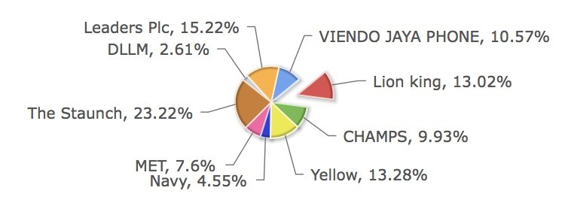
The global market share of the Lion King in year 6 is 13.02% by placing the company in the 4th place in the market sector. The price skimming strategy which was used in all the market sectors helped us to achieve a sales revenue of more than 50% in this year when compared with previous year. In all the market sectors the USA, Asia and Europe. The company has achieved more number of market share in Europe with tech 2 and tech 4 products by placing the company in 2nd place in the European market achieving a total market share of 18.89% from the previous year’s 17.03%. In Asian market, also the sales has increased from 9.7% of last years to 11.16% in this year. But in the USA a percentage has reduced from previous year in the market share making it 12.2% in this year (Cesim, 2017).

Figure 16: Market share of Lion King in the USA by the end of year 6
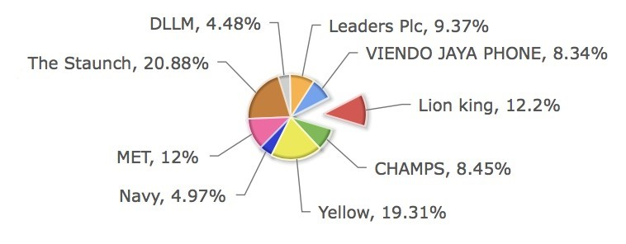

Figure 17: Market share of Lion King in Asia by the end of year 6
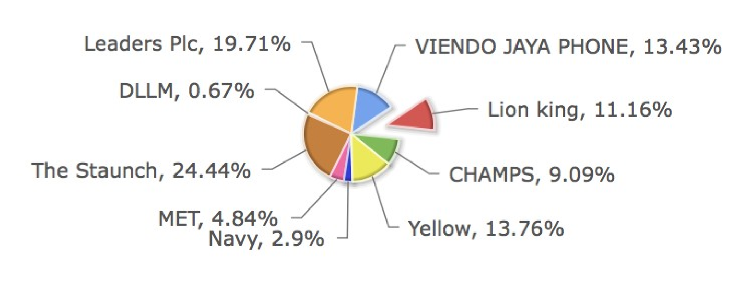

Figure 18: Market share of Lion King in Europe by the end of year 6
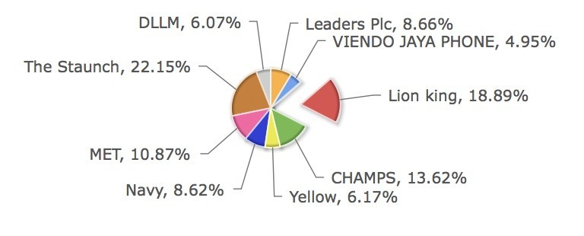

4.6 Recommendations for the next round
This year the Lion King has accomplished its objectives when it comes to the ratio, return on capital employed (ROCE), sales revenue and overall profit. Sales revenue and profit has increased more than the targeted point. The company must maintain the same strategy for marketing in the USA, Asia and the European market to improve the sales even more in the upcoming year with more number of features. The company must invest more in the R & D department to come up with new technologies and features and they have to mainly concentrate on short term debts and make sure not to take any short-term loans which can help to improve the company profit. They also need to reduce the debts of long term. By maintaining the profit, they can return the shareholders their value and keep them happy. They shouldn’t lose focus of what they are achieving and try to gain more and more profit along with satisfying the customers.

4.7 Conclusion
Overall the Lion King has performed really well in this year by reaching its objectives. The cumulative shareholder return has increased more than 4% by reaching 2.23% from negative and the equity ratio has increased slightly up to 67% The company bought back the shares and the profit is more than 200% and also the sales revenue hit the targeted 50% and above by reaching 3094820 k USD. The Strategies have worked out in a positive way by increasing its numbers. Not all the objectives achieved its targeted point but they have showed the better performance. Total this year’s performance the Lion King has been placed in the 2nd position in the global market and also the company performance was up to the expected level and has shown many improvements.
Lion King
MO28 – Global Business Simulation
Team Performance Review
(years 1 to 6)

5.0Team Performance Review

5.1 Introduction
The Lion King is built with a 3 members team given with the responsibilities to maintain the company by making decisions in all the 3 departments which are, Production and Operation department, department of Marketing and department of Finance. The 3 members should make sure the company should reach its objectives and they agreed to work hard for the company to reach the required targets. The aim of the company is to meet the demands of its customers. The team has used the theory of Bruce Tuckman to plan the team work to run the business. The team also used Belbin’s theory for planning team roles. Both the above mentioned theories are used to improve the team works and to use the team to its full efficiency. The simulation given consists of 3 practice rounds plus additional 6 years. The team have to run the Lion King company for the 6 years. So, all the team members should take different tasks in different year to work towards the common goal of the company.
After making the teams with all the instructions, the Lion King was ready to take the journey with a goal of competitiveness and performing better in the given market. But before that the should select a leader for the Lion King company which had a great impact on all the team members. Everyone in the team wanted to take the responsibility of leading the team. But deciding the team leader among the team mates was very difficult as each of the team members had their own idea of leading the team. We had to decide the leader who will make the right decision and keep the team together maintaining good performance and until the company reach its goals. Based on the John Adair’s theory of leadership we decided to choose the team leader and we were looking for the quality characteristics in that person who has calmness, must achieve the task in time and with the one who has the good knowledge about business, the one who help the other team members to develop themselves individually and as well as a team. The Lion King selected Mr. Junkai Wang to lead the team and the Lion King towards its mission and thus the journey of Lion King started.

5.2 Literature review

Leadership:
John Adair is one of the one of Britain's chief experts on administration in associations. Till today people call his theories as “Great man theory”. Adair's hypothesis is more down to earth and tells that anyone can be made leader by teaching them how one should be. he believed that the leadership skill is transferable to person to person.
Adair’s model is fundamental, simple and practical. It says how a leader should be and what they have to in order to be effective. The model says the leader should be able to achieve the task on time, build and maintain the team at the same time by developing the individual (Adair, 2015).
According to Adair the three slogans of leadership are task, team and individual. He believes that these three slogans of leadership need to overlap. If the tasks are achieved it will build the team and the individuals will be satisfied. If the team lacks cohesiveness then it will affect the task as well as individual satisfaction and if the individual requirements do not meet the team lack cohesiveness and it will affect task which needs to be achieved.

Motivation:
According to Maslow the individual requirement should be met before they get motivated to achieve the greater goals. Maslow and Herzberg (1943), these two came up with the Maslow’s hierarchy adding the needs of the individual one above the other.
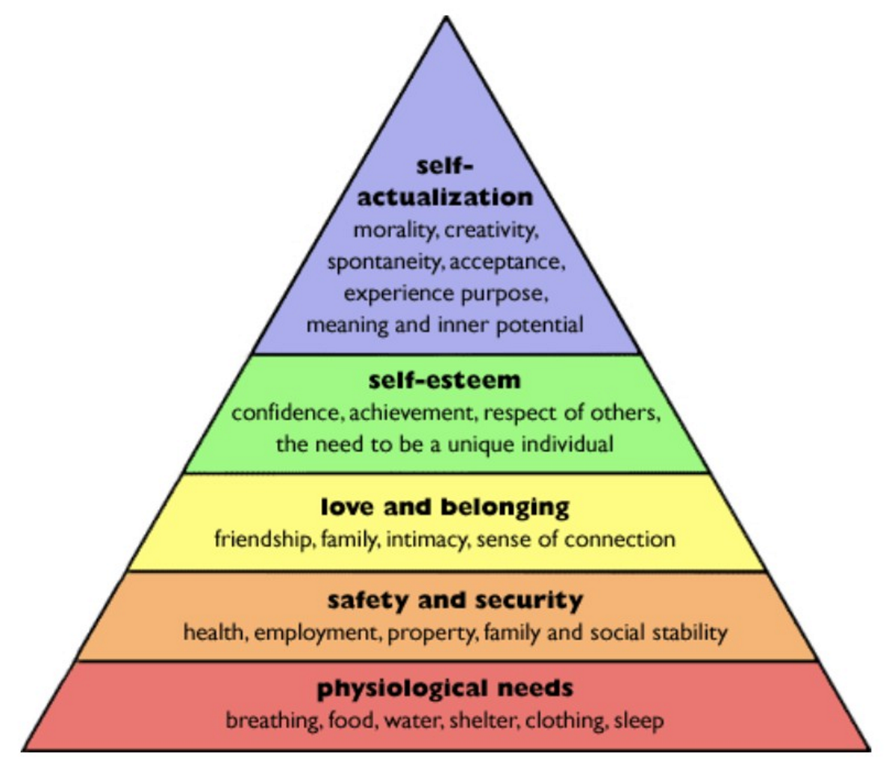
Figure 19: Maslow’s hierarchy of motivational pyramid
Maslow’s motivational pyramid is designed in such a way that in order to reach the top block of the pyramid, the below block’s needs must be satisfied. If the base of the pyramid is strong the whole pyramid will be stronger. This is designed to motivate the employees to work harder to reach the higher goals with individual better performance will help to improve the performance of the overall team (Redeye, 2014).

Teamwork:
The Teamwork theory which is designed by Bruce Tuckman contains forming, storming, norming and performing. He designed this model in the year 1965, till today it is followed by the organizations to develop the teams.
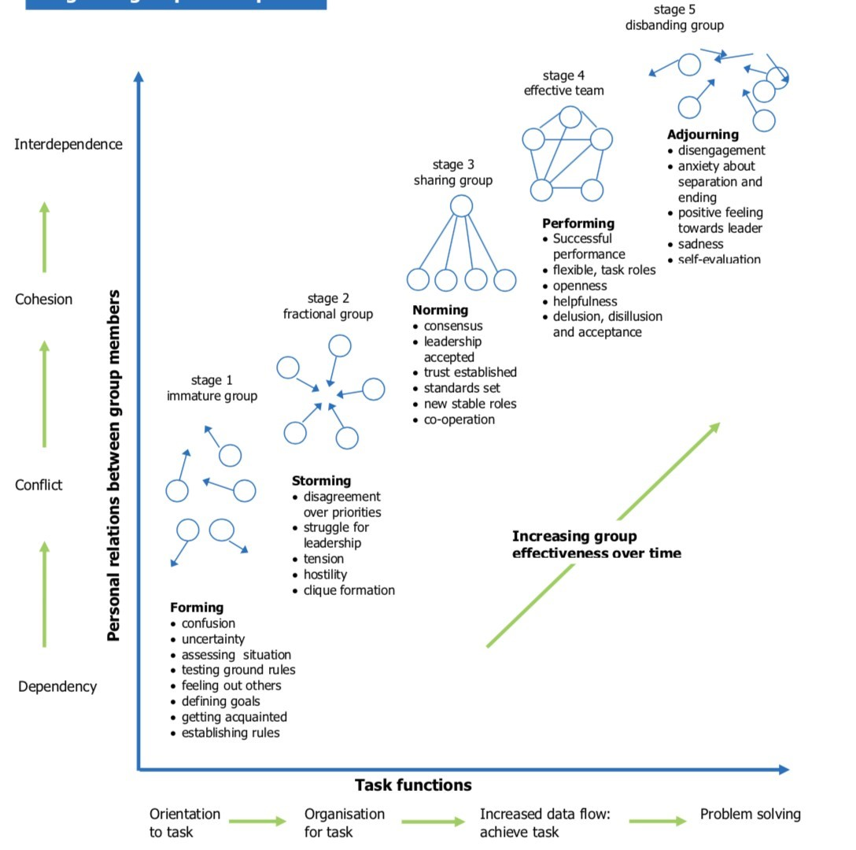
Figure 20: Bruce Tuckman’s Group development model
This learning model allows the employees to learn the task functions which includes orientation, organization, increased data flow tasks and as well as problem solving. It also helps to lean the personal relations between the group members which includes dependency, conflict, cohesion and interdependence. All these tasks and personal relations can be learned by following the Forming, Storming, Norming and Performing methods (Tuckman, 1965).

Team roles allocation:
The team roles are given to them team members on the basis of their strength and weaknesses according to Belbin (1969). Every individual behaves differently based on their priorities, he finds the strengths in an individual based on the group of their behaviours. These behaviours are naturally coming within those individuals. Depending on the ones individual strength, one’s team role should be allocated to improve the team performance efficiently and more effective. Belbin listed out the nine roles which he thinks each team must have. “The nine roles: Co-ordinator, plant, implementer, complete finisher, specialist, monitor, team worker, shaper, resource investigator” (Beblin, 1969).

Organizational culture:
Depending on the organization the organizational culture differs as it will be designed to the specific organization.

Commitment:
The organization commitment theory by Walter Johnson says that when a team member work for the team and give everything he got in order to improve the overall team performance that means he has realised the important role he is playing in the team. This can help the individual as well as the team to be on positive side and bring out the best of the team as well as on one’s self.

5.3 Evaluation of team performance

1.Decision making and Team work:
Decision making is made in the beginning of the company’s year. During the time of decision making they fix the objectives and strategy for that year.
After a series of discussion, the leader will make his final decision. Similarly, Lion King also followed the same method where the decision was made to set the objectives and strategy of each department of the company which are, operation and production department, marketing department and the finance department. Once the decisions are made by the team after a few meetings of discussion the team leader took the final decision for that year. This can be related to Bruce Tuckman’s theory. As the forming, storming, norming and performing all the 4 stages were matched to the theory from the setting of objectives and strategy for each department, changes were made based on the needs, final decision by the leader will be accepted and made plans accordingly and finally getting the effective results.

2.Leadership:
Lion King followed the Leadership theory of John Adair. As the
leadership theory says the leader must be able to achieve the task within the given time limit as well as maintaining the team while building it by motivating the team members to work towards the goal with helping individual team members when lost their track. Our team leader at Lion King made team like 1 solid working team who are working towards the company’s objectives. Team members including leader worked hard to achieve the given target but in some market sectors and productions our strategy did not work out well. After getting the unsatisfied result in year one the team gathered up for the 2nd year to make the decisions. During this 2nd year we took more time to make the decisions as were looking in all possible aspects. Then in the end our team leader asked each of our opinion on the decision making ideas and then we voted and made the best decision possible. Leader made us feel like the whole team as one and the output of 2nd year was up to the expectations. All this made us realise the importance of leadership theory.

3.Cohesiveness
in the beginning of the year at Lion King, as each of our team members
are from different cultural background, we were having trouble with the communications within the team. Later all the team members came to an agreement and created a set off ground rules. The communication between us improved day by day and as it got stronger and stronger, the bonding between the team members started growing and everyone in the team started working together with more coordination. And we started to work together towards the company’s objectives with more effectiveness.
Team members were allocated with different departments individually in the 1st year of the business. In the second year the departments among the team members got interchanged. Over the years each team member has to run the same department twice. It was organized in such a way that each that each team member will get to run all the same departments twice over the period of 6 years. If any team member found difficulty in their department other team members used to help that member. Likewise our team overcome all the difficulties which we faced in which every team member became expert in operation and production department, marketing department, finance department by the end of 6th year. In the end our company’s team was noted as one of the strongest teams as we placed our company Lion King in the top 2nd position.

4.Commitment
In the beginning of the first year of the business all the team members
split up as we planned tasks and meeting schedule in a team work plan chart. According to the Walters theory of commitment, every individual in the team must dedicate themselves towards the company’s work and its objectives in order to achieve it. Lion King’s team committed themselves to work towards the company’s goals. The mode of communication was set while making the team work plan. We used social media like WhatsApp, Facebook and created a group by adding all the team members. Every meeting was held in the university location. In case any team member could not attend the meeting at that location we changed it to the convenient location for that team member. In some cases the team member will not be able to make it up to the meeting at that times we used media like skype and put up conference video calling and continued the meetings. Every individual in the team made sure they attended all the meetings on time. Through each team member’s dedication and work ethics we all succeeded.

5.4 Recommendation and conclusion
All the team members of Lion King put up a very good effort every year to reach the target, which helped the Lion King to secure the 2nd position in the market as one of the top most competitive company. Based on the cumulative shareholder return the company’s performance was decided in which the Lion King succeeded by reaching the 2nd top cumulative shareholder returns by the end of year 6. The market share was not up to the expected level in year 6 as we aimed to achieve more number of shareholder’s return. But in the year 5 Lion King achieved the top 2nd market share holder globally. A very dedicated team effort has been shown by the Lion King to achieve the required targets as each member of the team dedicated themselves towards the company’s goals and objectives.
The performance could have been even better and the Lion King could have achieved 1st place in the global market with good team co-ordination and bonding. The Lion King can improve by understanding a good relationships in its team with much better communication which could have led the company to achieve even greater goals.
Lion King
MO28 – Global Business Simulation Individual Reflection
(years 1 to 6)

6.0 Individual reflection

6.1 Introduction
The report reflects the author’s experience of business simulation of 6 years, where working in the Lion King under the departments of Production and Operation, Marketing and Finance. The author has worked twice under all departments. I have learnt many things in business including team work, time management, how to run a business online, planning. It just the real business I had to make my own decisions. Working with team of 3 people also helped me to learn how to synchronize with the other people. In real business, I might meet many unknown people with who I may have to work with. This report also reflects the two theories which influenced the author the most in business along with the personal reflection analysis.

6.2 Personal reflection
Doing the business simulation had been a great help to me and I had the great experience in my lifetime. It all started on first day when I went to the class. My tutor gave the briefing about how the business simulation works and he was explaining about how we must work in a team of 3 people and he also mentioned that we have to run this business online. Everything will be given to u like the company to run, company assets, capital investment, short term and long term loans which you can borrow with interest of course. I have attend few business simulation before but this simulation module is way far from all the simulations which I have attended. My tutor is very cool person. He comes and speaks to everyone regrading if we have any doubts about the course. So, in my simulation I will be teamed up with 2 of my classmates to run a mobile company. Everyone in my class are teamed up and there were total of 9 teams with the competition among ourselves. The first 3 rounds were trail rounds in order to get us use to the simulator. After the trail rounds 6 main years of company we have to run on the basis of 1 year per week. In second week I met my team mates and we decided and gave the company name as Lion King. Me and my team mates spend that week to figure out how the simulation works and how each section is linked to each other. This was also a new experience for my team mates as well. At the beginning I found it very hard to understood the concept but by the end of 3rd trail round I knew everything like how exactly the simulation works. During these trail rounds I tried putting in random numbers just to understand the business better. These 6 years of simulation had 3 departments in which me and my team members each of us will get one department twice. Everyone in the team get to make decision in all the departments twice in these 6 years. My department order was In first year I had to take operations and production department and in second year I got marketing department and in 3rd year I got finance department. The same order continued for another 3 years. Then came the 1st year where we must seriously take the business and make the decision. Me and my team mates helped each other to improve ourselves. If I faced any trouble in my department my team mates used to help me out. And the same way if they had any trouble in their department I used to help them. If none of us knew what it was and if we got stuck our tutor would help us out. In the first year of my production and operations department I had to plan everything out before making the decision by knowing the market condition of that year. Then place for the production based on their demands. By the end of that week I got my teams result. Once everyone make their decision in the team we had to discuss the best strategy for the team and we had to choose one decision like this it continued for every round. Whatever we were lagging in first year and before the 2nd year of simulation starts; my tutor gave each of us the feedback of which every decision we made. Like that year it continued till year 3. After year 3 all the teams must give presentation on the report of the first 3 years each one of decided which part to do and we presented for 15min. after that week our 4th year started in simulation where we continued to do the same but this time each of us had to write a report of 2500 words on our departments. I made mistake in year 5 round and we had to re strategies it to make it more profitable for the company. Each year I was deciding the goals and objectives for the company with the help of my team mates. My team decision will be based on everyone’s opinion about the strategies. And in the end of year 6 with the help of my team mates and my work we achieved the top 2 cumulative shareholder return which placed my company Lion King in the 2nd place in the global market.

6.3 Conclusion
Overall the simulation gave me a very good experience of how a business should be run and how it works. This simulation also helped me to know the importance of team work. While deciding the strategic theory it was so complex we don’t know whether it suits the market condition or not. So, each of us in the team had to discuss and decide together like which one of the strategies suits the best. This simulation has given me the practical experience of the business which I had theoretical knowledge about. I also learnt about leadership and how the leader should be in order to lead the team. At last, this simulation gave the enough confidence to run my own business in the upcoming years.

7.0 References
Smallbusiness.chron.com. (2018). Advantages and Disadvantages of Forecasting Methods of Production and Operations Management. [online] Available at:
http://smallbusiness.chron.com/advantages-disadvantages-forecasting-methodsproduction-operations-management-19309.html
SearchERP. (2018). What is inventory management? - Definition from WhatIs.com. [online] Available at: http://searcherp.techtarget.com/definition/inventorymanagement [Accessed 8 Jan. 2018].
Taylorfrancis.com. (2018). Taylor & Francis Group. [online] Available at:
https://www.taylorfrancis.com/books/9781136708558
Viana (2018).
Learn curve. [online] Slideshare.net. Available at:
https://www.slideshare.net/ubviana/learn-curve?next_slideshow=1
Taylor & Francis. (2018). A market-oriented approach to accomplish product positioning and product recommendation for smart phones and wearable devices.
[online] Available at:
http://www.tandfonline.com/doi/full/10.1080/00207543.2014.991046
Contactzilla - Contact management made simple. (2018). 5 Psychological Theories of Motivation to Increase Productivity. [online] Available at:
https://contactzilla.com/blog/5-psychological-theories-motivation-increaseproductivity/
Google.co.uk. (2018). Cite a Website - Cite This For Me. [online] Available at: https://www.google.co.uk/url?
sa=t&rct=j&q=&esrc=s&source=web&cd=1&cad=rja&uact=8&ved=0ahUKEwjLvsW-
7sfYAhUDDcAKHXU5CQIQFgguMAA&url=https%3A%2F%2Fwww.lfhe.ac.uk
%2Fdownload.cfm%2Fdocid%2F3C6230CF-61E8-4C5E9A0C1C81DCDEDCA2&usg=AOvVaw2kuReVB-Hi4kxtO0E4cpZc
The Personal Finance Engineer. (2018). Cost of Capital. [online] Available at: https://thepfengineer.com/2016/07/27/cost-of-capital/
The Balance. (2018). Here Is a New Investor's Guide to Capital Structure and Why It Matters. [online] Available at: https://www.thebalance.com/an-introduction-to-capitalstructure-357496
Emeraldinsight.com. (2018). The theory of work commitment: a facet analysis |
Personnel Review | Vol 36, No 4. [online] Available at:
http://www.emeraldinsight.com/doi/abs/10.1108/00483480710752849
Journals.sagepub.com. (2018). Theories of Organizational CultureOrganization Studies - Yvan Allaire, Mihaela E. Firsirotu, 1984. [online] Available at: http://journals.sagepub.com/doi/abs/10.1177/017084068400500301? journalCode=osa
Baily, M. (1972) "Research And Development Costs And Returns: The U.S. Pharmaceutical Industry". Journal Of Political Economy 80 (1), 70-85
Lion King (2017). Henbyuo yang, Dan yo, Nikhil Shiva Kumar
E. Parcharidis and N.C. Varsakelis (n.d.) Investments In R&D And Business
Performance. Evidence From The Greek Market. [online] available from
<http://www.lse.ac.uk/europeanInstitute/research/hellenicObservatory/pdf/3rd_Symp osium/PAPERS/PARCHARIDES_EFTSTATHIOS.pdf>
Hall, B. (2002) "The Financing Of Research And Development". Oxford Review Of Economic Policy 18 (1), 35-51
Hamlett, K. (2017) What Are The Strategies Used In Production Planning & Scheduling? [online] available from <http://smallbusiness.chron.com/strategies-usedproduction-planning-scheduling-1808.html>
Ryan, J. (n.d.) Democratic Leadership Style [online] available from
<http://www.academia.edu/1320375/Democratic_Leadership_Style>
https://sim.cesim.com/student/Home
NIKHIL 2017. Nikhil Shiva Kumar, 7363054.
Walter Johnson. (2017). Commitment. [online] Available at: https://bizfluent.com/info-8497160-theories-organizational-commitment.html
Joshua Kennon. (2017). Capital Structure and Why It Matters. [online] Available at: https://www.thebalance.com/an-introduction-to-capital-structure-357496
Meredith Belbin. (1976). Team Roles. [online] Available at:
https://www.businesscoaching.co.uk/files/belbin_team_role_theories.pdf
Brian T. Holman. (2015). Total Shareholder Return - TSR. [online] Available at:
https://www.investopedia.com/terms/t/tsr.asp

