Background of Telekom Malaysia
Telekom Malaysia Berhad (TM) was established back in 1946 as the Telecommunications Department of Malaya. Since then, the Company has been continuously developing and enhancing the country’s telecommunications infrastructure and services to fulfil the communications needs of Malaysians, regardless of their location. TM, as Malaysia’s Convergence Champion, is the one and only service provider whom consumers can trust to share their moments with everyone and everything that matters to them. With its vision, “To Make Life and Business Easier, for a Better Malaysia”, TM Group offers a comprehensive suite of converged communications services and solutions in fixed, mobility, content, WiFi and Smart Services.
As Malaysia’s key enabler for national communications infrastructure, TM enhances the lives of all Malaysians delivering the benefits of being connected via true convergence anywhere, anytime, on any device empowering a digital lifestyle towards creating a knowledge/high-income economy. TM is also committed to its role as an enabler and accelerator of business opportunities by providing solutions and value for businesses to realise their digital aspirations. The Group recently rebranded its business clusters, with unifi representing lifestyle offerings for homes, individuals as well as small and medium enterprises (SMEs); TM ONE offering endto-end converged solutions to business verticals in the enterprise and public sector space; and TM GLOBAL positioned to accelerate the digital opportunities of domestic and international telecommunications

TM Group remains at the leading edge of enabling the country’s digital economy via national broadband deployment and in bridging the digital divide. In its unique role as a protector of national interest, the Group’s achievements thus far have been numerous. Through its products and services, the Group has delivered countless benefits to not only its customers, but all Malaysians. Over the years, TM has been leading the development of the industry and, today, has become a strategic partner to the Government in nation-building initiatives beyond products and services. It provides employment opportunities within TM Group itself as well as within its vendor/partner ecosystem, which it empowers through the Bumiputera Vendor Development Programme (BVDP). TM’s network serves as the country’s telecommunications backbone. It is investing in sub-urban and rural areas including through Universal Service Provision (USP) initiatives towards addressing the digital divide for national interest; producing high quality, innovative workforce for the nation through Multimedia University (MMU); and connecting Malaysia and the region to the rest of the world via submarine cables and international Points-of-Presence (POPs), elevating Malaysia as a ICT regional hub.

Characteristics of Oligopoly industry

5.1.1 Few sellers
One of the criteria of Oligopoly Market Structure is there are only a few firms operated in that particular industry.
Therefore, we can classify telecommunication industry in Malaysia as an oligopoly market industry. This is because telecommunication industry in Malaysia is dominated by a few firms which is, Maxis, Digi, Celcom and TM.
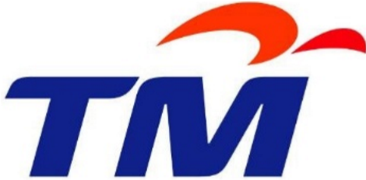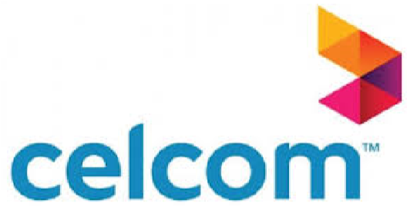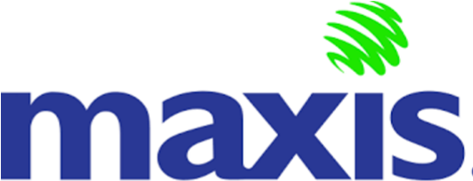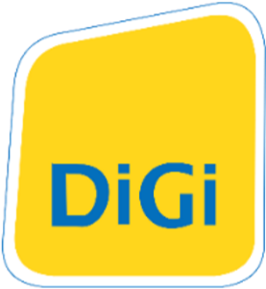
Table 1 Telecommunication firms in Malaysia
In oligopoly, the number of firms is small but the size is large. For instance, telecommunication industry in Malaysia is controlled by four major firms which is, Maxis, Digi, Celcom and TM. Through advanced technologies and connection of firms, these four major companies have made the new firms difficult to enter the industry. They will try to minimize the number of firm in order to protect their position as main companies in telecommunications industry.
So, sometimes these companies will co-operate each other to prevent any new firm that wish to enter the market. Furthermore, since the government is favouring these companies, it is difficult for new firm that wish to enter the market. For example, new firm such as OneXOX need to compete hard and put much effort so, they can be in the same level with the existing one.
Other than that, this characteristic will give each of the firm substantial market control. It does have as much market control as monopoly but it is definitely more than monopolistic competition firm. In my point of view, telecommunication firm in Malaysia meet one of the characteristics of oligopoly market structure which has a few firm running in the market.

5.1.2 Barriers to entry
The second characteristic that Telekom Malaysia can be recognised as an oligopoly is barriers to entry. Entry barriers are obstacles that stop or prevent the entrance of a new firm into a specific market. It is associated with the situation in which a firm wants to enter a market due to high profits or increasing demand but cannot do so because of these barriers.
The types of barriers to entry are control of certain resources, ownership of patent and copyright, exclusive financial requirements and other legal barriers that involves with their products. Higher barriers to entry in telecommunication market can be prove as the new firm that wish to enter this industry must have large investment to be on par with the current companies such as Celcom, Digi and Maxis. Thus, a potential firm requires additional revenue expected to be offset by an increase in incremental costs and risk.
Besides, developing consumer loyalty through establishing a strong brand image can deter entry of a market. With a very strong brand image, a new firm will have to compete with the well-established firms in the industry to attract customers. For example, Unifi struggled for few years to overcome the difficulties of promoting their service. As the competition is tight with big companies such as Telekom Malaysia, Celcom, Maxis and Digi exist in this market, Unifi need to put a lot of effort so that they can stand on the same level with the existing company.
This also can be shown as Celcom has understood the need to make customers satisfied and providing not just what they need today, but what will they need in the future. Through advancing technology, they have made it difficult for small companies to enter the market, resulting for a barrier to entry for this small firm to enter the market.
This situation also applied to big telecommunication firms such as Telekom Malaysia, Digi, Celcom and Maxis. All these four major telecommunication firms have higher barrier to entry for new competitors to enter this market. For example, Telekom Malaysia Berhad takes a drastic action to prevent the entry of new company by flooding the market by producing the product at excess production which would drive the price down.
Thus, when there are oligopoly companies in the market, the big firms will be controlling and conquering the pricing of the product, which in this case is the telecommunication service. This results to a higher barrier to entry in this market especially for the new firm to enter.’

Advertising & promotions
Then, the other characteristics that proved Telekom as an oligopoly company is advertising and promotions. Since there are few firms that provide the same communication services, they compete with each other through advertisements and promotions. At first, consumer does not have a perfect knowledge on the services provided and that is why the company spends quite a lot in advertising and improving their services quality. If Telekom Malaysia decides to attract the people using their price system, they will have to face a price war with the other suppliers.
Telekom Malaysia offered interesting internet packages to their users especially for home users which are UNIFI( tolomg masukan product unifi yg farza isi) There are many benefits that users can gain from these packages. First, users get to watch HyppTV as it is connected with these packages. They also offer unlimited call to all TM line networks while flat rate 10 sen/min to the network other than TM. Maxis offered a MaxisOne plan which the subscribers get benefits of unlimited international call, sms and data and free travel protection gain positive feedback from the customers. Celcom also come up with CelcomFirst plan which also provide higher satisfaction compared to MaxisOne plan. Each of the firm will compete against each other to attract the customers to use their service. Because of this, Digi also come up with internet plan which their services are available in wide range of area including rural area.

Mutual interdependence
Next, the characteristic of Telekom Malaysia which proved them as an oligopoly market is mutual interdependence. Telekom Malaysia is the largest telecommunication company in Malaysia. There are small number of companies compete with each other making the business organizations are more efficient to produce profitable inputs to the consumers.
In monopoly and perfect competition, organizations do not take into consideration the decisions and reactions of other organizations, therefore, the decision of organizations in such types of market structures are independent. However, in oligopoly, an organization is not able to take an independent decision.
Mutual interdependence implies that organizations are influenced by each other’s decisions. These decisions include pricing and output decisions of organization. For example, in oligopoly, a few numbers of sellers compete with each other. In such a case, the sale of one organization depends on its own price of products as well as the price of competitor’s products. This mutual interdependence differentiates oligopoly from rest of the market structures.
When there are oligopoly companies in the market, they will be controlling and conquering the pricing of the product, which in this case is the telecommunication service. Hence, since they are the ones that will be setting up the price policy, they will have mutual interdependence towards each other because one’s action will affect others. For example, if Telekom suddenly came out with a very strong marketing strategy for the new upcoming mobile plans with much cheaper price than Maxis, Celcom and DIGI, it is for sure that more customers will go to Telekom and subscribe with their plans. In order to avoid this kind of scenario, these three companies will have strategic behaviour among them. One of the dilemmas that most oligopoly companies have is to cooperate or to compete. If they were to compete, they really need to compete fiercely with each other.

Kinked demand curve
Other than that, another characteristic which define that Telekom is an oligopoly company is demand curve of Telekom Malaysia will be kinked. The reaction of each company in telecommunication industry towards price changes depends on whether the price of products is raised or lowered. These changes will affect the elasticity of demand and the gradient of the demand curve. The demand curve will be kinked at the current price. If only the company is not an oligopoly company then they can assume that their rivals will keep their price remain unchanged although they make changes to their own price as other market structure like monopolistic competition are not mutually interdependent to each other. However, due to the interdependence that occurs in oligopoly, the company cannot assume that their rivals will keep their price unchanged when they make their own price changes. As a result of this, the demand curves of the company will constantly be shifting because there are always price changes due to the reaction of each company towards the changes in price of product of other company. The demand curve that loses its definiteness and determinateness is the one that we call kinked demand curve. Telekom Malaysia also show similar characteristics as they keep changing their prices when their rivals like Maxis make changes to their prices of product.
The kinked demand curve can be shown by graph below. Although there are high increase in marginal cost but the price will remain close to the original price with high price elasticity of demand for any price rise.

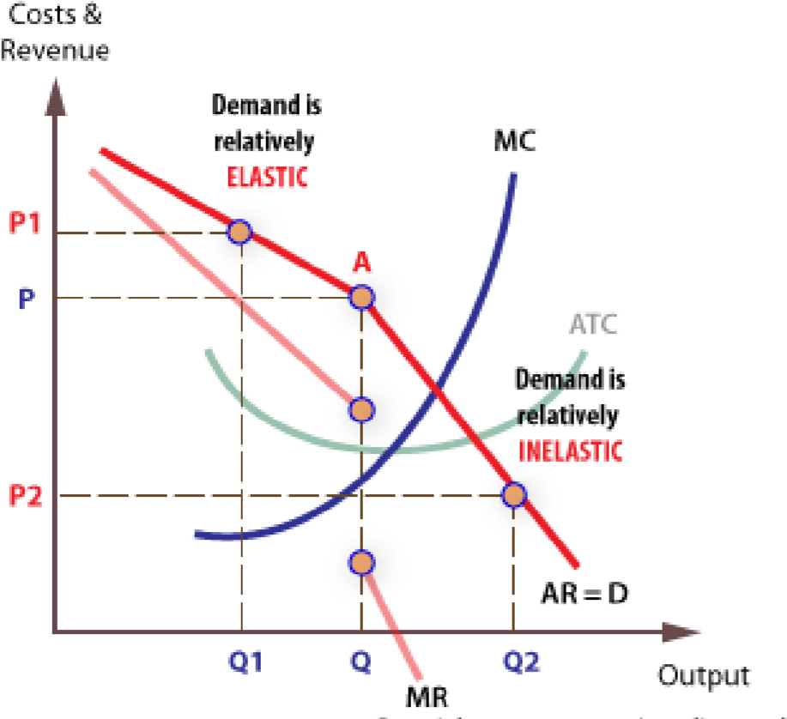
Graph 1 Kinked demand curve of oligopoly companies
Advantages and disadvantages of oligopoly
Advantages of oligopoly

1) Gain high profits
Since this is an oligopoly market structure which has lesser competition than others, the companies in this market structure have higher potential to bring large number of profits. The goods and services provided by them are controlled through oligopoly which needed or wanted by majority of population.

2) Simple choices
There are only few companies in this industry which offer goods and services that we have been looking for and it is easy to compare the products whenever we want to buy them. It is difficult in other market as we need to look thoroughly to all competitors to compare pricing and services offered by them.

3) Competitive prices
Consumers who are easy to compare the prices of goods and services offered have forced the companies to keep their prices as they are or lower the price in order to compete with other companies. A company’s action will affect others. This brings benefits to the customer as the price continually gets lower as other companies lower the price.
Disadvantages of oligopoly

1) Difficult to place a spot
It is difficult for new and small business to enter into this market although they have creative ideas in expanding their business. This is because in oligopoly, the market is controlled by large and advanced companies and is favouring by government which make that it is nearly impossible for new market to break the barrier.

2) Fixed prices bring bad effects to customers
Because of price rigidity that occurs in oligopoly, each company cannot easily make changes in their price of products. Due to this, all businesses which are part from oligopoly market have agreed to fix their prices. This means that even thugh they want to lower their prices, there is a limit for the price to go how low.

3) No fear of competition
There are only a few sellers in oligopoly market. So, the companies have become very satisfied with their business. They assumed that the profits that they have gained won’t get affected too much although they do not come up with any creative ideas to increase their profits just like how other company do.

