Organizational
Behavior
Assignment #2

INTRODUCTION:
The commissioner of the WA Police has asked your consulting firm to make the report on how they can establish a more positive culture. As consultant I have focused on the two main areas i.e. what must be done to address the concerns detailed in the stimulus article and how the commissioner should manage the change process to give the organization the best chance of changing in the desired fashion. In other words the report is focusing on the two major areas of management, Cultural effect and change management. So here I have given my opinion and suggestion to the commissioner for the concerned issues. Let discuss it in brief.
TASK 1 WHAT NEEDS TO CHANGE IN THE CULTURE TO MAKE IT MORE POSITIVE:
OVERVIEW:
For every head of populace, Western Australia is the most socially assorted state in Australia. It is home to individuals from more than 200 separate nations. Just about 28% of WA's populace was conceived abroad. Of those 40% talk a dialect other than English at home. On account of this social differing qualities dialect hindrances, religious convictions, misguided judgments, errors and preconceived mentality a "social crevice" has been made in the middle of police and ethnic minority bunches. Social equity alludes to the value or the right all inhabitants have to the same privileges and profits without separation. All parts have the right to get to administrations which are fitting to their individual needs. Uniformity intimates that people are not advantaged or distraught in their right to gain entrance to group assets and administrations. (John M. Gottman)
Law and equity is society particular and value to all will undiscovered alarm, give strength and cultivate congruous relations between ethnic groups and Police. The policing needs of ethnic groups are pretty much as fluctuated as their ethnicity. Experience has demonstrated that technique created and actualized focusing on the standard group won't essentially help individuals from socially and phonetically various foundations.
What is Positive Culture?
A positive society has a tendency to be sustaining, vote based and dynamic. At the point when a society is in positive mode it supports and qualities the commitments of its parts; subsequently thoughts develop and prosper. A positive society is adaptable to change and adjusts to help its parts in an element and continually evolving world. With the consolidated vitality of all its parts, a positive society can earnestly seek after the difficulties without bounds.
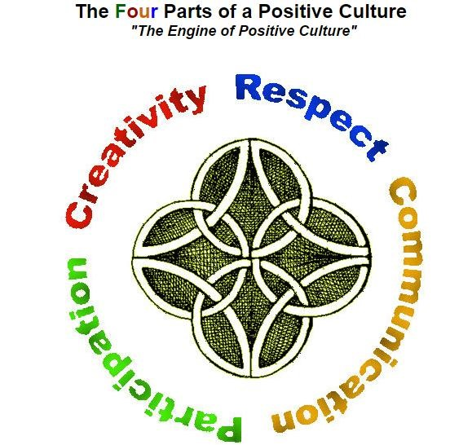

(
Source:
http://www.positiveculture.ca/positive-culture-what-is.html)

The Four Parts of a Positive Culture:

•

Respect:
It is the course to information and an eagerness to impart. Information
commits it conceivable to abstain from rehashing errors and
offering gives the
gathering access to more and various learning.
•

Communication:
We require correspondence to tell individuals what we need, to
pass on thoughts and to fulfill undertakings.
•

Participation:
We require cooperation to get anything going that will require more
than one individual's close to home capacity. Arranging needs to include individuals
and individuals need to feel definitively included.
•

Creativity:
It is critical thinking force, without it our predecessors would not have
survived. Each test without bounds will need to be taken care of innovatively.
In order to make more positive culture the WA police department can take following steps;
Create a sense of oneness
Leaders who unite individuals discuss "us" more than 'I'. They spread the stories of history and present stories that make a feeling of harmony. They additionally make goals for the association and structure the workforce that guarantees that they need to cooperate.
Highlighting the dangers from outside additionally unites individuals, as dangers from contenders and weights from client and governments demonstrate that the best way to survive is by cooperating.
Promote a sense of membership
Having a place likewise originates from the profits that individuals pick up, so take a shot at the prize and separate framework. Help individuals deal with their vocations, making advancements genuine and not being advertised adequate.
More than whatever else might be available; the most essential process in an association is choice, whether it is advancement or recruitment from outside. Making a meritocracy implies this is carried out decently, with a concentrate on the best individual for the occupation instead of on preference.
At the point when individuals join, have an exceptionally ponder methodology of socialization, where they take in the society and the present association. Having senior administrators present to the newcomers sends a compelling message. Similarly in preparing and advancement, a predictable advancement of the society through all things maintains the message and the importance.Socialization regularly begins with a modesty prompting background that demonstrates the individual that they truly don't see how things function. This is trailed by an in-the-trenches inundation that teaches the society.
Increase contact and exchange
Help individuals stay in contact with each other. This is especially essential in a worldwide or overall appropriated association. Have meetings and gatherings over a few days so individuals can standardize at night. Unite individuals deliberately for social occasions at any rate.Work to make between gathering collaboration and cooperation. Have work-trade projects and move individuals sideways so they spread thoughts and get to comprehend the greater picture.

HOW THE COMMISSIONER SHOULD MANAGE THE CHANGE PROCESS TOGIVE THE ORGANISATION THEBEST CHANCE OF CHANGING IN THE DESIREDFASHION:

As we all realize that police has exceptionally chaotic employment profile, they generally manage wrongdoing, criminal and frightful things in the general public. They barely appreciate their life and much after their retirement, they are harassed by the culprits and other contradicting part of the general public. A portion of the reasons are said in the article that why police employment is bad. For example:

- Difficult to balance the job and family obligations
- It is not a good paid job
- They have to deal with crime and criminals
- 40 per cent said the service did not offer promotion and career development opportunities
- 20 per cent of departing officers and staff said WA Police did not have a positive culture or healthy work environment
In this report there is an application of some organizational behaviour theories to make the workplace environment better. A few issues of associations need to do with the authoritative society: the path in which the association, including its stakeholders, utilization to act and think. This authoritative mental make-up is -more than structure or procedure the definitive variable in getting achievement. On the off chance that the hierarchical society is blocking achievement, the change of society must be considered.
Policing in Australia has been composed along tyrant and paramilitary lines, which incorporates regulation of representatives through strict authoritative standards and enactment. Policing is extremely various levelled in nature with positions by and large running from Constables to Commissioner. Inside the association there is a strict consistence with the levels of leadership for choice making, arrangement 24 plan and managerial assignments.
One Australian police purview has as of late attempted a steady initiative mediation, as one of various different intercessions, trying to modify the current authoritative society and atmosphere to a work environment portrayed by strong authority and suitable correspondence hones. Strong administration (steady pioneer) is characterized as "mentality, correspondence, practices and activities by directors and bosses that empower staff to feel backed consequently to work adequately, profitably and suitably" (Supportive Leadership Workshop, Participant Workbook, p.3). Supportive leadership has previously
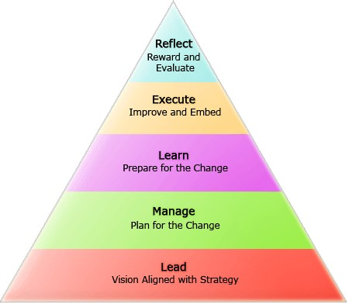
been identified as one of the factors that contribute positively to organizational climate
(
Head, 2000).
Understanding the culture of the organization:
Organizational culture alludes to what we call the identity of an association: if the structure of
the association is the body: the bone structure, the bolstering structure of veins and the
correspondence channels of sensory system, then the identity or soul is the way individuals
manage each other, the qualities and convictions that exist inside the association.
Rebuilding an association, with a specific end goal to accomplish a certain objective,
frequently falls flat or gets stuck on the grounds that the identity does not change. That is the
reason we concentrate on the society of the association when managing change. (Mullins
2006)

Society is characterized as the aggregate personality set or 'the product of the brain'. Since it
is regularly hard to portray what the identity is, the accompanying system can be utilized to
comprehend the deeper social parts of an association.

(Source: http://www.mybusinessprocess.net/change-process)

The organisation's culture can be described in terms of Hofstadter’s 'onion':
- The exterior layers consist of symbols (the building, the way employees are dressed, the 'language' they speak, the cars they drive, collective behaviour, etc.)
- one layer deeper one can notice the 'heroes' or the 'anti-heroes' in the organization (the leader or founder who is 'worshipped' or who is being used as an example, thereby telling a lot about how to behave here in order to be accepted)
- One layer deeper one can find the rituals (eating together or not, greeting each other, how meetings are organized, celebrations of birthdays, etc.)
Through these whole "layers" one can see flashes of the heart of the onion: the true estimations of the association:
- The inward core of the onion, the estimations of the association: what is truly esteemed or degraded? Be mindful of the qualification in the middle of embraced and coordinated qualities. Upheld qualities are the qualities individuals say are imperative to the association. Be that as it may a large portion of the times such embraced qualities outline the future point of view of the association, not the real moving qualities. Coordinated qualities are the values that really give off an impression of being imperative; the heart of the society. Some of the time there is a hole between the embraced and the coordinated qualities. This can be a true issue, particularly when managing sex: lip administration and no genuine expectation to coordinate sexual orientation strategies.
How does an organizational culture develop?
- To comprehend the society of an association and its improvement, it is imperative to investigate its "introduction to the world" and history. Case in point: if an association is conceived out of challenge against the current framework, the battling disposition can be exceptionally solid. However helpful that may have been to start with, such a battling inclination can turn into prevention, if the association sticks to it, without a real reason. This obliges an endeavour to comprehend the association inside its history and connections, the traumas that impact the way they manage outside impacts or change. Comprehension is more helpful than getting irate. (Daft, R, L., 2009)
So the change agent has to include the following elements in the analysis:
- Its products: 'what business are we in?' Every branch has its specific 'smells', sounds, characteristics.
- Its history: like a personality, what are the traumas, life events, happenings, etc? How did the organization react and how does that still influence the way this organization deals with matters?
- Internal/external interaction (stakeholder's context): threats formed outside will have reactions on the inside.
The pioneer program has brought about the execution of new steady pioneer practices or the fortification of existing strong pioneer practices. Strong pioneer procedures are seen to be generally esteemed and illustrations from the meetings give proof of this. The utilization of strong pioneer methodologies in work-related practices (e.g. including staff in choice making, discussion gatherings, open-entryway arrangement, giving input both positive and negative) are likewise clarified to give understanding of how strong pioneer is esteemed and utilized.
Personal support at work:
The meetings uncovered the estimation of support for people when they are experiencing a scope of individual encounters – i.e. imperative breakthroughs in individuals' lives, for example, the conception of a youngster, a looming wedding or birthdays. At the point when these are perceived by tokens, for example, the buy of blooms, blessing or a card it helps emotions of support.
For example, in some cases the Peer Support Officer or the treasurer of the social club may be given the responsibility to make such arrangements. In one specific segment, the Officer in Charge has made notes of the first names of the accomplices of the staff so that on the off chance that he needs to contact them he can utilize their first name. Remarks fixated on the issue of perceiving that staff parts have a life outside of the Police Jurisdiction.
Workplace Support Strategies:
Work environment methodologies showing the utilization of SL are joined in various ranges – participative choice making, interview gatherings, open-entryway arrangement and giving criticism.
There were numerous samples that proposed that SL methodologies were rehearsed by directors/supervisors every day. For instance, one Officer in Charge had day by day associations with the staff and if a work related issue emerged, for example, a vocation that had „gone badly‟ , they would get to be familiar with the circumstances by talking straightforwardly with the staff included. An alternate interviewee welcomed all his group pioneers to go to a workshop he had conceived, to recognize the society of their specific area so they could create methodologies to make it a more supportive environment. (Freeman, 1992)
Participative decision-making:
Including staff parts in choice making was utilized by an Officer as a part of Charge as a system for utilizing the standards of Supportive Leadership. For instance, when the police division was encountering an increment in the burglary of plane skis, the Officer in Charge, talked with the important staff parts to devise a plan to address the circumstances. The staffs were asked to give information into the choice making process and aid in the detailing of the plan to address the issue. One interviewee clarified the strategy for participative choice making at his station in the accompanying way - “My Sergeants and I, what we do is we go and have lunch and we talk about some of the staff, how they are performing, where we best think they could go.”
Open-door policy:
A dominant part of the interviewees had a „open door‟ approach and distinguished that they thought it reflected the standards of SL. Essentially, it implied that staff parts were ready to enter the workplace of the manager and talk with them about any issue of concern. The issues raised by the staff may be work-related or identified with an individual matter. Numerous interviewees saw this approach as a method for lessening the progressive nature of policing to a more individual, strong and open administration style. One interviewee said -
“It doesn’t matter who you are, if you want to come and talk to me, you come and talk to me.
If there are issues you want to discuss, come and discuss them.”
Senior officers not applying the SL principles in the workplace:
Interviewees felt "let down‟ when senior officers did not utilize the standards of SL within normal work practices and collaborations with staff. One interviewee said - "Well, there are times when I think, well, why trouble" (when senior staff are not mattering the standards of SL). An alternate interviewee watched that it was fundamental for the officers at the lower levels to see SL backed and utilized all the more by police of higher positions. An alternate interviewee made the accompanying remarks - "In what capacity would you be able to expect it (SL) to have any believability if your authorized rank or your official officers don't grasp it? The effect of non-steady authority had huge negative ramifications for staff. Case in point, "it can be extremely unpleasant on occasion in light of the fact that we are in an administration part ourselves, in the event that I needed to 23 advances myself; the imperious style of initiative that I get is keeping me away from learning different occupations or different parts of my employment even.

REFERENCES:
- Bateman, T.S. and Snell, S.A., (1999) Management: Building
CompetitiveAdvantage, McGraw-Hill, 3rd Edition
- Daft, R, L., (2009), Organisational culture, The West series in management., WestPub. Co., cop, ISBN 978-0-314-69645
- Daft R, L., (2009) Organisation Theory and Design, South Thompson publishersMullins (2003) Organisation behaviour and management, Prentice Press
- Natarajan et al (2010) Principles of Management, Tamilnadu Textbook Corporatio n College Road, Chennai - 600 006
- Stoner, J.A.F., Freeman, R.E.,(1992) Management, Prentice Hall, 5th Edition,1992
- Needleman, S. A. (2008, December 23). Avoiding the ax: Where the jobs are.
Wall Street Journal, Section D, pp. 1, 5.
- Breaugh, J. A. (2008). Employee recruitment: Current knowledge and important areas for future research. Human Resource Management Review, 18 (3): 103118.
- Society for Human Resource Management. (2008, April-June). The employer brand: A strategic tool to attract, recruit and retain talent. SHRM Staffing Research, 2.
- Overman, S. (2006). Show off your brand. Staffing Management 2, pp. 2-6.
- Kiger, P. J. (2007). Burnishing your employment brand. Workforce Management, 86 (18): 39-45.
- Crispin, G., & Mehler, M. (2006, September). The candidate experience: Black hole or north star [A CareerXroads Whitepaper on Staffing Strategy and Process].
- Carlson, K. D., Connerley, M. L., & Mechan, R. L. (2002). Recruitment evaluation: The case for assessing the quality of applicants attracted. Personnel Psychology, 55, 461-490.


