Ms Access ASSIGNMENT

I. OBJECTIVE
The primary objective of this assignment is to teach you how to create tables and forms in Microsoft Access. However, by completing this assignment, you will also be able to gain DBMS skills such as (1) backing up an Access file, (2) setting up table structures and field properties, (3) establishing table relationships, and you will gain familiarity with DBMS concepts such as a. primary and foreign keys, b. one-to-many and many-to-many relationships, c. a relationship table (i.e., a bridge entity), d. referential integrity, and e. a REAL diagram, (4) creating single and multiple-table forms, (2) entering data using forms, (5) inserting an OLE object—a graphic logo in this particular assignment, and (6) copy and paste forms and tables.

II. COMPANY BACKGROUND
Almost a year ago Tom Waren, owner of Waren Distributing, was approached about an idea for a new business venture by his twin sister Jill. Jill had been considering starting a VIDEO SHOPPING NETWORK show to distribute various products to retail customers. Jill wanted Tom to sell his products to her new business Waren Unlimited at cost and in exchange Tom would receive a 20% share of Waren Unlimited profits after one year. Jill started operations in July without Tom's participation, but he decided to join with Jill in September. Several cable television stations have broadcast the program, which demonstrates name brand products and flashes a 1-800 number that viewers can dial to order items. Waren Unlimited's product pricing is very competitive as inventories are purchased in very large quantities directly from Waren Distributing and a number of other manufacturers/distributors. Also, overhead is minimal in comparison to retail outlets.
This is a critical time in Waren Unlimited's growth. National cable network time has recently been purchased and decisions need to be made on how to best use the expensive national air-time. You have been asked to develop some relational database tables Waren Unlimited can use to collect data on operating activities. The data will be used to formulate future business plans.

III. PARTIAL REAL DIAGRAM
Below you will find selected entities and relationship for Waren Unlimited. A complete database would consist of customer payment records, inventory purchases, etc. and would involve complete interactions between all aspects of the database. However, these few tables shown below will provide a representative exposure to relational databases and provide you with the understanding of how to create and use tables.
M*
1
Supplier
Item
Order
Salesperson
Customer
Order-
Item
1
M
M
M*
1
M
1
1
M
M
(*Many-to-Many relationships are implemented with a relationship table which results in the Order-Item Table. The table titled “Order-Item” is necessary because inventory items have a many-to-many relationship with purchase orders. This means that any particular inventory item can be purchased by several customers while any one customer may purchase several different items. Therefore, the individual items included in each order are identified in the table “Order-Item”. Access turns the many-to-many relationship between the Item and Order tables into a One-to-Many relationship between Item and Order-Item and One-to-Many between Order and Order-Item tables.) The attributes (or fields) required in the tables are shown as follows:
Customer = (Customer#, Name, Address, City, State, Zip, Age, Sex, Occupation)
Item = (Stock#, [Supplier# ], Description, Unit Cost, Sales Price, QOH, Air Time)
Order = (PO#, [Customer#], [SSN], Date)
Order-Item = ([PO#], [Stock#], Quantity)
Salesperson = (SSN, Name, Commission Rate)
Supplier = (Supplier#, Name, Address, City, State, Zip)
The underline indicates the table’s primary key and the brackets, [ ], designate a foreign key. The primary key is the unique identifier for each item in the table. The foreign keys are derived from the relationships between the entities. The rule followed is the primary key of the "one" is placed in the table of the "many” as the foreign key.
Primary keys need to be designated when they are created in the tables. However, there is no bracket or designation needed when you create the foreign keys in the database. Foreign keys are simply treated as the same as other attributes.

IV. GENERAL INSTRUCTIONS FOR CREATING A TABLE AND ESTABLISHING TABLE RELATIONSHIPS
First you will create the six tables indicated above and then you will set the primary key(s) for the tables. After that, you will establish the relationships between the tables which automatically establishes the foreign keys. Be sure to periodically save your work according to the directions below.
To Create The Tables o Open a new database: Choose Blank Database. Then go to file and save the blank database. To save the database, you first have to select directory (either a flash drive or the desktop on C drive. Then enter Waren UnlimitedXX as the file name where XX stands for your group number (e.g., group 6 would be Waren Unlimitedgroup6). Then click on the Create button. o Create tables: Select Create Table in Design View and enter the field names and data types and descriptions as shown below. Also adjust the field properties indicated below and identify primary keys. To set the primary key, click on the primary key field and select Edit/Primary Key or click the "Key" button on tool bar. Note: For a composite primary key (involving more than one attribute/field), click on one field, then holding down the Control (Ctrl) key, click on the second field and select Edit/Primary Key or click on the "Key" button on the tool bar. After setting the primary key, save the file (File/Save As or click "Save" button on tool bar and enter name and then OK), and then close the table.
For uniformity, we will all use the following field names and data types as show below. Adjust the field properties to the field sizes and number types as indicated. When adjusting the field properties of the table, use the wizards that appear when you click on the item you wish to adjust. To do this, click on the little down arrow or the expression builder (a box with 3 periods) that appears. This will give you the wizard choices. Be sure to adjust the input masks as indicated. (Each of you will make up and enter your own description for each field). You should always include your group number at the end of your table name and each field you create. For example, for the OrderXX table, Group 6 would name its table Ordergroup6 and the Purchase Order field as PO#group6.
YOU WILL NOT RECEIVE CREDIT IF YOUR GROUP NUMBER ARE NOT INCLUDED IN YOUR TABLE NAME. DON’T FORGET TO SETUP THE PRIMARY KEYS AS DESCRIBED EARLIER.
CustomerXX
FIELD NAME
DATA TYPE
FIELD PROPERTIES
Customer#XX
Text
Field size 5
NameXX
Text
Field size 30
AddressXX
Text
Field size 30
CityXX
Text
Field size 20
StateXX
Text
Field size 5
ZipXX
Text
Field size 10
AgeXX
Number
Integer
GenderXX*
Text
Field size 1
OccupationXX
Text
Field size 20
- Under Gender, after setting the field size to 1, tab down to (Default Value) enter a "F" since most customers are female. Under (validation Rule) enter =F or M. Indicating Male or Female. Finally, under (Validation Text) enter the following text: Must Enter a "F" for female or a "M" for male! Test this to make sure it works.
ItemXX
FIELD NAME
DATA TYPE
FIELD PROPERTIES
Stock#XX
Text
Field size 5
]
Supplier#XX
[
Text
Field size 7
DescriptionXX
Text
Field size 25
Unit CostXX
Currency
Sales PriceXX
Currency
QOHXX
Number
Integer
Air TimeXX
Number
Integer
OrderXX
FIELD NAME
DATA TYPE
FIELD PROPERTIES
PO#XX
Text
Field size 7
[
Customer#XX
]
Text
Field size 5
[
SSNXX
]
Text
Field size 15 (Adjust the
Input mask to SS type)
DateXX
Date/Time
(
Adjust the input mask to
Short Date type)
Order-ItemXX
FIELD NAME
DATA TYPE
FIELD PROPERTIES
[
PO#XX]
Text
Field size 7
[
Stock#XX
]
Text
Field size 5
QuantityXX
Number
Integer
SalespersonXX
FIELD NAME
DATA TYPE
FIELD PROPERTIES
SSNXX
Text
Field size 15 (Adjust the
Input mask to SS type)
NameXX
Text
Field size 30
Commission RateXX
Number
Field size is Double
Format is Percent
SupplierXX
FIELD NAME
DATA TYPE
FIELD PROPERTIES
Supplier#XX
Text
Field size 7
*NameXX
Text
Field size 30
AddressXX
Text
Field size 30
CityXX
Text
Field size 20
StateXX
Text
Field size 5
ZipXX
Text
Field size 10
- For the Required Field change it to Yes. Test this when entering data to make sure it works.
IF YOU HAVEN'T ALREADY MADE A BACKUP COPY PLEASE DO SO FOLLOWING THE DIRECTIONS AT THE END OF THIS ASSIGNMENT.
To Establish The Relationship Between The Tables o Before you begin setting up your relations MAKE ABSOLUTELY SURE that you have set up both the PO# and Stock# as the (composite) primary key in the Order-Item table.
  - In the Database window, select Relationships from the Tools menu. Add each of the tables listed in the Show Table dialog box to the Relationships window and close the Show Table dialog box.
  - Establish the relationships between the tables based on the REAL Diagram (or data model) depicted in section III. Be sure you follow the order the tables are
listed as shown in section III. Establish the relationship between two tables by clicking on a primary (foreign) key field in one table and dragging and dropping it to a foreign (primary) key field in the related table. For example, the first relationship you establish will be to drag from the Customer field in the Customer table to the Customer field in the Order table. An Edit Relationships dialog box will appear when you release the mouse button from dropping. Verify the table relationships in the Edit Relationships dialog box and the relationship type (one-to-many). Click on "Enforce Referential Integrity" option and then click on the Create button. Referential integrity prevents you from deleting related records in an improper order. For example, you would not be allowed to delete a customer until all of the customer’s orders have been deleted first. Continue in the order the tables are listed as shown in section III until all the relationships are established and then close the Relationships window.

V. GENERAL INSTRUCTIONS FOR CREATING FORMS, ENTERING DATA, PRINTING FORMS AND TABLES
Some data about salespeople, inventory items, suppliers, and customers of Waren Unlimited are listed below. You are to create four single-table forms to be used to enter data into the tables: salespeople, customers, suppliers, and items. You will then use the forms to enter data in four of the six tables you created earlier. See the following instructions for creating a single-table form before beginning the assignment. After that you will be creating a multi-table form: Order form to enter the data into the Order and Item tables. There are many different ways to create forms in Access, we will show you two methods in this assignment.

To Create The Forms
The following instructions will help you create the form.
• Start Access and Open the Waren Unlimited database: After you launch MS Access, Choose Open an existing file and then click the OK button when the MS Access dialog box displays, select the drive when the Open dialog box displays, click on the file named Waren UnlimitedXX, where XX represents your group number and then click the Open button.
- Create a form using Form (Single-Table Form): Click Tables in the Objects bar of the Database window and select the desired table. Do not open the table. (Insert/Form/AutoForm: Columnar) Note that the desired table is already selected and shown in the box “Choose the table ……”. Click the OK button. You can apply this method to the Salesperson, Item, Supplier, and Customer tables. DO NOT apply this method to the Order and Order-Item tables unless you are familiar with linking a subform to a main form.
- Create a form using a form wizard (We are using the form wizard to create a Multiple-Table Form, it can also be used to create a Single-Table Form):
(Insert/Form/Form Wizard and use the drop down arrow to choose a desired
table, for example “Order” table, and then OK to execute it). On the next screen, under where it says “Available Fields” you will see a single and a double arrow. Click on the double arrow to select all the fields in the Order Table and add them to the Selected Fields box. Then go back to where it says Table/Queries and use the drop down arrow and choose the Order-Item table. Select Stock# and use the single arrow to add it to the Selected Fields box. Do the same thing to select the Quantity fields. Click on the Next button. It will ask how you want to view your data, choose “by Order” and make sure the “Form with Sub-forms” radio button is selected. Click the Next button. Select Datasheet view and click on the Next button. Select “Standard” and click on the Next button. Access will allow you to name the forms. Choose frm_Order and frm_Order/Item Subform and then choose Finish to automatically save the forms.
• After the form is created, click on the “Close” button.

To Enter The Data
The following instructions will help you enter the data.
- Start Access and Open the Waren Unlimited database: use the above instruction given under the Creating Forms section.
- Enter data: Start entering data provided in this assignment. Press TAB or
ENTER to enter the data and continue until all fields are entered. BE SURE
YOU ENTER THE DATA INTO THE TABLES IN THE ORDER THE TABLES ARE GIVEN ABOVE TO AVOID REFERENTIAL INTEGRITY ISSUES.
- Note: for the order form (i.e., frm_orderXX), you can enter multiple Stock#s and Quantities for each order. After you complete the last item on the PO#, click the next record button (at the very bottom of the screen) for a new PO and click the PO# box to move the cursor to that point and start entering another PO. Access automatically saves the records in the table.
- If things don’t go correctly when setting up the form, go back and make sure you set up both PO# and Stock# as primary keys on the Order-item table.
- When all records are entered, click on the “Close” button.
- View your tables to verify your data was entered accurately.
Note: View the data in the table using the form. If you find an error in the data in your table, use the form you created above to correct it. For the record with the error, doubleclick the field with incorrect data, correct the data, and press the TAB or ENTER key to move to other fields and correct them. Close the form when all errors are corrected.
Some data about salespeople, inventory items, suppliers, and customers of Waren Unlimited are listed below.
SalespersonXX
SSN
Name
Commission Rate
234-34-5212
Johns, Kathleen
.02
401-93-8888
Holmes, Patty
.02
519-23-5909
Steele, Chloe
.03
SupplierXX
Supplier
Name
Address
City
State
Zip
1000
Waren Distributing
1978
W. Michigan Ave.
Chicago
IL
60612
1030
Ephraim Inc.
3232
Industry Rd.
Silicon
CA
84444
1040
Bethel Company
One Trident Lane
Bellevue
WA
93111
1050

We-Be-Gadget
1000
Topanga Hill
West Hills
CA
91303

CustomerXX
Cust# Name Address City State Zip Age Gender Occupation
- Crosse, 425 Center Scenic UT 84058 29 M Accountant
Clay St. City
- Ben-Judah, 1286 Sequoia Chico CA 91307 42 M Truck
Tsion Driver
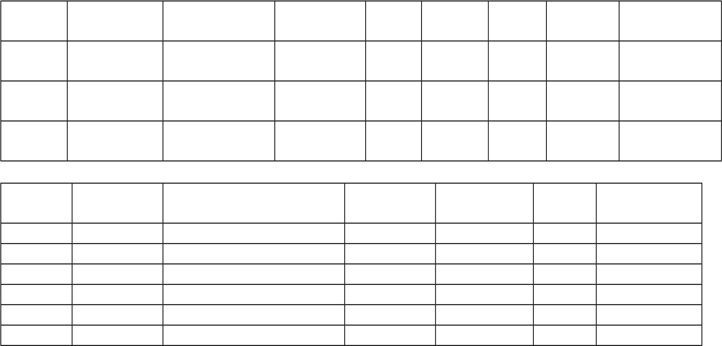
- Winan, 345 Sherm Resceta CA 91405 31 F Housewife CeCe Rd

ItemXX
Stock# Supplier# Description Unit Cost Sales Price QOH Air Time
- 1000 Toaster $27.00 $46.00 600 300
- 1000 Coffee Maker $39.00 $60.00 435 240
- 1000 Alarm Clock $15.00 $18.00 2000 450
- 1030 Fuzzy Slippers $2.90 $3.95 1200 300
- 1030 Aerobic Exercise Wear $9.00 $11.95 435 240
- 1030 Neon Beach Towel $4.20 $7.00 2000 450
Below are listed the first few orders for Waren Unlimited. You are to create a multipletable form to be used to enter the data in the Order and Order-Item tables. The OrderItem table is filled automatically as you enter the order data if you structure your form correctly. See the following instructions for creating a multiple-table form before beginning the assignment.

OrderXX
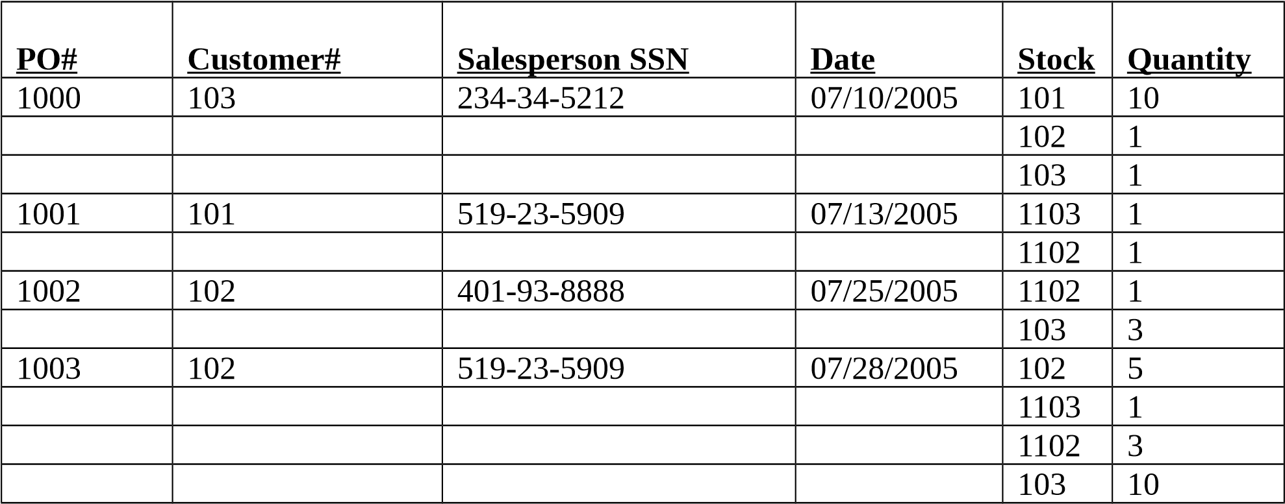

VI. SPECIFIC INSTRUCTIONS FOR INSERTING AN OLE OBJECT

To Insert A Picture Or Logo Into Your Form (an unbounded OLE object)
- First, you will need to save the provided image to add to your form. To do this, go to the web. The JTW logo file is saved with the assignment files. Copy it to your disk.
- Now to add the image, display your Supplier form in Design View.
- In the body of Design View you will see 3 sections called Form Header, Detail, and Form Footer. Place your cursor between the Form Header and the Detail sections and an I-bar icon will appear. At this point you will be able to click while the I-bar icon is present and hold and drag down to open your Form Header section for data entry. (NOTE: If left clicking doesn’t work for you try a right click!)
- You will be placing your saved JTW.gif image in the Form Header section. To do this you will need this section highlighted by a simple ONE left mouse click in any area of your Form Header. (NOTE: If left clicking doesn’t work for you try a right click!)
- Look at the top toolbar for Insert and click. You will find Picture… Click it to open the Insert Picture dialog box.
- You will probably have to browse to find the drive that you placed your image in.
Once you find it just double click the file. This will insert your picture into the Form Header section automatically.

VI .Show Table Results in a MS Word document
• Show table results in one MS Word document: While the Waren UnlimitedXX database is open, open a session of MS Word. Click on File and choose Page Setup. Then choose the Landscape button to turn your page horizontally (or, use the Portrait if it fits better). With the Access table open (it should look like a spreadsheet), find the button that is located in the top-left corner of the table. The button is directly to the left of the first column heading. Click it and the whole table will become highlighted. Hit Ctrl-C or Edit/Copy to copy the selected area to the clipboard. Toggle over to MS Word. Place your cursor where you want the results to appear. Hit Ctrl-V or Edit/Paste and Word will paste your results as a perfect table. Using Word, type the name of the table above the previously pasted table.

MAKING A BACKUP COPY
o Make a Backup copy: Don’t forget to make a backup regularly. There is nothing worse than having to redo work because you didn’t make a backup. You can’t do a “Save As” to back up Access files as you do in other Microsoft applications. To get a backup you need to actually make a copy of the file itself. If you are working off the hard drive, close out Access and use Windows Explorer to locate your Access file on the C drive and copy it to a flash drive.

TURN-IN
- Upload your final database file to SacCT.
- The MS word file with cover page and table results to SacCT (like a spreadsheet with data).

